Appendix 2.2

Report of International Conference Presentation

Name:  (Presenter) | Kanokvate Tungpimolrut
Affiliation: | National Electronics and Computer Technology Center
Project Title: | Visual IoT Network for Environment Protection and Disaster Prevention
Name of International Conference:  (Link to website) | The 21st International Conference on Computer Applications (ICCA 2024)  https://ucsy.edu.mm/ICCAConference24.do
Title of Research Paper: | Visual IoT System for Smoke/Fire Detection in Chiang Mai (Thailand)
Name of all Co-authors (if any)
Comments or feedback received at the conference:
- How to access to the dataset constructed by NECTEC team ?
Answer: Via the QR code post on the slide.
- Is it also applicable to smoke/fire detection in Myanmar ?
Answer: In principle it could be applied to smoke/fire detection in Myanmar, but the accuracy might be different.
- How about reliability of RasPi system for this outdoor application ?
Answer: We use industrial grade RasPi which is more reliable, so it should be used in outdoor environment. We have installed our system in the field since 2 weeks ago and it could be used normally.
- When did NECTEC team do dataset construction in Thailand ? Is it dry season or rainy season ?
Answer: We constructed the dataset around last June which is end of dry season and beginning of rainy season.

Contribution to the project:
Dr. Kikuta (NICT team) presented concept of Visual IoT System in various application domains and the proposed technique based on optical flow by using short streming videl to detect the smoke. This presentation continued to his presentation and shown some information about the system design and results of smoke/fire detection based on another concept using still images.

Photos

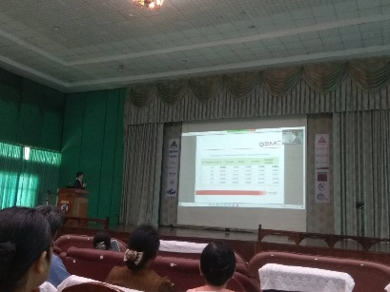 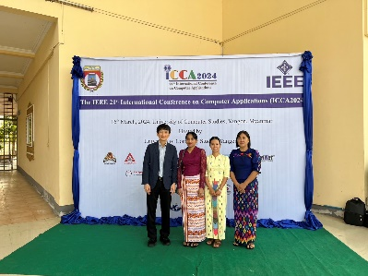\
[Required Documents]
- Presentation Materials (e.g. PPT slides)
- Final Program of the conference

Reporter: _____Kanokvate Tungpimolrut_____
Date: _______20 March 2024____________

