Appendix 4.2

[Cyber to Real World Integrated Testbed for
Dam Safety Management and Water Governance System]
[Symposium and Meeting]
Report Form

I. Organizer:
Name: | Mr. Kanokvate Tungpimolrut
Position: | Research Fellow, Research Group Director
Institution: | National Electronics and Computer Technology Center (NECTEC)

II. Program:
Date: 8 – 10 May 2024
Venue: 1. Mercure Bangkok Surawong Hotel, Bangkok, Thailand
2. Srinagarind dam, Kanchanaburi province, Thailand

Program Agenda:

8 May  Symposium | 09:00 – 12:00  9.00-10.30  10.30-10.45  10.45-12.00 | Venue: Hotel’s meeting room  - Overview of ASEAN IVO project by Kanokvate  - NICT present on utilization of CyReal Testbed  - Overview of CyReal Testbed and its usecace by Dr. Miyachi  - Training of CyReal Testbed Part 1: Basics of CyReal Testbed (StarBED/TENTOU) by Dr. Miwa and Mr. Miyakawa  Coffee break:  - Training of CyReal Testbed Part 2: Hands-on of CyReal Testbed (StarBED/TENTOU) by Dr. Miwa and Mr. Miyakawa  - Discussion of how to emulate dam safety management and water governance system
 | 12:00 – 13:00 | Working lunch
 | 13:00 – 17:00  13.00 – 15.00  15.00-15.15  15.15-16.45 | Venue: Hotel’s meeting room  - Ms.Pothikul Vivithkeyoonvong, Civil Engineer of Dam Safety Review Section, EGAT, "Dam Safety Overview”.  - Prof. Kantoush Sameh Ahmed, Disaster Prevention Research Institute, Kyoto University, “Development of a Dam Safety for Multi-hazards Alert and Risk reducTion (Dam-SMART) in the ASEAN basins." [via online]  - Ms. Patsorn Rakcheep, Head of Aquatic Ecology Section, EGAT, “Water Management in Thailand”.  - Discussion  Coffee break:  - Prof. Warakorn Mairiang, Department of Civil Engineering, Faculty of Engineering, Kamphaeng Saen Campus, Kasetsart University, "Dam Instrument”.  - Dr. Rangsarit Vanijjirattikhan, Senior Researcher, NECtEC, “Dam Safety Remote Monitoring System“.  - Discussion
9 May  Symposium | 08:00 – 12:00 | Venue: Srinagarind dam  - Depart from hotel to Srinagarind dam
 | 12:00 – 13:00 | Working lunch
 | 13:00 – 15:00  15.00 – 19.00 | Venue: Srinagarind dam  - Mr. Sirichete Samrangyoodee, “Instruments in Dam Safety Remote Monitoring System”.  - See the sensors and system around dam site  - Depart from Srinagarind dam to hotel
10 May  Meeting | 09:00 – 12:00 | Venue: Hotel’s meeting room  Share information on current status and technical requirement of each member country  - NUOL team  Coffee break:  - CADT team  - UCSY team
 | 12:00 – 13:30 | Working lunch
 | 13:30 – 17:00 | Venue: Hotel’s meeting room  - Conclude the output of symposium  Coffee break:  - Conclude the future plan

III. Participants:

No. | Name | Organization | Itinerary
1 | Dr. Somsanouk Pathoumvanh | NUOL | 7/5/2024 (in)  11/5/2024 (out)
2 | Dr. Kamla Non Alinsavath | NUOL | 7/5/2024 (in)  11/5/2024 (out)
3 | Dr. Ly Rottana | CADT | 7/5/2024 (in)  12/5/2024 (out)
4 | Dr. Cheab Sovuthy | CADT | 7/5/2024 (in)  11/5/2024 (out)
5 | Dr. Thin Lai Lai Thein | UCSY | 7/5/2024 (in)  11/5/2024 (out)
6 | Ms. Zin May Oo | UCSY | 7/5/2024 (in)  11/5/2024 (out)
7 | Dr. Toshiyuki Miyachi | NICT | 7/5/2024 (in)  11/5/2024 (out)
8 | Dr. Shinsuke Miwa | NICT | 7/5/2024 (in)  11/5/2024 (out)
9 | Mr. Shinichi Miyakawa | NICT | 7/5/2024 (in)  11/5/2024 (out)
10 | Dr. Hiroshi Emoto | NICT | 7/5/2024 (in)  10/5/2024 (out)
11 | Mr. Hisanori Nishino | NICT | 8/5/2024 and  10/5/2024
12 | Ms. Nanthiya Raphitphan | EGAT | 8/5/2024
13 | Ms. Patsorn Rakcheep | EGAT | 8/5/2024
14 | Mr. Jirayu Kontoengern | EGAT | 8/5/2024
15 | Mr. Pakkapol Aueteerasarun | EGAT | 8/5/2024
16 | Ms. Pothikul Vivithkeyoonvong | EGAT | 8/5/2024
17 | Assoc.Prof.Dr.Warakorn Mairaing | Kasetsart U. | 8/5/2024
18 | Dr.Wiphada Thepchantra | RUTS | 8/5/2024
19 | Dr. Kanokvate Tungpimolrut | NECTEC | 8/5/2024 to  10/5/2024
20 | Dr. Rangsarit Vanijjirattikhan | NECTEC | 8/5/2024
21 | Ms. Rungtip Nuntawattanaririchai | NECTEC | 8/5/2024
22 | Ms. Paramaporn Jinthanakorn | NECTEC | 8/5/2024
23 | Dr. Sasiya Usomsuk | NECTEC | 8/5/2024
24 | Mr. Pakorn Lopattanakij | NECTEC | 8/5/2024
25 | Mr. Sutiwat Khamhaeng | NECTEC | 8/5/2024
26 | Prof. Kantoush Sameh Ahmed | Kyoto U. | 8/5/2024 (Online)
27 | Mr. Sirichete Samranyoodee | EGAT | 9/5/2024
28 | Dr. Jittiwut Suwatthikul | NECTEC | 9/5/2024
29 | Mr. Kampee Suksomboon | NECTEC | 9/5/2024
30 | Mr. Anan Jomtarax | NECTEC | 9/5/2024
31 | Mr. Thaweesak Thanasapthawee | EGAT | 9/5/2024
32 | Mr. Wachira Piamsapong | EGAT | 9/5/2024
33 | Mr. Naruepon Premgamonwijit | EGAT | 9/5/2024
34 | Mr. Pornthep Methapituk | EGAT | 9/5/2024
Remark:
- RUTS : Rajamangala University of Technology Suvarnabhum
- Mapua University team could not attend to this symposium and meeting because of their primary activities in Manila were rescheduled due to postponements caused by extremely hot weather (hear index advisories.

IV. Summary of the activities corresponding to the objectives
In this symposium and meeting, there are the following 3 objectives. The meeting could be successfully completed as scheduled. The summary of each meeting is shown below.

Objective #1: To share information and knowledge of the implemented collaborative project between NECTEC and EGAT (Electricity Generating Authority of Thailand), the Dam Safety Remote Monitoring System (DS-RMS), to all project members by visiting to the dam site. NECTEC and EGAT as speakers will share the best practices from the viewpoint of electronics & computer technology and civil & hydrology engineering, respectively for the implementation of DS-RMS at 14 large dams in Thailand.
- On the first day of the symposium (May 8,2024, afternoon session), two speakers from EGAT presented about Dam Safety Overview and Water management in Thailand and one speaker from NECTEC presented about the Dam Safety Remote Monitoring System. Two invited speakers from Kyoto university (Prof. Kantoush) and Kasetsart university (Prof. Warakorn) also presented about dam safety from the viewpoint of hydrology and geology, respectively. All participants (in total 25 persons) could have a chance to discuss and share their opinions with each speaker.
- On the second day of the symposium (May 9, 2024), a representative of EGAT briefly introduced about instruments in Dam Safety Remote Monitoring System (DS-RMS) installed at Srinagarind Dam and bring all participants (in total 20 persons) to see the sensors and Remote Terminal Unit (RTU) around the dam area. The project member has opportunities to discuss to representative of NECTEC, EGAT staffs both from head quarter and Srinagarind dam.

Objective #2: To share information and knowledge of utilization of the CyReal Testbed which was designed and developed by NICT team to all project members as well as participants from NECTEC and EGAT for further research activities in each member country.
- On the first day of the symposium (May 8,2024, morning session), Dr. Miyachi (NICT) presented about the overview of CyReal Testbed and its usecase. Dr. Miwa and Mr. Miyakawa (NICT) organized a training course for all participants (in total 25 persons) which covers Part 1: Basics of CyReal Testbed (StarBed/TENTOU) and Part 2: Hands-on of CyReal Testbed (StarBED/TENTOU). All participants could have an opportunity to download, install and configure all necessary software and documents by themselves. All participants could ask and discuss to the speakers directly whenever they had some problems during the training.

Objective #3: To organize a meeting among all project members to conclude the output of symposium and to reconfirm the scope, action plan and output of the project and to identify the tentative activities in each member country in more detail.
- All project members have discussed the goal and scope of the project based on all information gathered from the symposium. An online communication channel for this project has also been discussed and all members decided to use and create an account on “Slack”. A Google drive for sharing all necessary documents such as tutorial material etc., has also been created for all project member.
- Each project member presented about the targeted dam and local partners in their country. More information about targeted dam has been also discussed and confirmed. More discussion about system implementation, simulation and emulation have also been discussed in more detailed.
- Future activities plan and budget plan for the first year (May 2024 to April 2025) has also been discussed. Next online training on CyReal Testbed will be held on either Jun 26 (Wed), 2024 or Jun 28 (Fri), 2024 from 13.00-16.00 ICT (15.00-18.00 JST). NICT team will select one of the existing projects (problem statement) on CyReal and will present in more detail about how to implement everything on Cyreal including required software development, model and input data etc.
- Each project member will coordinate with the local dam operator to share information about our project and collect the requirement for setting scope of R&D in this project. The result of discussion with local dam operators will be also updated during the next online meeting on Jun 26 or Jun 28.
- Each project member should create a plan for publication & conference expenses, system installation and onsite Meeting/Workshop etc., and discuss on the next meeting.
- The preparation and timeline of CRDA signing of this project has also been discussed.

V. Others

Symposium on May 8 2024

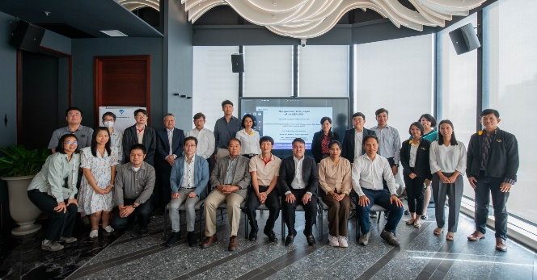

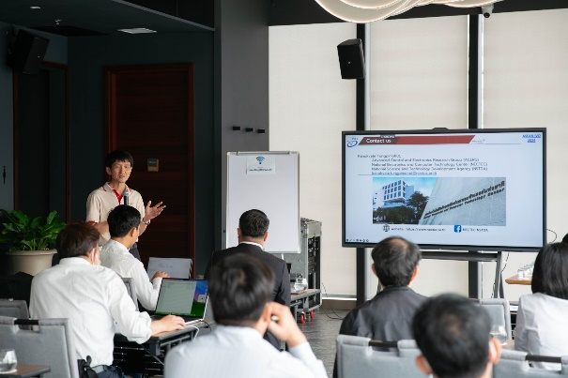

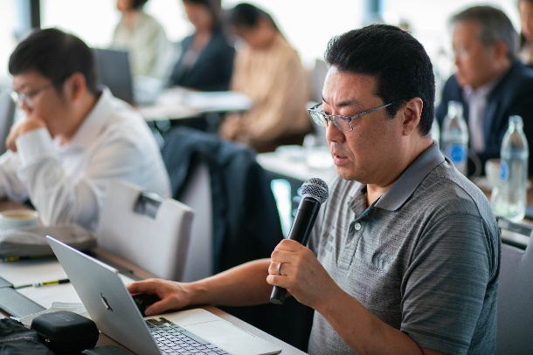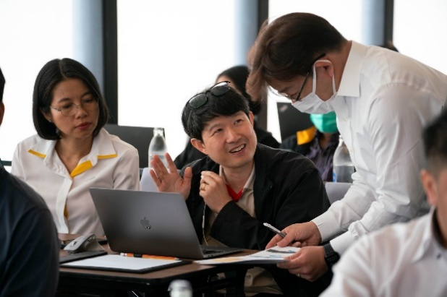

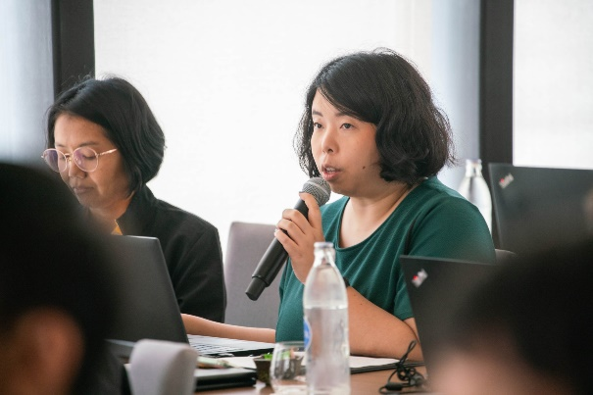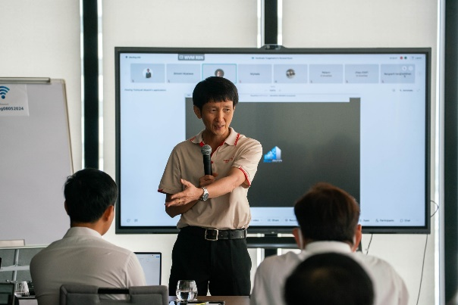

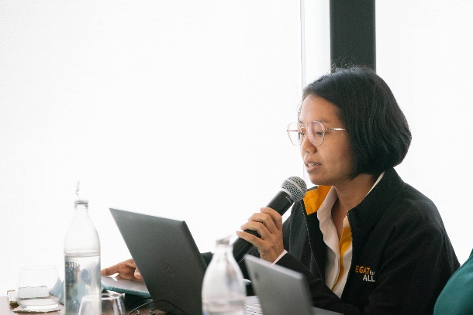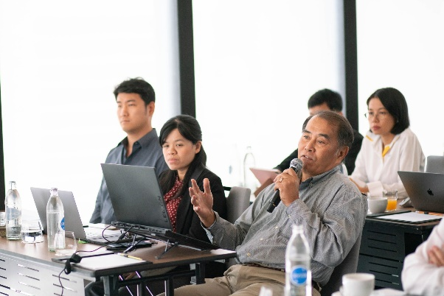

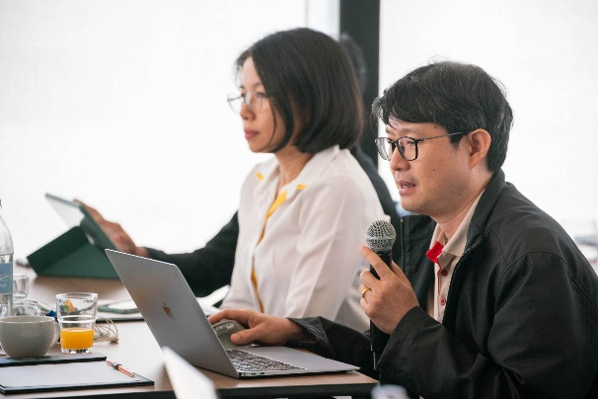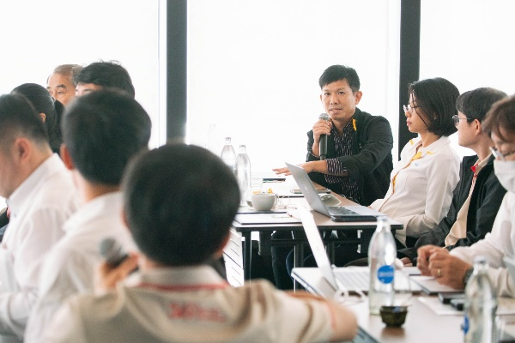

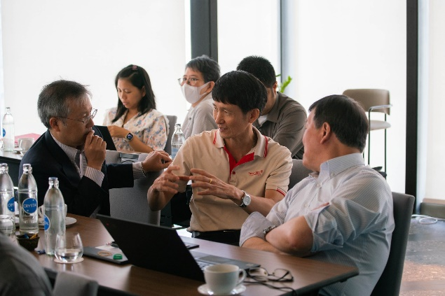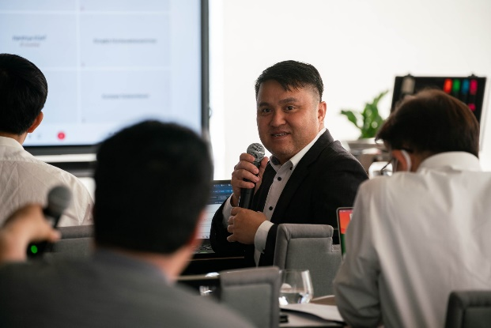

Symposium on May 9 2024

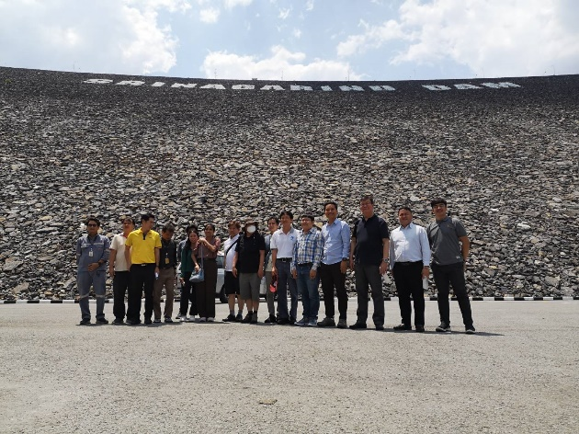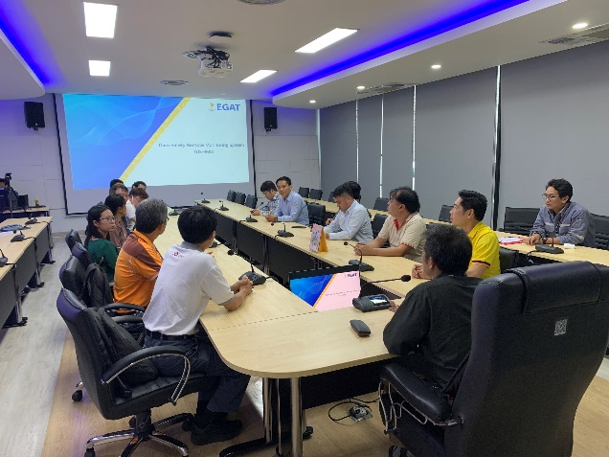

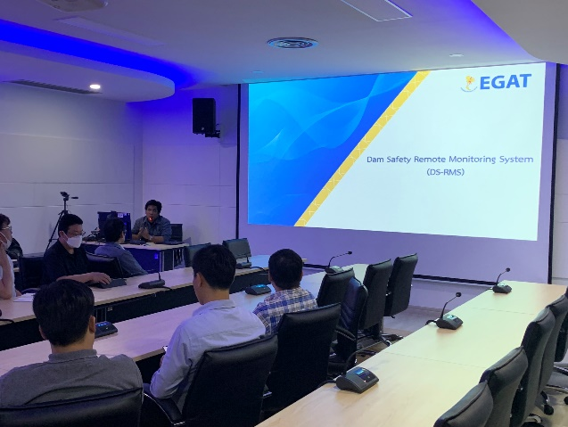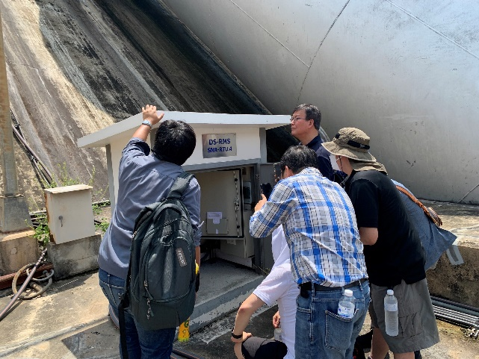

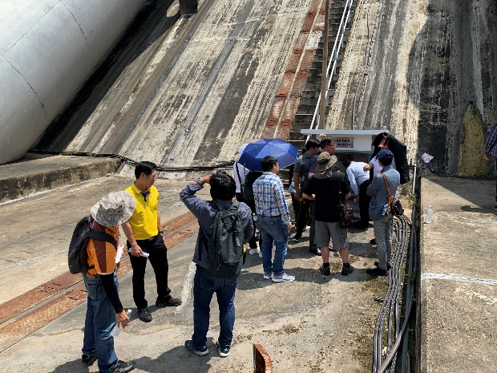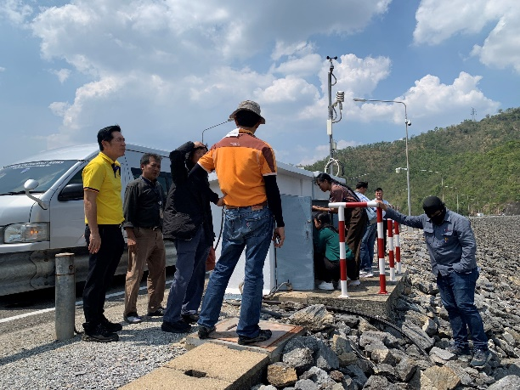

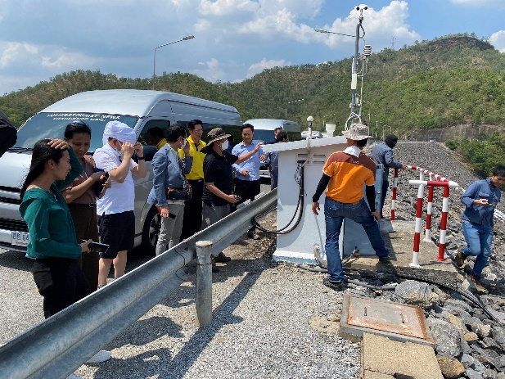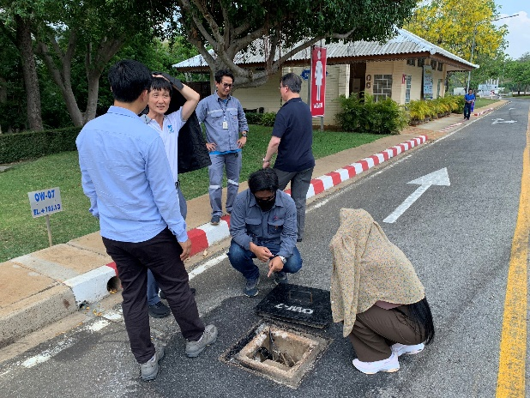

Meeting on May 10 2024

