**Appendix 4.2**

**Cyber to Real World Integrated Testbed for**

**Dam Safety Management and Water Governance System**

**[Symposium and Meeting in Myanmar]**

**Report Form**

**I. Proposer:**

|  |  |
| --- | --- |
| Name: | Prof. Thin Lai Lai Thein |
| Position: | Professor |
| Institution: | University of Computer Studies, Yangon (UCSY) |

**II. Objective:**

1. To share information and knowledge of the implemented collaborative project between NECTEC and EGAT (Electricity Generating Authority of Thailand), the Dam Safety Remote Monitoring System (DS-RMS), to representatives of dam operator in Myanmar and to visit to the targeted dam site with UCSY. NECTEC and EGAT as speakers will share information about implementation of Dam Safety Remote Monitoring System (DS-RMS) in Thailand from the viewpoint of electronics & computer technology and civil & hydrology engineering, respectively.
2. To remotely share information and knowledge of utilization of the CyReal Testbed which was designed and developed by NICT team to UCSY team and representatives of dam operator in Myanmar for further research activities in Myanmar.
3. To organize a meeting among project members from NICT (on line participants), NECTEC and UCSY as well as experts of EGAT and representative of local dam operator under Ministry of Electric Power (MOEP) for discussing about the requirements of R&D and possible solutions from this project and to identify the tentative activities in Myanmar.

**III. Program:**

Date: 3 – 5 Sep 2024

Venue: 1. The Lake Garden Nay Pyi Taw – MGallery hotel, Nay Phi Taw, Myanmar

2. Lower Paunglaung dam, Nay Phi Taw, Myanmar

**Program Agenda:**

|  |  |  |
| --- | --- | --- |
| 3 Sep  *Symposium* | 09:00 – 12:00  10.15-10.30  10.30-12.00 | **Venue**: Hotel’s meeting room   * Project overview by Prof. Thin Lai Lai Thein (30 mins with Q&A) * Implementation of Dam Safety Remote Monitoring in Thailand by Mr. Kanokvate Tungpimolrut (45 mins with Q&A)   Coffee break:   * Instruments and monitoring systems in Dam Safety Remote Monitoring System by Mr. Sirichete Samranyoodee (45 mins with Q&A) * Water Management in Thailand by Mr. Pakkapol Auteerasarun (45 mins with Q&A) |
|  | 12:00 – 13:30 | Working lunch |
|  | 13:30 – 16:00  15.00-15.15  15.15-16.30 | **Venue**: Hotel’s meeting room   * Introduction and use case of CyReal testbed by NICT team (90 mins with Q&A)   Coffee break:   * Dam Safety Management and Water Resource Management of Lower Paungluang Dam by representative of Ministry of Agriculture, Livestock and Irrigation (35 mins with Q&A) * Basic Information of Dam Construction and Hydro Power Plant in Paunglaung dam by representative of Ministry of Electric Power (35 mins with Q&A) |
| 4 Sep  *Symposium* | 09:00 – 12:00  10.15-10.30 | **Venue**: Lower Paunglaung dam   * Travel from the hotel to Lower Paunglaung dam   Coffee break:   * Visit Lower Paunglaung dam |
| 12:00 – 13:30 | Working lunch |
| 13:30 – 16:00  15.00-15.15 | **Venue**: Hotel’s meeting room   * Q&A session to all speakers and site visit   Coffee break:   * Discussion – Conclude the requirements, concerns and potential research questions |
| 5 Sep  *Symposium* | 09:00 – 12:00  10.15-10.30 | **Venue**: Hotel’s meeting room   * Proposed Projects in Paunglaung River Basic (Upper and Lower Paunglaung Dam) by representative of Ministry of Electric Power (75 mins with Q&A and discussion)   Coffee break:   * Discussion – Scope of collaboration, contribution & support from each party and action plan . |
|  | 12:00 – 13:30 | Working lunch |
| *Meeting* | 13:30 – 16:00  15.00-15.15 | **Venue**: Hotel’s meeting room   * Progress update from each project member and reconfirm the future plan of each party   Coffee break:   * Conclude the output of symposium |

**V. Participant List & Itinerary:**

|  |  |  |  |
| --- | --- | --- | --- |
| **No.** | **Name** | **Organization** | **Itinerary** |
| 1 | Dr. Kanokvate Tungpimolrut | NECTEC | 2/9/2024 (in)  6/9/2024 (out) |
| 2 | Dr. Toshiyuki Miyachi | NICT | On line participant |
| 3 | Dr. Shinsuke Miwa | NICT | On line participant |
| 4 | Mr. Shinichi Miyakawa | NICT | On line participant |
| 5 | Dr. Thin Lai Lai Thein | UCSY | 2/9/2024 (in)  6/9/2024 (out) |
| 6 | Ms. Zin May Oo | UCSY | 2/9/2024 (in)  6/9/2024 (out) |
| 7 | Ms. Moe Moe Myint | UCSY | 2/9/2024 (in)  6/9/2024 (out) |
| 8-9 | Invited speakers and experts – (Mr. Sirichete and Mr. Pakkapol) | EGAT | 2/9/2024 (in)  6/9/2024 (out) |
| 10 | Mr. Nay Win Aung | UCSY | NA |
| 11-12 | Representatives of MOALI | MOALI | NA |
| 11-14 | Representatives of MOEP | MOEP | NA |
| 15-22 | Participants from MOALI | MOALI | NA |
| 23-30 | Participants from MOEP | MOEP | NA |
|  |  |  |  |

*Remark: The name list of all participants from MOALI and MOEP on each date could be seen in the signed participant list in the attached files. On Sep 3 and Sep 4, all participants attended the symposium and meeting (27 persons participated on site and 3 persons participated on line), but on Sep 5 only 4 representatives of MOALI and 2 representatives of MOEP attended the symposium and meeting together with UCSY, NECTEC, EGAT and NICT (in Total 13 persons participated on site and 3 persons participated on line).*

**V. Summary of the activities corresponding to the objectives**

In this symposium and meeting, there are the following 3 objectives. The meeting could be successfully completed as scheduled. The summary of each meeting is shown below.

**Objective #1**: To share information and knowledge of the implemented collaborative project between NECTEC and EGAT (Electricity Generating Authority of Thailand), the Dam Safety Remote Monitoring System (DS-RMS), to representatives of dam operator in Myanmar and to visit to the targeted dam site with UCSY. NECTEC and EGAT as speakers will share information about implementation of Dam Safety Remote Monitoring System (DS-RMS) in Thailand from the viewpoint of electronics & computer technology and civil & hydrology engineering, respectively.

* On the first day of the symposium (Sep 3, 2024), in morning session, UCSY started to present the overview of this ASEAN IVO projects to the participants who are mainly from MOALI and MOEP. NECTEC presented about the implementation of DS-RMS project in Thailand which has been developed by EGAT and NECTEC. In afternoon session, two speakers from EGAT presented about instruments and monitoring system in DS-RMS as well as water management in Thailand. All participants (in total 30 persons – 27 persons on site and 3 persons on line) could have a chance to discuss and share their opinions to each speaker. Representatives from MOALI and MOEP will also share information about dam safety and water resource management as well as hydro power plant in Lower Paunglaung dam and their responsibilities, respectively.
* On the second day of the symposium (Sep 4, 2024), in morning session, the representatives of MOALI bring all participants (in total 27 persons) to see and introduce about all installed instruments for dam safety and water governance system in Lower Paunglaung dam. The representatives of MOEP also bring all participants to see and introduce about hydro power plant and its control room. The project members from UCSY and NECTEC together with invited speakers from EGAT could have an opportunity to see the real instruments and systems and could directly ask questions and give comments directly to responsible staffs of MOALI and MOEP for more clearly understanding about currenct situation and requirements or further advancements.

**Objective #2**: To remotely share information and knowledge of utilization of the CyReal Testbed which was designed and developed by NICT team to UCSY team and representatives of dam operator in Myanmar for further research activities in Myanmar.

* On the first day of the symposium (Sep 3, 2024, afternoon session), Dr. Miyachi (NICT) presented about the overview of CyReal Testbed and its usecase to all participants (in total 27 persons). Dr. Miyachi also briefly introduced about examples of simulation that NICT team is discussing to NECTEC team which is about flood routing simulation.
* Both MOALI and MOEP have to perform simulation to determine inundation map which is the map to show the effect of released water from the dam and flood water to the community living in downstream areas. They are mainly using the open source software tool named HEC-RAS for the simulation tasks ( <https://www.hec.usace.army.mil/software/hec-ras/>) while EGAT is using commercial software named MIKE11.
* Using commercial software on CyReal Testbed is more complicated than the open source software, since we have to check about license agreements carefully. Therefore, the HEC-RAS software is preferable in this project. Moreever, EGAT would kindly support MOALI and MOEP to verify or compare the simulation results of Lower Paunglaung dam based on HEC-RAS to the MIKE 11.
* NICT team has browsed the web site of HEC-RAS in order to clarify about how to arrange the environment on CyReal to perform any simulation and emulation for HEC-RAS and the issue about the operation system on CyReal which is Linux based have been mentioned. MOALI and MOEP are using Windows based HEC-RAS, so they have to check that Linux based HEC-RAS could be used for their required simulation or emulation. NICT team will also check the possibility to use Windows based HEC-RAS on CyReal.
* NICT team also continuously gave comments and suggestions to all knowledge sharing and discussion sessions from Sep 3 to Sep 5.

**Objective #3**: To organize a meeting among project members from NICT (on line participants), NECTEC and UCSY as well as experts of EGAT and representative of local dam operator under Ministry of Electric Power (MOEP) for discussing about the requirements of R&D and possible solutions from this project and to identify the tentative activities in Myanmar.

* MOEP would like to perform simulation of inflow forecasting of Upper Paunglaung dam while MOALI would like to perform simulation of inflow forecasting of Lower Paunglaung dam.
* The action plan during this 2 years project will be divided into 3 steps as follows:
  + Step 1 – Repeat the simulation of inundation map that have done by MOALI and MOEP by using the existing software (HEC-RAS window version) and existing historical data.
  + Step 2 – Simulation of Hazard map including depth, velocity and time to calculate the loss of life for Emergy Action Plan.
  + Step 3 – Emulation for reservoir operation by integrating the data from real sensors to the simulation model on CyReal testbed.
* The information of rainfall in upstream area will be use for improvement of simulation of inflow forecast. There are some semi-automatic rainfall measuring system in the upstream area of Upper Paunglaung dam while there is no rainfall measuring system in the upstream area of Lower Paunglaung dam. Therefore, at least one set of rainfall measuring system (semi-automatic or fully automatic system) is necessary and it will be installed in the catchment area between Upper and Lower Paunglaung dam. Recently, the Middle Paunglaung dam is under the plan to construct in that catchment area, so the information of the newly installed rainfall measuring system will be also useful for the Middle Paunglaung dam.
* In the next step, after successfully signing the CRDA, UCSY will closely coordinate to MOEP, MOALI and NICT to have next online meeting and/or tutorial session for using CyReal to perform the simulation as planned.

**VI. Others**

**Symposium on Sep 3 2024**

**Symposium on Sep 4 2024**

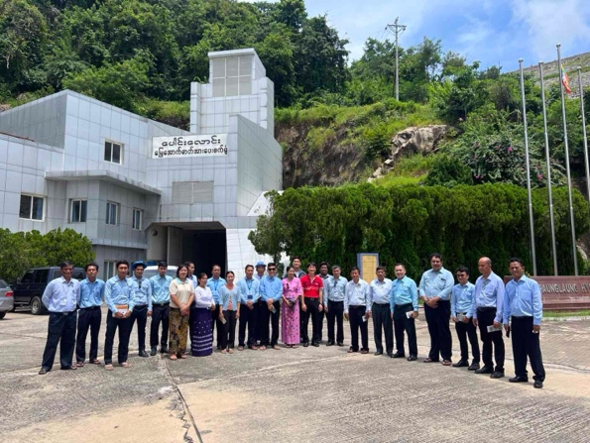 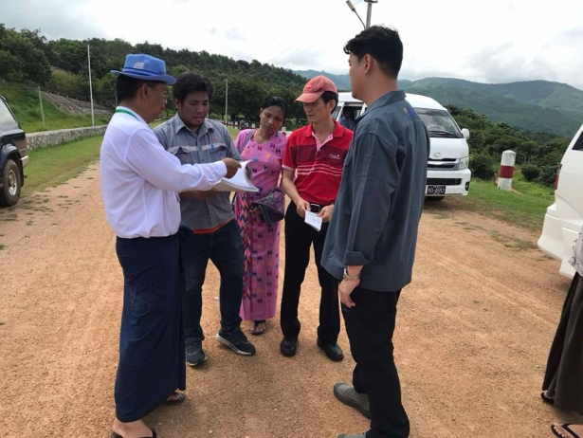

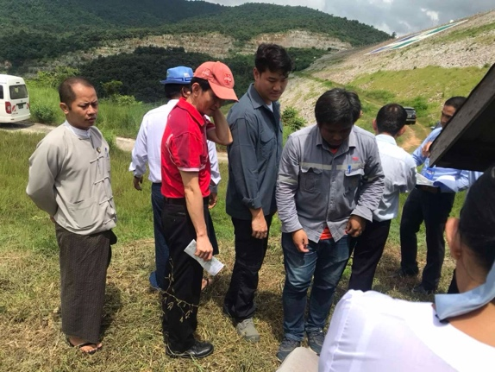

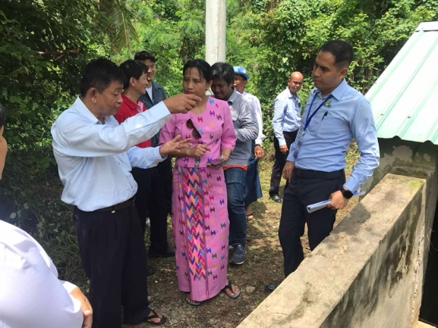

**Meeting on Sep 5 2024**

