Appendix 4.2

Research and development for precise positioning with Artificial Intelligence (AI) during ionospheric disturbances in low-latitude region in ASEAN
“Project Kick-off Meeting”
Report/Minutes Form

I. Organizer:
Name: | Prof. Dr. Pornchai Supnithi
Position: | Professor
Institution: | King Mongkut’s Institute of Technology Ladkrabang (KMITL),  Thailand

II. Program:

Date: 2nd – 4th August 2023
Venue: A Building, School of Engineering, King Mongkut’s Institute of Technology Ladkrabang (KMITL), Thailand

Program Agenda:

Wednesday, 2nd August 2023
Participants will arrive Bangkok and check in the hotel from late afternoon to evening.
Canalis Suvarnabhumi Airport Hotel

Thursday, 3rd August 2023
08.15 | Registration
08.30 | Welcome speech by Dean of School of Engineering, KMITL
08.40 | Group photo
08.50 | Project Introduction/Timeline by Prof. Pornchai Supnithi, KMITL
09.10 | Member Introduction Presentation (not more than 10 min./ institute)  - Chiang Mai University  - King Mongkut's University of Technology Thonburi  - National University of Laos  - Institute of Geophysics  - Cambodia Academy of Digital Technology  - Institute of Technology of Cambodia  - National Institute of Information and Communication Technology  - King Mongkut's Institute of Technology Ladkrabang, Prince of Chumphon Campus  - Le Quy Don Technical University (Online)  - Asian Office NICT, Thailand
10.30 | Welcome and Administrative Issues by Dr. Hiroshi Emoto (ASEAN-IVO)
11.00 | Coffee Break
11.15 | Discussion Time for Role play of each institute, annual progress schedule, budget allocation of each member
12.15 | Lunch
13.30 | Hands-on Training session (Precise positioning technique using real-time kinematic (RTK) system) by KMITL
16.00 | Lab Tour to KMITL’s Excellence Center in GNSS and Space Weather Lab
16.30 | Return to Hotel
18.30 | Dinner at Suvarnabhumi Suite Hotel

Friday, 4th August 2023
09.00 | Presentation of the SEALION Project and NICT’s SW research by NICT team
10.00 | Hands-on training session on Total Electron Content computation by KMITL
12:15 | Lunch
12:45 | Return to the hotel.
Participants will depart Bangkok from afternoon to evening.

III. Participants:

No. | Name | Organization
1 | Somyot Kiatvanijwilai  Dean of School of Engineering | KMITL, Thailand
2 | Uma Seeboonruang  Sn. Vice Dean of School of Engineering, | KMITL, Thailand
3 | Varesa Chuwattanakul  Vice Dean of School of Engineering, | KMITL, Thailand
4 | Watid Phakphisut  Head of Telecommunications  Engineering Department | KMITL, Thailand
5 | Narong Hemakon  Former Head of Telecommunications Engineering Department and Space Weather Expert | KMITL, Thailand
6 | Pornchai Supnithi  Project Leader | KMITL, Thailand
7 | Punyawi Jamjureegulgarn | Chumphon campus  KMITL, Thailand
8 | Kasemsuk Sepsirisuk | Chumphon campus  KMITL, Thailand
9 | Lin Min Min Myint | KMITL, Thailand
10 | Prasert Kenpankho | KMITL, Thailand
11 | Jirapoom Budtho | KMITL, Thailand
12 | Somkit Sophan | KMITL, Thailand
13 | Napat Tongkasem | KMITL, Thailand
14 | Thananphat Thankulketsarat | KMITL, Thailand
15 | Alisa Kongthon | KMUTT, Thailand
16 | Phimmasone Thammavongsy | NUOL, Laos
17 | Tick Sengthipphany* | NUOL, Laos
18 | Phouthong Southisombath* | NUOL, Laos
19 | Tharadol Komolmis | CMU, Chiang Mai, Thailand
20 | Witsarut Achariyaviriya | CMU, Chiang Mai, Thailand
21 | Phutphalla Kong | CADT, Cambodia
22 | Soklay Heng | CADT, Cambodia
23 | Sainglong Kaing | ITC, Cambodia
24 | Hoang Van Phuc* | LQDTU, Vietnam
25 | Nguyen Van Trung* | LQDTU, Vietnam
26 | Dung Nguyen Thanh | IGP, Vietnam
27 | Ha Thanh Nguyen | IGP, Vietnam
28 | Takuya TSUGAWA | NICT, Japan
29 | Michi Nishioka | NICT, Japan
30 | Septi Perwitasari | NICT, Japan
31 | Hiroshi Emoto | ASEAN-IVO, NICT, Japan
32 | Nishino Hisanori | Asian Center, NICT, (Thailand)
33 | Takahara Minoru | Asian Center, NICT, (Thailand)
34 | Phyo C Thu** | KMITL, Thailand
35 | Waritsara Rungsawang** | KMITL, Thailand
36 | Efren Martin Alban Cuestas** | KMITL, Thailand
37 | Gleb Mutasov** | KMITL, Thailand
*Online participant ** Observer

IV. Summary of the activities corresponding to the objectives

The project kick-off meeting is a vital function for a research project collaborated by many institutes from various countries. Therefore, KMITL planned to organize an on-site meeting with the project members. However, some members joined the meeting through an online platform due to their time constraints. The objectives of the meeting are as follows:
- To familiarize all members with the project description, budgetary and administrative guidelines,
- To discuss how to implement the project and to distribute the tasks among the project members and institutes,
- To share ideas and opinions among the project members from different countries.
- To decide the time and location of a next project meeting for project progress discussion.

The revised research plans and share of collaborative research and developments according to the discussion of the meeting are as below,

Overall Timeline

Activity/Deadlines | Apr 2023 - Sept 2023 | Apr 2023 - Sept 2023
CRDA Signing | X
Kick-off Meeting | X
GNSS receiver purchase and RTK Setup and Test(RTK and TEC Workshop) | X | X
First Progress Meeting/ EPB and Applications Workshop |  | X
(6-month) Progress Report |  | November 20th
Annual ASEAN IVO Forum (2023) |  | X
(1-year) Progress Report |  | March 15th 2024

Share of Collaborative Research and Development
Research and Development Description |  | Subcategories |  | NICT | KMITL | CMU | NUOL | CADT | ITC | IGP | KMUTT | ISI-LQDTU
A : | To Install GNSS receivers in Cambodia and Vietnam |  |  | 2 | 1 | - | - | 2 | 1 | 2 | - | -
B: | To analyze the EPB statistics during the solar maximum and mitigate the EPB effects | a: | Analyze ionospheric parameters such as foF2, h’F, spread F | 2 | 1 | 1 | 1 | - | - | 2 | - | -
 |  | b: | Analyze TEC and ROTI | 2 | 1 | 1 | 2 | 2 | - | 2 | - | -
 |  | c: | Mitigate the effects of EPB in positioning system | 2 | 1 | - | - | - | - | 2 | - | -
C | To develop forecasting models for EPB occurrences | a: | AI model from VHF radar system | 2 | 1 | - | - | - | - | - | - | -
 |  | b: | AI model from 2-D TEC map | 2 | 1 | - | - | - | - | 2 | - | -
D | To develop and test RTK (Real Time Kinematics) receivers for various applications | a: | RTK system test | 2 | 1 | 2 | 2 | 2 | 2 | 2 | - | 2
 |  | b: | RTK base station setup | 2 | 1 | - | - | - | 1 | - | - | 2
 |  | c | RTK application development | 2 | 1 | 1 | 2 | 2 | 1 | 2 | - | -
E | To identify trends and emerging topics in EPB and RTK research using data mining |  |  | 2 | 2 | - | - | - | - | - | 1 | -
- “1” indicates the Party that takes the primary responsibility, and “2”, secondary responsibility.
Detail Project Timeline
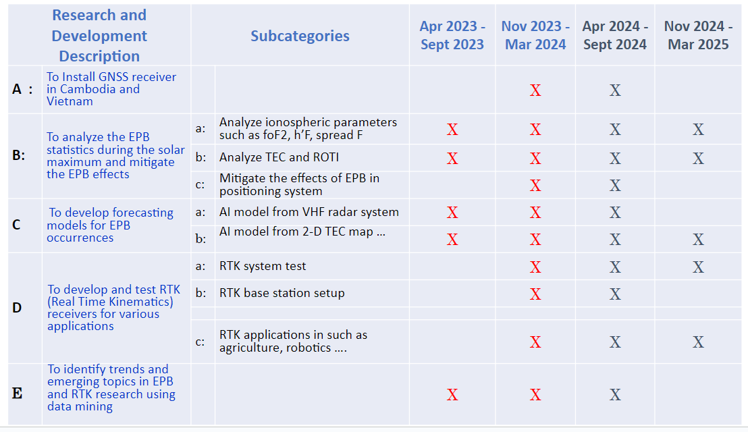

The main purpose of the hands-on training sessions is to dissimilate the knowledge of precise positioning techniques such as Real-time kinematics (RTK), and Ionospheric error or total electron content (TEC), as part of the project goals. After the training, the participants are expected to implement the project activities efficiently in their own institutes and communities.

V. Others
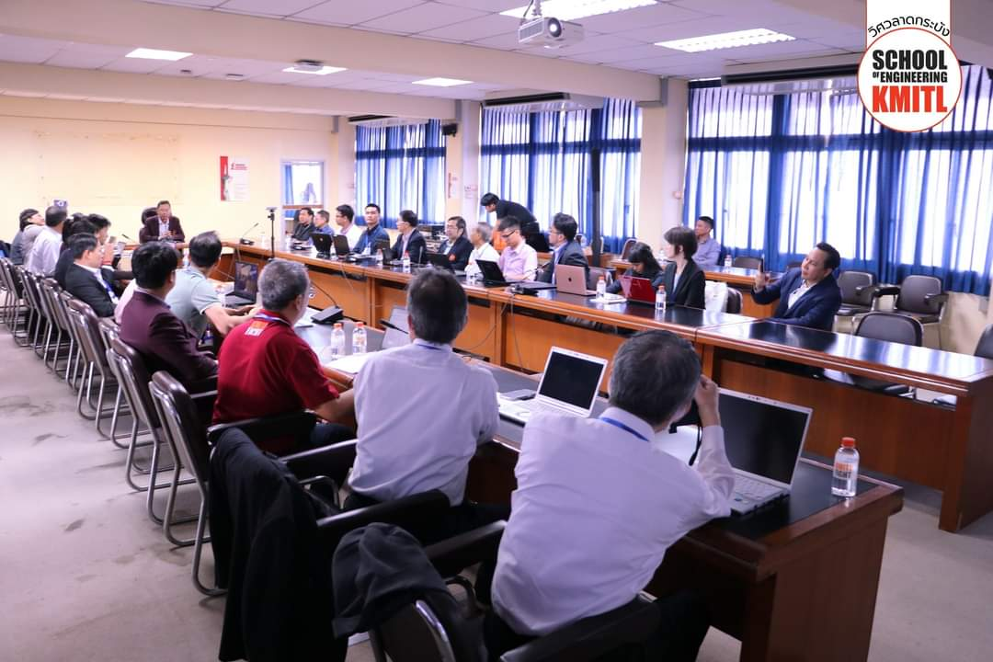  Figure 1. First day of Kick-off meeting | 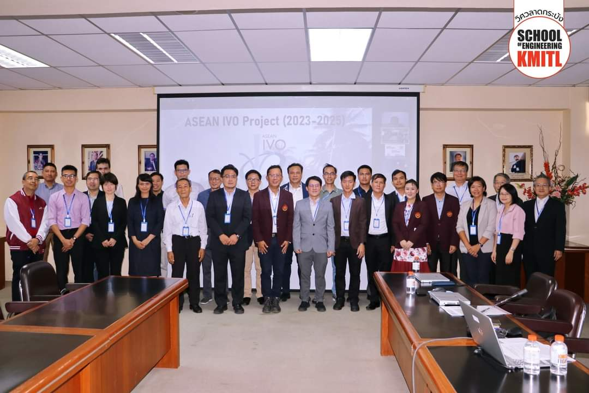  Figure 2. Group photos during the early part of the Kick-off meeting.
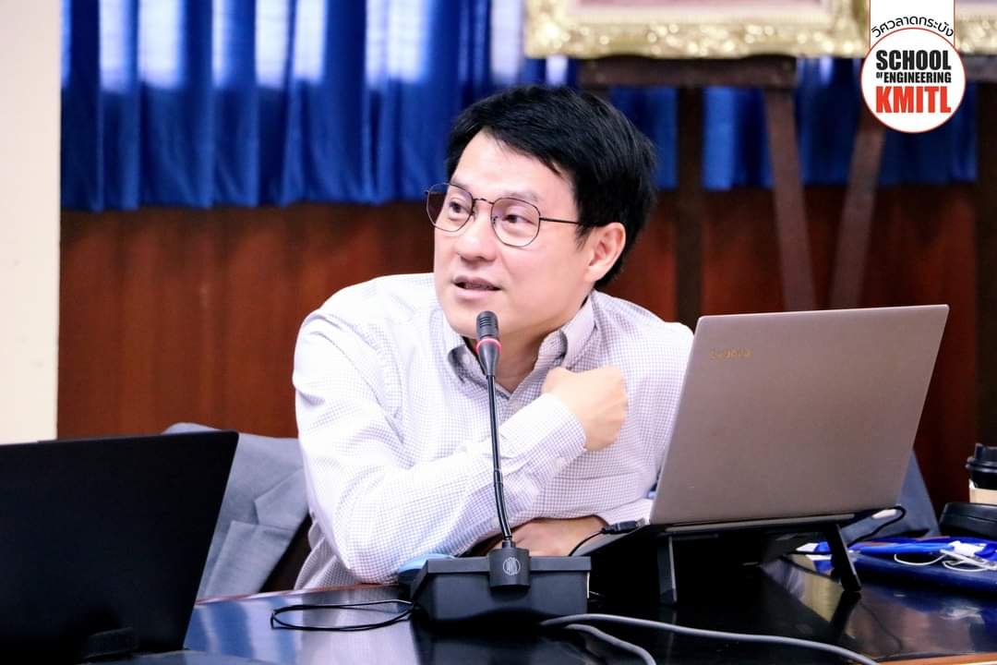  Figure 3. Presentation and Discussion by Project leader Prof. Pornchai Supnithi, KMITL | 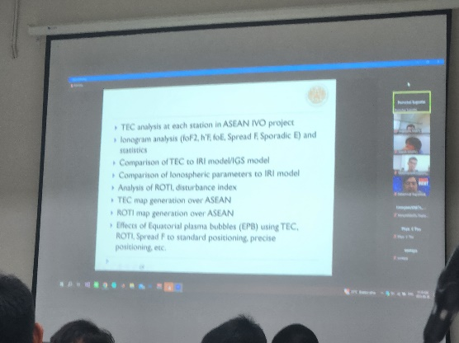  Figure 4. Presentations and Online participants
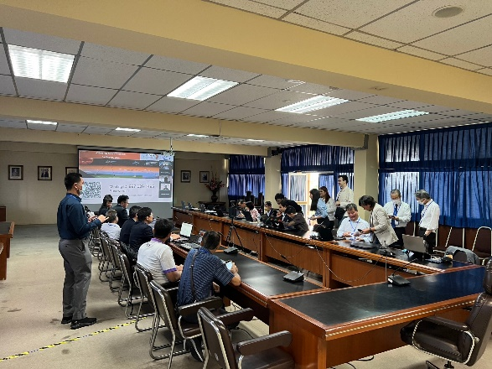  Figure 5. RTK hands-on training and discussion | 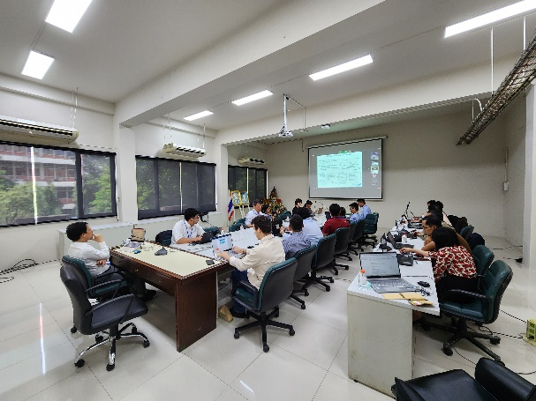  Figure 6. Second day of Kick-off meeting
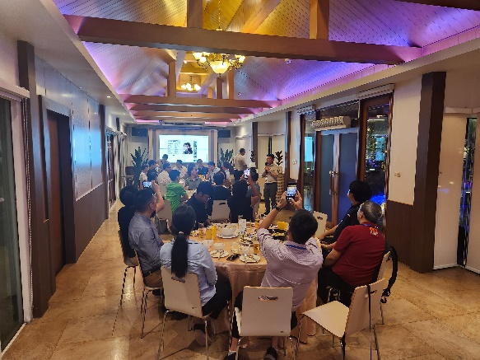  Figure 7. Kick-off meeting’s Dinner Reception | 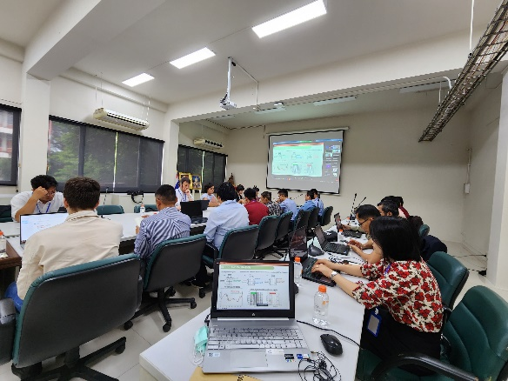  Figure 8. TEC Analysis hands-on training and discussion

