Appendix 2.2

Report of International Conference Presentation

Name:  (Presenter) | Alisa Kongthon
Affiliation: | Graduate School of Innovation and Management,  King Mongkut’s University of Technology Thonburi,  Bangkok 10140, Thailand
Project Title: | Research and development for precise positioning with Artificial Intelligence (AI) during ionospheric disturbances in low-latitude region in ASEAN
Name of International Conference:  (Link to website) | Portland International Conference on Management of Engineering and Technology (PICMET)  https://www.picmet.org/new/Conferences/2024/
Title of Research Paper: | Artificial Intelligence Applications in Ionospheric Irregularities: A Bibliometric Analysis
Name of all Co-authors (if any) | Pornchai Supnithi (KMITL)
Comments or feedback received at the conference:
Since the audience consists of experts in the technology management community, they suggested that a bibliometric analysis is the right approach to use in identifying research trends on the applications of AI in ionospheric irregularities detection. This method not only highlights current trends but also provides insight into emerging areas of research. With the rapid advancement of AI technologies, particularly in deep learning, neural networks, and real-time data processing, the potential for AI to revolutionize ionospheric studies is significant. These advancements have led to more accurate models, faster data processing, and the ability to predict and detect irregularities with greater precision. The audience expects that AI research will continue to accelerate in the upcoming years, driven by these technological breakthroughs. Therefore, it would be crucial to keep monitoring research activities closely, as staying informed on the latest developments will allow us to harness the full potential of AI in this field and address the complex challenges posed by ionospheric irregularities.

Contribution to the project:
At this conference, I conducted an oral presentation to the audience in session MD-01.3 on the first day (5th August) of PICMET2024, which provided a valuable platform to showcase our work on using bibliometric analysis to identify the research trends on the applications of AI for ionospheric irregularities detection. The presentation was well-received, and I received great feedback from the audience, which included experts in technology management and innovation. This feedback has not only validated the relevance of our research but also provided insights into new methodologies and techniques that can further enhance our project.

During the conference, I also learned about additional techniques that can be used to monitor and identify research trends, such as technology roadmapping, patent analysis, the Delphi method, and topic modeling. These techniques offer different perspectives and approaches to understanding the evolution of research fields. For example, technology roadmapping can help us visualize the development trajectory of AI applications in ionospheric research, identifying key milestones and future opportunities. Patent analysis can reveal the latest innovations and emerging technologies in this area, highlighting potential applications and areas for further exploration. The Delphi method can be employed to gather expert opinions and forecasts on the future direction of AI in ionospheric studies, while topic modeling can assist in identifying emerging themes and trends from large bodies of research literature. I plan to explore if these techniques can help identify current trends in research on applying AI in ionospheric irregularities detection for our ASEAN-IVO project.
Photos
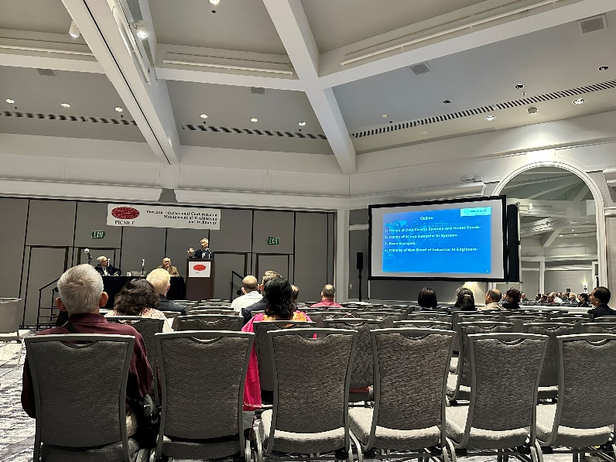

Figure 1: Attending Keynote Speech at the Opening Ceremony on Monday August 5, 2024

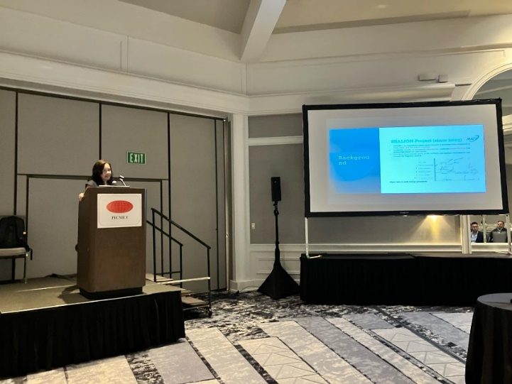
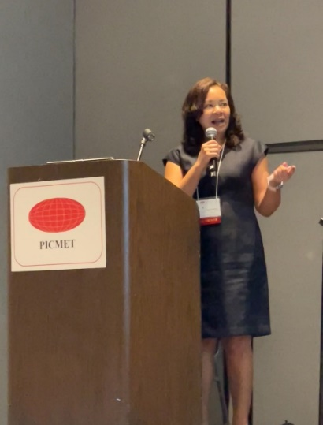

Figure 2 and 3: Oral presentation for session MD-01.3 on Monday August 5, 2024
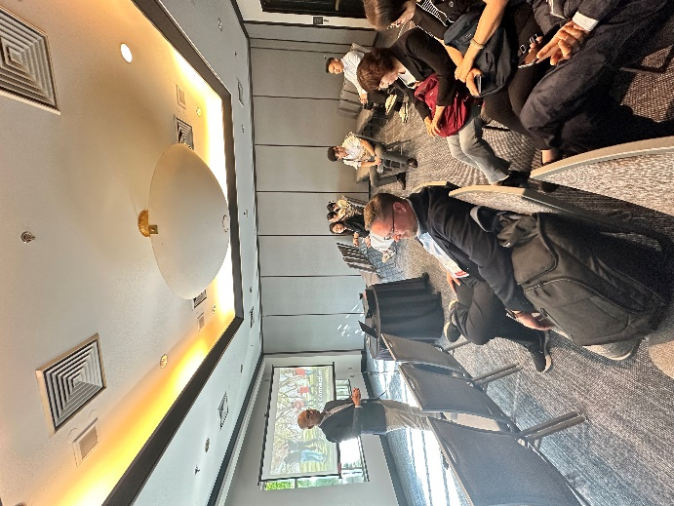
Figure 4: Attending other presentation session

[Required Documents]
- Presentation Materials ( Presentation slides)
- Final Program of the conference

Reporter: _____Alisa Kongthon_________
Date: ________27/08/2024_________

