Appendix 2.2

Report of International Conference Presentation

Name: (Presenter) | Hay Mar Soe Naing
Affiliation: | University of Computer Studies, Yangon, Myanmar
Project Title: | Spoof Detection for Automatic Speaker Verification
Name of International Conference:  (Link to website) | M3Oriental: Workshop of Multimodal, Multilingual and Multitask Modeling Technologies for Oriental Languages  https://sites.google.com/view/m3oriental
Title of Research Paper: | A Large Vocabulary End-to-End Myanmar Automatic Speech Recognition
Name of all Co-authors (if any) | Prof. Dr. Win Pa Pa
Comments or feedback received at the conference:

- Q: This paper has its contribution to the important regional language. Could the authors give their work a name to remember, e.g., UCSY-Myan-ASR? The title "UCSY-Myan-ASR: A Large Vocabulary End-to-End Myanmar Automatic Speech Recognition" could be more attractive, what do you think?

A: - In Abstract Section, I answered this question as follow: "This paper proposes the use of transformer- and conformer-based models on Myanmar automatic speech recognition system (UCSY-Myan-ASR)."
- Also in the Introduction Section, I mentioned like that "In this work, we propose and evaluate a transformer-based and conformer-based ASR system (UCSY-Myan-ASR) to improve the performance of Myanmar speech recognition area."
- In Conclusion Section, I answered this question as follow: "This UCSY-Myan-ASR improved the performance of Myanmar speech recognition with the use of end-to-end architecture and compare the classical hybrid LSTM model."

- Q: Do not copy the transformer architecture figure from [10], authors need to redraw those figures by themselves with slight modifications.

A: The figure of transformer architecture (Figure 1) is redrawn in Section 2.1.

- Q: What kind of tokens used in thesis system should be explained since label tokens are important in end-to-end ASR.

A: I answered this question as follow: "Therefore, syllable-level tokens are used to transcribe text and applied in this transformer and conformer based end-to-end experiments. A set of regular expression rules is employed to segment the sentences as the syllable-level tokens."

- Q: In decoder blocks, there should be cross-attention blocks while authors only mentioned self-attention in decoder blocks. Authors may need to carefully correct their explanation.

A: - I responded this question in Section 2.1.1. "In Transformer, when information is passed from the encoder to the decoder, this part is called cross-attention. The decoder block is tasked with converting the encoder’s attention vectors into output data. At the training phase, the decoder uses an attention mechanism to process the expected outcomes and create attention vectors. Like the encoder module, the decoder attention vectors are passed through feedforward layers. The result is then mapped to a vector of target data size."

5. Q: In experiments, authors mentioned weight for CTC, it seems that authors used hybrid CTC/AED modeling strategy. It is better for authors to explain more clearly in their revision.

A: I responded this question in Section 4. Experimental Setup Section.
Contribution to the project:

This M3Oriental Workshop of ACM Multimedia Asia 2023 is designed to address the challenges in low-resourced language problems in speech recognition.

This workshop covers the scope of -
Audio, Speech and Language Processing
Datasets, Benchmark Systems, Models and Shared Tasks
Multimedia, Biomedical and Health Informatics
Information Forensics and Security

Photos



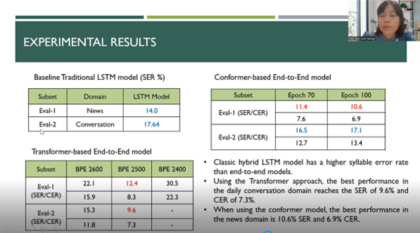

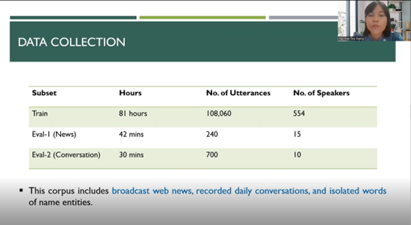
[Required Documents]
- Presentation Materials (eg. PPT slides)
- Final Program of the conference

Reporter: Hay Mar Soe Naing
Date: 15/12/2023

