Appendix 2.2

Report of International Conference Presentation

Name:  (Presenter) | Miss Kasorn GALAJIT
Affiliation: | NECTEC, National Science and Technology Development Agency,
Project Title: | Spoof Detection for Automatic Speaker Verification
Name of International Conference:  (Link to website) | The 18th International Joint Symposium on Artificial Intelligence and Natural Language Processing (iSAI-NLP 2023)  https://isai-nlp-aiot2023.aiat.or.th/
Title of Research Paper: | ThaiSpoof: A Database for Spoof Detection in Thai  Language
Name of all Co-authors (if any) | Kasorn Galajit, Thunpisit Kosolsriwiwat, Candy Olivia Mawalim, Pakinee Aimmanee, Waree Kongprawechnon,Win Pa Pa, Anuwat Chaiwongyen, Teeradaj Racharak, Hayati Yassin, Jessada Karnjana, Surasak Boonkla, MasashiUnoki,
Comments or feedback received at the conference:

Q1: Making a spoofed speech in Thai, are there any feature that require special adjustments compared to making spoofed speech in other languages such as English, Chinese, Japanese?

A: That is an interesting question. For the text to speech- spoof type, yes, the feature is to make a spoofed speech is might slightly different in each language and it is language dependent. However, it cannot be said that we need to adjust the parameter itself. The best way to deal with this problem is to select text-to-speech tool for specific language because that tools already adjust the sound to suitable with each language.
For the spoof type of F0, pitch shifting, we intend to check whether can spoof detection work well on cross language database.

Q2: Why do you choose to do the spoofed voice with F0 modification and pitch-shifting.

A: A fundamental frequency (F0) of a person’s voice can give listeners clues about the speaker’s identity, gender, and age. The pitch of a person’s voice can be affected by several factors, including their vocal cords, their size and shape, and their breathing. Therefore, if the F0 and pitch change, it can make a confuse to identify the person. Thus, we modified these two parameters to make a spoofed speech.

Contribution to the project:

This research has brought to light pertinent concerns regarding language usage and linguistic accuracy in Thai, currently recognized as a prominent issue and verification challenge. Additionally, it addresses the prevalence of misinformation not only in Thai but worldwide, particularly on social media platforms. The study employs lucid and methodical procedures, underscoring essential research principles. Furthermore, it presents statistical data validating the systematic approach and robust research methodologies. In sum, this research proves both valuable and intellectually stimulating.

Photos

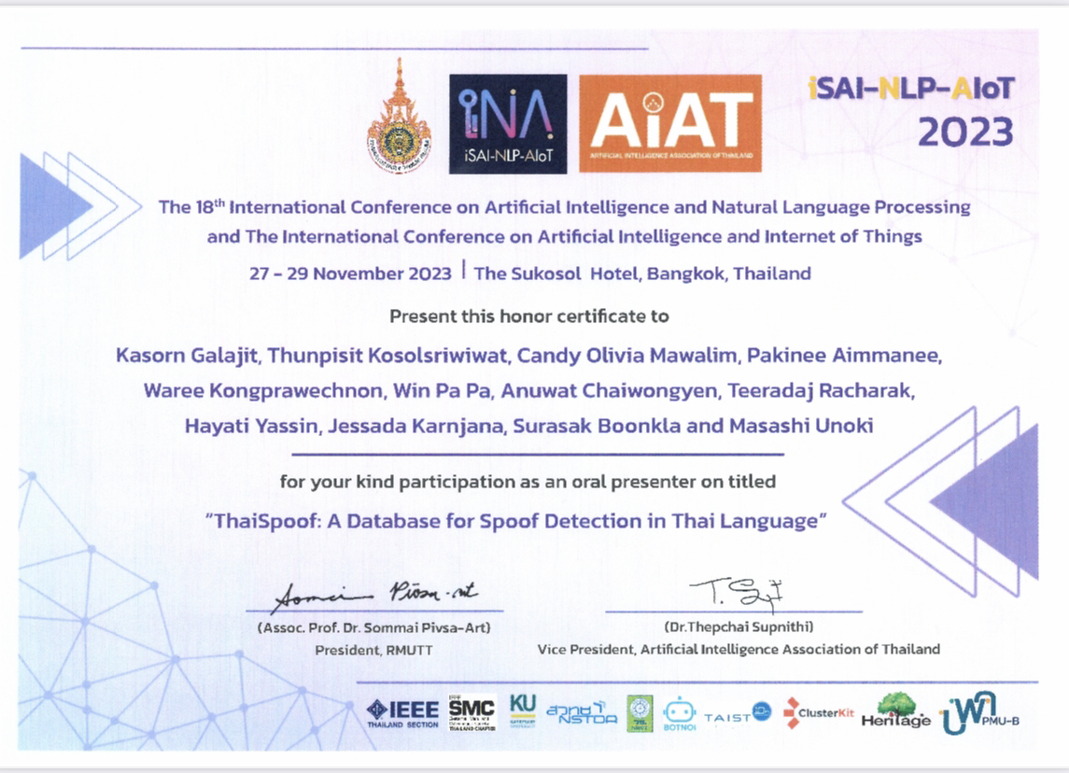

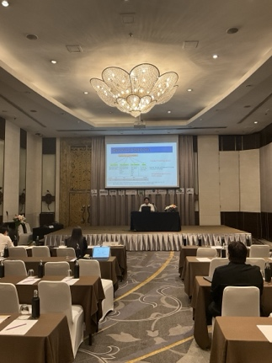

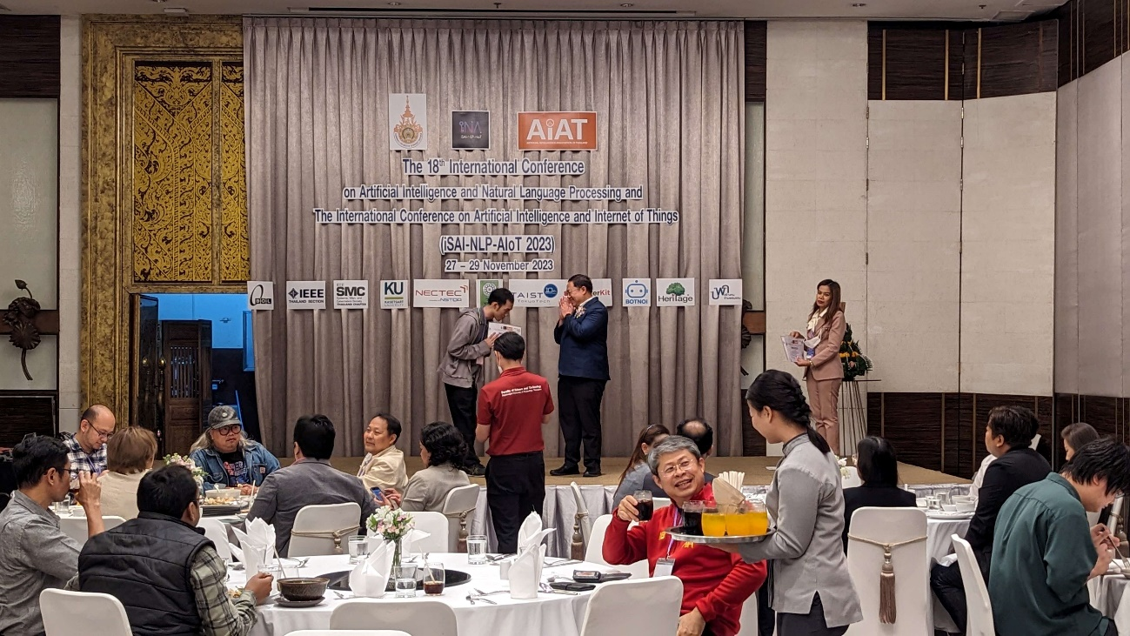

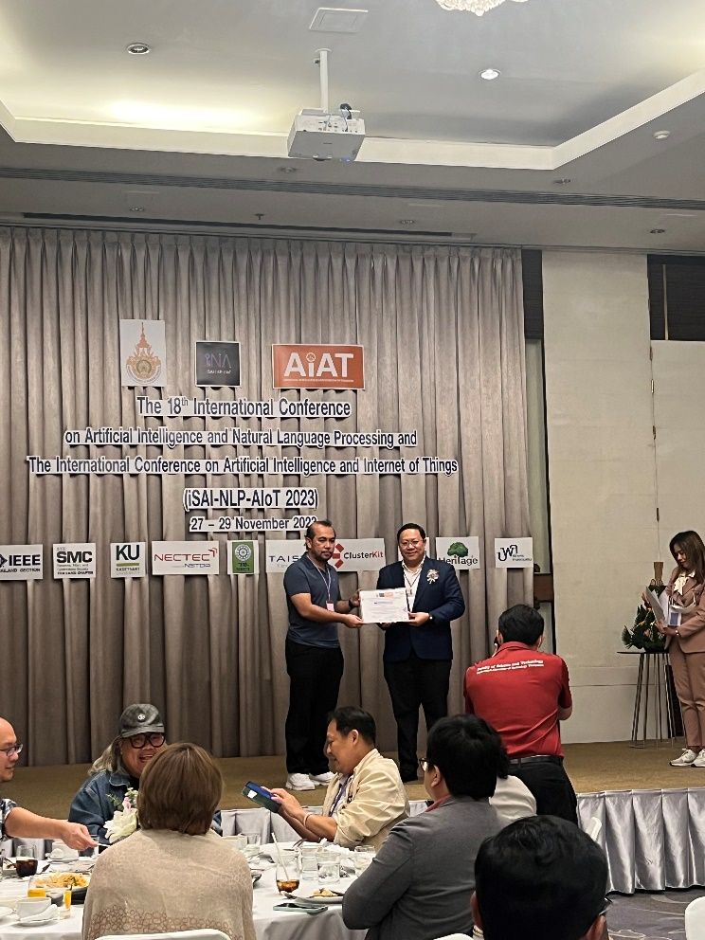

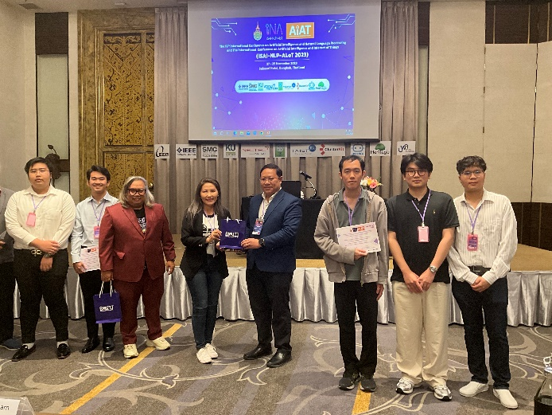

[Required Documents]
- Presentation Materials (e.g. PPT slides)
- Final Program of the conference

Reporter: ______Kasorn GALAJIT______
Date: __________28/11/2023____

