Appendix 2.2

Report of International Conference Presentation

Name:  (Presenter) | Ms. Khaing Zar Mon
Affiliation: | Sirindhorn International Institute of Technology, Thammasat University
Project Title: | Spoof Detection for Automatic Speaker Verification
Name of International Conference:  (Link to website) | The 18th International Joint Symposium on Artificial Intelligence and Natural Language Processing (iSAI-NLP 2023)  https://isai-nlp-aiot2023.aiat.or.th/
Title of Research Paper: | Spoof Detection using Voice Contribution on LFCC features and ResNet-34
Name of all Co-authors (if any) | Khaing Zar Mon, Kasorn Galajit, Candy Olivia Mawalim,  Jessada Karnjana, Tsuyoshi Isshiki, Pakinee Aimmanee
Comments or feedback received at the conference:

Q1: What is the difference between your proposed method and existing ones?
A: The main difference is that we integrated the percentage of voice part to be consider in doing classification while another method changes only the feature.

Q2: What is the future plan of your research work?
A: Our future plan is to do the fusion between the score from different feature as well as different percentage of voice from each feature.

Contribution to the project:

In this study, we aimed to propose an approach that integrates LFCC and ResNet-34 for spoof detection. We conducted experiments to explore the potential benefits of employing different voice percentages to enhance the model's accuracy and efficacy in detecting replay attacks, speech synthesis and voice conversion attacks.

Photos

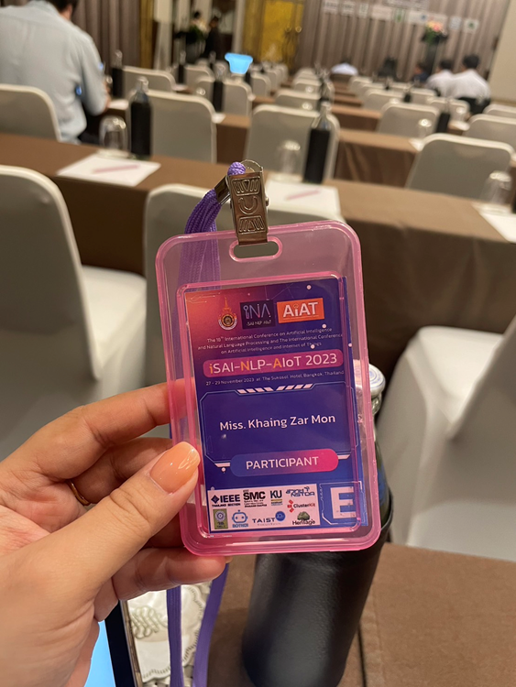

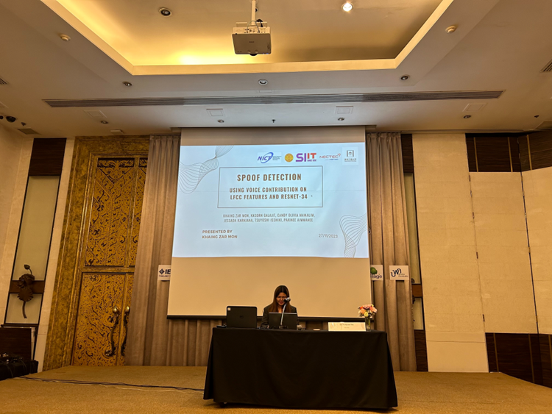

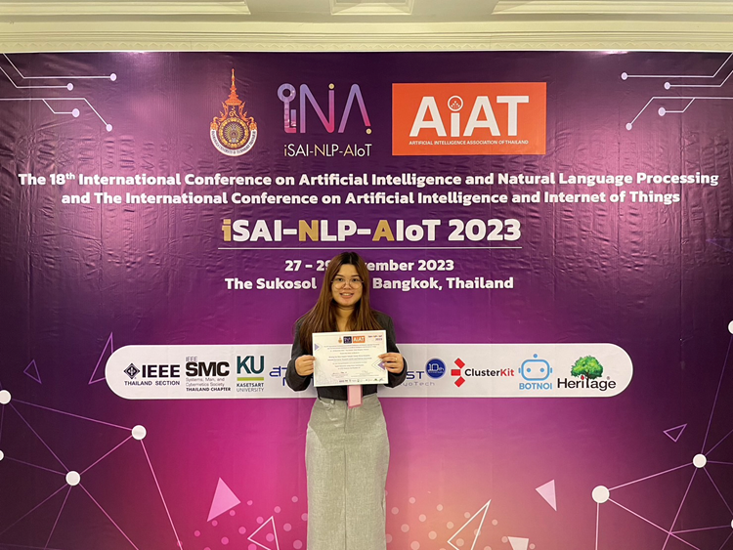

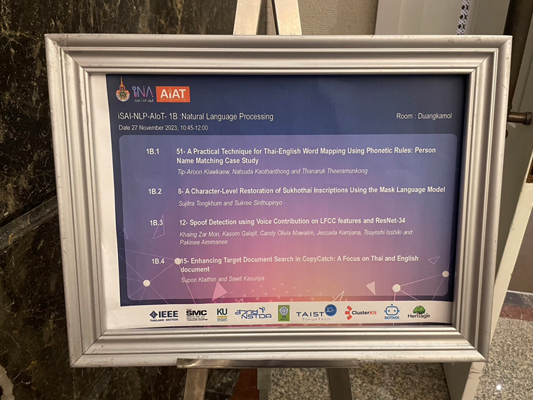

[Required Documents]
- Presentation Materials (e.g. PPT slides)
- Final Program of the conference

Reporter: ___Ms. Khaing Zar Mon__________
Date: _________28/11/2023 ______________

