Appendix 2.2

Report of International Conference Presentation

Name:  (Presenter) | Jessada Karnjana
Affiliation: | National Electronics and Computer Technology Center (NECTEC)
Project Title: | Spoof Detection for Automatic Speaker Verification
Name of International Conference:  (Link to website) | The 26th Conference of the Oriental COCOSDA (https://www.ococosda2023.com/)
Title of Research Paper: | Speech Watermarking for Tampering Detection Using Singular Spectrum Analysis with a Psychoacoustic Model
Name of all Co-authors (if any) | Phondanai Khanti, Pannathorn Sathirasattayanon, Patthranit Kaewcharuay, Nanthayod Termkoh, Ekachai Phaisangittisagul, Kasorn Galajit, and Jessada Karnjana
Comments or feedback received at the conference:

Q. How large is the payload to be embedded using the proposed scheme?

A. It depends on the frame size and duration of the audio signal. In our experiment, the frame size is set to 1024 samples, and the duration is fixed in such a way that the signal can have a 100-bit payload.

Contribution to the project:

Most of the work presented in the conference applied the ML-based method, which is lack of explain ability. The proposed method is of the old school that analyzes the signal concerning the human perception. Therefore, our work can help us to gain more understanding of the effectiveness of the proposed method compared to the others.

Photos

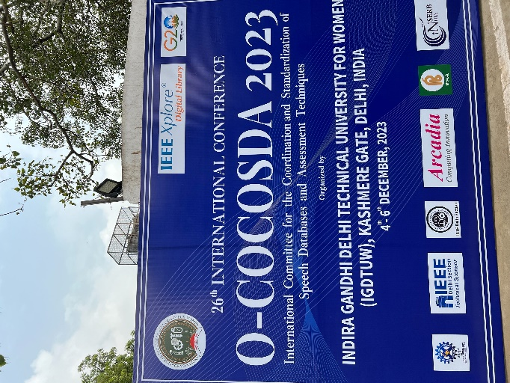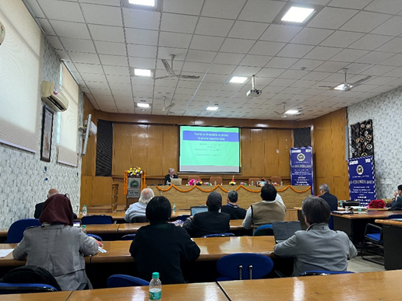

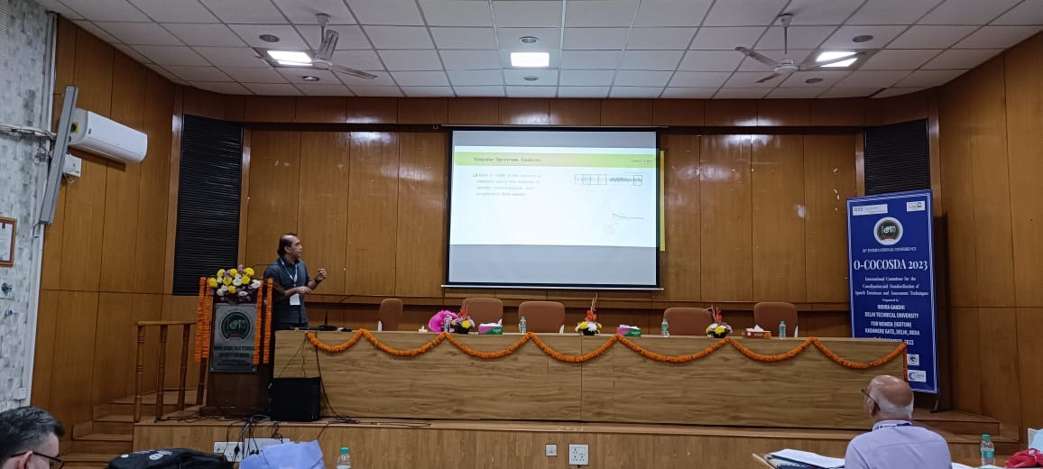

[Required Documents]
- Presentation Materials (e.g. PPT slides)
- Final Program of the conference
Reporter: Jessada Karnjana
Date: 14 December 2023

