**Report of Workshop for Innovation of photonic and electrochemical biosensors for cholangiocarcinoma diagnosis, mission plan in Laos (Nov 13-14) on Nov 13-16, 2023.**

**I. Organizer:**

|  |  |
| --- | --- |
| Name: | Champadeng VONGDALA |
| Position: | Deputy of Cancer Planning and Registry |
| Institution: | Cancer Center – Mittaphab Hospital, Laos |

**II. Program:**

Date: 13th-14th November 2023

Venue: Lao Plaza Hotel, Vientiane Capital, Laos

**Program Agenda**

|  |  |  |  |
| --- | --- | --- | --- |
|  | **Activities** | **Speaker** | **Remark** |
| 13-Nov-23 | | | |
| 8.30-9.00 | Registration / Modulator / MC | Ms. Narumon Mahaamnad  Ms. Srinapha Klungsaeng  Khonkaen University |  |
| 8.45-9.00 | Open Remark | Vice PresidentforResearch *and*  Graduate*Studies,*  Professor Dr.Monchai Duangjinda  Khon Kaen University, Thailand | Via zoom meeting |
| 9.00-9.15 | Open Remark | Head, Department of Health (MoH)  Khamsay Dethleuxay  Mittaphab Hospital, Laos |  |
| 9:15-9:30 | Liver flukes:  Updates on pathogenesis | Dr.Apisit Chaidee  Khonkaen University |  |
| 9.30-10.15 | CCA and liver flukes: Questions & Answers | Prof. Chawalit Pairojkul (Zoom)  Khonkaen University |  |
| 10.15-11.00 | Innovation of photonic and electrochemical biosensors for CCA diagnosis | Dr. Somchai Pinlaor  Khonkaen University |  |
| 11.00-11.15 | Refresh |  |  |
| 11.15-11.40 | Introduction to Cancer Situation of Laos | Director of Cancer Center  Phetsamone AROUNLANGSY MD, PhD  Mittaphab Hospital, Laos |  |
| 11.40-12.00 | Cholangiocarcinoma in Laos | Champadeng Vongdala MD, MPH  Mittaphab Hospital, Laos |  |
| 12.00-13.00 | Lunch |  |  |
| 13.00-13.30 | Progress report 1 | Dr. Chavit Srichan  Dr. Phopporn Danvirutai  Khonkaen University |  |
| 13.30-14.00 | Progress Report 2 | Dr. Somchai Pinlaor  Dr. Sirinapha Klungsaeng  Khonkaen University |  |
| 14.30-15.00 | Progress Report 3 | Dr. Ukrit Mankong  Dr. Suruk Udomsom  Chiang Mai University |  |
| 15.00-15.30 | Refresh |  |  |
| 15.30-16.00 | Wrap-up/ Discussion 1 | Dr. Atsushi Matsumoto/NICT team |  |

PROJECT MEETING

|  |  |  |  |
| --- | --- | --- | --- |
| 14-Nov-2023 | | | |
| 9.00-9.45 | Introduction to Cancer Center | Dr. Champadeang Vongdala /team |  |
| 9.45-11.00 | Visit Cancer Center  Visit Pathology Lab in University of Health Sciences | Dr. Champadeang Vongdala /team |  |
| 11.00-11.15 | Refresh |  |  |
| 11.15-12.00 | Discussion 2 | Dr. Toshimasa Umezawa  Dr.Somchai Pinlaor  Dr.Ukrit Mankong  Dr.Chavis Srichan  Dr.Champadaeng Vondala |  |
| 12.00-13.00 | Lunch |  |  |
| 13.30 | Closing remark | Dr. Kouichi Akahane |  |

**III. Participant List & Itinerary:**

|  |  |  |  |
| --- | --- | --- | --- |
| **No** | Name | Organizations | Itinerary |
| 1 | Dr. Somchai Pinlaor | MD-KKU | Date in: 12th Nov 2023  Date out: 17th Nov 2023 |
| 2 | Dr. Chavis Srichan | EN-KKU | Date in: 12th Nov 2023  Date out: 17th Nov 2023 |
| 3 | Dr. Apisit Chaidee | MD-KKU | Date in: 12th Nov 2023  Date out: 17th Nov 2023 |
| 4 | Dr. Pobporn Danvirutai | EN-KKU | Date in: 12th Nov 2023  Date out: 17th Nov 2023 |
| 5 | Dr. Sirinapha Klungsaeng | MD-KKU | Date in: 12th Nov 2023  Date out: 17th Nov 2023 |
| 6 | Dr. Ukrit Mankong | CMU | Date in: 12th Nov 2023  Date out: 15th Nov 2023 |
| 7 | Dr. Suruk Udomsom | CMU | Date in: 12th Nov 2023  Date out: 15th Nov 2023 |
| 8* | Miss Narumon Mahaamnad | MD-KKU | Date in: 12th Nov 2023  Date out: 17th Nov 2023 |
| 9 | Phetsamone AROUNLANGSY MD, PhD | National Cancer Center, Laos | Local Host |
| 10 | Champadeng Vongdala MD, MPH | National Cancer Center, Laos | Local Host |
| 11 | Keoudone THAMMAVONG | Mittaphab Hospital, Deputy of general surgery | Local Host |
| 12 | Khamsay Dethleuxay | Department of Health (MoH), Laos | Local Host |
| 13 | Dr. Somphou XAYYASONE | Vice director of TPHI Laos | Local Host |
| 14 | Representative from National of Tropical and Public Health Institute (TPHI), Laos | Researchers | Local Host |
| 15 | Dr. Khaisy | Vice director, Mahosot Hospital | Local Host |
| 16 | Dr. Toshimasa Umezawa | National Institute of  Information and  Communications Technology (NICT), Japan |  |
| 17 | Dr. Atsushi Matsumoto | National Institute of  Information and  Communications Technology (NICT), Japan |  |
| 18 | Dr. Kouichi Akahane | National Institute of  Information and  Communications Technology (NICT), Japan |  |
| 19 | Dr. Thidsamay Luangxay | National Cancer Center, Laos, Laboratory, Pathologists | Local Host |
| 20 | Dr. Phonesavanh Thammavong | National Cancer Center, Laos, Medical Oncologist | Local Host |
| 21 | Dr. Sengthong Mounphoumy | National Cancer Center, Laos, Medical Oncologist | Local Host |
| 22 | Dr. Bounleuang Kounsonh | Dept. of Pathology and forensic Medicine, University of Health Sciences | Local Host |
| 23 | Mrs. Matsy Tayxayavong | Dept. of Health care and rehabilitation, MoH, secretary | Local Host |
| 24 | Mrs. Hak Phommachanh | National Cancer Center, Laos, Laboratory technician | Local Host |
| 25 | Dr. Bounphet THAMMAVONG | Mittaphab Hospital, Head of general surgery department | Local Host |

**IV. Summary of the activities corresponding to the objectives**

The workshop is go as planned, We initiated with introduction of everyone and their institutes by each country, we presented the project and mission.

1. We present objective as agenda to Lao's team including Medical surgery, pathologists, nurse and lab technician,
2. We have give responsible for each institute, progress a report from each member
3. We present the research areas and up to date in CCA
4. We visited the Department of Pathology and Forensic Medicine Laboratory, University of Health and Sciences, Laos and Laboratory of National Cancer Center, and Radiotherapy center at Mittaphab Hospital.
5. Advise and coaching of a project performance and management by NICT team.

*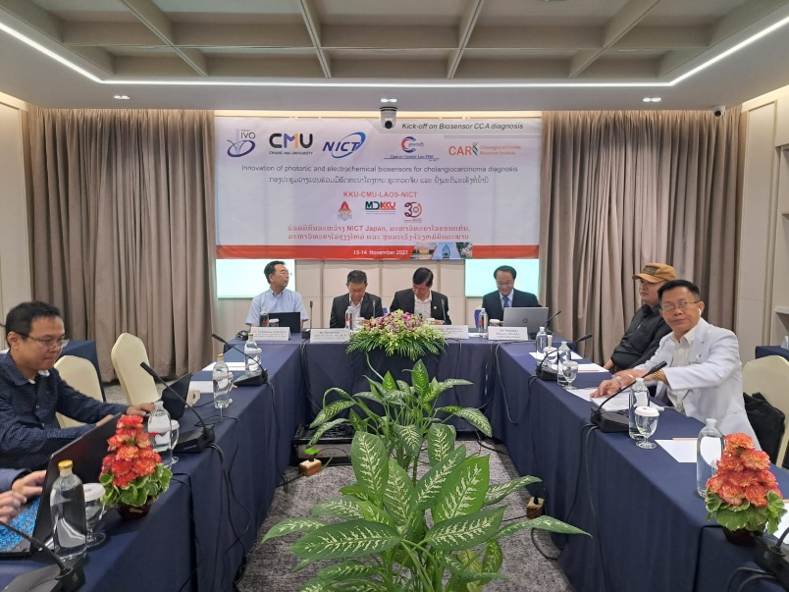***V. Others**

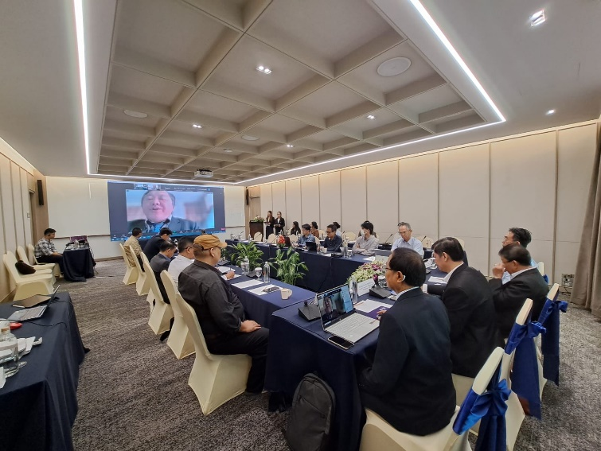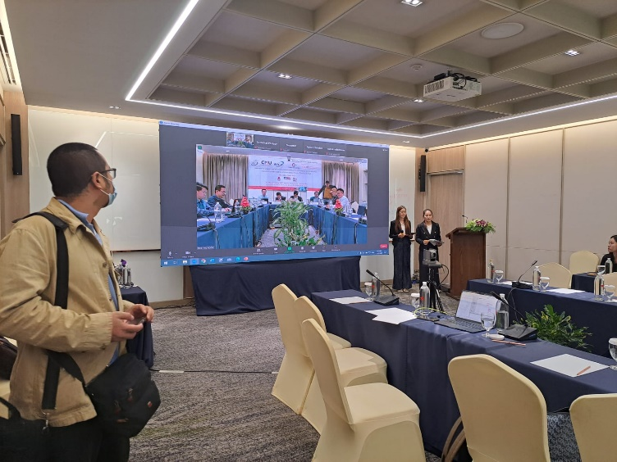

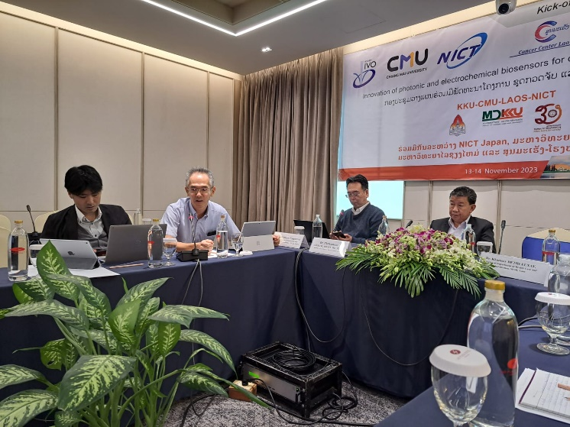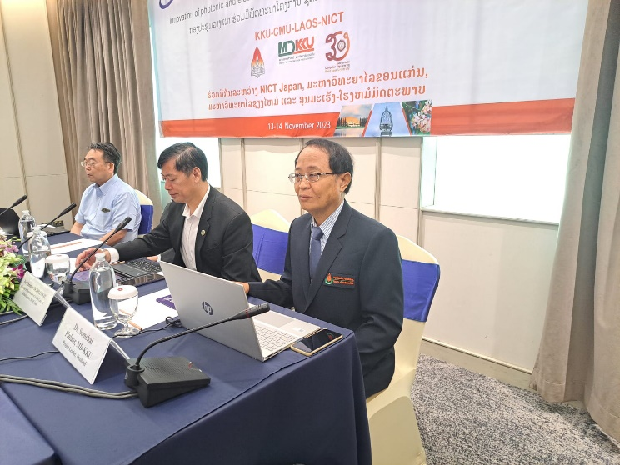

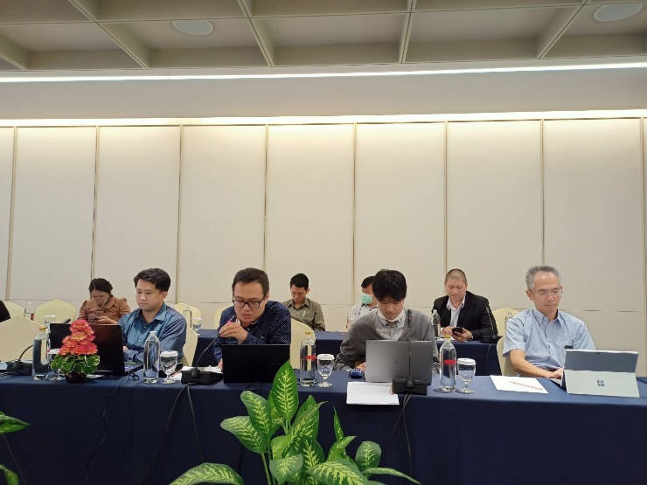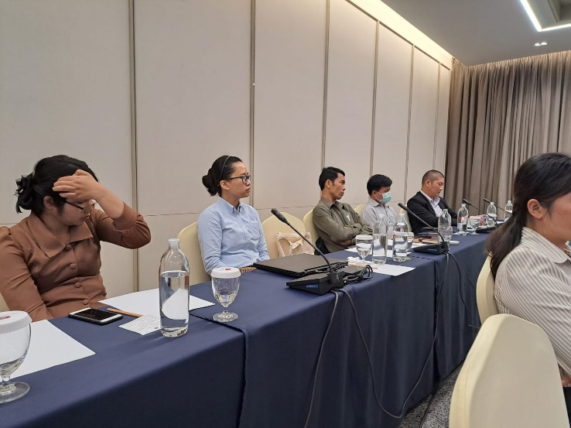

***Workshop at Lao Plaza Hotel Day 1 and Day 2***

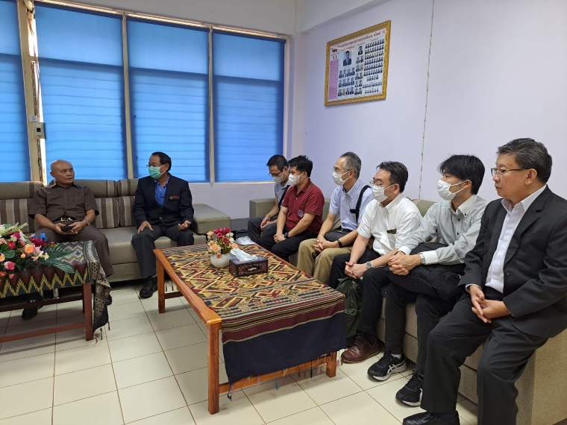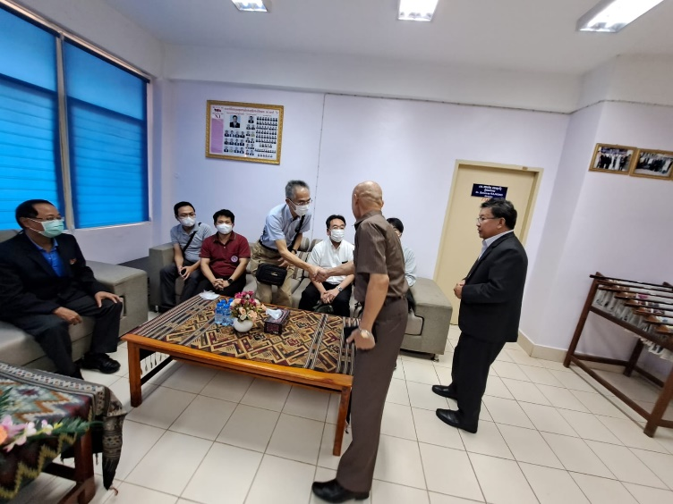

*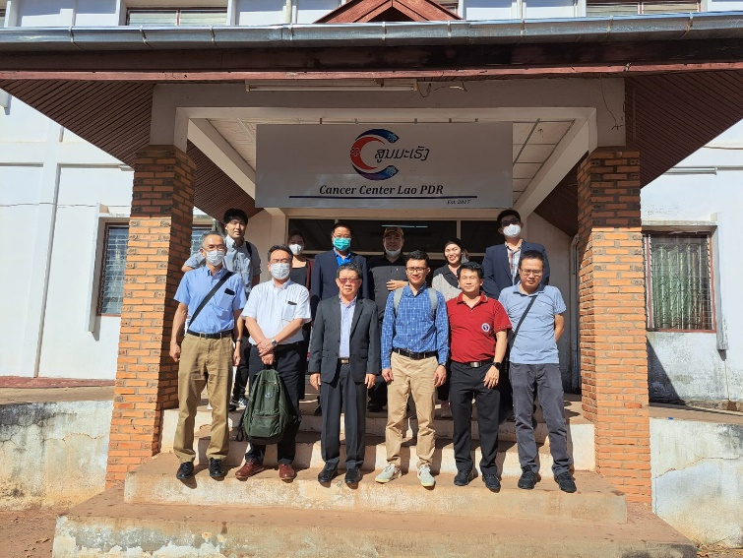****Visit Mittaphab Central Hospital***

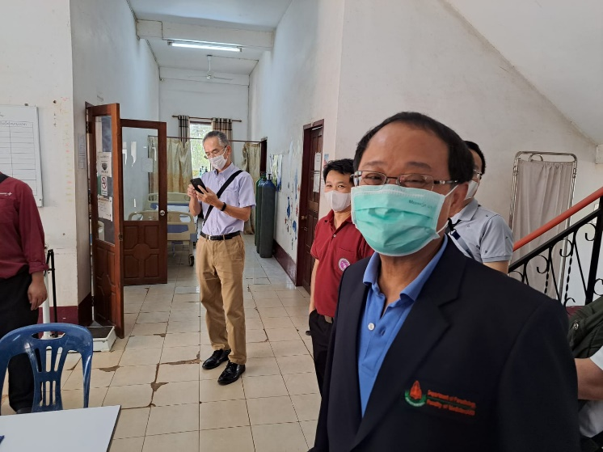

***Visit National Cancer Center***

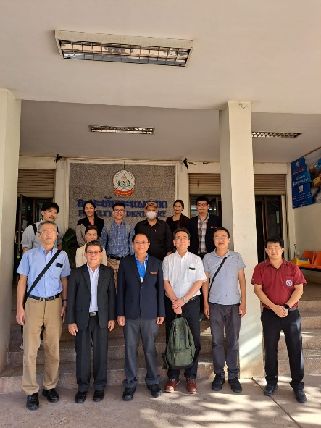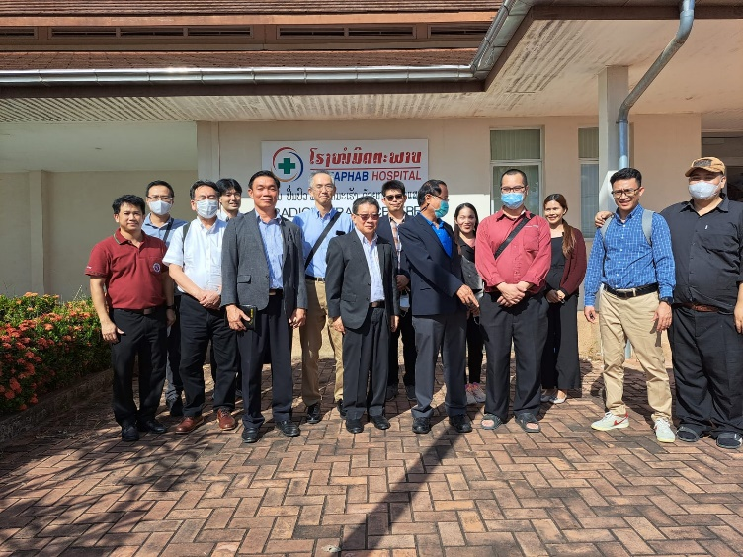

***Visit Radiotherapy Center Visit Pathology Lab University of Health Sciences***

**VI. Workshop Evaluation Questionnaire**

**WORKSHOP EVALUATION QUESTIONNAIRE**

**Workshop Name: ______________________________________________________**

**Location: _____________________________________________________________**

**Date: _______________________**

**Participant Name (optional): __________________________**

**Institution /Company name of participant (optional): _________________________**

**Job Title: __________________________________________**

**Please give us your comments here:**

[**https://docs.google.com/spreadsheets/d/149xT5AtwxUCAV75-UvhzdbfOmtS_RRfy0pUTW4mxnEs/edit#gid=28166543**](https://docs.google.com/spreadsheets/d/149xT5AtwxUCAV75-UvhzdbfOmtS_RRfy0pUTW4mxnEs/edit#gid=28166543)

|  |  |  |  |  |  |  |  |  |  |  |  |  |  |  |  |  |  |  |  |  |  |  |  |
| --- | --- | --- | --- | --- | --- | --- | --- | --- | --- | --- | --- | --- | --- | --- | --- | --- | --- | --- | --- | --- | --- | --- | --- |
| Timestamp | Gender | Role | | **Meeting content**  Please check the appropriate box for each of the following items regarding the meeting on the topic below. [The content was meaningful and relevant to me] | | **Meeting content**  Please check the appropriate box for each of the following items regarding the meeting on the topic below. [The speaker was cleared, effective, and stimulating] | | **Meeting content**  Please check the appropriate box for each of the following items regarding the meeting on the topic below. [I learned some new important information] | | **Meeting content**  Please check the appropriate box for each of the following items regarding the meeting on the topic below. [I am more encouraged to continue my work] | | **Meeting content**  Please check the appropriate box for each of the following items regarding the meeting on the topic below. [Time was properly allocated and enough for discussion] | | **Experience**  Please check the appropriate box for each of the below to your satisfaction. [The venue and facility] | | **Experience**  Please check the appropriate box for each of the below to your satisfaction. [The food and refreshment] | | **Experience**  Please check the appropriate box for each of the below to your satisfaction. [The quality of supporting material e.g., IT support] | | **Experience**  Please check the appropriate box for each of the below to your satisfaction. [Overall meeting experience] | | Please give us your comments and suggestions for improving (Themes, Content / Subject, Time allocation, etc.) | |
| 11/14/2023 9:08:48 | Female | Doctor/Public Health Officer/Participant | | Very satisfied | | Very satisfied | | Very satisfied | | Very satisfied | | Very satisfied | | Very satisfied | | Very satisfied | | Very satisfied | | Very satisfied | |  | |
| 11/14/2023 9:08:50 | Female | Doctor/Public Health Officer/Participant | | Very satisfied | | Very satisfied | | Very satisfied | | Very satisfied | | Very satisfied | | Very satisfied | | Very satisfied | | Very satisfied | | Very satisfied | |  | |
| 11/14/2023 9:09:05 | Female | | Other | | Very satisfied | | Very satisfied | | Very satisfied | | Very satisfied | | Very satisfied | | Very satisfied | | Very satisfied | | Very satisfied | | Very satisfied | | Food so tasty | |
| 11/14/2023 9:11:02 | Male | Researcher/Project investigator | | Very satisfied | | Very satisfied | | Very satisfied | | Very satisfied | | Very satisfied | | Very satisfied | | Very satisfied | | Very satisfied | | Very satisfied | |  | |
| 11/14/2023 9:13:44 | Female | Researcher/Project investigator | | Very satisfied | | Very satisfied | | Very satisfied | | Very satisfied | | Very satisfied | | Very satisfied | | Very satisfied | | Very satisfied | | Very satisfied | |  | |
| 11/14/2023 10:25:24 | Male | Researcher/Project investigator | | Very satisfied | | Very satisfied | | Very satisfied | | Very satisfied | | Very satisfied | | Very satisfied | | Very satisfied | | Very satisfied | | Very satisfied | | Very good | |
| 11/14/2023 10:25:48 | Male | Researcher/Project investigator | | Very satisfied | | Somewhat | | Very satisfied | | Very satisfied | | Very satisfied | | Very satisfied | | Very satisfied | | Very satisfied | | Very satisfied | |  | |
| 11/14/2023 10:26:18 | Male | Researcher/Project investigator | | Very satisfied | | Very satisfied | | Very satisfied | | Very satisfied | | Very satisfied | | Very satisfied | | Very satisfied | | Very satisfied | | Very satisfied | |  | |
| 11/14/2023 10:26:39 | Male | Researcher/Project investigator | | Very satisfied | | Very satisfied | | Very satisfied | | Very satisfied | | Very satisfied | | Somewhat | | Very satisfied | | Very satisfied | | Very satisfied | |  | |
| 11/14/2023 10:29:03 | Male | Researcher/Project investigator | | Very satisfied | | Very satisfied | | Very satisfied | | Very satisfied | | Very satisfied | | Very satisfied | | Very satisfied | | Very satisfied | | Very satisfied | |  | |
| 11/14/2023 11:14:15 | Male | Researcher/Project investigator | | Very satisfied | | Very satisfied | | Very satisfied | | Very satisfied | | Very satisfied | | Very satisfied | | Very satisfied | | Very satisfied | | Very satisfied | | Very good managed event | |
| 11/14/2023 11:46:10 | Male | Researcher/Project investigator | | Very satisfied | | Very satisfied | | Very satisfied | | Very satisfied | | Very satisfied | | Very satisfied | | Very satisfied | | Very satisfied | | Very satisfied | |  | |
| 11/14/2023 23:34:34 | Male | Researcher/Project investigator | | Very satisfied | | Very satisfied | | Very satisfied | | Very satisfied | | Very satisfied | | Very satisfied | | Very satisfied | | Very satisfied | | Very satisfied | |  | |
|  |  |  | |  | |  | |  | |  | |  | |  | |  | |  | |  | |  | |