**[PROJECT TITLE: Artificial Intelligence Powered Comprehensive Cyber-Security for Smart Healthcare Systems (AIPOSH)]**

**[OPEN WORKSHOP: Intelligent Edge Computing and Machine Learning Solutions for Internet of Things Systems]**

**Report Form**

**I. Organizer:**

|  |  |
| --- | --- |
| Name: | Hoang Van Phuc |
| Position: | Associate Professor |
| Institution: | Le Quy Don Technical University, Hanoi, Vietnam |

**II. Program:**

Date: 4-5, June 2024

Venue: Convention Center, No. 236 Hoang Quoc Viet Str., Hanoi, Vietnam.

**Program Agenda:**

|  |  |  |
| --- | --- | --- |
| **Date** | **June 04th, 2024** |  |
| **Time** | **Agenda** | **Speaker** |
| 9:30 AM | Welcoming | Vice President of LQDTU |
| 9:45 AM | The project achievement and implementation plan | Prof. Hoang Van Phuc, LQDTU |
| 10:15 AM | **Tea break** |  |
| 10:30 AM | Keynote 1: Secured Network-on-Chip (SoC) Framework for RISC-V Based Edge Computing Systems | Prof. Trong Thuc Hoang and Prof. Cong-Kha Pham (UEC Tokyo, Japan) |
| 11:15 AM | Keynote 2: Low Effort, Energy Efficient IC Design for IoT Systems | Prof. Orazio Aiello (UNIGE, Italy) |
| 12:00 PM | Lunch |  |
| 1:30 PM | Keynote 3: A System-Level Approach for Poisoning Prevention in Edge Data Collection | Norrathep Rattanavipanon (PSU, Thailand) |
| 2:30 PM | PUF Design for Internet of Things Device Authentication | Prof. Trinh Quang Kien (LQDTU, Vietnam) |
| 3:30 PM | Tea break |  |
| 3:45 PM | Energy Efficient RF EH Power Supply for Edge IoT Devices | Dr. Nguyen Van Trung (LQDTU, Vietnam) |
| 4:45 PM | Efficient Implementation of Neural Networks for Edge Computing | Dao Manh Hiep (VNU ITI , Vietnam) |
| **Date** | **June 05th, 2024** |  |
| **Time** | **Agenda** | **Speaker** |
| 9:00 AM | Keynote 4: Low Power IC Design for IoT Systems | Dr. Le Duc Hong (VNU HCM City) |
| 9:30 AM | Anomalous Indoor Human Trajectory Detection Based on the Transformer Encoder and Self-Organizing Map | Dr. Doi Thi Lan (University of Ulsan, Korea) |
| 10:15 AM | Tea break |  |
| 10:30 AM | Energy Efficient Power Management IC for IoT Systems | Dr. Pham Van Thanh (Hanoi University of Industry, Vietnam) |
| 11:15 AM | Spread Spectrum-based Countermeasures for Cryptographic RISC-V SoC | Tran Thai Ha (UEC Tokyo, Japan) |
| 12:00 AM | Lunch |  |
| 1:30 PM | Improving Security in RISC-V Based IoT Systems | Luu Van Tuan (LQDTU, Vietnam) |
| 2:30 PM | Keynote 5: Secure, Low Power Sensors for IoT Systems | Prof. Dao Thanh Toan (UTC HCM City, Vietnam) |
| 3:30 PM | **Tea break** |  |
| 3:45 PM | TinyML Implementation for Edge Computing Systems | Dr. Do Ngoc Tuan (LQDTU, Vietnam) |
| 4:30 PM | Discussion and follow-up plan | Chair: Prof. Hoang Van Phuc, LQDTU |
| 5:00 PM | Closing | Prof. Hoang Van Phuc, LQDTU |

**III. Participants:**

|  |  |  |  |
| --- | --- | --- | --- |
| **No.** | **Name** | **Organization** | **Itinerary** |
| 1 | Van Phuc Hoang | LQDTU (Project member) | 03-06, June 2024 |
| 2 | Nguyen Van Trung | LQDTU (Project member) | 03-06, June 2024 |
| 3 | Trinh Quang Kien | LQDTU (Project member) | 03-06, June 2024 |
| 4 | Dao Thi Nga | LQDTU (Project member) | 03-06, June 2024 |
| 5 | Trinh Quang Kien | LQDTU (Project member) | 03-06, June 2024 |
| 6 | Van Tuan Luu | LQDTU (Project member) | 03-06, June 2024 |
| 7 | Le Duc Hong | VNU HCM City | 03-06, June 2024 |
| 8 | Dao Thanh Toan | UTC, HCM City | 03-06, June 2024 |
| 9 | Nguyen Van Thanh | LANCSNET, Hanoi | 03-06, June 2024 |
| 10 | Le Ha Khanh | LQDTU | 03-06, June 2024 |
| 11 | Nguyen Van Bac | LQDTU | 03-06, June 2024 |
| 12 | Le Minh Thuy | HUST, Hanoi | 03-06, June 2024 |
| 13 | Hoang Minh Quang | LANCSNET, Hanoi | 03-06, June 2024 |
| 14 | Nguyen My Linh | LANCSNET, Hanoi | 03-06, June 2024 |
| 15 | Bui Van Duc | LANCSNET, Hanoi | 03-06, June 2024 |
| 16 | Le Minh Tuan | MIC, Vietnam | 03-06, June 2024 |
| 17 | Nguyen Van Tinh | MIC, Vietnam | 03-06, June 2024 |
| 18 | Nguyen Lan Phuong | MIC, Vietnam | 03-06, June 2024 |
| 19 | Hoang Van Xiem | VNU, Hanoi | 03-06, June 2024 |
| 20 | Tran Duc Manh | VNU, Hanoi | 03-06, June 2024 |
| 21 | Bui Duy Hieu | VNU, Hanoi | 03-06, June 2024 |
| 22 | Diem Cong Hoang | HUMG, Hanoi | 03-06, June 2024 |
| 23 | Pham Thi Huyen | UTC, Hanoi | 03-06, June 2024 |
| 24 | Nguyen Huu Thang | VNPT Technology | 03-06, June 2024 |
| 25 | Bui Van Viet | ASIC Technologies | 03-06, June 2024 |
| 26 | Ngoc Tuan Do | LQDTU | 03-06, June 2024 |
| 27 | Nguyen Huu Hung | LQDTU | 03-06, June 2024 |
| 28 | Pham Van Phu | Viettel Group | 03-06, June 2024 |
| 29 | Dam Duc Thuan | UEC | 03-06, June 2024 |
| 30 | Nguyen Phuc Phan | UEC | 03-06, June 2024 |
| 31 | Koichiro Ishibashi | UEC | 03-06, June 2024 |
| 32 | Doi Thi Lan | University of Ulsan | 03-06, June 2024 |
| 33 | Pham Van Thanh | Hanoi Industrial Uni. | 03-06, June 2024 |
| 34 | Nguyen Thị Viet Ha | Hanoi Industrial Uni. | 03-06, June 2024 |
| 35 | Do Ngoc Tuan | LQDTU (Project member) | 03-06, June 2024 |
| 36 | Dao Manh Hiep | VNU ITI, Vietnam | 03-06, June 2024 |
| 37 | Orazio Aiello | UNIGE, Italy | 03-06, June 2024 |
| 38 | Cong Kha Pham | UEC (Project member) | 03-06, June 2024 |
| 39 | Trong Thuc Hoang | UEC (Project member) | 03-06, June 2024 |
| 40 | Norrathep Rattanavipanon | PSU (Project member) | 03-06, June 2024 |
| 41 | Kuljaree Tantayakul | PSU (Project member) | online |
| 42 | Bah Hwee Gwee | NTU (Project member) | online |
| 43 | Thai Ha Tran | UEC (Project member) | online |
| 44 | Nguyen Trong Hung | UEC | online |
| 45 | Takeshi Takahashi | UEC | online |
| 46 | Keisuke Furumoto | NICT | online |

Total: 40 people (offline) + 6 (online)

**IV. Summary of the activities corresponding to the objectives**

1. Objective

The main objective of this workshop is to provide a forum for exchange of ideas and latest research results in intelligent edge computing and machine learning solutions for Internet of Things systems. The workshop is necessary for this project in gathering leading experts in different fields to solve the issues of providing a convergence artificial intelligence powered cyber-security platform for IoT based smart healthcare systems in ASEAN region. The workshop aims to provide the overall solutions for this project. It should be taken place in Hanoi due to several reasons. Firstly, as the capital of Vietnam, Hanoi has leading experts in different fields of IoT systems which are also main topics of our project and famous universities. Secondly, it is convenient to gather leading experts from Japan (without budget from IVO project) thank to its convenient travel. Also, some local companies in Hanoi are willing to join the workshop. Moreover, experts from Vietnam National University and Hanoi University of Industry will have invited talks in this workshop without budget from the project. The first keynote talk presents the advances and implementation of secured network-on-chip (SoC) framework for RISC-V based edge computing systems which can be used for smart healthcare systems in this project. In the keynote 2, the low effort, energy efficient IC design for IoT systems will be investigated to point out the security threats and solutions for smart healthcare. Keynote 3 will mention the A system-level approach for poisoning prevention in edge data collection which will be useful for this project. Keynote 4 will present low power IC design techniques for IoT systems which can be used for smart healthcare systems in this project. Moreover, in the Keynote 5, authors will present secure, low power sensors for IoT systems including smart healthcare systems.

2. Activities corresponding to the objectives

1. Review the progress of project:

* Prof. Mai Quang Huy (Vice President of LQDTU) gives welcome message of the workshop.
* Prof. Hoang Van Phuc presents the project achievement and implementation plan.

1. Present, discuss the latest research results in intelligent edge computing and machine learning solutions for Internet of Things systems, and conclusions:

* Prof. Trong Thuc Hoang presents the first keynote talk about Secured Network-on-Chip (SoC) Framework for RISC-V Based Edge Computing Systems. Prof. Cong-Kha Pham also mentions about Human Resource Development for Semiconductor Talents.
* Prof. Orazio Aiello gives a keynote talk on Low Effort, Energy Efficient IC Design for IoT Systems.
* Prof. Norrathep Rattanavipanon presents about A System-Level Approach for Poisoning Prevention in Edge Data Collection;
* Dr. Le Duc Hong presents about Low Power IC Design for IoT Systems;
* Prof. Dao Thanh Toan gives an invited talk on the topic of organic transistor based sensors for smart healthcare systems.
* Dr. Nguyen Van Trung presents and discusses the results of the energy efficient RF EH power supply for medical IoT devices.
* Prof. Dao Thanh Toan delivers a keynote talk on Secure, Low Power Sensors for IoT Systems.
* Dr. Do Ngoc Tuan gives a talk and merged tutorial on the topic of TinyML Implementation for Edge Computing Systems.
* Other speakers present technical talks on various topics on intelligent edge computing and machine learning solutions for Internet of Things systems.
* Prof. Hoang Van Phuc chairs the discussions, gives follow-up plan for the project and closing remarks. In conclusion, the project has achieved remarkable results with qualified published papers and scientific exchange activities. For the follow-up plan, the project team will perform the site experiments, prototype system development and propose the application model after the project.

3. Detailed changes from the initial proposal: In general, the workshop content is unchanged. We only change the order of presentations for the convenience of speakers.

**V. Others**

The workshop related pictures as below:

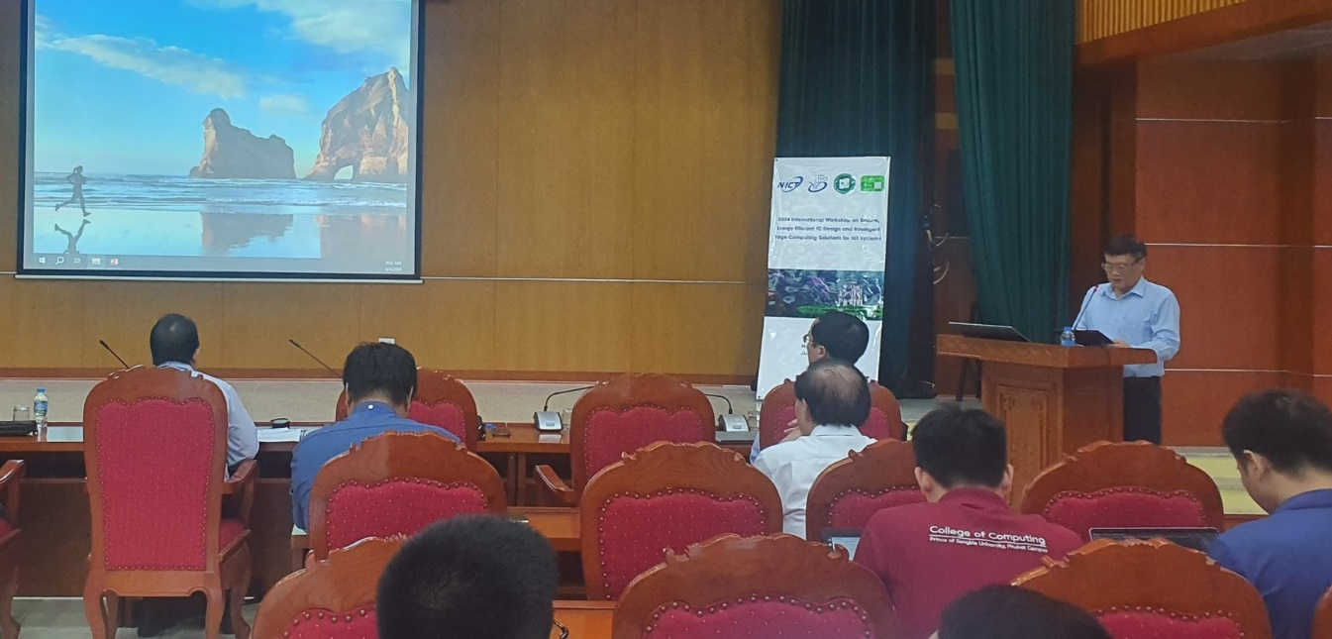

Prof. Mai Quang Huy (Vice President of LQDTU) gives welcome message of the workshop.

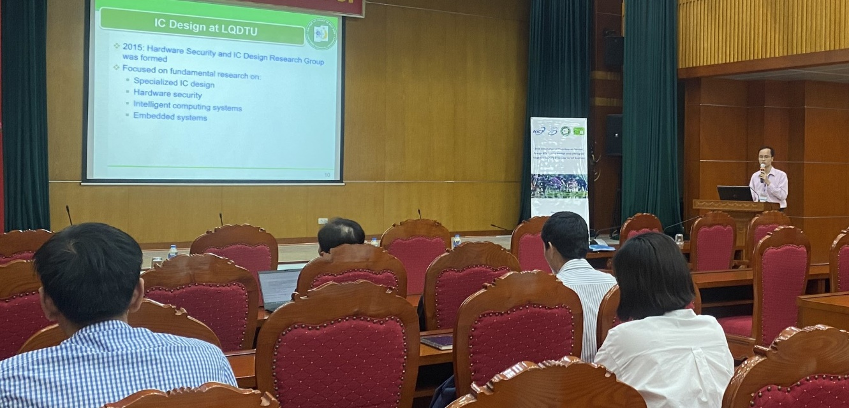

Prof. Hoang Van Phuc presents project achievement and implementation plan.

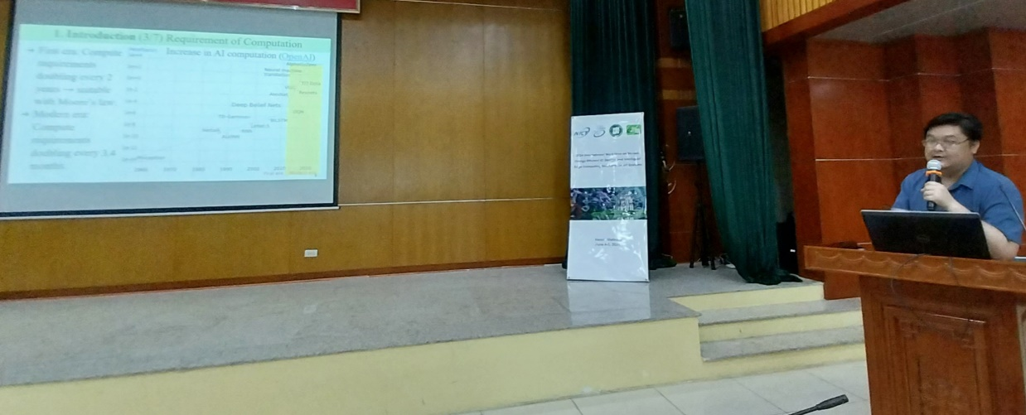

Prof. Trong Thuc Hoang presents the keynote talk about Secured Network-on-Chip (SoC) Framework for RISC-V Based Edge Computing Systems

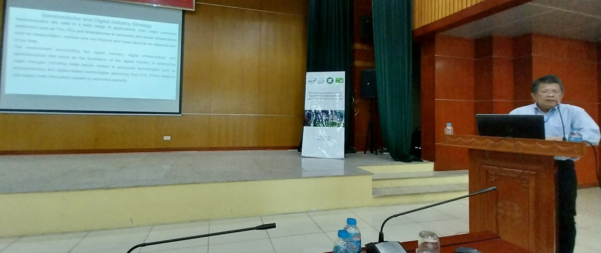

Prof. Cong-Kha Pham talks about Human Resource Development for Semiconductor Talents

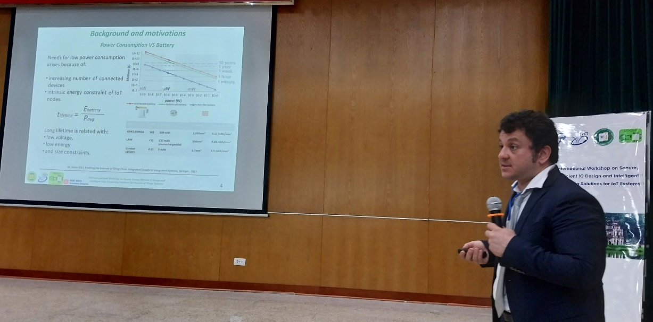

Prof. Orazio Aiello gives a keynote talk on Low Effort, Energy Efficient IC Design for IoT Systems

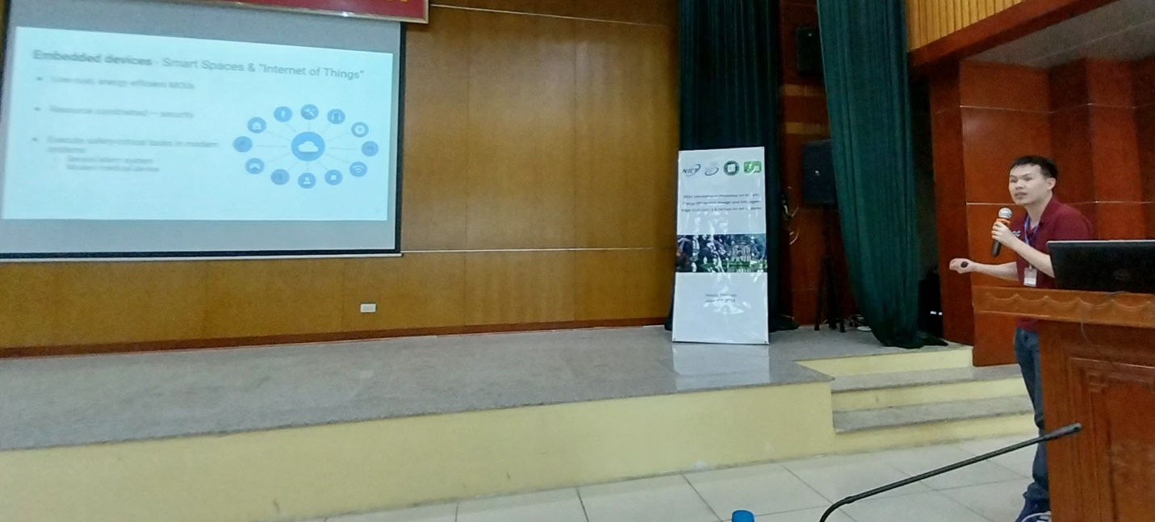

Prof. Norrathep Rattanavipanon gives a keynote talk on A System-Level Approach for Poisoning Prevention in Edge Data Collection.

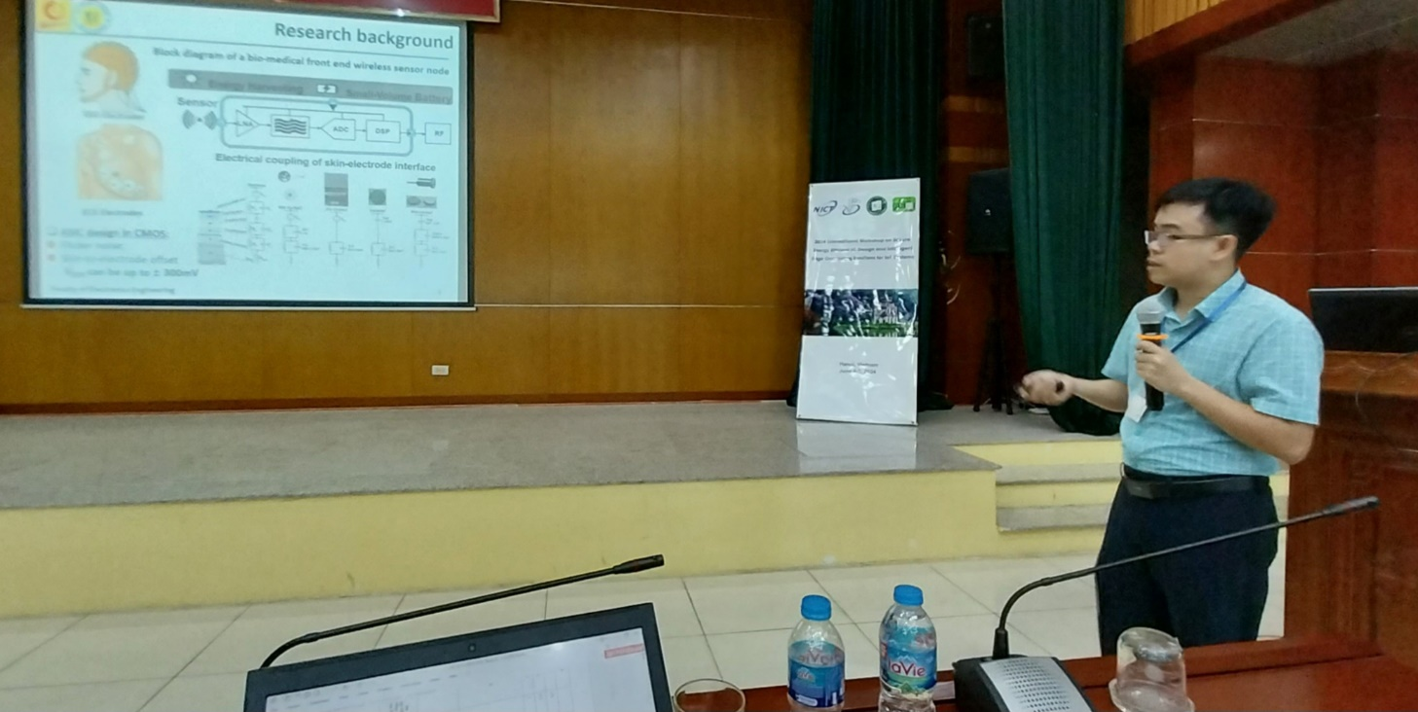

Dr. Pham Van Thanh presents about Energy Efficient Power Management IC for IoT Systems.

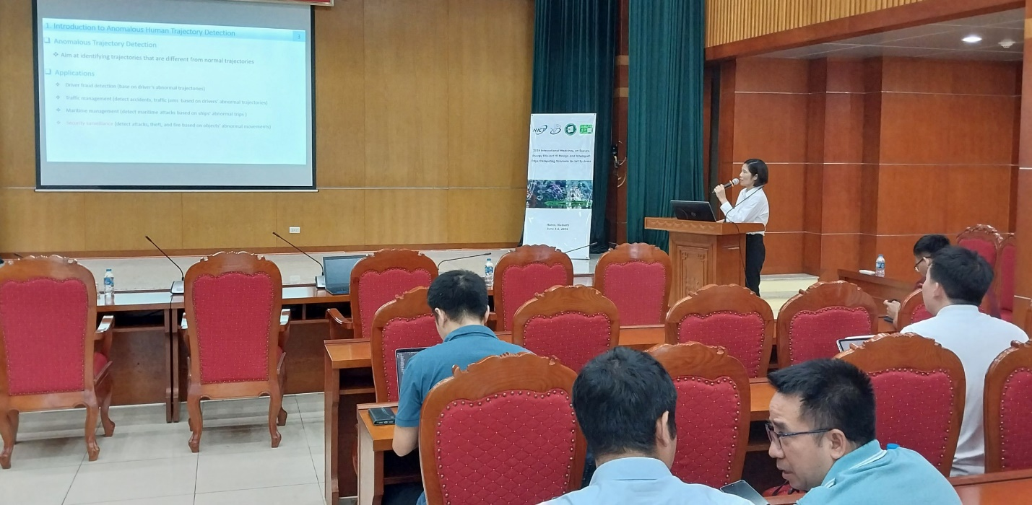

Dr. Doi Thi Lan delivers a talk on Anomalous Indoor Human Trajectory Detection Based on the Transformer Encoder and Self-Organizing Map.

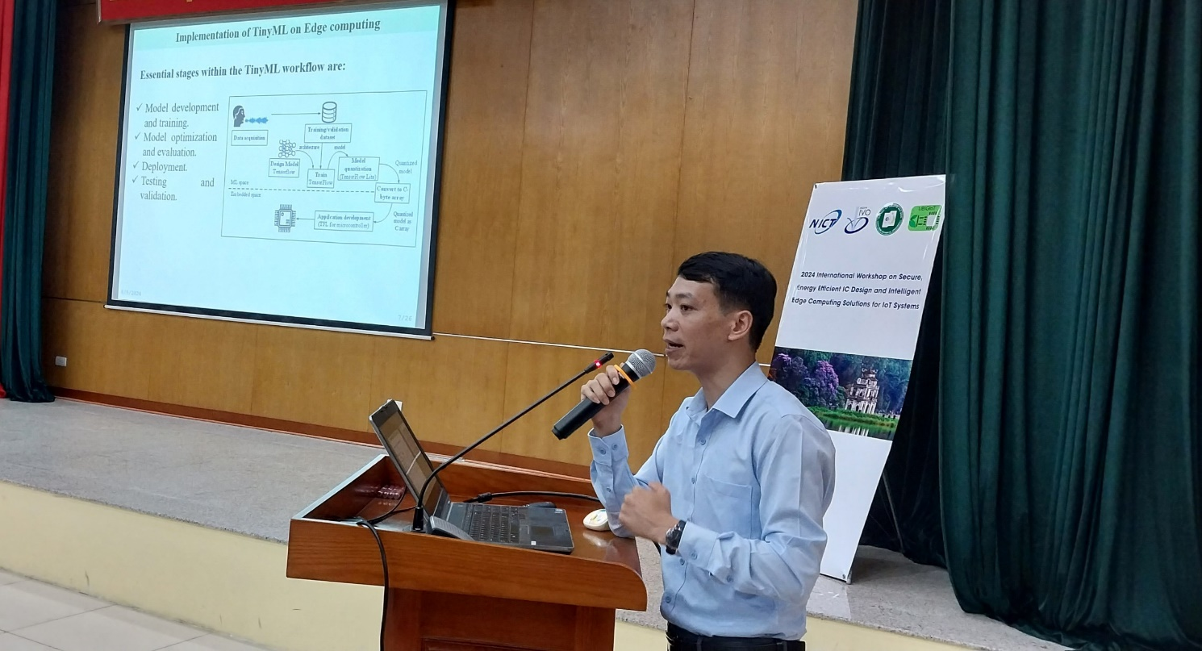

Dr. Do Ngoc Tuan presents TinyML Implementation for Edge Computing Systems.