**[PROJECT TITLE: Artificial Intelligence Powered Comprehensive Cyber-Security for Smart Healthcare Systems (AIPOSH)]**

**[OPEN WORKSHOP: Advanced Cyber-security Solutions for IoT Systems]**

**Report Form**

**I. Organizer:**

|  |  |
| --- | --- |
| Name: | Hoang Van Phuc |
| Position: | Associate Professor |
| Institution: | Le Quy Don Technical University, Hanoi, Vietnam |

**II. Program:**

Date: 10-11, November 2023

Venue: Convention Center, No. 236 Hoang Quoc Viet Str., Hanoi, Vietnam.

**Program Agenda:**

|  |  |  |
| --- | --- | --- |
| **Date** | **November 10th, 2023** |  |
| **Time** | **Agenda** | **Speaker** |
| 9:00 AM | Welcoming | Prof. Van Phuc Hoang, LQDTU |
| 9:15 AM | The project achievement and implementation plan: Toward an intelligent IoT platform for smart healthcare systems in ASEAN | Prof. Van Phuc Hoang, LQDTU |
| 10:00 AM | **Tea break** |  |
| 10:15 AM | Keynote 1: Security Evaluation for IoT Devices | Dr. Takeshi Takahashi, Dr. Keisuke Furumoto (NICT, Japan) |
| 11:15 AM | Keynote 2: On the Trust Issues in Remote Resource-constrained IoT Devices for Smart Healthcare | Norrathep Rattanavipanon (PSU, Thailand) |
| 12:00 PM | **Lunch** |  |
| 1:30 PM | Invited talk 1: Open Source EDA Tools based IC Design for IoT Systems | Dr. Bui Duy Hieu (VNU ITI, Vietnam) |
| 2:30 PM | Invited talk 2: Post Quantum Cryptography for IoT Systems [Online] | Prof. Trong Thuc Hoang, Trong Hung Nguyen (UEC Tokyo, Japan) |
| 3:30 PM | **Tea break** |  |
| 3:45 PM | Energy Efficient RF EH Power Supply for Medical IoT Devices | Dr. Nguyen Van Trung (LQDTU, Vietnam) |
| 4:45 PM | Invited talk 3: Organic Transistor Based Sensors for Smart Healthcare | Prof. Dao Thanh Toan  (UTC, Vietnam) |
| **Date** | **November 11th, 2023** |  |
| **Time** | **Agenda** | **Speaker** |
| 9:00 AM | Keynote 3: AI Powered Security Evaluation for IoT Systems [Online] | Prof. GWEE Bah Hwee (NTU, Singapore) |
| 9:30 AM | Deep Learning Based Lightweight Intrusion Detection for IoT-based Smart Healthcare Systems | Dr. Dao Thi Nga (LQDTU, Vietnam) |
| 10:15 AM | **Tea break** |  |
| 10:30 AM | PUF Design for IoT Device Authentication | Prof. Trinh Quang Kien (LQDTU, Vietnam) |
| 11:00 AM | Transition Factors of Power Consumption Models for CPA Attacks on Cryptographic RISC-V SoC [Online] | Mr. Tran Thai Ha (UEC Tokyo, Japan) |
| 12:00 AM | **Lunch** |  |
| 1:30 PM | Keynote 4: Trusted Execution Environment (TEE) based on RISC-V Processor for Smart Healthcare Systems [Online] | Prof. Cong-Kha Pham, Prof. Trong Thuc Hoang (UEC Tokyo, Japan) |
| 2:15 PM | Connected Care: Innovating Healthcare with SDN and IoT Integration | Dr. Kuljaree Tantayakul (PSU, Thailand) |
| 3:00 PM | Non-Contact Vital Sign Monitoring for Smart Healthcare Systems | Dr. Hoang Thi Yen (UEC Tokyo, Japan) |
| 3:30 PM | **Tea break** |  |
| 3:45 PM | Short Training: “Deep Learning Based SCA in IoT Systems” | Dr. Ngoc Tuan Do (LQDTU, Vietnam) |
| 4:45 PM | Discussion and follow-up plan | Chair: Prof. Hoang Van Phuc, LQDTU |
| 5:00 PM | Closing | Prof. Hoang Van Phuc, LQDTU |

**III. Participants:**

|  |  |  |  |
| --- | --- | --- | --- |
| **No.** | **Name** | **Organization** | **Itinerary** |
| 1 | Van Phuc Hoang | LQDTU | 09-12, November 2023 |
| 2 | Nguyen Van Trung | LQDTU | 09-12, November 2023 |
| 3 | Trinh Quang Kien | LQDTU | 09-12, November 2023 |
| 4 | Dao Thi Nga | LQDTU | 09-12, November 2023 |
| 5 | Trinh Quang Kien | LQDTU | 09-12, November 2023 |
| 6 | Van Tuan Luu | LQDTU | 09-12, November 2023 |
| 7 | Doan Van Sang | LQDTU | 09-12, November 2023 |
| 8 | Dao Thanh Toan | UTC, HCM City | 09-12, November 2023 |
| 9 | Nguyen Van Thanh | LANCSNET, Hanoi | 09-12, November 2023 |
| 10 | Tran Duc Tan | Phenikaa Uni., Hanoi | 09-12, November 2023 |
| 11 | Tran Duc Nghia | VAST, Hanoi | 09-12, November 2023 |
| 12 | Le Minh Thuy | HUST, Hanoi | 09-12, November 2023 |
| 13 | Nguyen My Linh | LANCSNET, Hanoi | 09-12, November 2023 |
| 14 | Pham Van Thanh | LANCSNET, Hanoi | 09-12, November 2023 |
| 15 | Chu Van Hai | LANCSNET, Hanoi | 09-12, November 2023 |
| 16 | Trinh Trung Hieu | MIC, Vietnam | 09-12, November 2023 |
| 17 | Le Minh Tuan | MIC, Vietnam | 09-12, November 2023 |
| 18 | Nguyen Tai Tuyen | MIC, Vietnam | 09-12, November 2023 |
| 19 | Dao Manh Hiep | VNU, Hanoi | 09-12, November 2023 |
| 20 | Tran Xuan Tu | VNU, Hanoi | 09-12, November 2023 |
| 21 | Bui Duy Hieu | VNU, Hanoi | 09-12, November 2023 |
| 22 | Diem Cong Hoang | HUMG, Hanoi | 09-12, November 2023 |
| 23 | Pham Thi Huyen | UTC, Hanoi | 09-12, November 2023 |
| 24 | Nguyen Huu Thang | VNPT Technology | 09-12, November 2023 |
| 25 | Bui Van Viet | ASIC Technologies | 09-12, November 2023 |
| 26 | Ngoc Tuan Do | LQDTU | 09-12, November 2023 |
| 27 | Nguyen Huu Hung | LQDTU | 09-12, November 2023 |
| 28 | Pham Van Phu | Viettel Group | 09-12, November 2023 |
| 29 | Hoang Thi Yen | UEC | 09-12, November 2023 |
| 30 | Nguyễn Đình Chi | FPTU | 09-12, November 2023 |
| 31 | Bui Ngoc Kien | ETA SEMI | 09-12, November 2023 |
| 32 | Le Trong Hieu | Electric Power Uni. | 09-12, November 2023 |
| 33 | Phan Ngoc | Electric Power Uni. | 09-12, November 2023 |
| 34 | Nguyen Viet Nam | Quantum AI Co,ltd | 09-12, November 2023 |
| 35 | Nguyen Manh Truong | Tri Nam Group | 09-12, November 2023 |
| 36 | Doan Minh Tien | HaUI, Vietnam | 09-12, November 2023 |
| 37 | Tran Phuong Nhung | HaUI, Vietnam | 09-12, November 2023 |
| 38 | Pham Xuan Thanh | HaUI, Vietnam | 09-12, November 2023 |
| 39 | Tran Thanh Hung | HaUI, Vietnam | 09-12, November 2023 |
| 40 | Nguyễn Thị Thanh Vân | Phenikaa University | 09-12, November 2023 |
| 41 | Dao To Hieu | Phenikaa University | 09-12, November 2023 |
| 42 | Nguyen Duy Ninh | Institute of Electronics | 09-12, November 2023 |
| 43 | Dinh Lam Tran | Institute of Electronics | 09-12, November 2023 |
| 44 | Nguyen Trung Kien | UTC, Hanoi | 09-12, November 2023 |
| 45 | Ngô Trường Giang | UTC, Hanoi | 09-12, November 2023 |
| 46 | Lê Hồng Anh | UTC, Hanoi | 09-12, November 2023 |
| 47 | Vu Minh Duc | UTC, Hanoi | 09-12, November 2023 |
| 48 | Nguyễn Hữu Sáng | UTC, Hanoi | 09-12, November 2023 |
| 49 | Nguyễn Đình Thành | UTC, Hanoi | 09-12, November 2023 |
| 50 | Koichiro Ishibashi | UEC | 09-12, November 2023 |
| 51 | Makoto Ikeda | University of Tokyo | 09-12, November 2023 |
| 52 | Keisuke Furumoto | NICT | 09-12, November 2023 |
| 53 | Trong Thuc Hoang | UEC (Project member) | 09-12, November 2023 |
| 54 | Norrathep Rattanavipanon | PSU (Project member) | 09-12, November 2023 |
| 55 | Kuljaree Tantayakul | PSU (Project member) | 09-12, November 2023 |
| 56 | Bah Hwee Gwee | NTU (Project member) | online |
| 57 | Thai Ha Tran | UEC (Project member) | online |
| 58 | Cong Kha Pham | UEC (Project member) | online |
| 59 | Takeshi Takahashi | NICT (Project member) | online |
| 60 | Nguyen Trong Hung | UEC | online |
|  | Trung Trinh | SINTEF, Norway |  |
|  |  |  |  |

Total: 55 people (offline) + 5 (online)

**IV. Summary of the activities corresponding to the objectives**

1. Objective

The main objective of this workshop is to provide a forum for exchange of ideas and latest research results in advanced cyber-security techniques and solutions for IoT-based smart healthcare systems. The workshop is necessary for this project in gathering leading experts in different fields to solve the issues of providing a convergence artificial intelligence powered cyber-security platform for IoT based smart healthcare systems in ASEAN region. The workshop aims to provide the overall solutions for this project. It is taken place in Hanoi due to several reasons. Firstly, as the capital of Vietnam, Hanoi has leading experts in different fields of IoT systems which are also main topics of our project and famous universities. Secondly, it is convenient to gather leading experts from Japan (without budget from IVO project) thank to its convenient travel. Also, some local companies in Hanoi are willing to join the workshop. Moreover, experts from Vietnam National University, Hanoi University of Science and Technology, Phenikaa University can have invited talks in this workshop without budget from the project. The first keynote talk present the solutions and methods in security evaluation for IoT devices. In the keynote 2, the trust issues in remote resource-constrained IoT devices will be investigated to point out the security threats and solutions for smart healthcare. Keynote 3 mentions the AI powered solutions for security evaluation for IoT systems which will be useful for this project. Keynote 4 presents the advances and implementation of Trusted Execution Environment (TEE) based on RISC-V Processor which can be used for smart healthcare systems in this project. Moreover, in the invited talk 1, the authors present the directions of using open source EDA tools in IC design for IoT systems including smart healthcare systems. Invited talk 2 provides the status and potential applications of post quantum cryptography for IoT systems. In the invited talk 3, authors present the achievement and applications of organic transistor based sensors for smart healthcare which will be useful for this project. Moreover, the short training on deep learning based SCA in IoT systems in the secon day is very useful for ensuring security in IoT based smart healthcare systems.

2. Activities corresponding to the objectives

1. Review the progress of project:

* Prof. Hoang Van Phuc gives welcome message of the workshop.
* Prof. Hoang Van Phuc presents the project achievement and implementation plan toward an intelligent IoT platform for smart healthcare systems in ASEAN.

1. Present, discuss the latest research results in advanced cyber-security techniques and solutions for IoT-based smart healthcare systems, and conclusions:

* Dr. Keisuke Furumoto presents the first keynote talk present the solutions and methods in security evaluation for IoT devices;
* Dr. Bui Duy Hieu presents the invited talk about open source EDA tools based IC design for IoT systems with the program funded by Google;
* Prof. Norrathep Rattanavipanon gives a keynote talk on the trust issues in remote resource-constrained IoT devices for smart healthcare systems. He also raises the issue to integrate software/hardware security solutions for IoT systems inthis project.
* Dr. Dao Thi Nga presents about the deep learning based lightweight intrusion detection for IoT-based smart healthcare systems;
* Prof. Trong Thuc Hoang presents the keynote talk about the advances and implementation of Trusted Execution Environment (TEE) based on RISC-V Processor which can be used for smart healthcare systems in this project;
* Prof. Dao Thanh Toan gives an invited talk on the topic of organic transistor based sensors for smart healthcare systems.
* Dr. Nguyen Van Trung presents and discusses the results of the energy efficient RF EH power supply for medical IoT devices.
* Prof. GWEE Bah Hwee delivers a keynote talk on AI Powered Security Evaluation for IoT Systems.
* Mr. Trong Hung Nguyen gives an invited talk on the topic of post quantum cryptography for IoT systems.
* Prof. Trinh Quang Kien presents PUF design for IoT device authentication. The achieved recults have clarified the feasibility of IoT device authentication with PUFs.
* Mr. Tran Thai Ha gives a talk on the topic of transition factors of power consumption models for CPA attacks on cryptographic RISC-V SoCs.
* Prof. Hoang Van Phuc delivers a short training on deep learning techniques for IoT systems. Training method includes lectures and simulation on MATLAB software.
* Prof. Hoang Van Phuc chairs the discussions, gives follow-up plan for the project and closing remarks. In conclusion, the project has achieved remarkable results with qualified published papers and scientific exchange activities. For the follow-up plan, the project team will perform the site experiments, prototype system development and propose the application model after the project.

3. Detailed changes from the initial proposal: In general, the workshop content is unchanged. We only change the order of presentations for the convenience of speakers.

**V. Others**

The workshop related pictures as below:

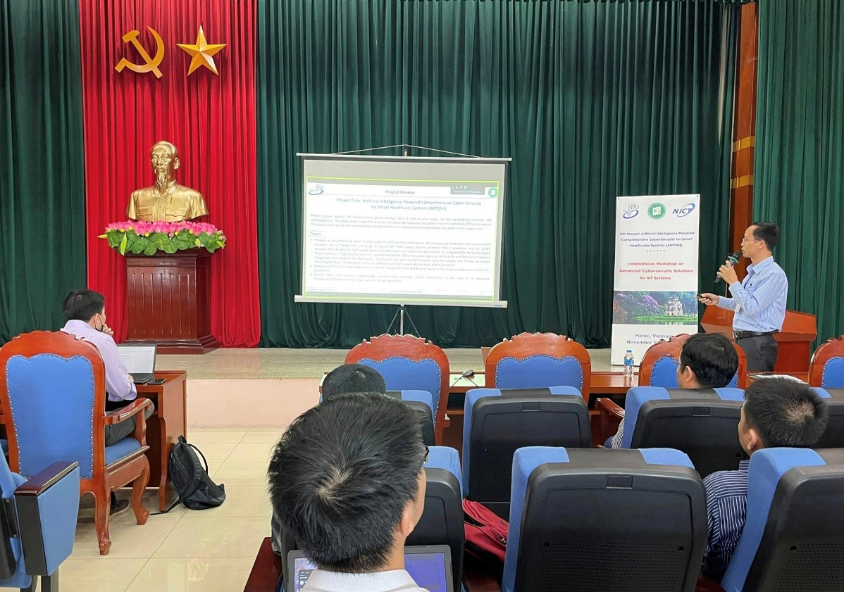

Prof. Hoang Van Phuc gives welcome message of the workshop, presents project achievement and implementation plan toward an intelligent IoT platform for smart healthcare systems in ASEAN.

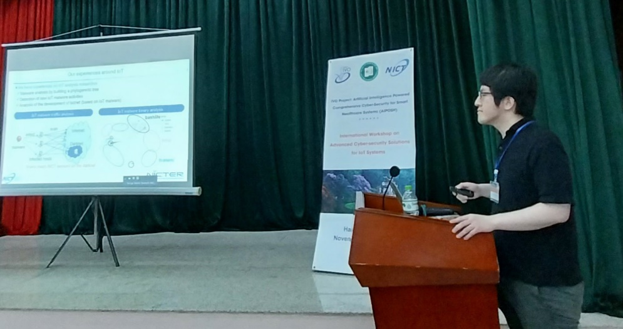

Dr. Keisuke Furumoto presents the first keynote talk on the solutions and methods in security evaluation for IoT devices.

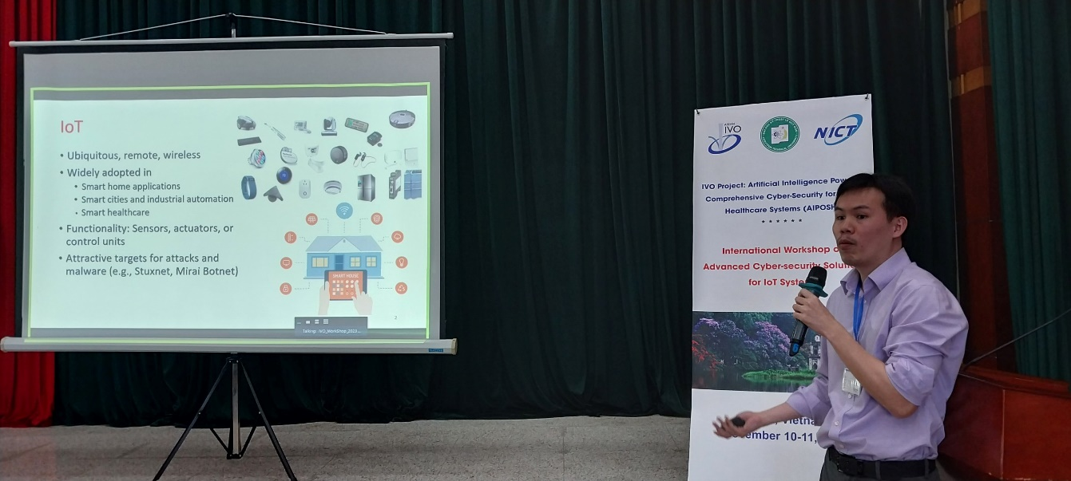

Prof. Norrathep Rattanavipanon gives a keynote talk on the trust issues in remote resource-constrained IoT devices for smart healthcare systems.

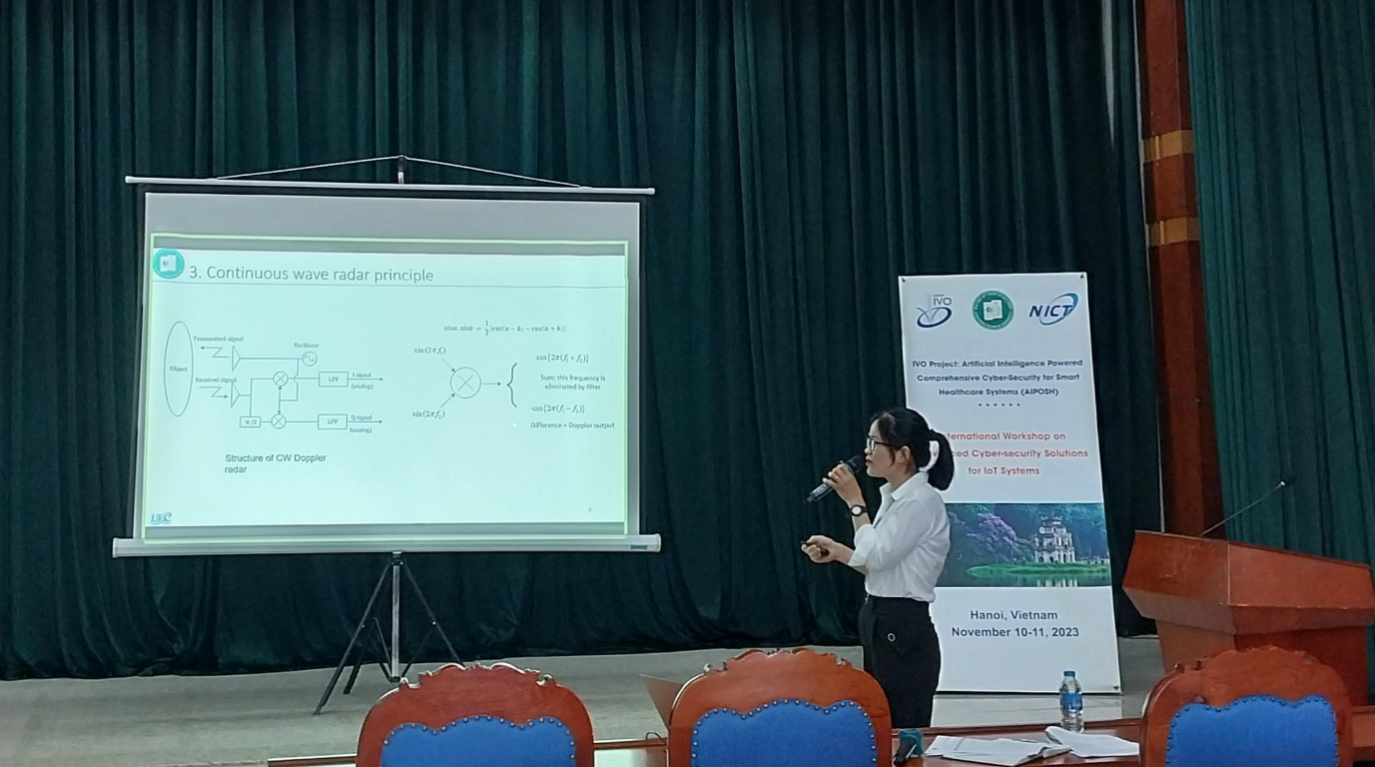

Dr. Hoang Thi Yen presents on Non-Contact Vital Sign Monitoring for Smart Healthcare Systems.

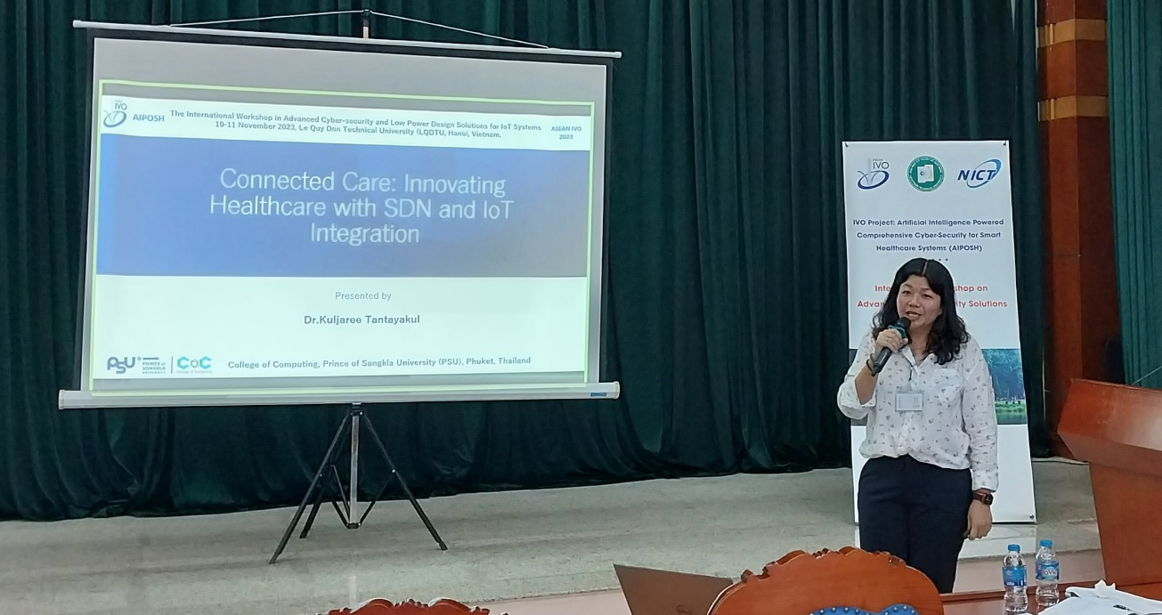

Dr. Kuljaree Tantayakul presents about the topic “Connected Care: Innovating Healthcare with SDN and IoT Integration”.

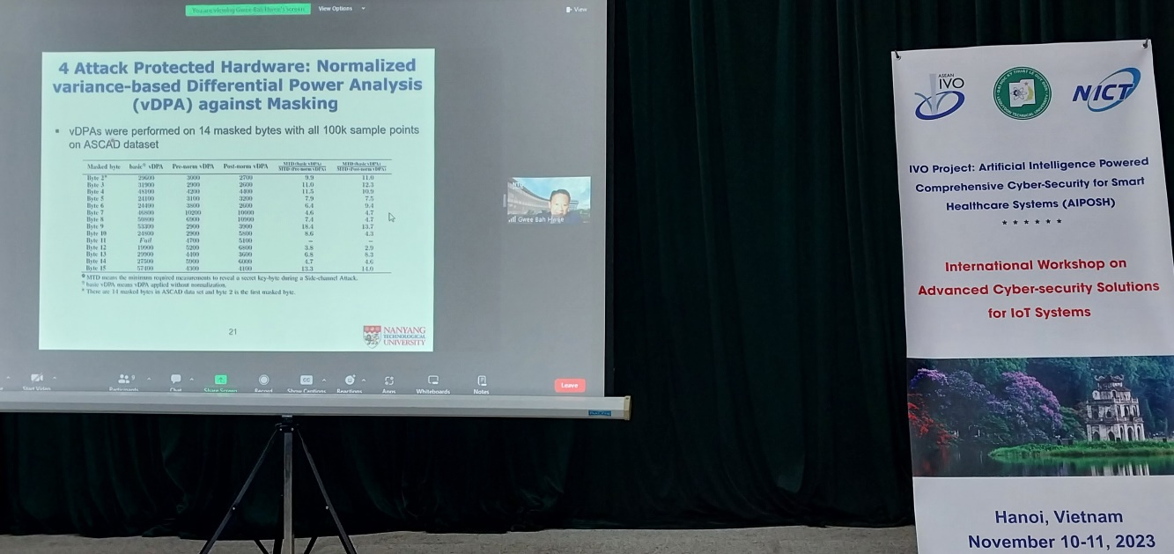

Prof. GWEE Bah Hwee delivers a keynote talk on AI powered security evaluation for IoT systems.

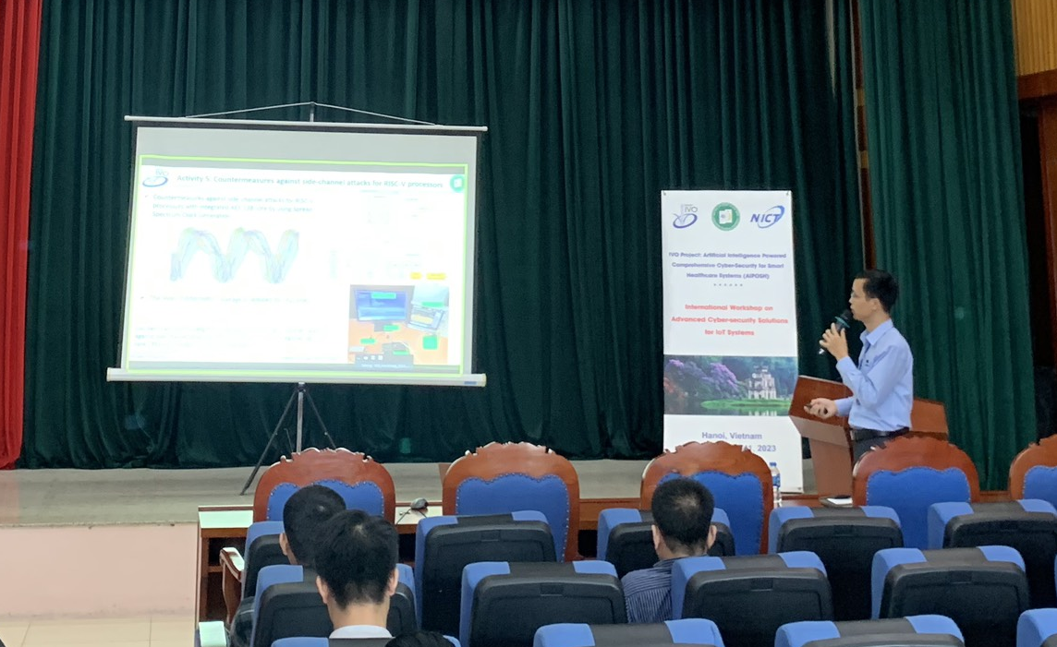

Short training on deep learning techniques for IoT systems. Training method: Lecture and simulation on MATLAB software.