Appendix 4.2

An Organic Food Tracking by using Blockchain in Lao PDR
Field and Workshop
Report/Minutes Form

I. Organizer:
Name: | Dr. Vimontha Khieovongphachanh
Position: | Project Leader
Institution: | National University of Laos

II. Program:

Date:28July2024
Venue: Field site (Thaxang Farm and Pawan Farm)

Date:29-30July2024
Venue: Workshop (Lao Plaza Hotel)

Program Agenda:

28July2024: Field site
Time | Description | Person in charge
8:00-9:00 | Registration at Lao Plaza hotel
9:00-12:00 | Organic Vegetable Thaxang Farmer group product | All participants
13:00-15:00 | Pawan Farm entrepreneur | All participants
15:00-16:00 | Back to Vientiane

29July2024: Workshop at Lao Plaza Hotel
Time | Description | Person in charge
8:00-9:00 | Registration
9:00-10:15 | Project Member Meeting  Overview of Field Trip and Findings and Project proposal | All member
10:15-10:25 | Brief Introduction of Host Academic Event | Dr.Vimontha Khieovongphachanh
10:25 – 11:30 | Introduction to Clean Agriculture in Laos | Clean Agriculture Standard Center, Ministry of agriculture and forest
11:30-12:00 | Discussion about Clean Agriculture and standard in Laos | All participants
12:00-13:30 | Working Lunch
13:30-14:00 | From Farmer to Market: The Journey of Agricultural Products | Thonmang organic agriculture Cooperative
14:00-14:20 | Lao National Blockchain | Dr.Sillivanxay Phetsouvanh, Department of Blockchain Technology, DOT, Ministry of Technology and Communications
14:20-15:00 | Basic of Blockchain Technologies  Concept of Blockchain, Concept of Ethereum | Technical Team
15:00-15:30 | Blockchain and Meta-World | Dr.Lunchakorn Wuttisitikulkij,CU partner
15:30-16:00 | Blockchain implementation | Dr.Boonprasert Surakratanasakul,KMITLpartner

30July2024: Workshop at Lao Plaza Hotel
Time | Description | Person in charge
8:00-9:00 | Registration
9:00-10:15 | Blockchain: Smart contract hand on (Lab) | Technical team
10:15-10:35 | Co-farm  The process of distributing agricultural produce | Mr Keerati Panyapitisonphon  Director of Co-farm
10:35-12:00 | Introduction to Blockchain infrastructure  - Overview of the system  - Hyperledy Besu | Dr. Phonepadith PHOUMMAVONG
12:00-13:30 | Working Lunch
13:30-14:00 | Metaverse by Lailaolab | Mr VannaphaSOUTHIVONG  Founder/CEO Lailaolab Groups
14:00-15:15 | Blockchain : Node setup  How to setup and config Node, Output or result of Node | Dr. Phonepadith PHOUMMAVONG
15:15-15:45 | Group Dissussion  - How to apply blockchain to the real world  - What's the best practice | Dr. Somsanouk PATHOUMVANH
15:45-16:00 | Introduction to ASEAN IVO and NICT | Dr. Hiroshi Emoto

III. Participants:

28July2024: Field site
No. | Name | Organization
1 | Asst. Prof. Dr. Vimontha Khieovongphachanh | NUOL
2 | Dr. Phonepadith PHOUMMAVONG | NUOL
3 | Dr. Hiroshi Emoto | NICT
4 | Dr. Lunchakorn Wuttisitikulkij | CU
5 | Dr. Charnchai Pluepitiwiriyawej | CU
6 | Dr. Boonprasert Surakratanasakul | KMITL
7 | Asst. Prof. Senglathsamy CHANTHAMENAVONG | NUOL
8 | Asst. Prof. Dr. Khamphao SISAAT | NUOL
9 | Asst. Prof. Dr. Khanthanou Luangxaysana | NUOL
10 | Asst. Prof. Dr. Khampheth Bounnady | NUOL
11 | Dr. Somphone Kanthavong | NUOL
12 | Asst. Prof. Dr. Phonexay Vilakone | NUOL
13 | Sirapop Saengthongkam | CU
14 | Navy Wuttiananchai | CU
15 | Mr. Apiwat Bunyasartpan | KMITL
16 | Ms. Nawisa Thanasuttawong | KMITL
17 | Ms. Pinya Nuangudom | KMITL
18 | Mr. Ongkone KHOUNPHITHAK | Student volunteer
19 | Ms. Xalisa CHANTHAVONG | Student volunteer
20 | Clean Agriculture Standard Center | Ministry of agriculture and forest
21 | Khamxay Leevatou | NUOL
22 | Ms Maniphet MIXAY | Student volunteer
23 | Mr Vilathep SISOUVONG | Student volunteer

29-30July2024: workshop
No. | Name | Organization
1 | Dr. Lunchakorn Wuttisitikulkij | CU
2 | Dr. Charnchai Pluepitiwiriyawej | CU
3 | Dr. Boonprasert Surakratanasakul | KMITL
4 | Dr. Hiroshi Emoto | NICT
5 | Asst. Prof. Dr. Vimontha KHIEOVONGPHACHANH | NUOL
6 | Assoc. Prof. Tha BOUNTHANH | NUOL
7 | Asst. Prof. Senglathsamy CHANTHAMENAVONG | NUOL
8 | Asst. Prof. Dr. Khampheth Bounnady | NUOL
9 | Dr. Phonepadith PHOUMMAVONG | NUOL
10 | Asst. Prof. Dr. Khanthanou Luangxaysana | NUOL
11 | Asst. Prof. Dr. Somsanouk PATHOUMVANH | NUOL
12 | Asst. Prof. Dr. Khamphao Sisaat | NUOL
13 | Dr. Somphone Kanthavong | NUOL
14 | clean agriculture standard center | Ministry of Agriculture and forest
15 | Keerati Panyapitisonphon | Co-Farm
16 | Dr. Sillivanxay Phetsouvanh | Ministry of Technology and Communications
17 | 2Speakers | Thonmang organic agriculture Cooperative
18 | Mr. Phanthavilai Nouanehoune | LAOTOP Collage
19 | Mr. Sompasong Vongthavone | LAOTOP Collage
20 | Dr. Sanouphab Phomkeona | NUOL
21 | Mr. Sithiphone PHANDALA | NUOL
22 | Asst. Prof. Dr. Phonexay Vilakone | NUOL
23 | Dr. Xaythavy Luang vilay | NUOL
24 | Mr. Khamxay Leevangtou | NUOL
25 | Ms. Manithda Thavongchid | NUOL
26 | Asst. Prof. Manolom Chanthavong | NUOL
27 | Mr Khonepaseuth SOUNAKHEN | NUOL
28 | Ms. Phetvilaii Chandara | Student Volunteer
29 | Mr. Photthasone CHANTHAVONGSA | Student Volunteer
30 | Ms. Xalisa CHANTHAVONG | Student Volunteer
31 | Mr. Ongkone KHOUNPHITHAK | Student Volunteer
32 | Sirapop Saengthongkam | CU Student
33 | Navy Wuttiananchai | CU Student
34 | Mr. Apiwat Bunyasartpan | KMITL Student
35 | Ms. Nawisa Thanasuttawong | KMITL Student
36 | Ms. Pinya Nuangudom | KMITL Student
37 | Ms. Maniphet MIXAY | NUOL Student
38 | Mr. Binly BOUNYAKHET | NUOL Student
39 | Mr Phaithoun Thammavong | NUOL Student
40 | Mr Saksith Sidavong | NUOL Student
41 | Mr Chanthida Vongsaya | NUOL Student
42 | Mr Ahnan Siphaxay | NUOL Student
43 | Mrs. Nut Donephondy | IT Center, NUOL
44 | Mr. Siliphone Laviengvong | IT Center, NUOL
45 | Ms. Chansouda Phetsiriseng | IT Center, NUOL
46 | Mr VannaphaSOUTHIVONG | Lailaolab Groups

IV. Summary of the activities corresponding to the objectives.
The purpose of the workshop and field site visit is to learn product verification standards from production to market while gathering critical data on organic food production practices. Invited speakers will share lessons on transportation, cooperation, and verification processes, providing valuable insights for integrating blockchain technology into organic food tracking systems. Additionally, the event covered national blockchain and startup initiatives related to agriculture and technology.
On the technical side, the event aimed to provide Blockchain training focused on basic Ethereum concepts and setting up node servers using Hyperledger Besu in a consortium model involving NUOL, CU, KMITL, and UTB. The program also explored smart contracts, low-code, and no-code applications, facilitating knowledge exchange and practical experience among institute members, young researchers, and interested students.
This was the first face-to-face meeting with all partners after previously connecting through online meetings. The field site visit and workshop provided a valuable opportunity for members to meet in person, engage in discussions, share insights, and collaboratively plan the next steps and upcoming activities.
The field site visit and workshop largely followed the planned agenda and objectives. However, due to some invited speakers having urgent work commitments and busy schedules, adjustments had to be made by inviting alternative speakers and modifying the schedule accordingly
V. Others

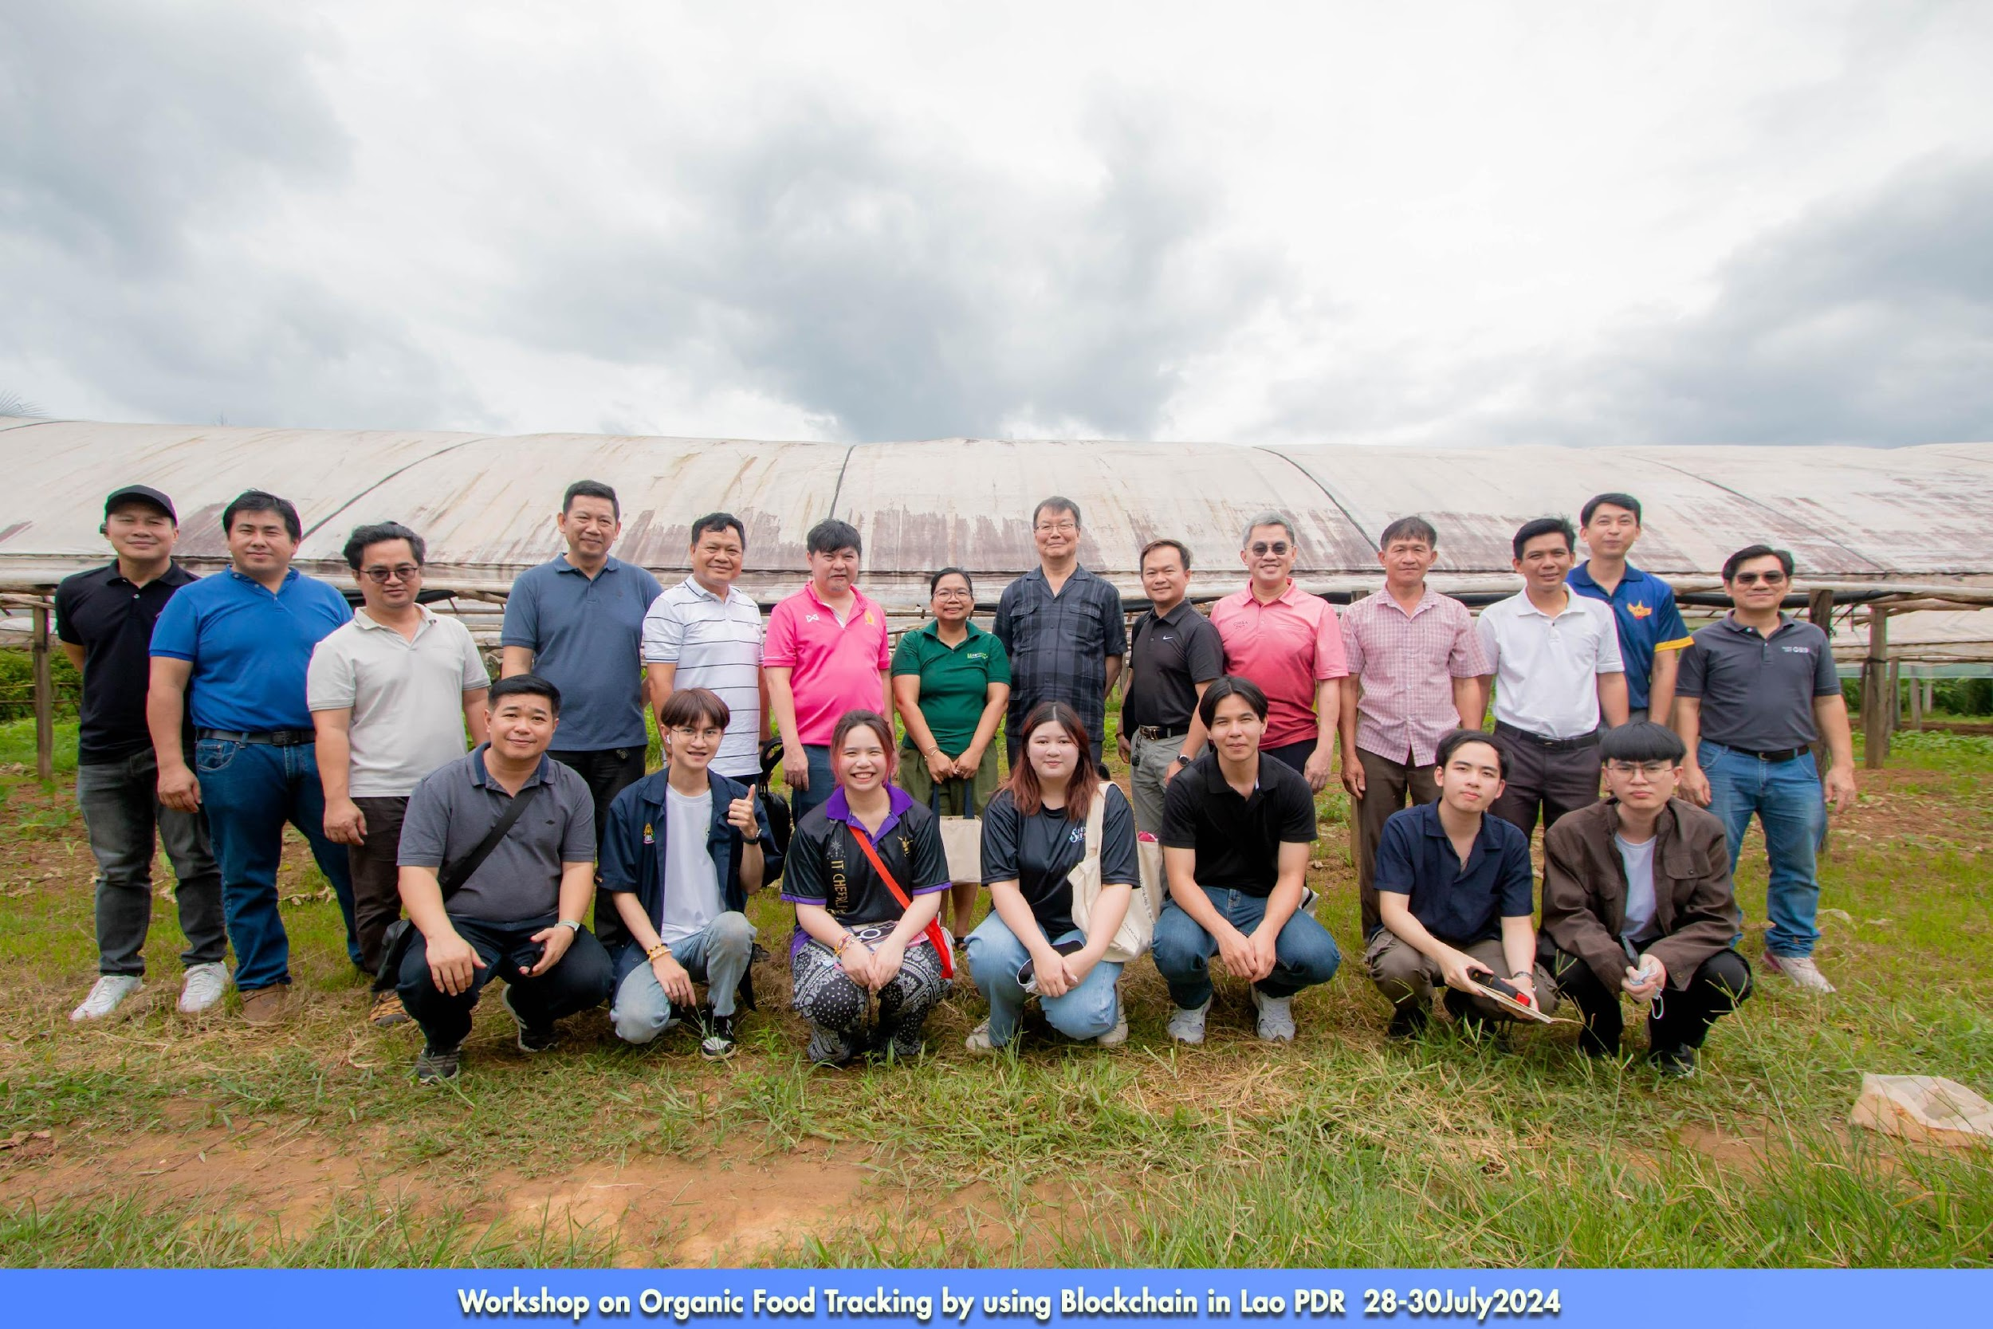
Field site on 28July2024

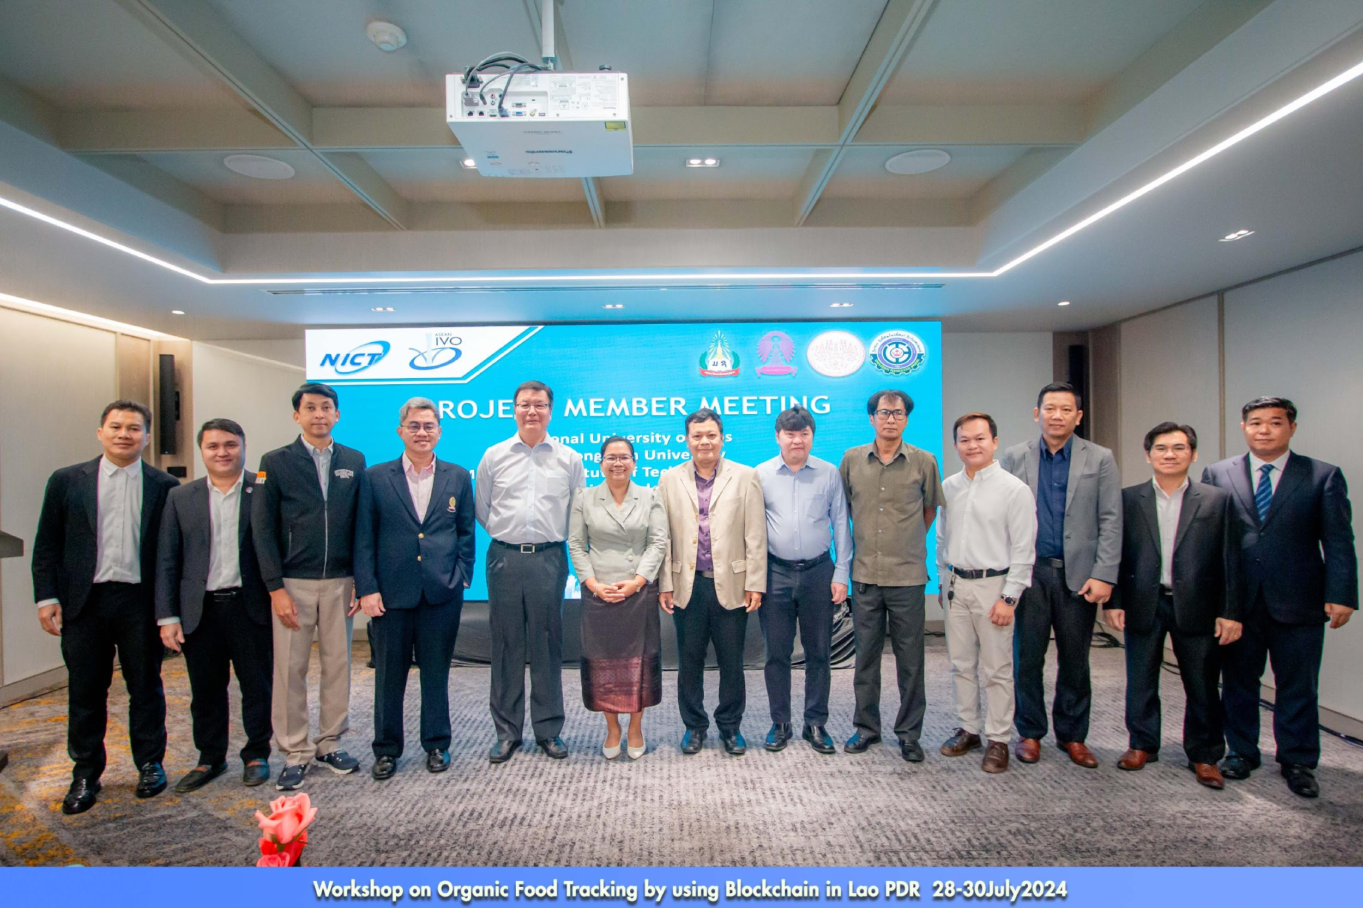

Project member: NUOL, CU and KMITL

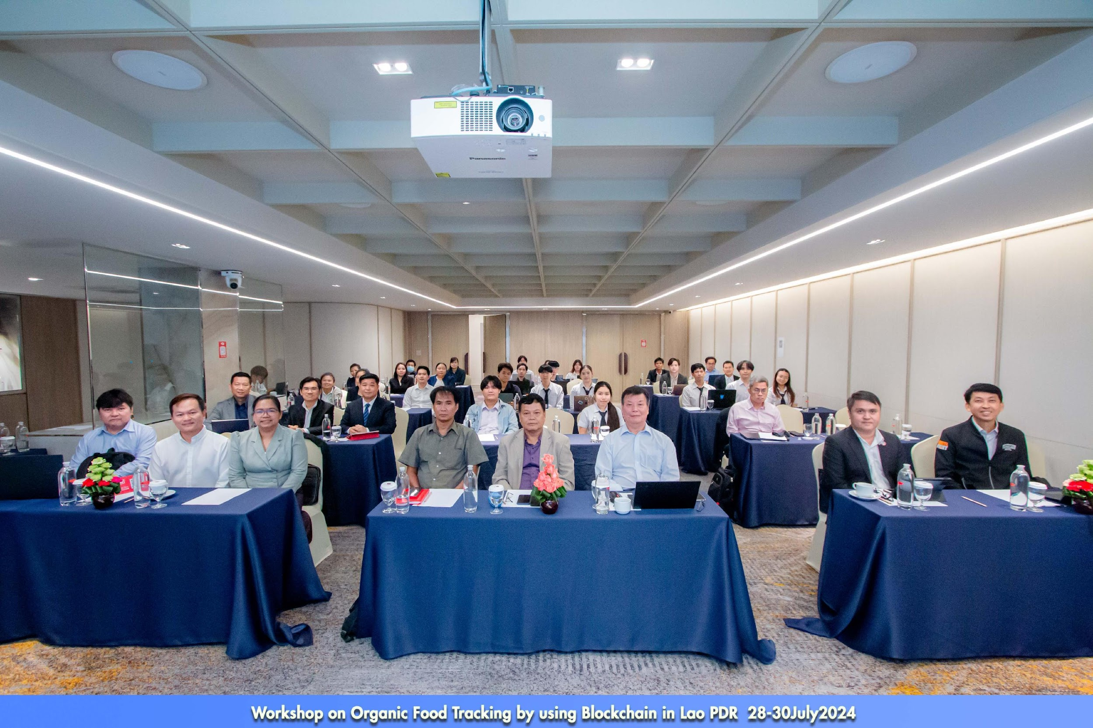

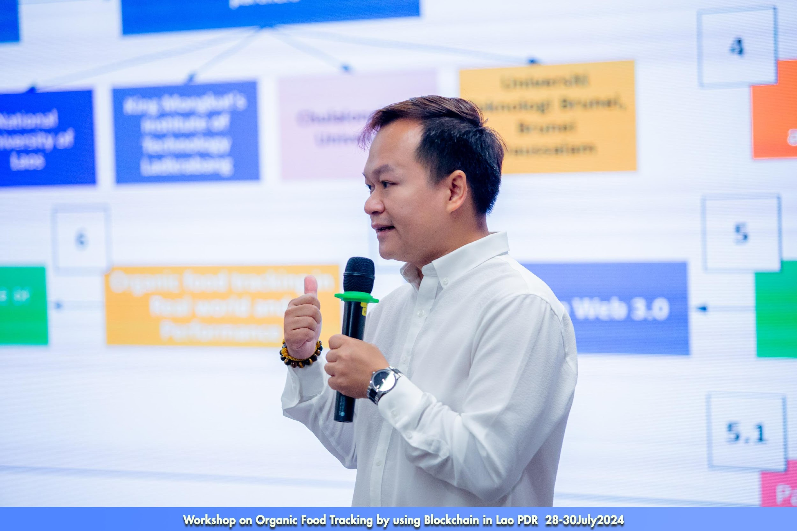
Speaker : Technical team

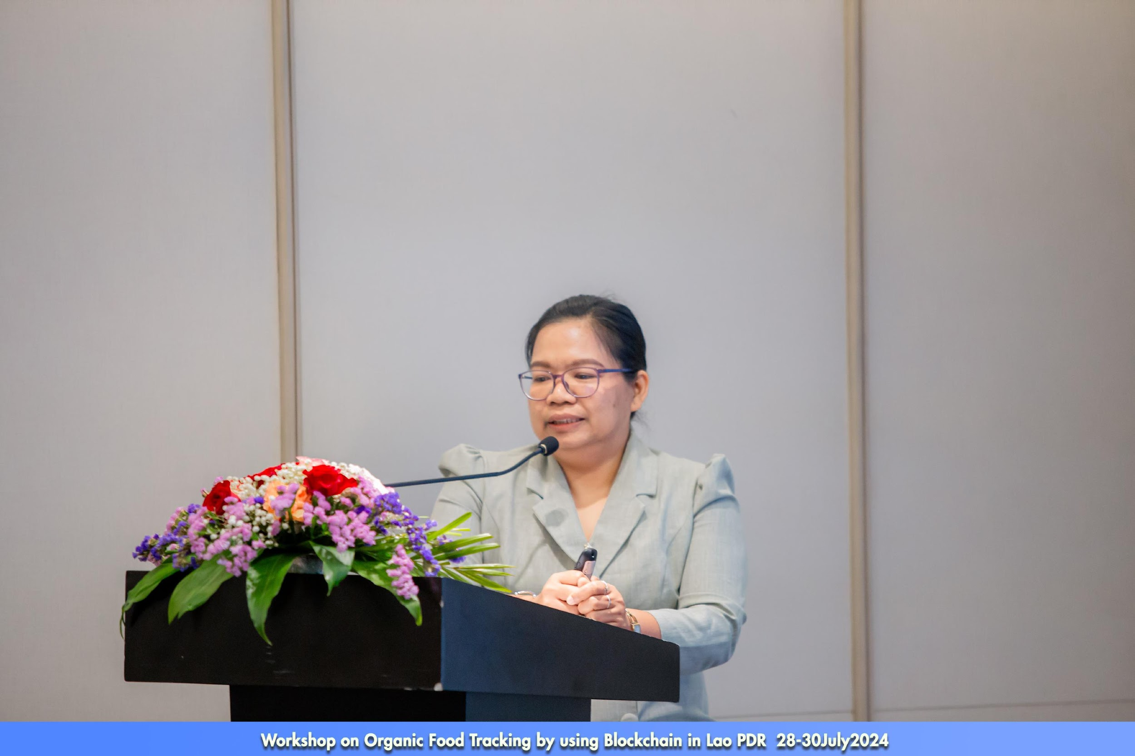
Project leader

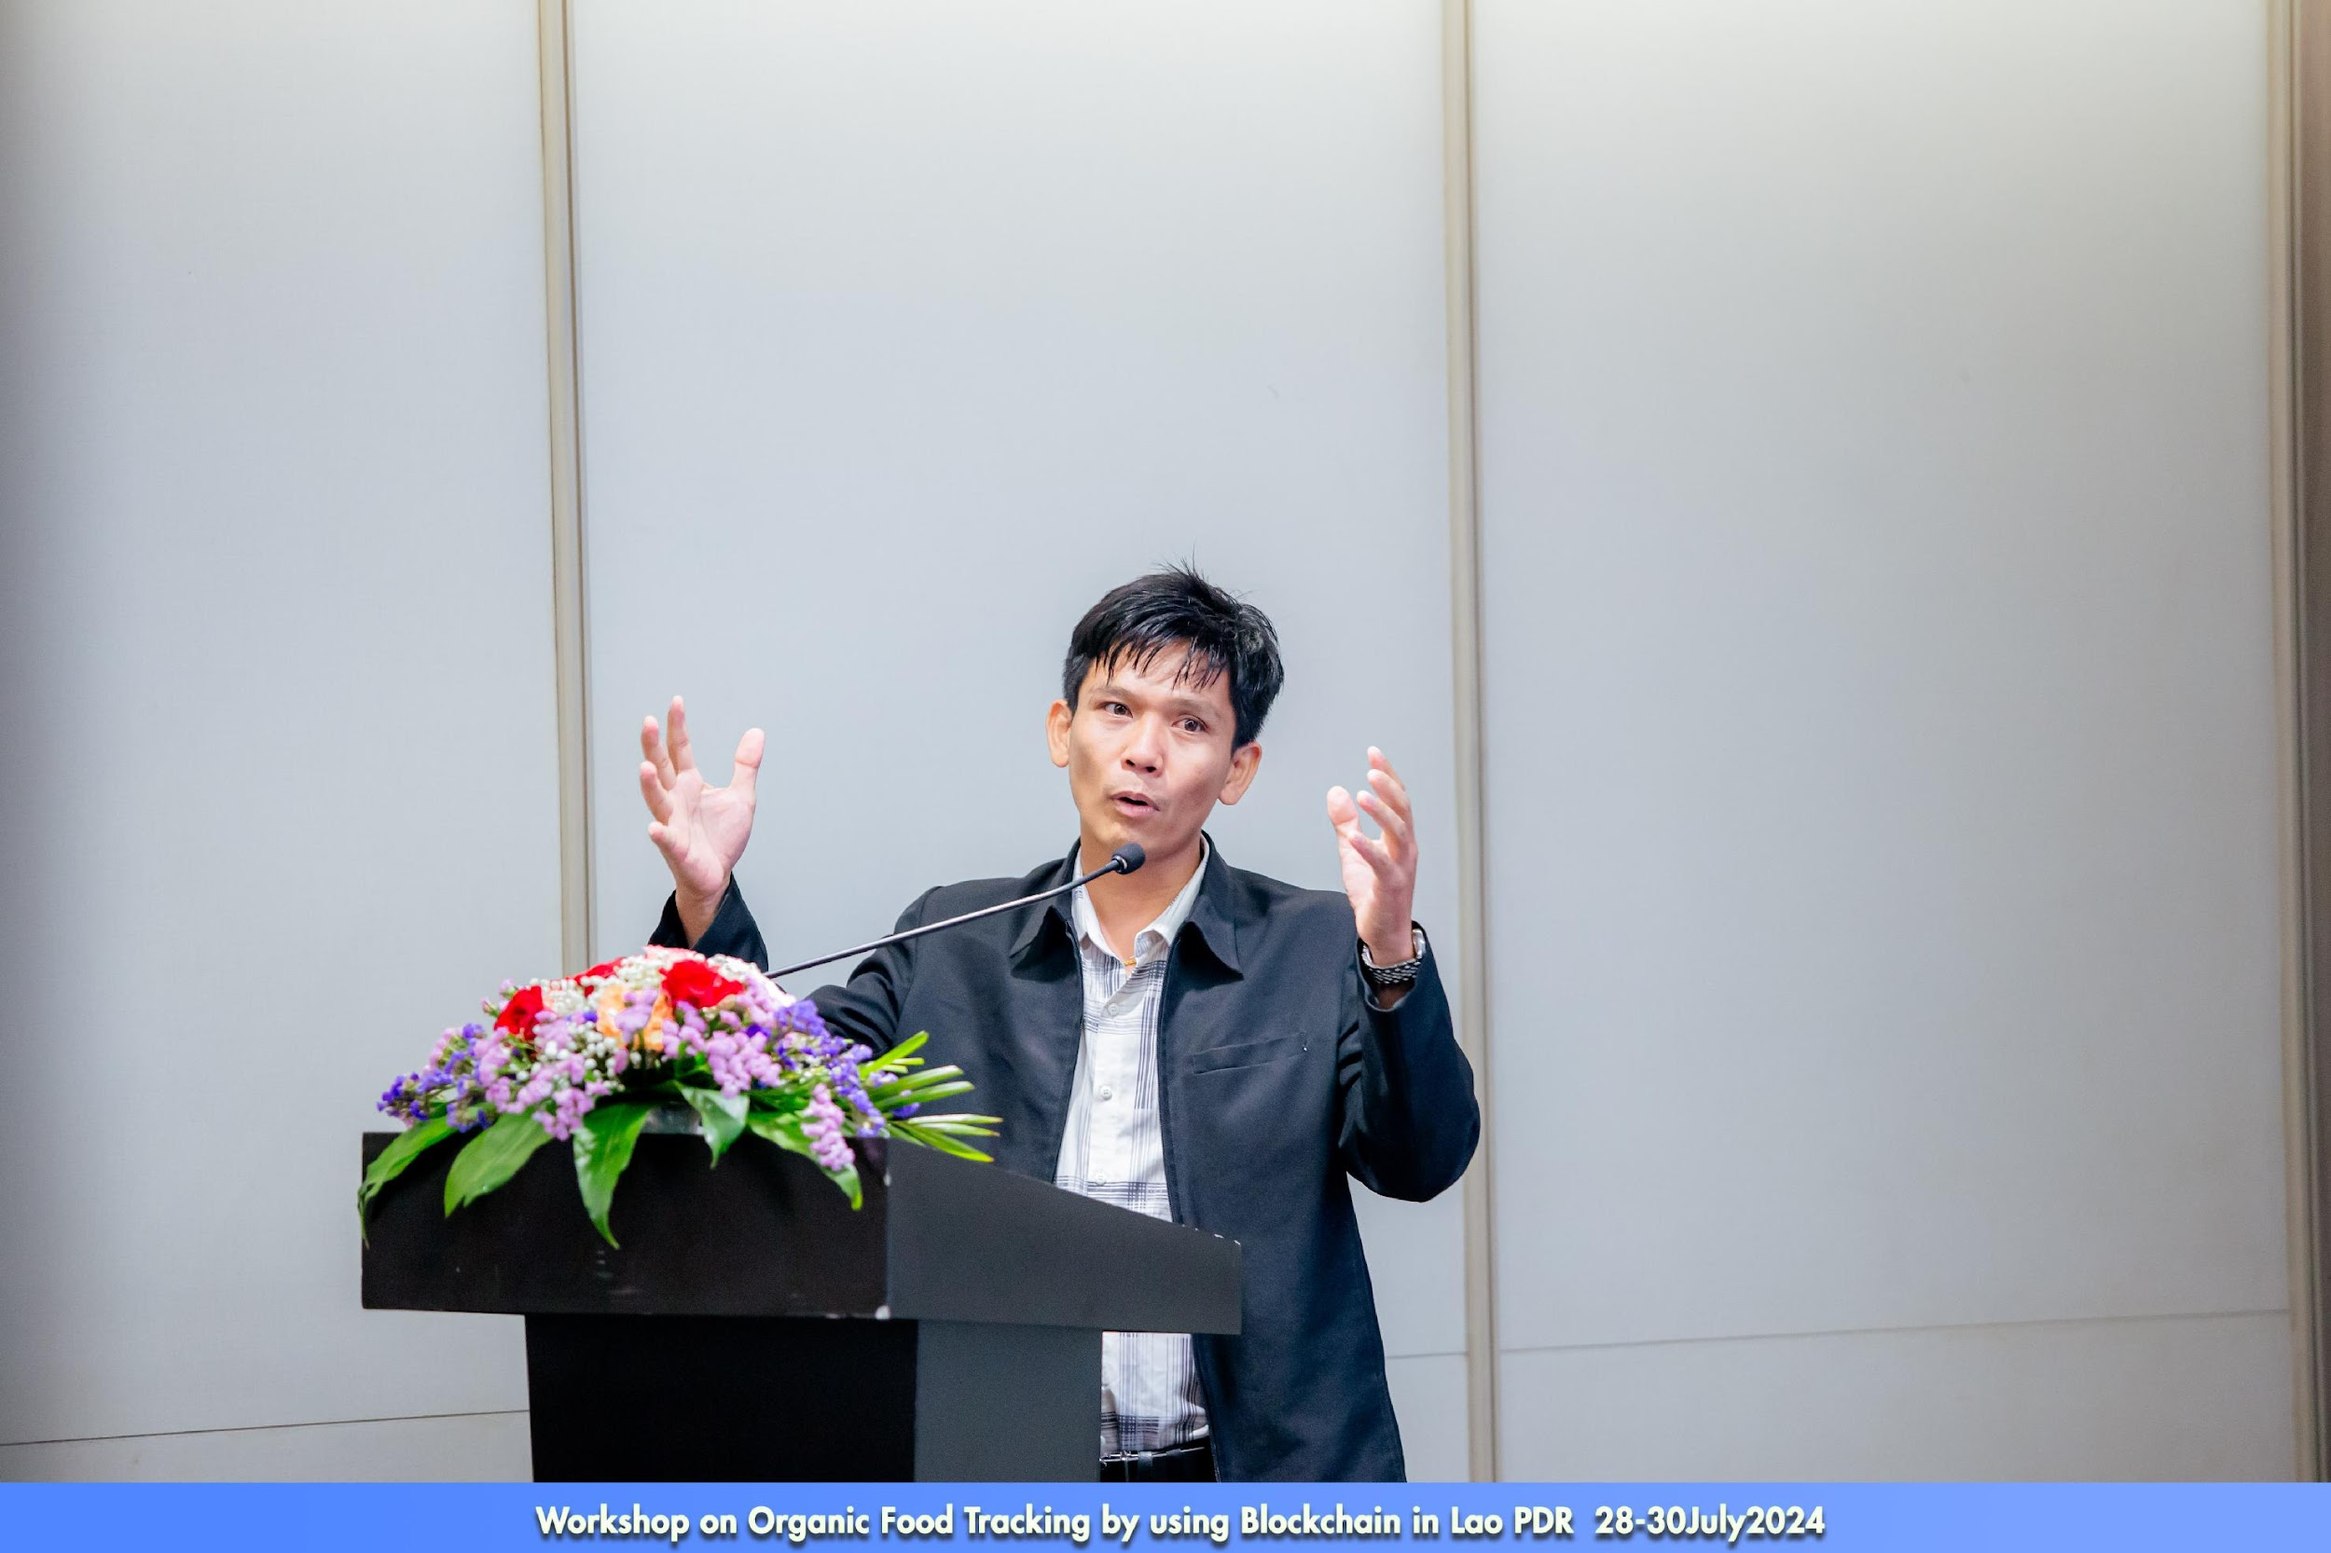
Speaker: clean agriculture standard center, Ministry of agriculture and forest
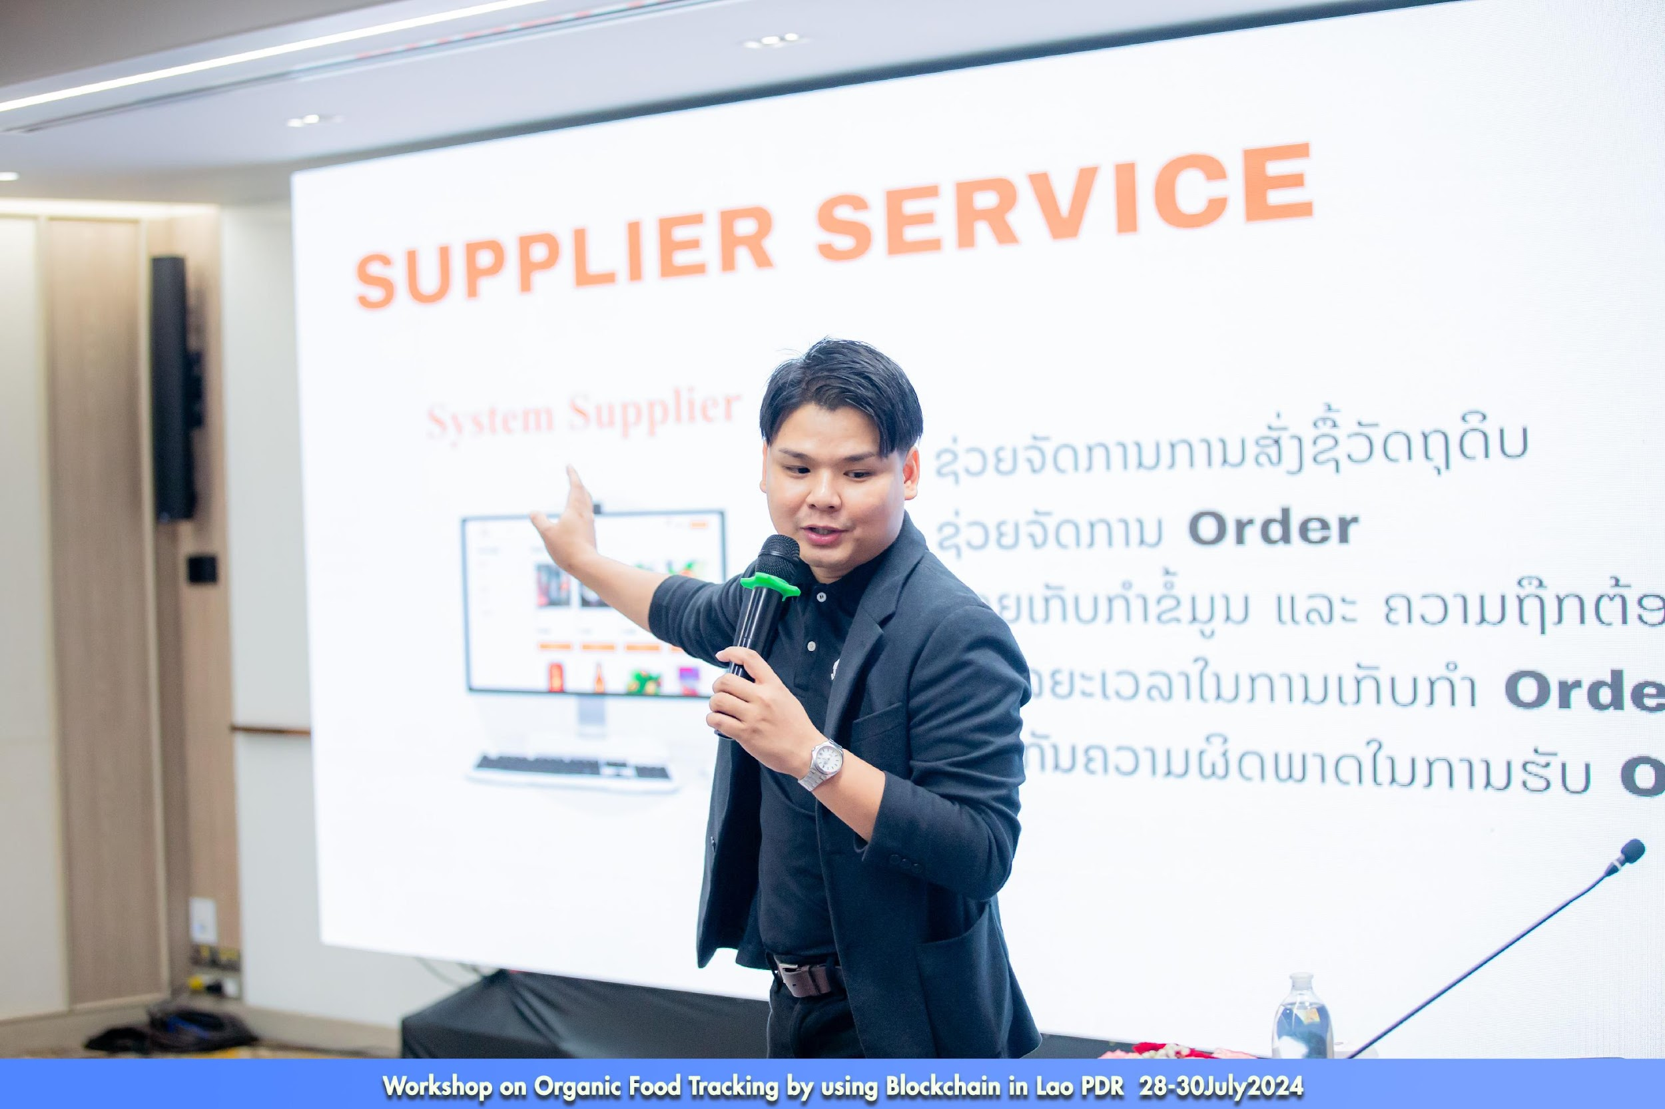
Speaker: Lailaolab
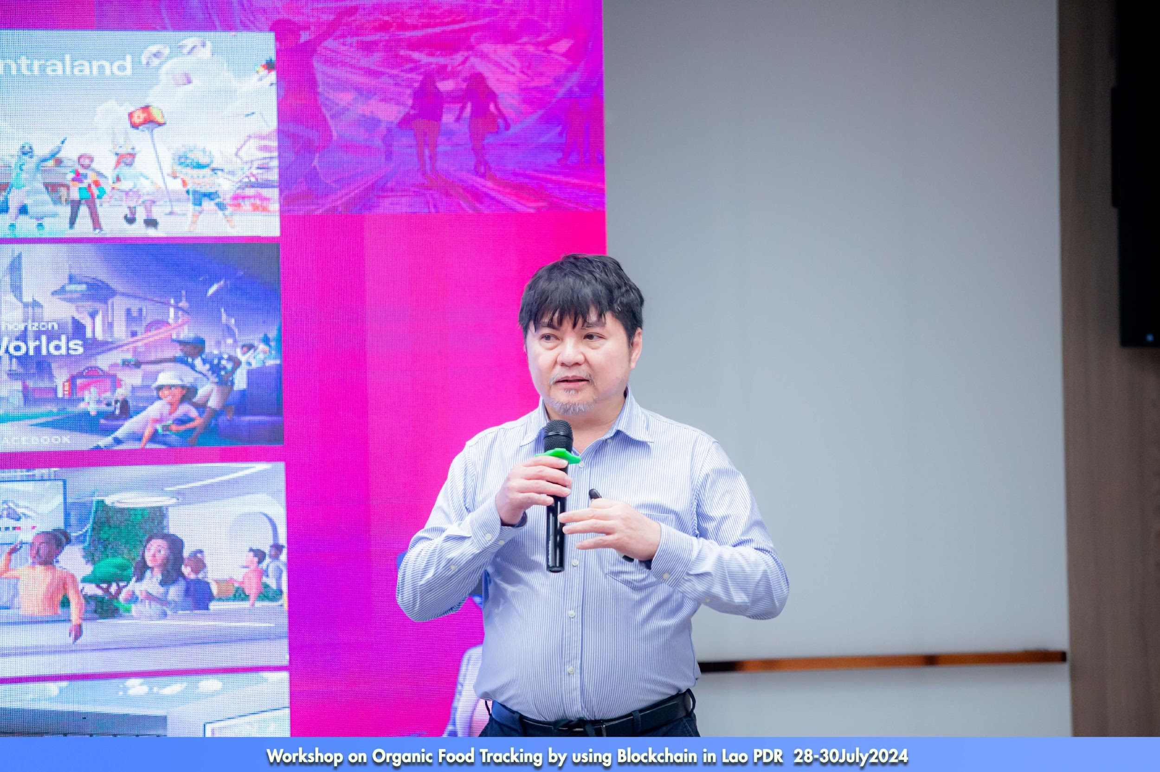
Speaker: CU partner
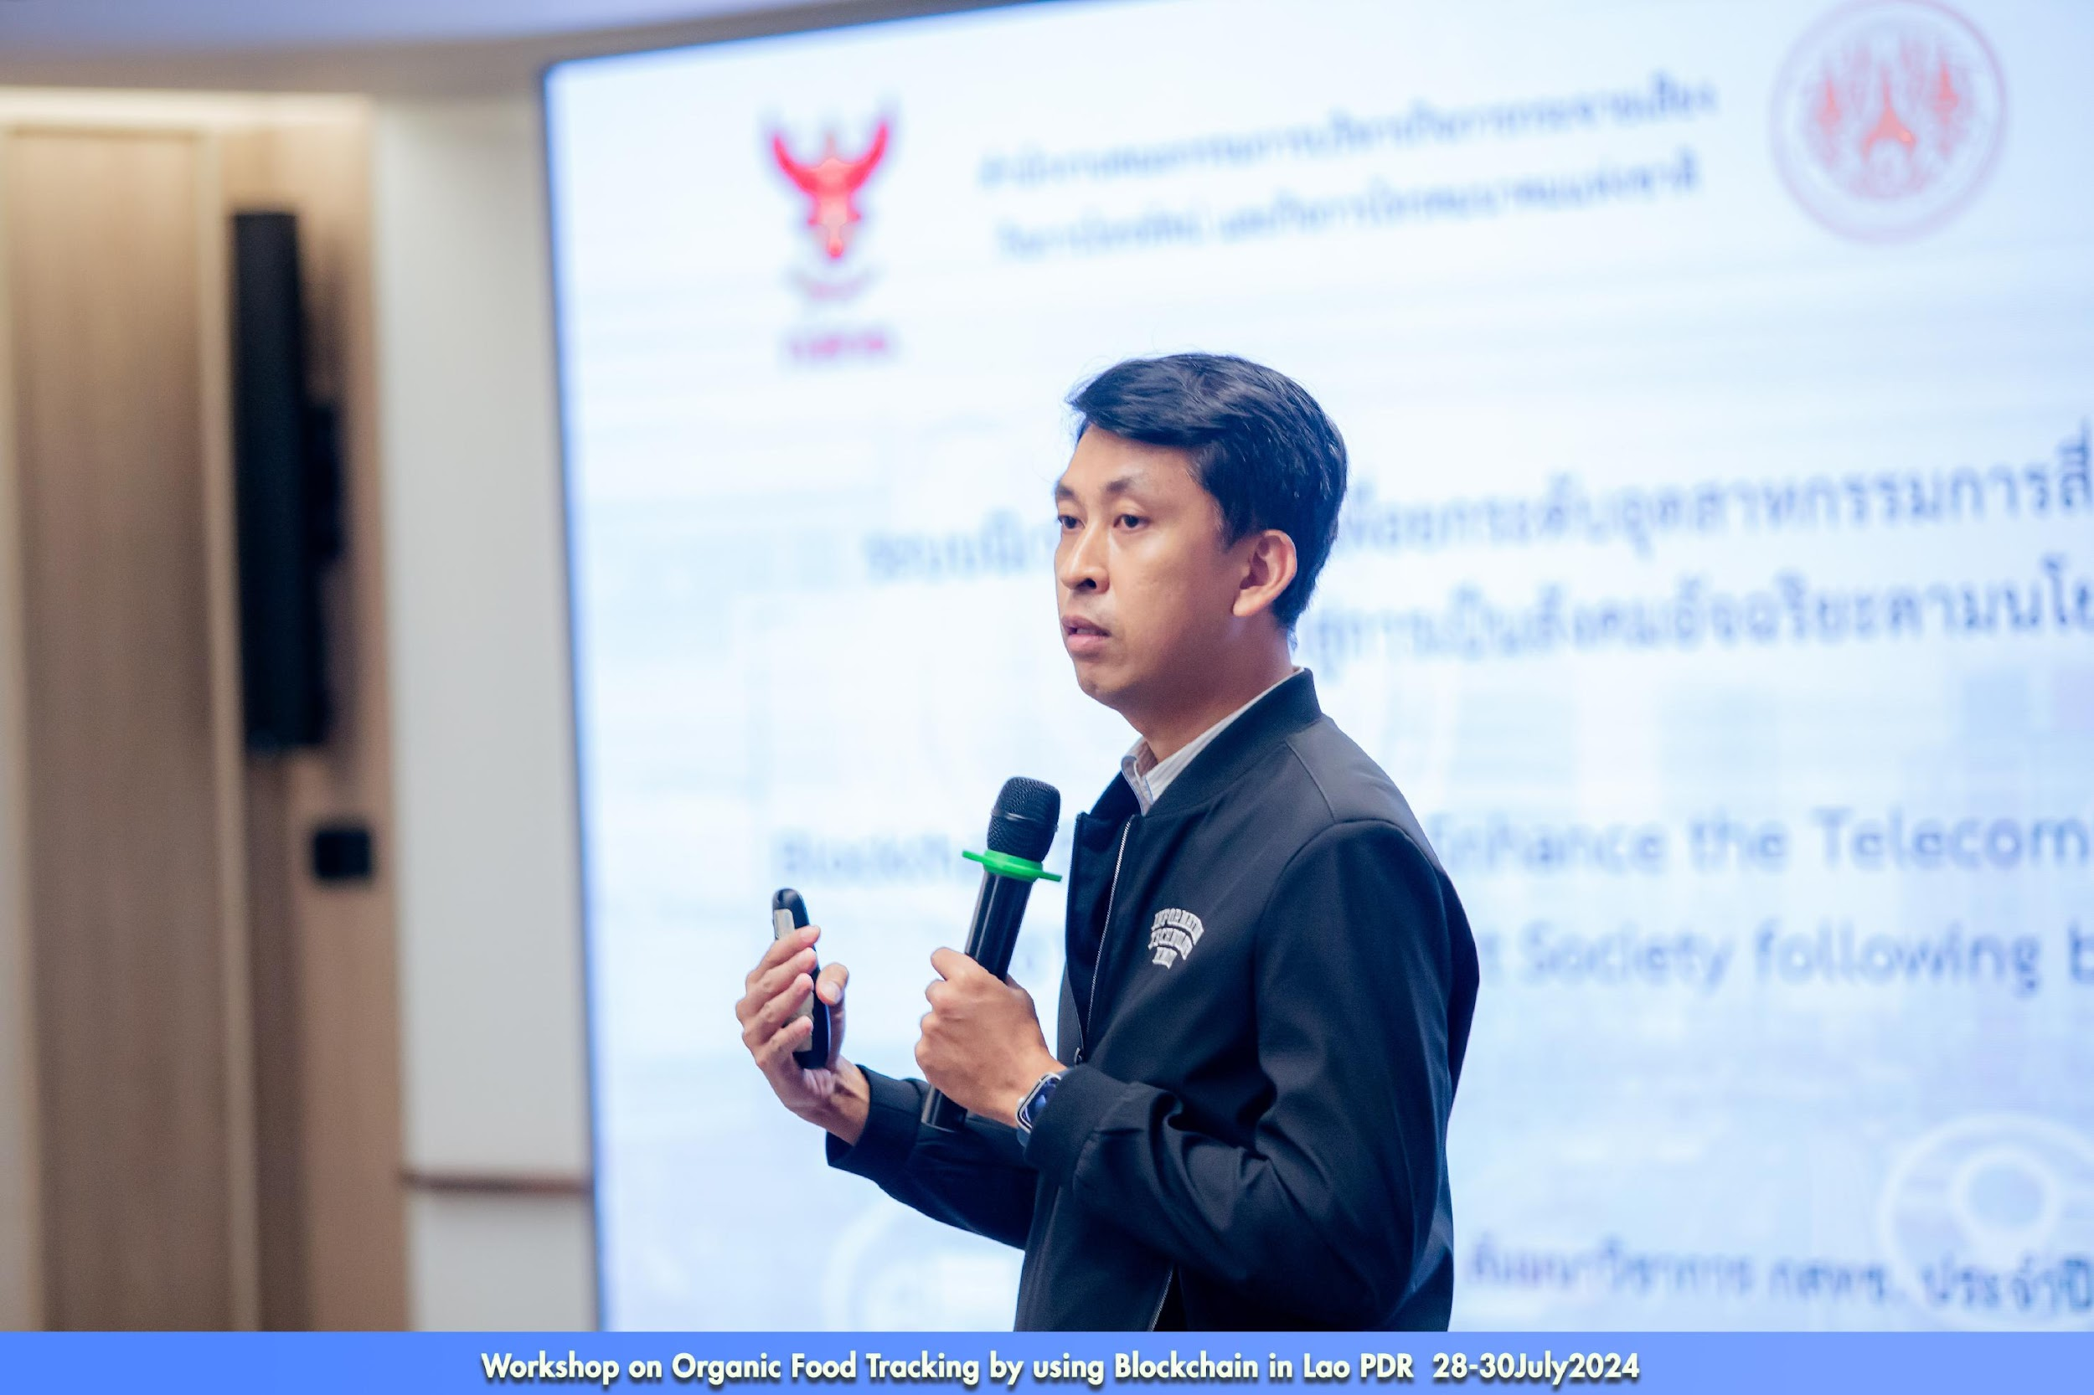
Speaker: KMITL partner
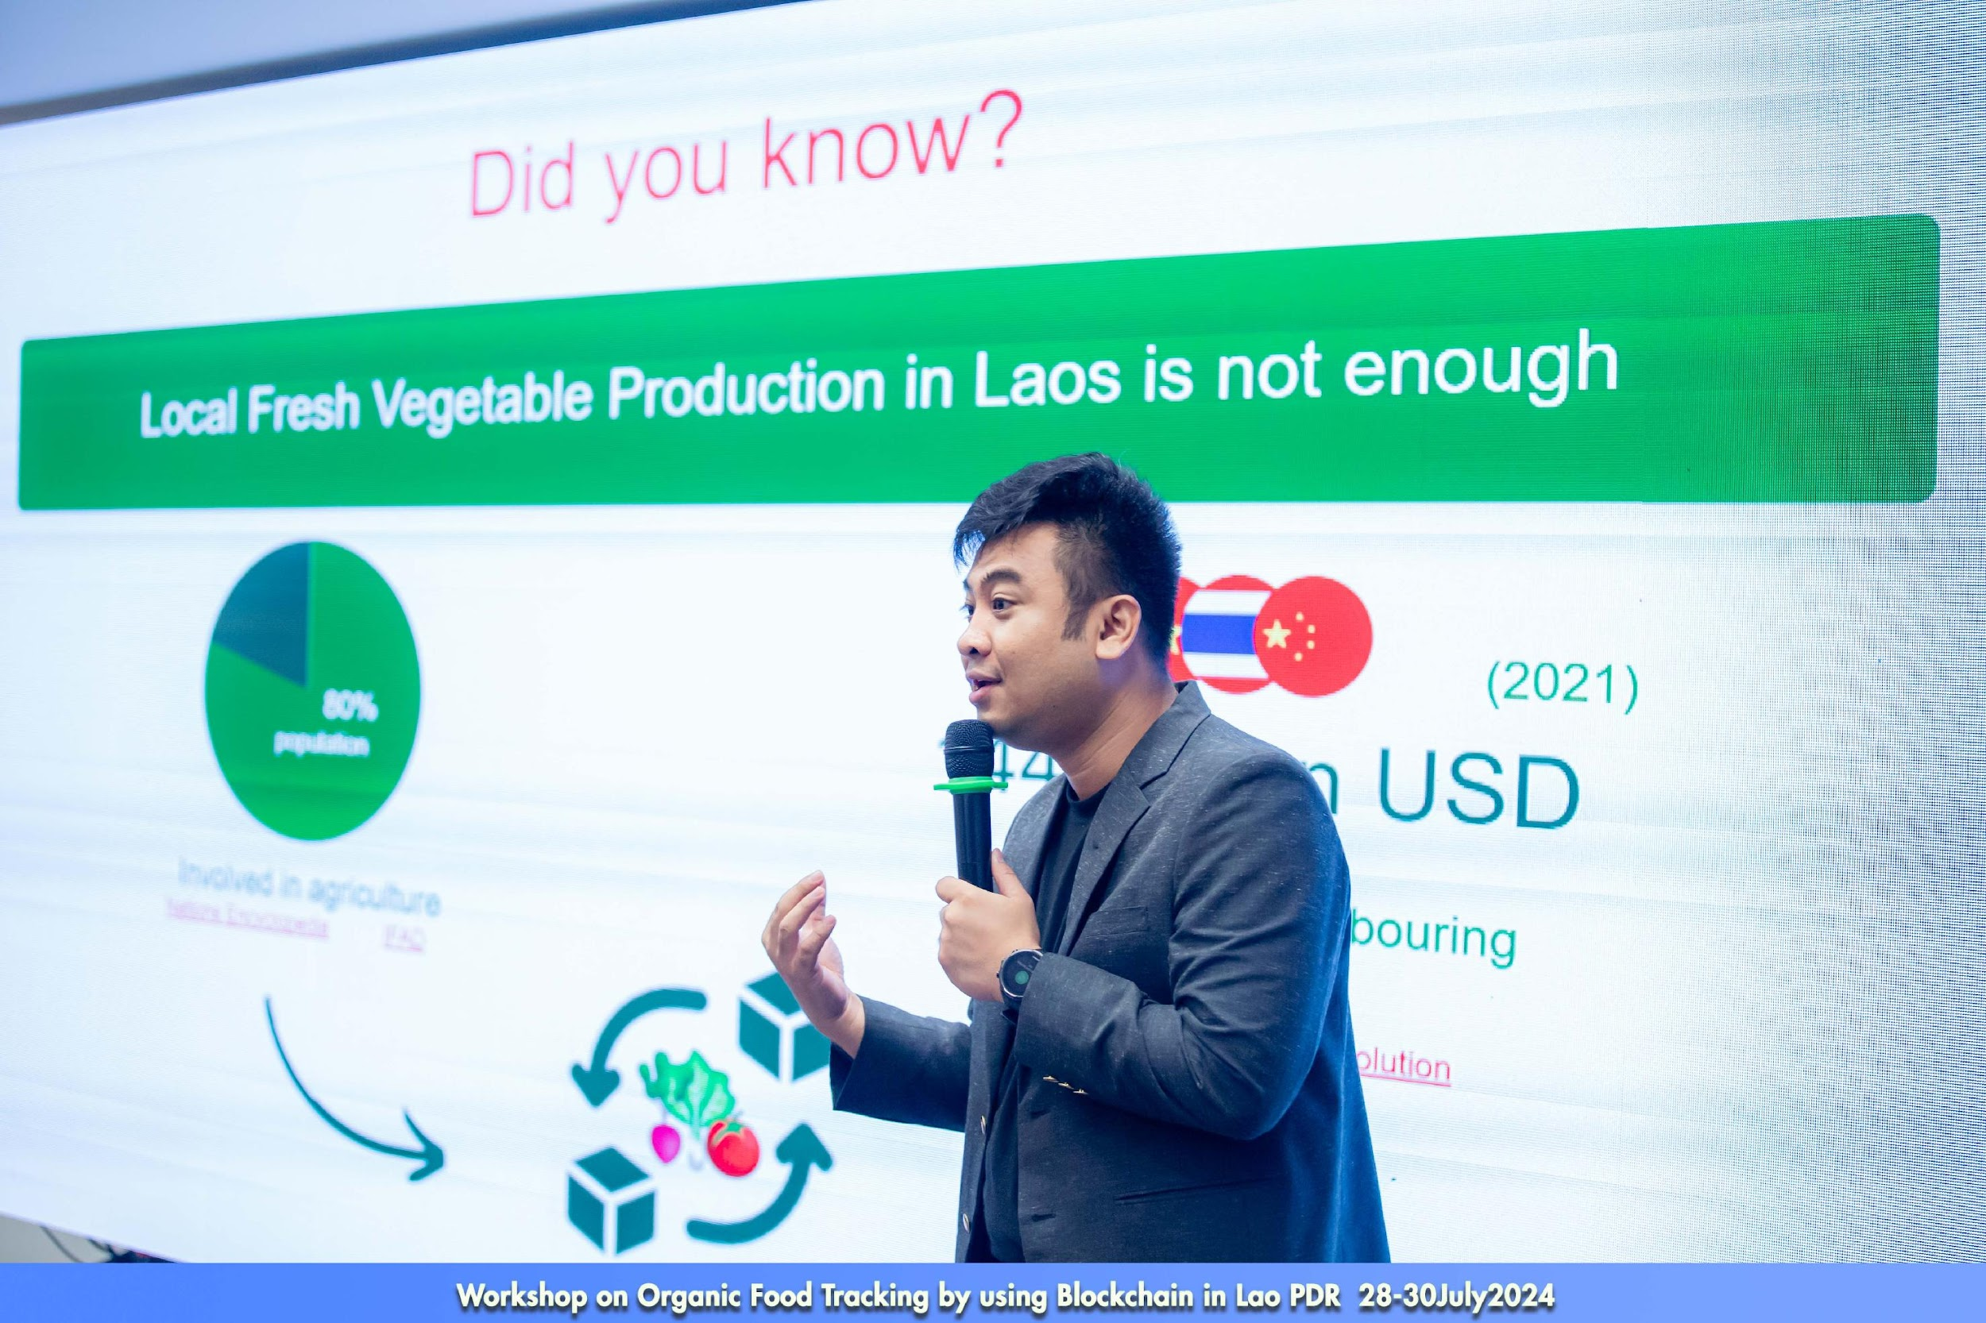
Speaker: Co farm
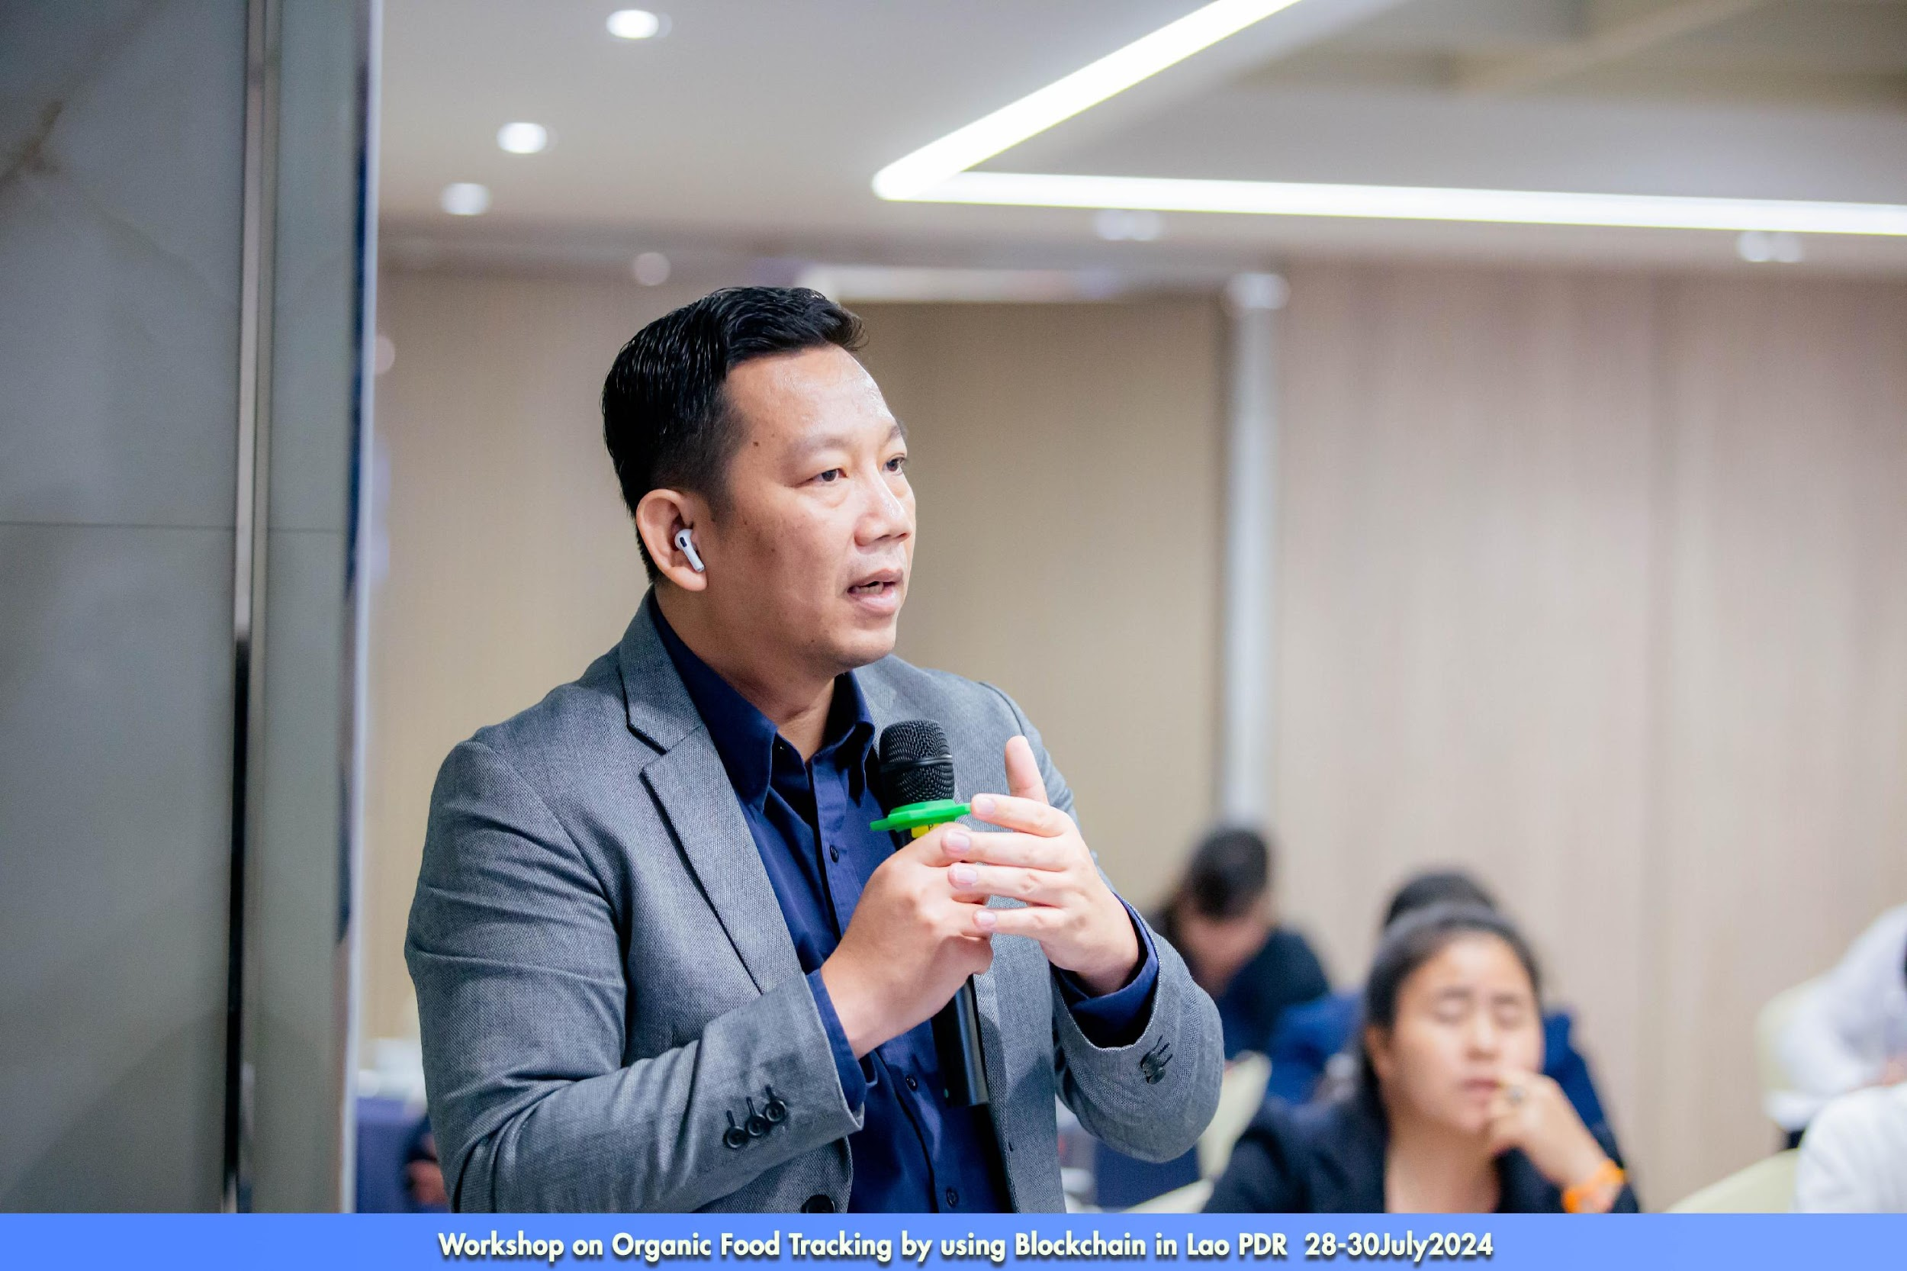
Participant on discussion
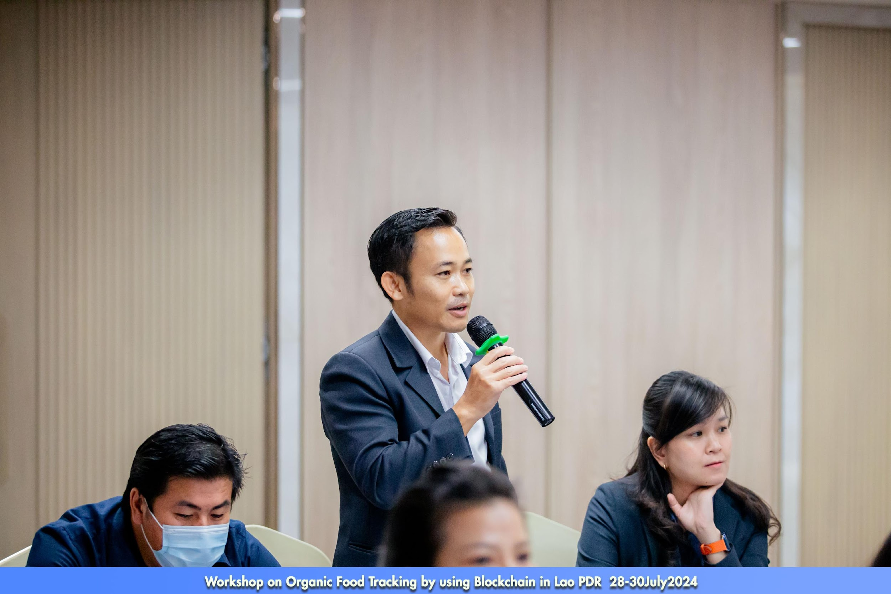
Participant on discussion
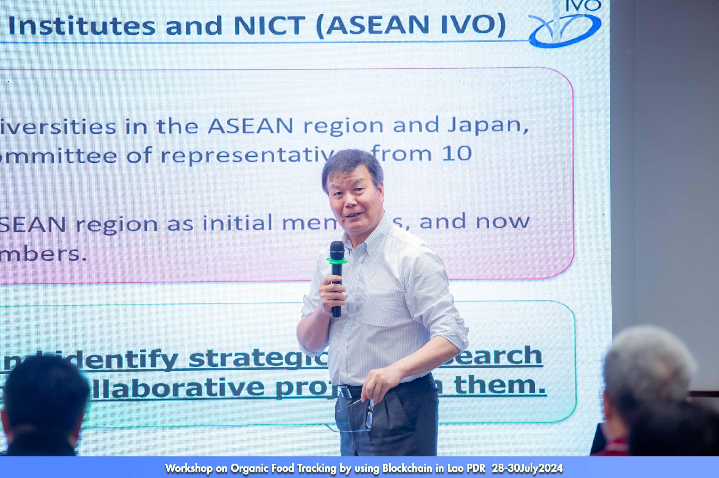
Introduction to ASEAN IVO and NICT
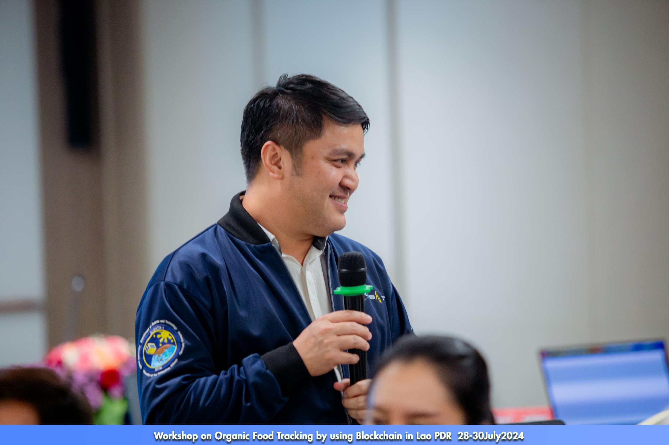
Speaker: Group Discussion- How to apply blockchain to the real world
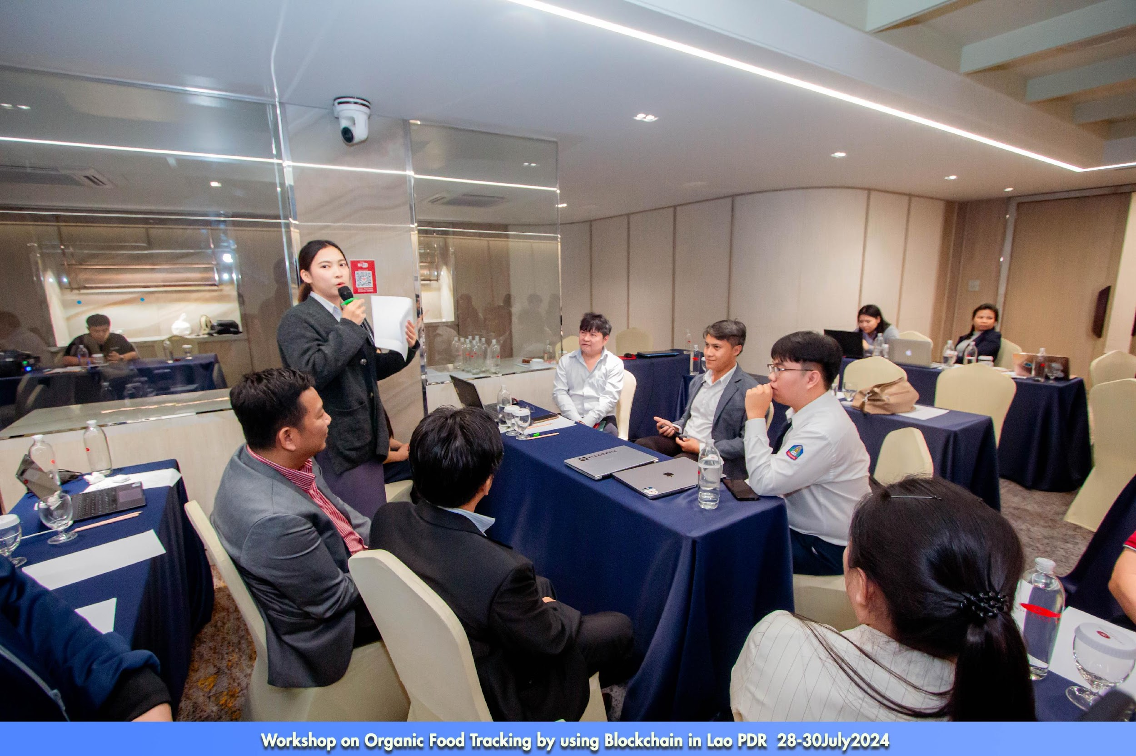
Group Discussion- How to apply blockchain to the real world

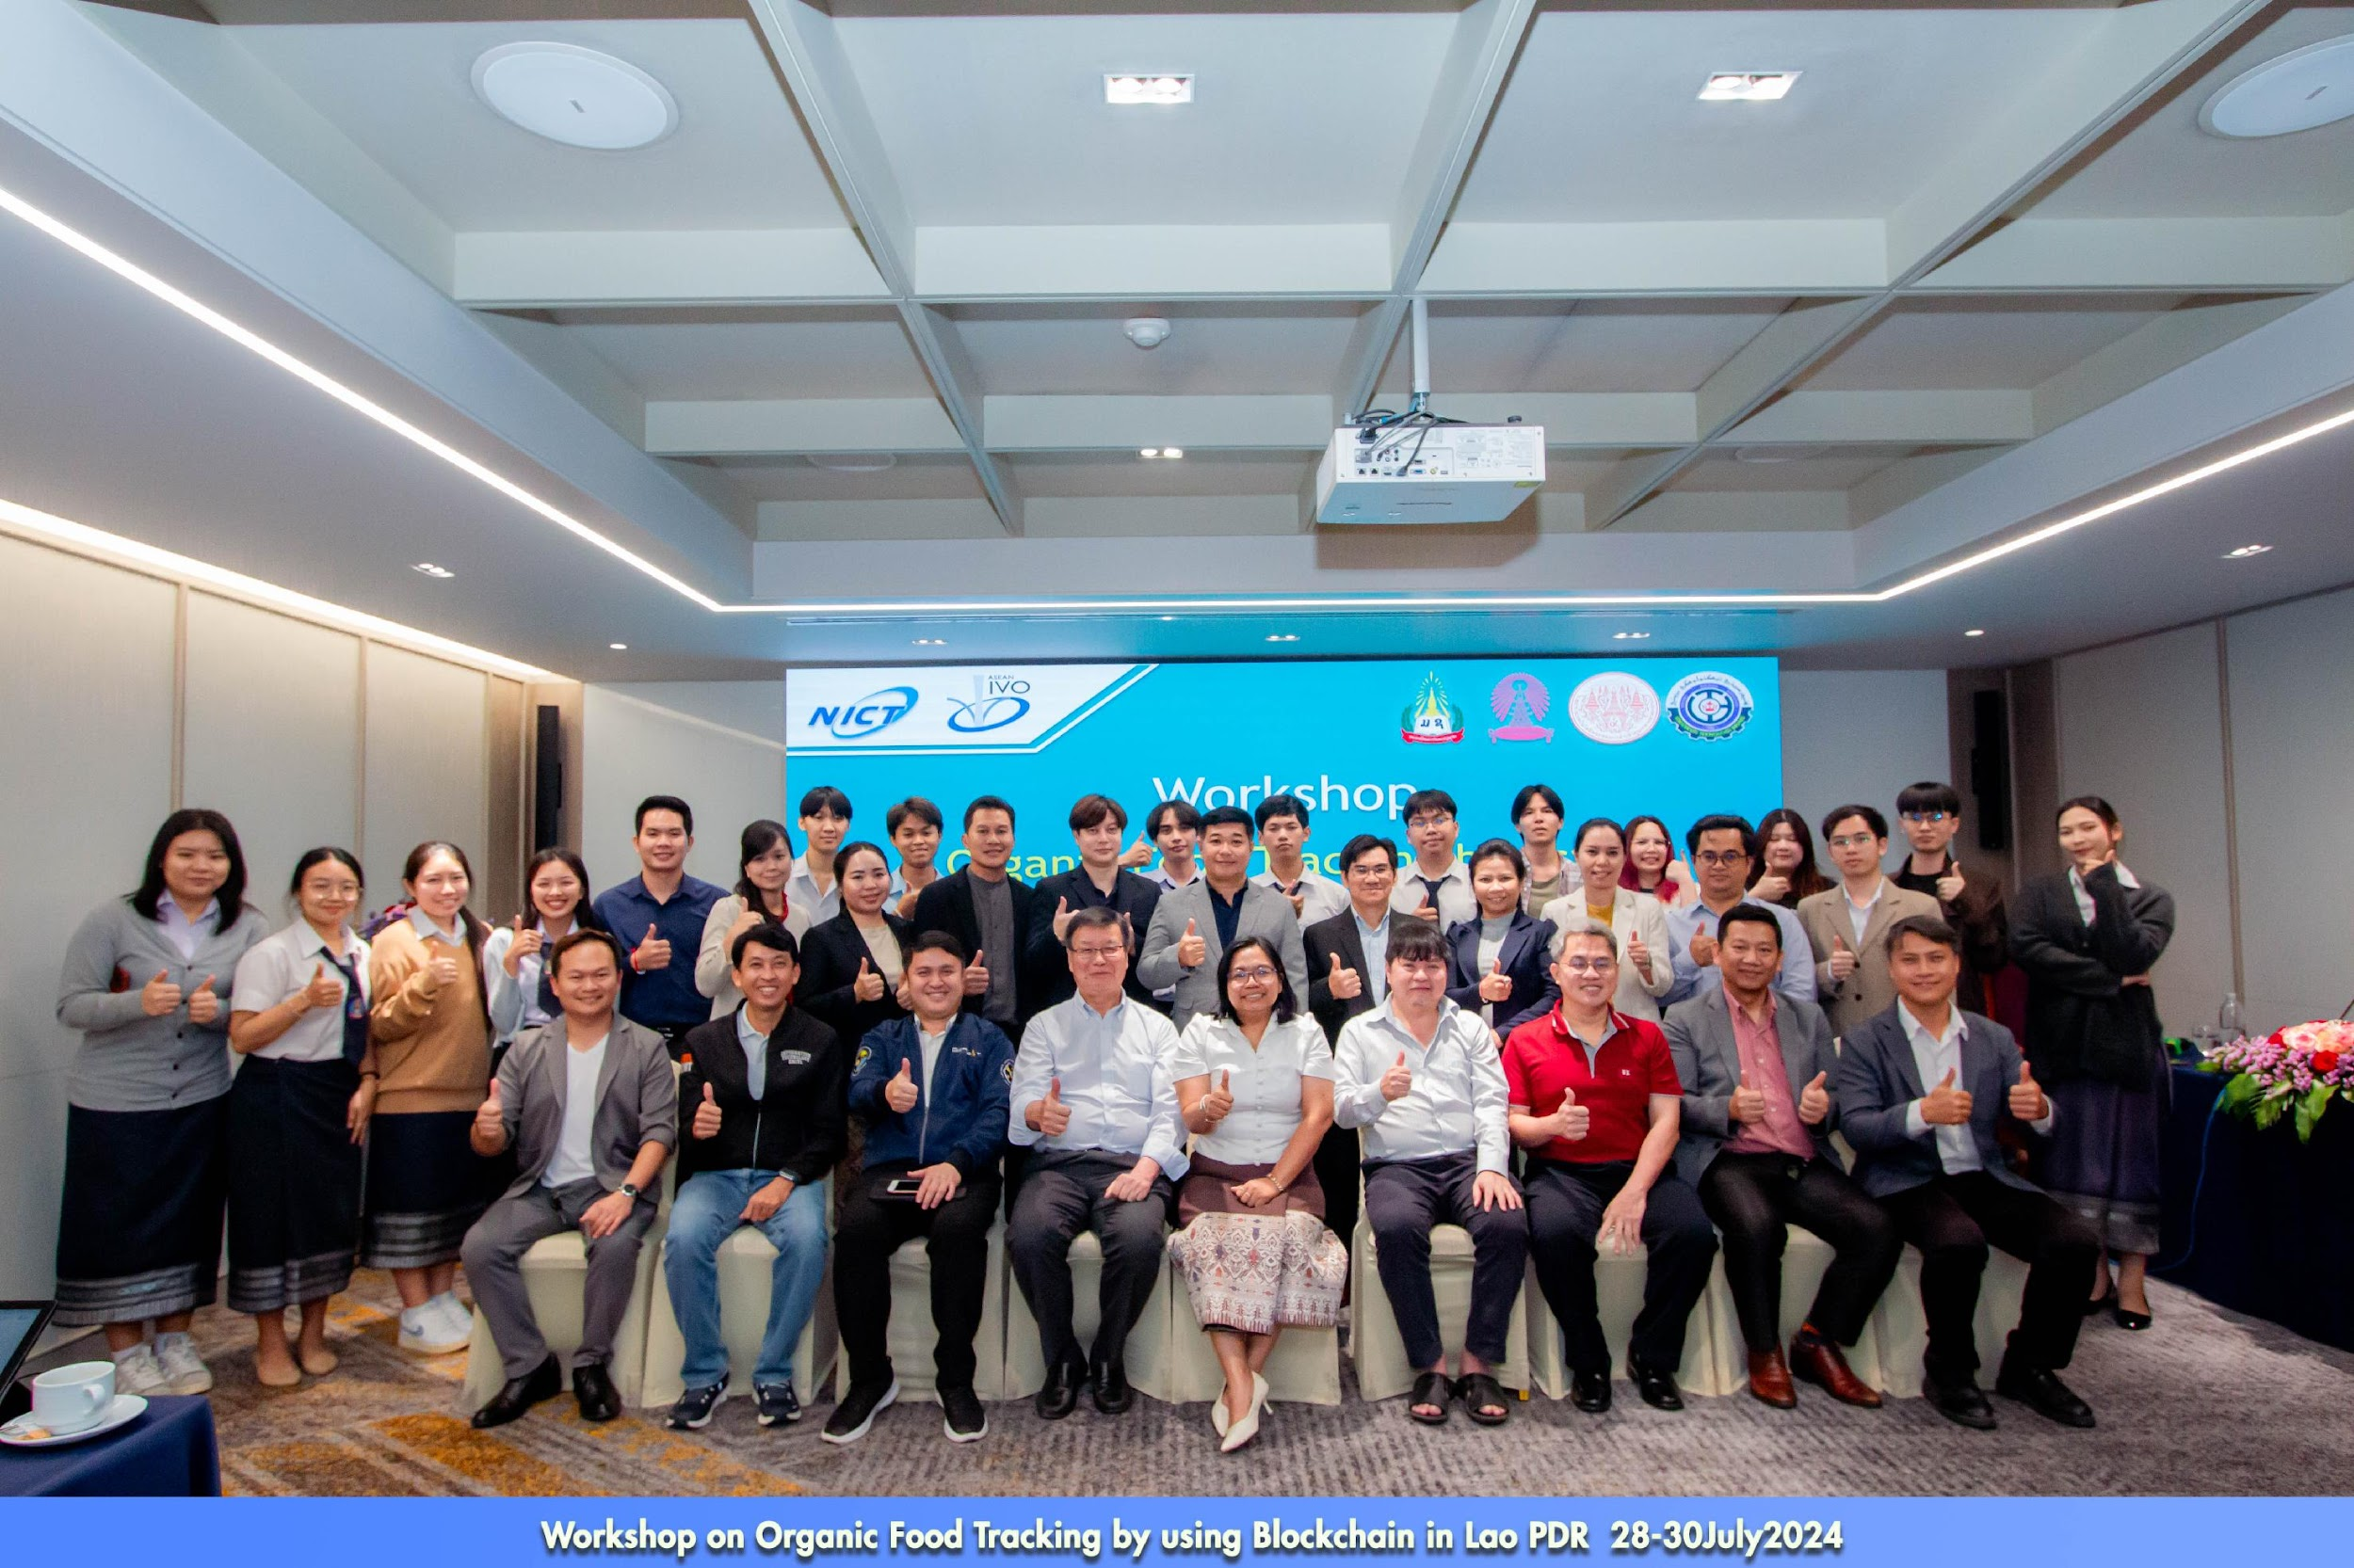

VI. Workshop Evaluation Questionnaire

WORKSHOP EVALUATION QUESTIONNAIRE

Workshop Name: An Organic Food Tracking by using Blockchain in Lao PDR
Location: Lao Plaza hotel, Lao PDR

Date: 28-30July2024

Participant Name (optional): __________________________

Institution /Company name of participant (optional): _________________________

Job Title: __________________________________________

Please give us your comments here:
- Participants appreciated the blockchain training, particularly sessions on Ethereum, Hyperledger Besu, and smart contracts
- While practical sessions were helpful, some participants requested additional hands-on workshops for deeper technical understanding

