Appendix 2.2

Report of International Conference Presentation

Name:  (Presenter) | Chalee Vorakulpipat
Affiliation: | NECTEC
Project Title: | Agricultural IoT based on Edge computing
Name of International Conference:  (Link to website) | IEEE Cyber Science and Technology Congress (CyberSciTech 2023) https://icnetlab.org/cyber-science2023/index.html
Title of Research Paper: | Safeguarding Devices and Edge Computing: A Responsive Anti-Scam Approach
Name of all Co-authors (if any) | Chalee Vorakulpipat, Soontorn Sirapaisan, Montida Pattaranantakul, Soontaree Songserm
Comments or feedback received at the conference:
There are two comments after presentation including-
- It should be applied to data in social media since today there are a lot of data on social media. In fact, it is possible if we can extract metadata from the social media platform.
- The concept needs validation in real environment.
Contribution to the project:
Our study is a component of a larger project aiming to construct an IoT framework based on edge computing, dealing with user identification. Other related papers include review study on security and privacy in metaverse which is a good resource to for secure smart city, self-management for data in IoT, trends in cyberterrorisms (and other cyber attacks), and a study on Steganography Techniques which could be applied for data in edge computing in other media form such as photos.

Photos
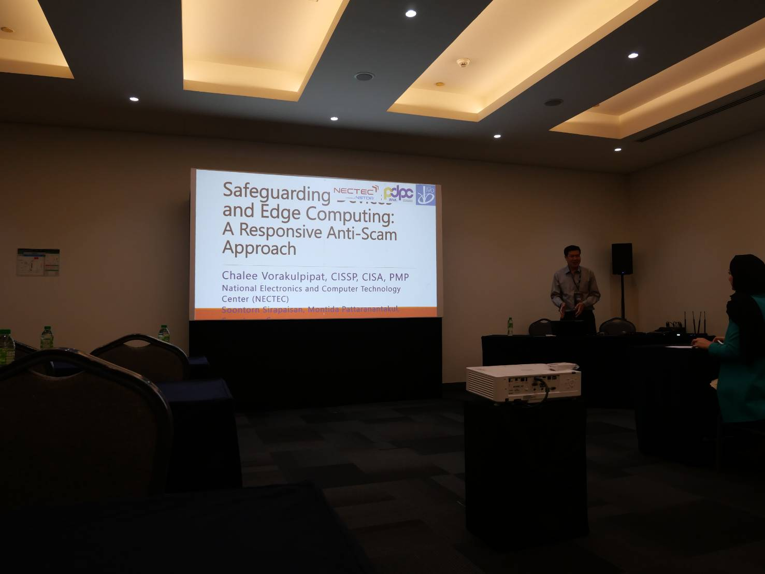

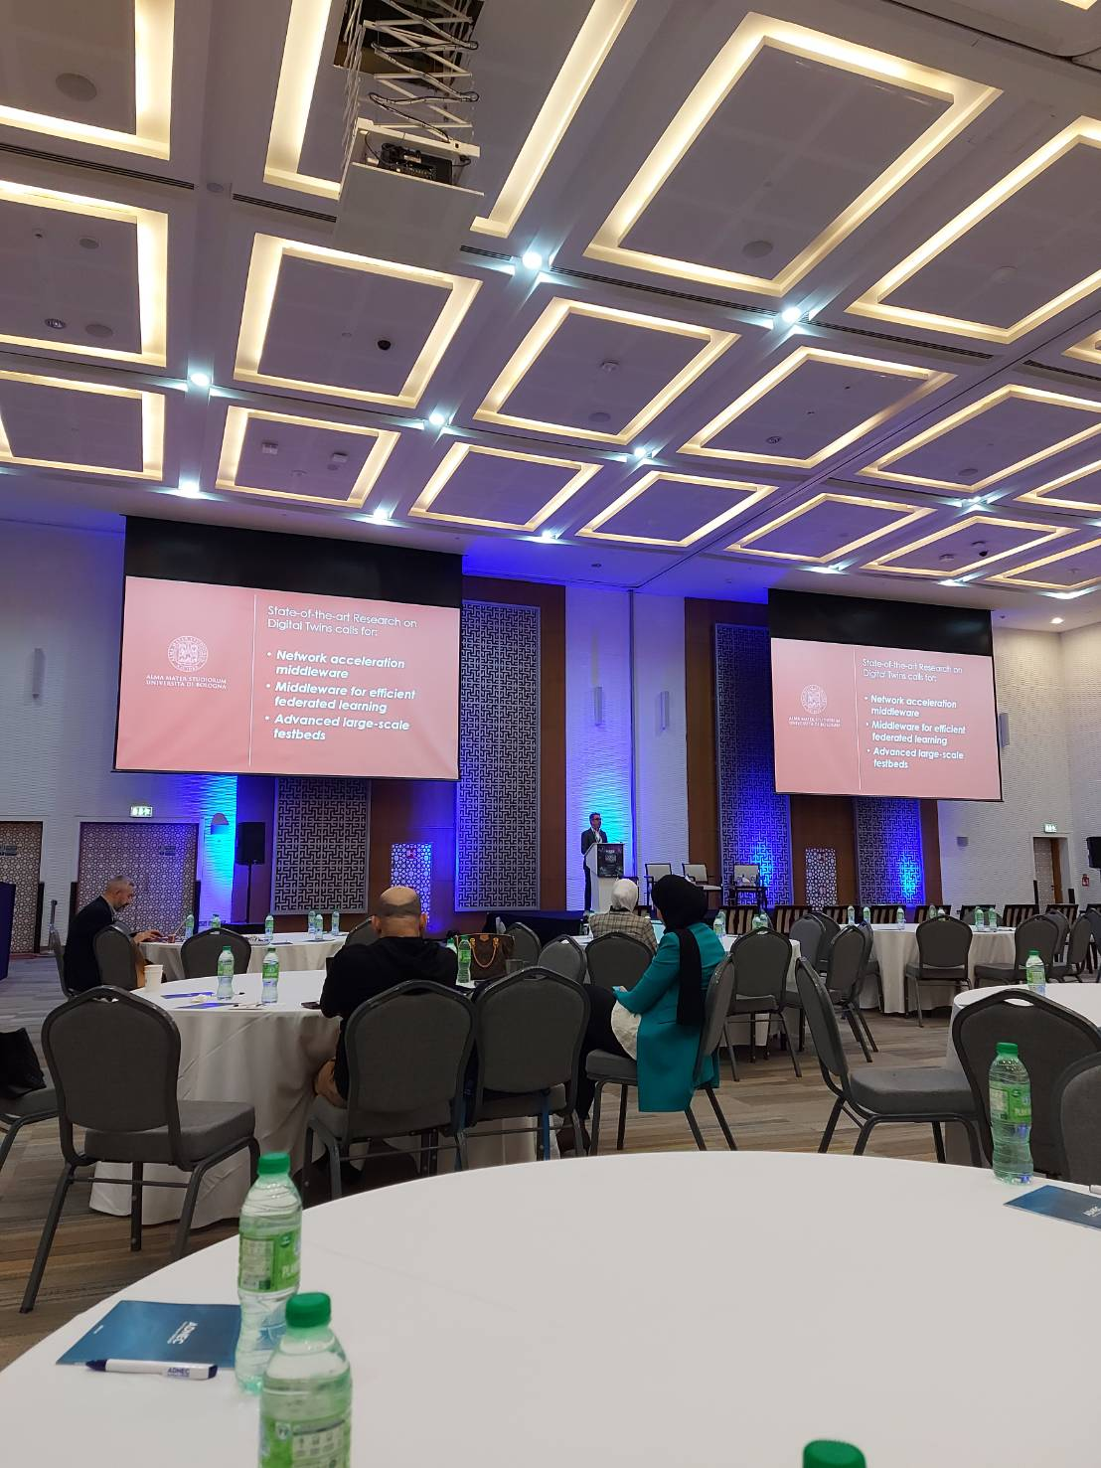

[Required Documents]
- Presentation Materials (e.g. PPT slides)
- Final Program of the conference

Reporter: ____Chalee Vorakulpipat___________
Date: _____21/11/2023_________________

