Appendix 5.2

[P2EI-WEALTH (Physiological and Psychological Edge Intelligence WEArable
LoRa HealTH) System for Remote Indigenous Community and Disaster Recovery Operations]
[Traveling to Field Test Sites & Closed Project meeting]
Report Form

I. Proposer:
Name: | Asma’ Abu Samah
Position: | Project Leader PJ2022-03, Senior Lecturer and academic researcher
Institution: | University Kebangsaan Malaysia

II. Objective:
The main objectives of the 3-days visit are:
- To hold research advancement task coordination meetings and results in analysis between UKM academic researchers and the members from Mapua University and GTek enterprise.
- Malaysian researchers to conduct site visits to QCDRRMCO-identified sites and monitor the management of wireless communications and network performance tests related to LoRa/LoRAWAN.
- GTek will demonstrate the LoRa operation for an emergency response using two P2EI-WEALTH devices and a data center.
- To evaluate the developed system's functionality in realistic environments to be applied in Malaysia

III. Schedule:
Date | Location | Work | Person in charge
Nov 9 | 8.15 - 12.15 | Flight Kuala Lumpur International Airport 2 - Manila Ninoy Aquino Airport (Air Asia) | UKM
 | 12.15 - Night | Settling down with assistance from MU | UKM
Nov 10 | 8.30 - 10.00 | San Sebastian Basilica IoT Project visit | Reginald Juan Mercado
 | 10.00 - 12.45 | Project advancement meeting and GTek demonstration at the Bayleaf hotel + preparation for ASEAN-IVO Forum 2022 | All
 | 12.45 - 14.00 | Lunch with Higher Management of MU | MU
 | 14.00 - 17.30 | QCDRRMC Office visit in Quezon City | MU
Nov 11 | 8.00 - 9.30 | Casual meeting over breakfast with colleagues from MU | MU
 | 9.30 - 11.30 | MU Visit | MU
(Note: describe the final schedule here)

IV. Participants:
No. | Name | Organization
1 | Asma’ Abu Samah | UKM (Team 1) | 9-11th November 2022
2 | Rosdiadee Nordin | UKM (Team 1) | 9-11th November 2022
3 | Nor Fadzilah Abdullah | UKM (Team 1) | 9-11th November 2022
4 | Jennifer Dela Cruz | MU (Team 2) | 9-10th November 2022
5 | Glenn Magwili | MU (Team 2) | 9-10th November 2022
6 | Reginald J. Mercado | GTek (Team 3) | 9-10th November 2022
(Note: please add a participant list if there are a lot of people participating)

*Xarjes C. Alejos couldnt join as he was away due to family matters.

V. Summary of the activities corresponding to the objectives
(Note: Describe, in detail, the activities, e.g. how to install the equipment, maintain the equipment, train local researchers for data collection, etc.)

The summary of the activities can be structured based on the objectives set for the visit.

- To hold research advancement task coordination meetings and results analysis between UKM academic researchers and the members from Mapua University and GTek enterprise.
  - During the meeting, we discusses the progress that are happening on Malaysia and Philippines side.
  - Malaysia has conducted its LoRa implementation in parallel with another project funded by ISIF-ASIA in Tasik Chini. We have identified an optimized placement of Gateway based on drive test. Malaysia has also established the communication with 3/7 villages consisting of indigeneous people from Tasik Chini.
  - Malaysian side is still waiting for ethics approval to conduct full test with P2EI device in Tasik Chini.
  - GTek demonstrate and update the development of the device to us. 2 devices were mounted and basic functionalities and display has already been tested. Still short on identifying the most suitable battery. Will try to finish by end of January.
  - Discussion on how to reproduce the other 8 prototype for testing purposes in Tasik Chini. Basically UKM will handle the purchase of components, GTek and MU will oversee the production by another company. Once ready, MU will ship to Malaysia.
  - GTek and MU has given their agreement to come and Visit Lake CHini to have a look at the full testing in March. UKM will handle the Field Test trip.
  - Go through the presentation for ASEAN-IVO Forum 2022.

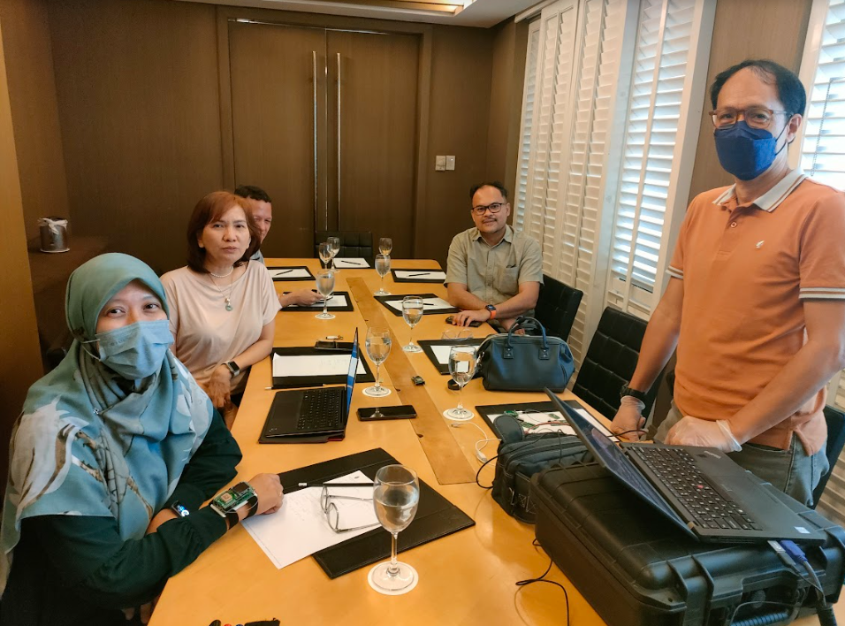
- Malaysian researchers to conduct site visits to QCCRRMCO identified sites and monitor the management of wireless communications and network performance tests related to LoRa/LoRAWAN.
  - Quezon City is located on the Guadalupe Plateau, just northeast of Manila, in the Philippines. It is actually the largest city in the Philippines. It has a population of 2.96 million people. Traversing in the City's eastern portion is a fault line called the Marikina Valley Fault System, identified as one of the country's most active faults. 7 out 21 kilometers of the fault line pass through Quezon City, making 9 local communities or around 15,800 families vulnerable to earthquake risks. We have received many more information on statistics on the different disaster covered continuously by the office.
  - Unfortunately we couldn't visit any sites due to the rainy weather in Quezon City. Typhoon just hit areas close to Quezon City 3 days prior to our visit.
  - We have specifically made a visit to 2 departments in the QCDRRMC Office which are the emergency operation centre and the medical intervention centre.
  - In the emergency operation centre, we were briefed on the whole existing monitoring system. Minus the surveying cameras, most of their monitoring system are already embedded in the web. Public can also have access to their data. But they managed the post and correlated analysis to inform the public over any potential risk. They are more than happy to have our system complements their monitoring system.
  - We have also conducted informal surveys on how they manage the operation and how they are psychologically effected by events happening in Quezon City. Most valuable information is that they are specifically stressed when there are events, and mostly due to the coordination task between the different layers of stakeholders. We can benefit from the device to measure how much the coordination procedures can effect the staff in the operation centre.
  - One of the rescue mission that we overlooked is the management of mosquitoes to the public.
  - In the medical intervention centre, surveys were also conducted and on top of that, Mr. Mercado has demonstrated the device. We have gained some valuable feedback from the team such as i) it is true once there are events such as flood, earthquake, heavy rain, connection can be lost, ii) the team have totally different stress situation as compared to those in the operation centre, iii) most relevant use of the device is to monitor those who cannot be rescued immediately but their vital measurements are crucial to be continuously reported, and iv) They mention the importance of having a good battery life.
  - The office houses many different type of rescue vehicles.

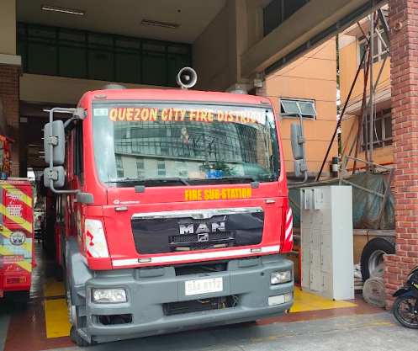

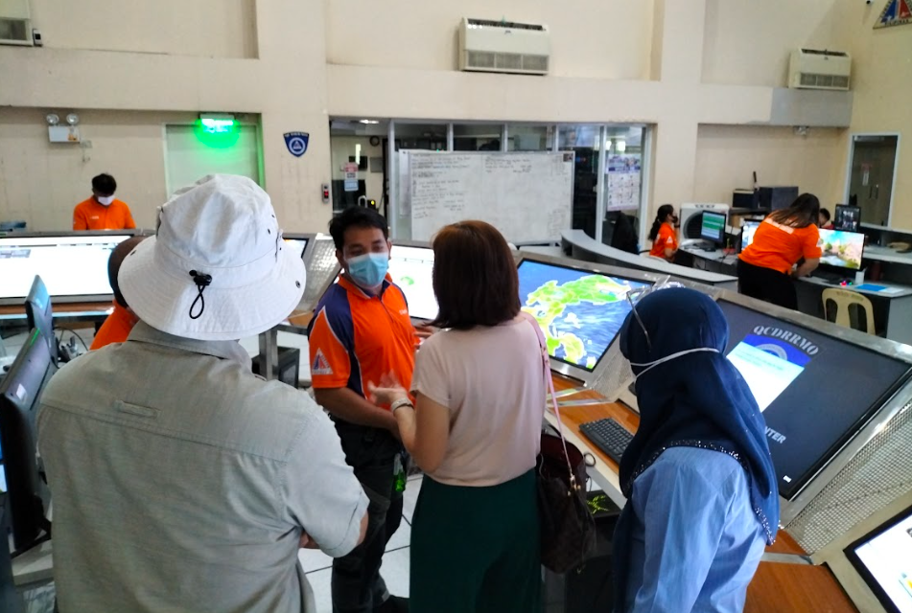

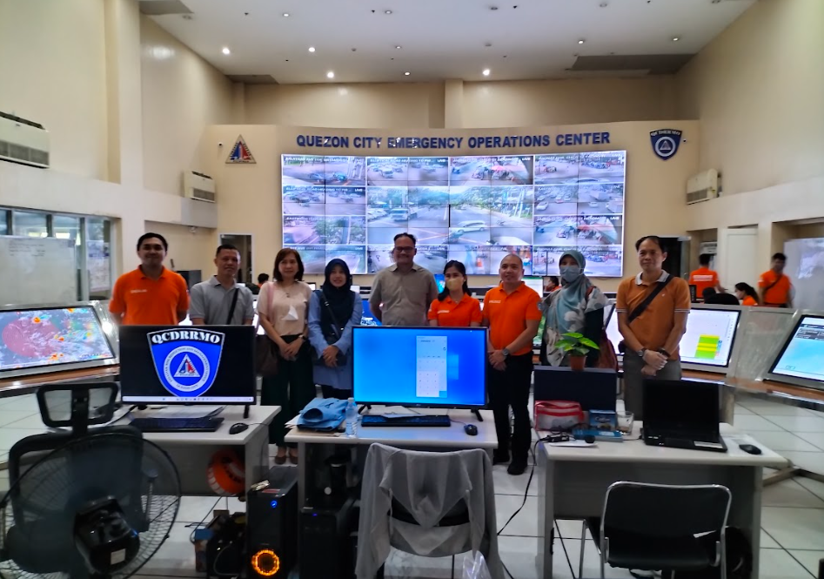
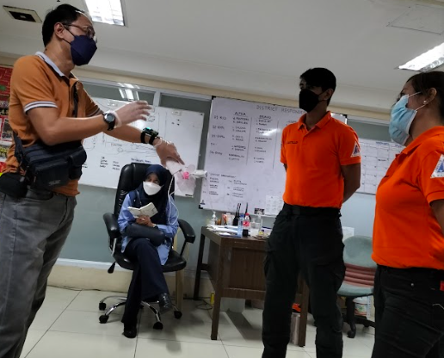

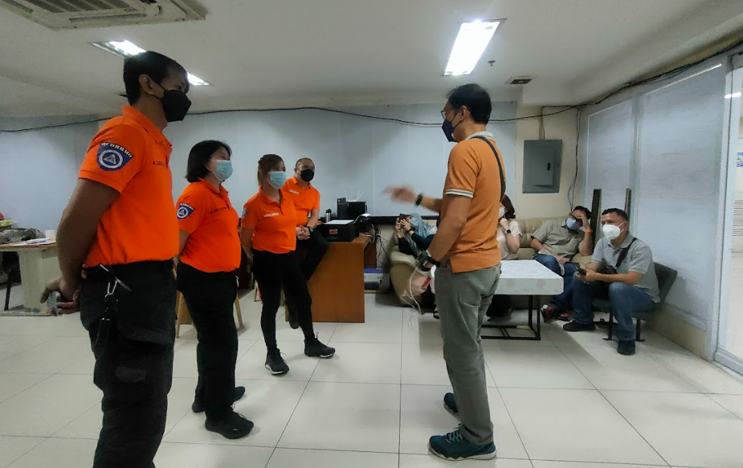

- GTek will demonstrate the LoRa operation for an emergency response using two P2EI-WEALTH devices and a data center.
  - We have seen how the P2EI device operate and how it is connected to the datacenter. At the moment the data center is built from scratch using Phyton basic libraries. UKM will explore the use of OpenSource Cloud services to support the monitoring purposes.
  - At the moment, the battery is not fully integrated. GTek is trying to identify the best solution for the battery.
  - The Galvanic Skin Response probe was not connected as well so we cannot see the demonstration on that.
  - We couldnt conclude on the validation strategies and will be the focus of our next meeting.
  - The picture depicts the real size device which have 2 functioning layers. At the same time, the device can be halved to optimize the size, but it is not the focus of this phase of the project.

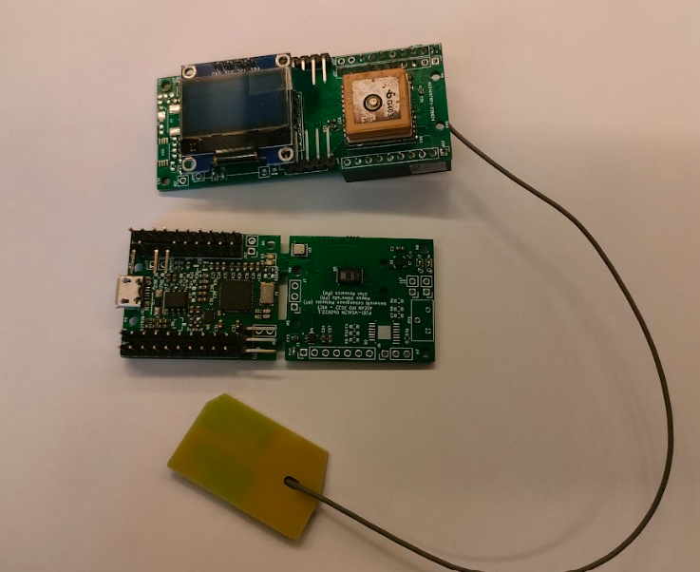
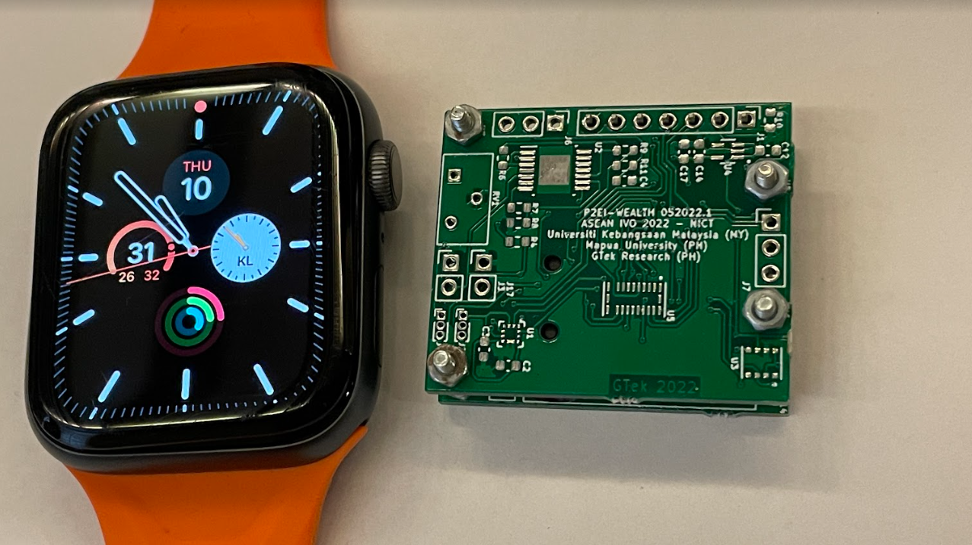
- To evaluate the developed system with its functionality in realistic environments to be applied in Malaysia
  - The system is suitable for Malaysian environment as well.
  - We need to finalize the validation strategies together.
  - We hope that we can come up with good battery solution before end of January 2023.

VI. Others
If any.
(It is best if you put pictures here)

On top of the objectives met throughout the visit, we are lucky to be able to do 3 extra activities.

- A visit to San Sebastian Basilica IoT Project developed by Mr. Mercado. The project consisting of temperature and humidity sensors to correlate with the corrosion happening to the church which is noted for its architecture. It is the only steel building church in the Philippines. It was designated as a National Historical Landmark in 1973 and as a National Cultural Treasure in 2011. We were briefed by the head of the restoration group for the Church and have a visit on the instalation throughout the church. The system is connected through LoRa.

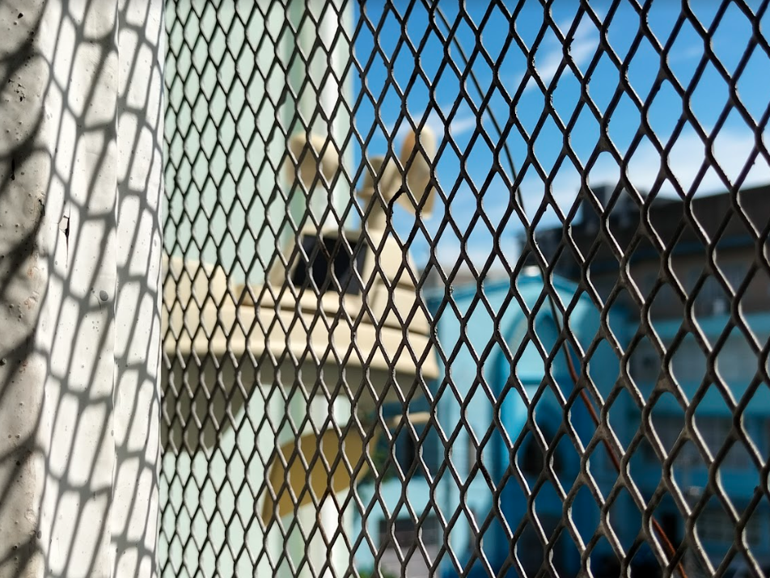

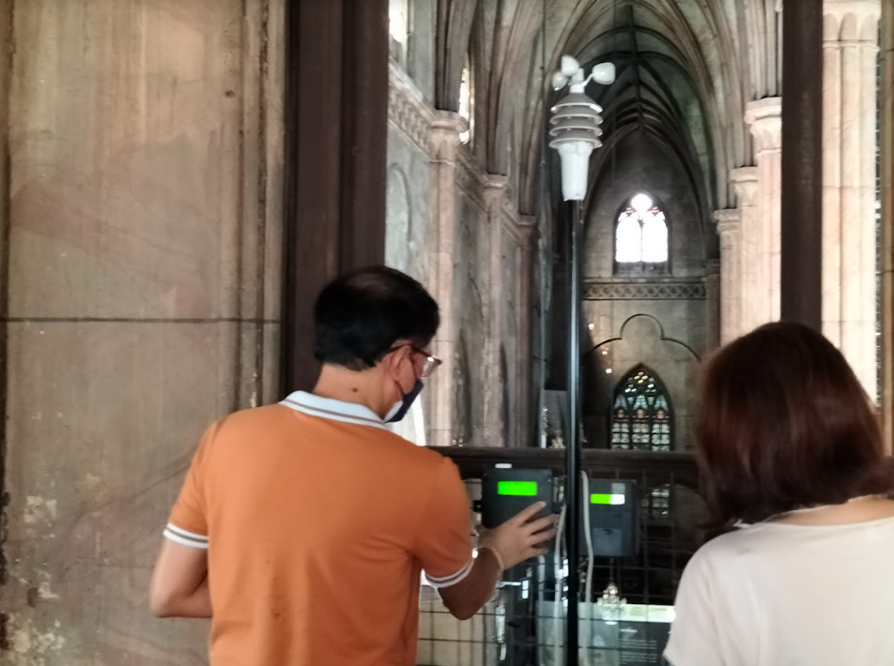

- Lunch session with the Dean offices of Mapua University School of Electrical, Electronics, & Computer Engineering (EECE). We had meaningful exchanges with the Dean, and the vice deans of the three department under the school. UKM is thinking of establishing and MoU with Mapua University to profit the network established via ASEAN-IVO to encourage more research efforts together in the future.

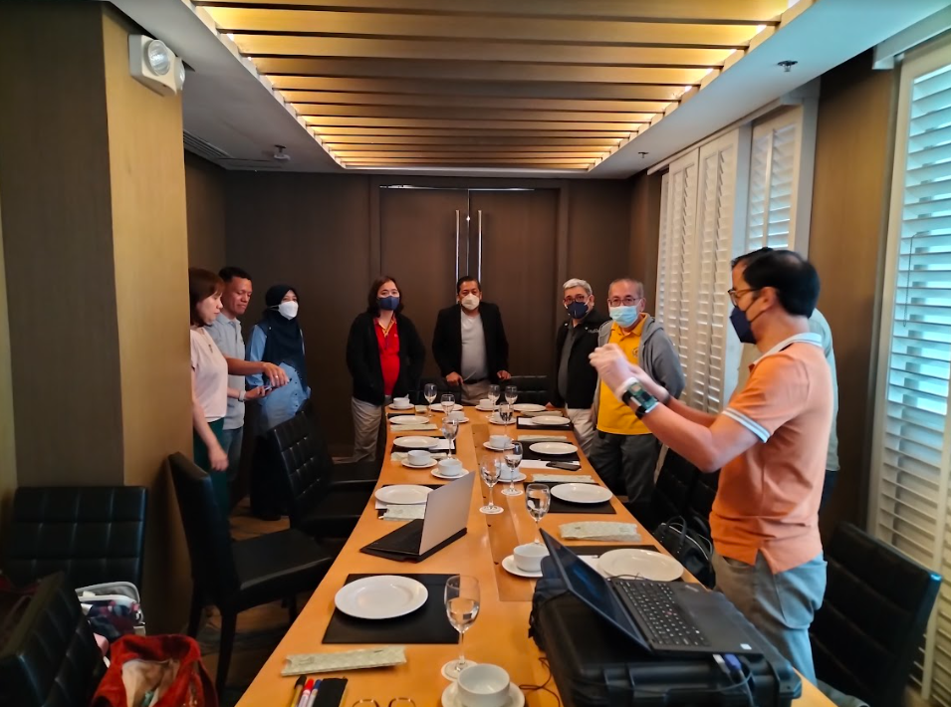

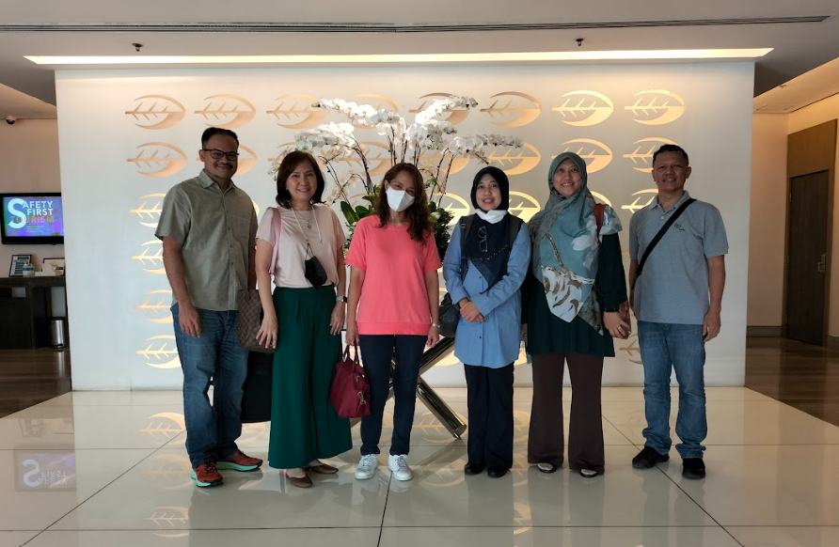

- Finally we had the opportunity to visit Mapua University which is located just beside our hotel. We were given a 1 hour tour by Prof. Jennifer C. De la Cruz.

