Appendix 2.2

Report of International Conference Presentation

Name:  (Presenter) | Muhammad Wafiq Haji Abd Zariful
Affiliation: | Universiti Teknologi Brunei
Project Title: | AI-Based Real Time Analysis and Control of The Monitoring on the Growth of Freshwater Prawn Using Video Image Processing from Underwater Drone
Name of International Conference:  (Link to website) | 2024 5th Asia-Pacific Conference on Image Processing, Electronics and Computers (IPEC2024) http://www.acipec.org/
Title of Research Paper: | Comparison of Biocode based Machine learning and Segmentation model for Automated Prawn Size Prediction for real prawn farm
Name of all Co-authors (if any) | Muhammad Wafiq Abd Zariful, Najeebah Az-Zahra Tashim, Tiong Hoo Lim, Aida Maryam Basri, Hanif Fakhrurroja, Suriayati Chuprat, Seno Adi Putra, Pengcheng Liu
Comments or feedback received at the conference:
No feedback as the presentation was good.

Contribution to the project:
We presented the AI based prawn biomass detection from the IVO project.
Keynote speaker on Next Generation IoT is very relevant to our project and also the presentation. The speaker highlighted the challenges of NG-IoT due to its interdisciplinary nature. It will be more human-centric and more than human and decentralized. The transparency, inclusive and privacy of the IoT will need to be taken into consideration as a future research area.
Another related talk is on context active resilience in CPS where a next generation cyber physical system for context active resilience that maintains state awareness and an acceptable level of operational in response to disturbance or failure. They proposed a deraining approached for image restoration to remove the disturbance in the image which can be applied to our underwater images
There are plenty of AI papers presented during the conference.
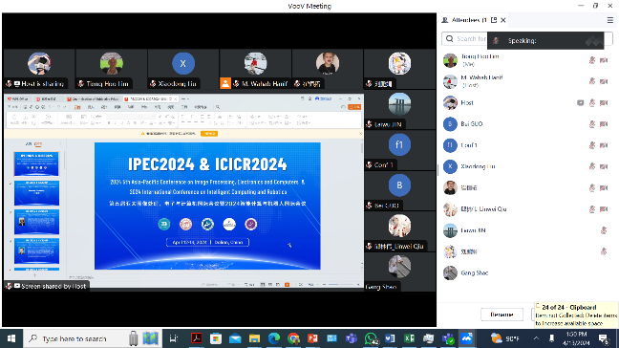
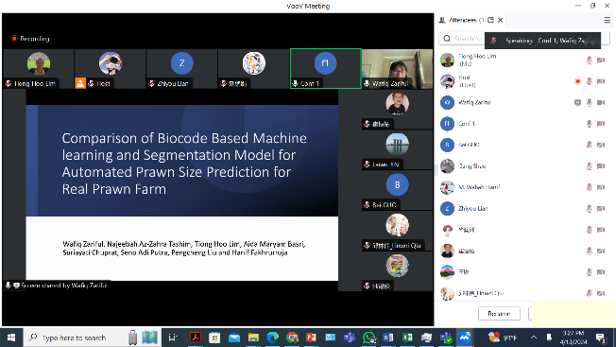

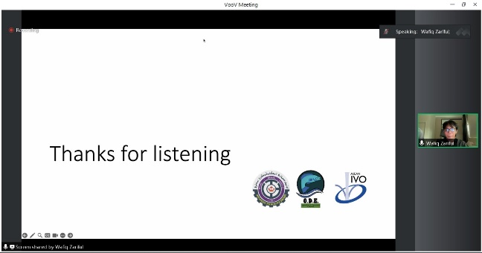

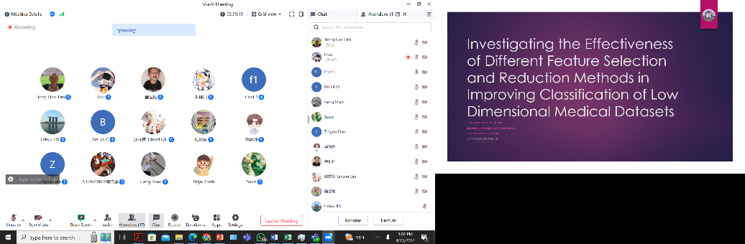

[Required Documents]
- Presentation Materials (e.g. PPT slides)
- Final Program of the conference

Reporter: Muhammad Wafiq Haji Abd Zariful
Date: 14/04/2024

