Final Project Report

I. Title of Proposed Project:

Study and evaluation of heterogeneous network for smart community and smart city applications

II. Project Leader:

Full name： Assoc. Prof. Kultida Rojviboonchai, Ph.D.
Institution： Chulalongkorn University
Address: Department of Computer Engineering, Faculty of Engineering
Chulalongkorn University, Phayathai Rd., Wang Mai,
Pathumwan, Bangkok, Thailand 10330
Phone： +66-2218-6954
E-mail: kultida.r@chula.ac.th

III. Project Members:

Name | Position/Degree | Department, Institution,Country | Email Address
Kulit Na Nakorn | Postdoctoral/Ph.D. | Department of Computer  Engineering, CU, Thailand | kulit.n@chula.ac.th
Kiattikun Kawila | Ph.D. Candidate | Department of Computer  Engineering, CU, Thailand | kiattikun.kaw@student.  chula.ac.th
Teerapat  Vongsuteera | Ph.D. Candidate | Department of Computer  Engineering, CU, Thailand | teerapat.von@student.  chula.ac.th
Adsadawut  Chanakitkarnchok | Ph.D. Candidate | Department of Computer  Engineering, CU, Thailand | 60714495@student.  chula.ac.th
Choong Khong  Neng | Researcher/Ph.D. | MIMOS, Malaysia | kn.choong@mimos.my
Kok Gin Xian | Researcher/Ph.D. | MIMOS, Malaysia | gx.kok@mimos.my
Chrishanton  Vethanayagam | Researcher/Ph.D. | MIMOS, Malaysia | chrishanton.v@mimos.  my
Tham Mau Luen | Lecturer/Ph.D. | UTAR, Malaysia | thamml@utar.edu.my
Yasunori Owada | Senior Researcher/Ph.D. | NICT, Japan | yowada@nict.go.jp
Goshi Sato | Senior Researcher/Ph.D. | NICT, Japan | sato_g@nict.go.jp

IV. Project Report

- Introduction

In Internet of Thing (IoT) era, number of sensors and devices are introduced which allow developers and researchers to advance applications and tools to be smarter than the existing ones. These devices or things require an easy and friendly communication to distribute their data between them. Moreover, the current devices are not fixed to the certain position as before so the additional challenges for communication are from mobility of these devices, big bulk of generated data and coverage area.
A wireless communication is the most convenient solution for data transferring that can support the mentioned requirement. However, the wireless communication has the limitation that should be considered e.g. coverage limitation in a large area and bandwidth limitation to support a lot of devices. The traditional deployment also needs a wire communication for each base station that are costly to install in the area where the wire communication is not ready or in rural area.
In this project, we proposed a data distribution platform on wireless mesh network using NerveNet to overcome the limitation of traditional wireless communication. The wireless mesh network is a wireless communication network made up of wireless nodes organized a mesh topology or an ad hoc network. The advantage of this network type is that each node is independent to each other. The communication can be scaled in terms of coverage area, bandwidth and reliability depending on the number of wireless nodes. The topology can be changed and then a routing protocol will automatically construct a new route for transferring data. Moreover, in an urgent situation such as disaster, the mesh network will act as a recovery system while most of infrastructure are destroyed. Moreover, the mesh network also provides a possible communication solution for non-infrastructure environment in rural area.
In order to achieve our promising objective, we need to consider many kinds of scenarios that cover most of existing or incoming applications, so the wireless mesh network will be an efficient and effective solution of such applications. Thus, the scope of this project is to proposing the solution for data distribution platform in wireless mesh network using NerveNet. And to study and experiment different scenarios by project members e.g. vehicular cloud system and wireless presentation system.
The vehicular cloud system on wireless mesh network represents mobile IoT sensors. The issues that need to be considered are mobility, high frequency data rate but low bandwidth and coverage area. And the wireless presentation system represents multimedia devices that require stable link quality, large number of devices with high bandwidth.
Therefore, the proposed data distribution platform on wireless mesh network using NerveNet offers the following benefits:
a. Improve the scalability in terms of coverage area, number of devices and bandwidth.
b. Reduce cost and complexity of infrastructure installation.
c. Provide a flexible system that can be deployed in both urban area for improving scalability or rural area for extending the coverage area.
d. Support further communication in disaster recovery.
e. Motivate countries within ASEAN to be ready for incoming applications and devices with mesh communication solution.

- Project Activities

- Development and Implement
The data distribution platform on wireless mesh network using NerveNet consist of two systems which are the vehicular cloud system on wireless mesh network and the wireless presentation system. The details of each system are described as follows:

- The vehicular cloud system on wireless mesh network

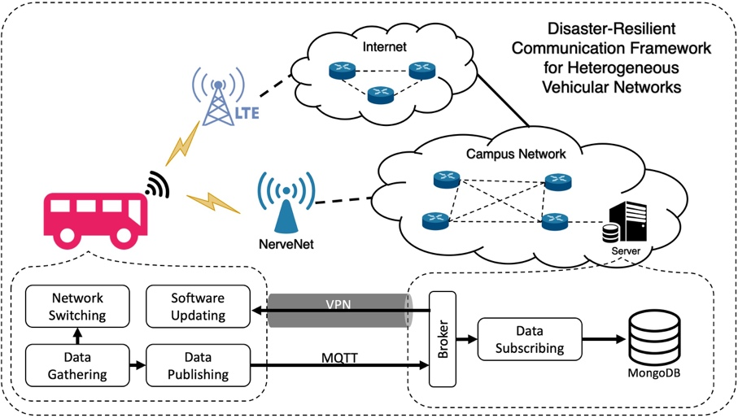
Fig. 1 Disaster-Resilient Communication Framework for Heterogeneous Vehicular Networks

We proposed a disaster-resilient communication framework for heterogeneous vehicular networks for using in the vehicular cloud system on mesh network. In this framework consists of four main components including LTE network, NerveNet network, the server and the vehicles.
- LTE Network
LTE network is the first component in our framework. It requires a cell tower to route the data between vehicles and the server. LTE network is designed for the low transmission latency. Hence, this communication type is well supported the V2I communications in the vehicular network. In the beginning of the vehicular network, LTE network is expected to be an important network to support the vehicular network. However, LTE network is a tree-topological network. It is efficient in providing the connectivity to the wide coverage range but it is weak against the failures. If any cell tower is damaged, the lower-level hierarchical of that cell tower cannot be connected to the Internet. In most of disaster situations, the cell tower is certainly destroyed and the LTE network will not be able to operate.
- NerveNet Network
For the second component, NerveNet is a mesh-topological access network. The communication concept of NerveNet is based on Layer 2 switching. NerveNet will calculate all possible spanning-tree topology of the network and then store each topology in the table with different VLANs number. After that, the initial communication route will be selected from one of the pre-calculated VLANs. When any NerveNet node is unusable or any link is broken, it will switch over to communicate in another VLANs among the pre-calculated VLANs that has no broken link. According to this feature, it makes NerveNet strong against a failure. In our framework, NerveNet network is connected to the campus network to access to the Internet.
- Server
The server in our framework is responsible for handling the data which is sent from the vehicles. The data communication in our framework is based on the IoT communication standard, named Message Queuing Telemetry Transport (MQTT). The concept of MQTT is a publish and subscribe system. In the publish and subscribe system, a client can publish the data on the topic or subscribe the particular topic to the broker for receiving the data. In our framework, the broker has been installed at the server which is located in the campus. Then, the data subscribing module subscribes the topic in the broker. At first, all of the data from the vehicles will be stored in the database. Since the data generated during disaster is unstructured data, the NoSQL database is considered in our framework. MongoDB is a document-oriented database which stores data in the JSON-like document. It is classified in the NoSQL database. According to the concept of JSON-like document, the field can be varied from document to document and data structure can be changed over time. For the maintenance phase, the Virtual Private Network (VPN) is established between each vehicle and the server to ensure the security of the messages and to be able to contact to the vehicle remotely.
- Vehicles
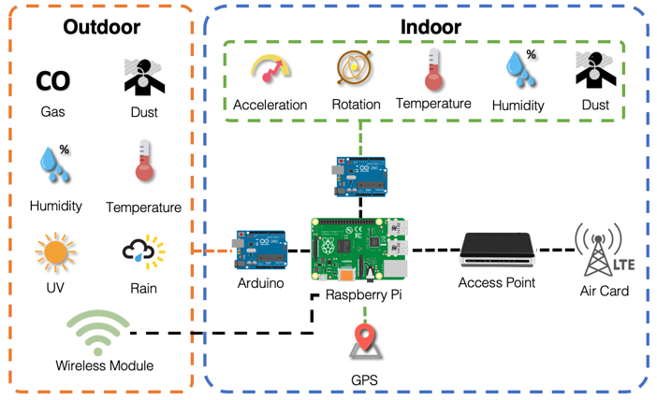
Fig. 2. Detail of deployed equipment

The key component of our framework is vehicles. We designed and assembled the equipment for installing in the vehicles to make the normal vehicle can communicate to the Internet. To communicate to multiple networks, each vehicle is equipped with 2 network interfaces for connecting to the server over LTE network or NerveNet network. Each NerveNet node will provide a Hotspot with IEEE802.11n standard for the vehicle. A wireless network adapter and wireless antenna is needed. For LTE network, we subscribe the Internet package with the mobile operator and install an air card into the vehicle.
Although, IEEE802.11p, which is the basis for dedicated short-range communications (DSRC), is a standard for vehicular communications, the frequency band used for this standard has already been allocated for Fixed-Satellite service in Thailand. According to the latest ITU-R Meeting of Working Party 5A report in 2018 from National Broadcasting and Telecommunication Commission (NBTC) of Thailand, it might interfere with the existing service if this frequency band is used for vehicular communication. In the conclusion of the meeting, it still cannot be publicly used in Thailand. Since DSRC cannot be used publicly in Thailand. We decided to use IEEE802.11n for vehicular communication.
In each vehicle, we also deployed 9 sensors including acceleration, rotation, temperature, humidity, dust, CO, UV, rain, and GPS to collect the environmental data and the location of the vehicle. Arduinos are used to collect the data from the sensors. The sensor data is then sent to a Raspberry Pi. After that, Raspberry Pi will aggregate and send the data to the server using MQTT protocol. There are two networks attached to Raspberry Pi which are Aircard for LTE network and Wireless network adapter. Fig. 2 illustrates the detail of our deployed equipment.
As shown in Fig. 1, there are 4 modules in the client part which are data gathering module, data publishing module, network switching module, and software updating module. The detail of each module is described as follows.
Data gathering module is responsible for collecting the data from sensors and the current network information. The network information consists of SSID, RSSI, channel, link quality, BSSID, current gateway address, and available networks. This network information will be considered to select either LTE network or NerveNet network. While sensor data is used to monitor the environment of the disaster area. Each sensor has different fetchable rates, the sampling rate will depend on the requirement of the application. For the example, the maximum sample rate of accelerometer and gyro meter are 1 kHz and 8 kHz respectively. However, with this high sample rate, it will be an overhead of the network. In our framework, we collect the acceleration and gyro meter value with 10 Hz rate and others sensor data with 1Hz rate including the network information.
Data publishing module is the module that handles how to transfer the data from the vehicle to the server. According to communication standard that is used in the server, vehicles also use MQTT protocol to publish all of the data to the broker. Due to the networks in heterogeneous vehicular network are switchable, the communication channel can be disconnected. MQTT has an automatically reconnect feature. It can automatically reconnect to the broker after switching to other networks.
Network switching module is the most important module in this work. Our network switching module is implemented at application layer. This is to provide low complexity and to let our framework be able to integrate with any operating systems. The procedure of network switching module requires the network information which is collected in data gathering module. The network information is used to identify how many available networks that the vehicle is connecting. This module is triggered every 1 second. In our heterogeneous network, LTE network is always an available network and NerveNet network is an alternative network for providing more network capacities and availability for vehicles. However, in disaster scenario, NerveNet will become the main infrastructure for providing the connectivity to the vehicles when LTE network is not available. After the system can detect the current available networks, there are 3 possible conditions to select the network as a gateway. The first condition is that only LTE network is available. The vehicle will set LTE as a gateway. The second condition is that both LTE and NerveNet are detected. The vehicle will set NerveNet network as a gateway because it has a higher priority. The last condition is that there are no any available networks. The vehicle has to hold the data until it can detect LTE network or NerveNet network. The pseudocode of network selection algorithm is shown in Algorithm 1.
Software updating module is used for the maintenance purpose only.

(a) (b)
Fig. 3. Deployed equipment in a campus shuttle bus of Chulalongkorn University
Algorithm 1: Network Selection Algorithm
1 | Input: RSSI, ESSID
2 | if ESSID == NerveNet and RSSI < 0:
3 | if current_gateway != NerveNet_gateway:
4 | delete current_gateway
5 | set static_IP_address
6 | set NerveNet_gateway
7 | else:
8 | if current_gateway != LTE_gateway:
9 | delete current_gateway
10 | set LTE_gateway

Experiment
We performed experiments to evaluate the performance of disaster-resilient communication framework for Heterogeneous Vehicular Networks by measuring three network metrics. The network metrics are bandwidth, end-to-end delay, and traffic load ratio. The bandwidth and the end-to-end delay are measured by using iPerf and Ping tool, respectively. Traffic load ratio represents the ratio of data that is sent to the server using NerveNet network or LTE network. The data is periodically sent to the server 10 messages per second. The experiment is conducted in Chulalongkorn University by using campus shuttle buses as vehicles. We deployed three NerveNet nodes in Chulalongkorn University to form a mesh network as shown in Fig. 4. The distance between each node is 215, 220, and 300 meters, respectively. Each node provides an open-access hotspot. The NerveNet node, N1, serves as a gateway node connecting to the campus infrastructure over IEEE802.11n standard. The vehicles can connect to the NerveNet nodes though IEEE802.11n standard.
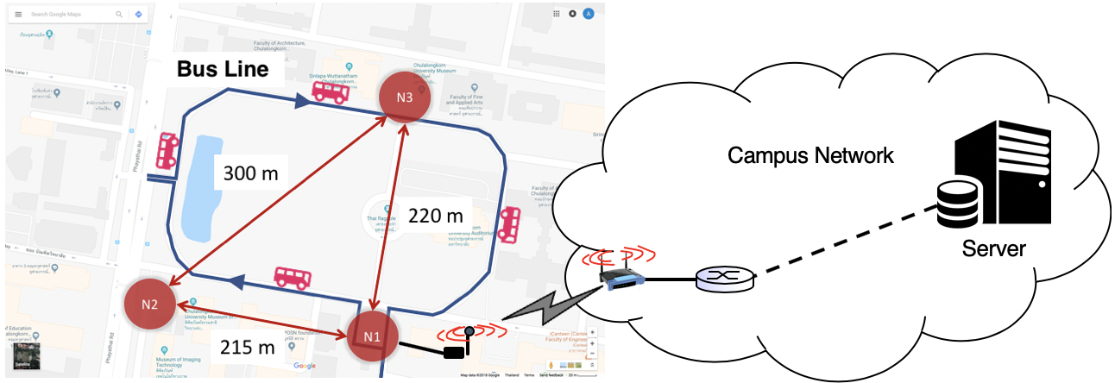
Fig. 4. The location of NerveNet nodes
In order to evaluate the performance of our proposed framework, the experiment is conducted into three scenarios as follows.
Normal Scenario without NerveNet: In this scenario, we consider the situation where only LTE network is available. The vehicles then send all messages to the server via LTE network.
HetVNet Scenario: In this scenario, we consider the situation where both LTE network and NerveNet network are available. The NerveNet network is deployed as depicted in Fig. 4. It covers approximately 20 percents of the overall vehicle routes. If the vehicle is in the communication range of NerveNet network, it will send messages via the NerveNet network. Otherwise, it will send messages via LTE network.
Disaster Scenario: In this scenario, we consider the situation where the main infrastructure (LTE network) is destroyed and unavailable. So, the NerveNet network can help form the mesh network for search-and-rescue operations and provide the connectivity to the vehicles. Since the coverage of the NerveNet network does not cover all areas, the vehicles have to carry the messages until they can connect to the NerveNet network.
Results

(a) Location where traffic is uploaded via (b) Location where traffic is uploaded via the
LTE Network in normal scenario NerveNet nodes and LTE network in HetVNet scenario

Fig. 5. Results of the traffic upload to the server in normal scenario and HetVNet scenario
Normal Scenario without NerveNet
Fig. 5(a) illustrates the location where the traffic was uploaded to the server via LTE network. The end-to-end delay and bandwidth were measured in the experiment. The result shows that the end-to-end delay ranges from 38 to 93 milliseconds and the bandwidth is up to 1.23 Mbps. This shows the network quality of LTE network.
HetVNet Scenario
In this scenario, if the vehicle can connect to both LTE network and NerveNet network, it will select the NerveNet network as the first priority. If the vehicle is in the communication range of more than one NerveNet nodes, it will choose the NerveNet node which provides the highest RSSI. The ratio of traffic uploaded to the server through the NerveNet nodes and LTE network was measured in this experiment. Fig. 5(b) depicts the location where the traffic was uploaded to the server via the NerveNet nodes and the LTE network. Table I shows the result of end-to-end delay of each network type. Table II shows the ratio of traffic uploaded to the server through the NerveNet nodes and LTE network.
As can be seen from Fig. 5(b) and Table II, the percentages of traffic uploaded to the server via N1, N2 and N3 are 8.48%, 1.51% and 13.07%, respectively. In total, the percentage of traffic uploaded via the NerveNet network is 23.06% whereas the percentage of traffic uploaded via LTE network is 76.94%. This shows that the vehicles can send messages efficiently in our heterogeneous vehicular network framework.
- End-to-End Delay between NerveNet Network and LTE Network
Network Types | End-to-End Delay (millisecond)
Network Types | Min | Average | Max
LTE Network | 37.813 | 56.017 | 92.806
NerveNet Network | 32.987 | 52.689 | 99.465
- Traffic Upload Ratio
 | N1 | N2 | N3 | LTE
Percentage of traffic uploaded to the server | 8.48% | 1.51% | 13.07% | 76.94%

Disaster Scenario
In disaster scenario, most of infrastructures are destroyed. It causes the communication in the disaster area not available. Instead, NerveNet which is a disaster-resilient mesh-topology network can response for forwarding and relaying the data to search-and-rescue operations. The vehicle will carry the messages and send to the server only if it can connect to the NerveNet network. The result shows that the end-to-end delay ranges from 33 to 100 milliseconds, the bandwidth between each NerveNet link is up to 96 Mbps, and the bandwidth of the link between the vehicles to the server is approximately 3.82 Mbps. This shows that the NerveNet network can work efficiently in the disaster scenario.
Conclusion
This system focuses on integrating a disaster-resilient mesh-topology network, named NerveNet, with the traditional network. A network selection algorithm which selects either NerveNet or LTE network is also proposed for this framework. The experimental results of our real implementation show that the NerveNet can be an alternative network in the heterogeneous vehicular network for data communication. When the disaster is occurred, NerveNet can become the main infrastructure for communication. The search and rescue operation will be done easier and faster.

- The wireless presentation system

The wireless presentation system which uses NerveNet consists of three NerveNet nodes as shown in 6. The nodes are labeled nodes 13, 14, and 15. Node 13 was designated as the front hotspot, node 15 as the rear left hotspot, and node 14 as the rear right hotspot. The wireless presentation box is connected to node 13 using Ethernet. The inter-node (backhaul) wireless links (13, 14), (14, 15), and (15, 13) operate on the 5 GHz radio band on channels 36, 40, and 44, respectively. Each of these nodes also has an access side Wi-Fi AP running on the 2.4 GHz radio band to allow users to connect to the network. The access side APs on nodes 13, 14, and 15 were operating on channels 6, 1, and 11, respectively. The purpose of using wireless mesh network is:
  - enhanced reliability as there could be multiple paths between any two nodes
  - ease of setup due to wireless links between nodes (cable-less)

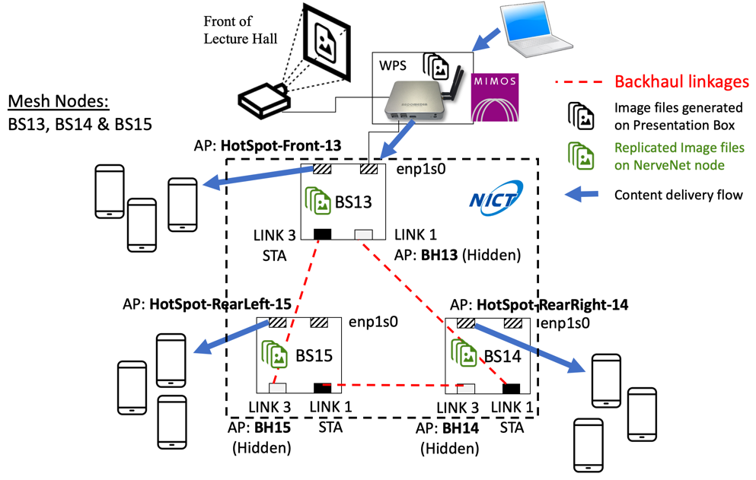

Fig. 6. NerveNet setup for wireless presentation system

For the NerveNet setup, a test run of the system was conducted at a lecture hall in a local university at about 8 pm of a normal workday. Custom software was installed on the NerveNet nodes for data collection. The glances monitoring tool was used for monitoring the system resource utilization of the NerveNet nodes.

Experimental Results

Fig. 7. shows the number of stations connected to the different NerveNet nodes. The combined total number of stations peaked at 79 at about 8:21 p.m.. Specific instructions were given to the audience to connect to the different NerveNet nodes based on their classroom seating locations. From the figure, it can be seen that the front center NerveNet node, i.e., node 13 hosted the most stations and a roughly equal amount of stations were hosted by the rear left and rear right NerveNet nodes, i.e., nodes 15 and 14, respectively

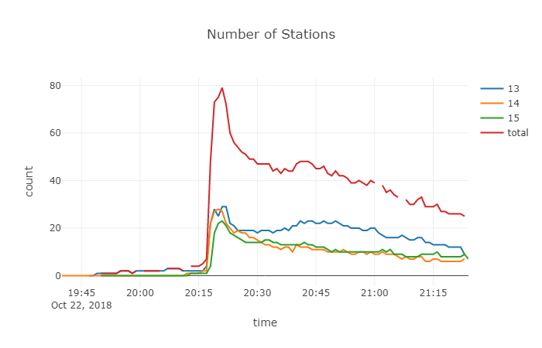
Fig. 7. Number of stations connected to different NerveNet nodes

Fig. 8-10. show the receive and transmit bitrates on links (13, 14), (14, 15), and (15, 13), respectively.
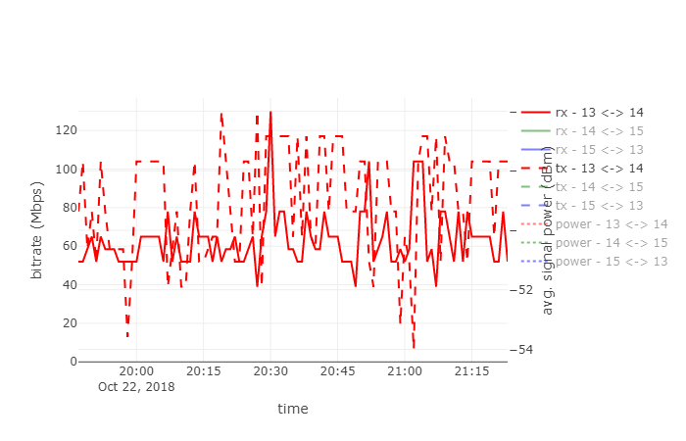
Fig. 8. Receive & transmit bitrate on backhaul link (13, 14)

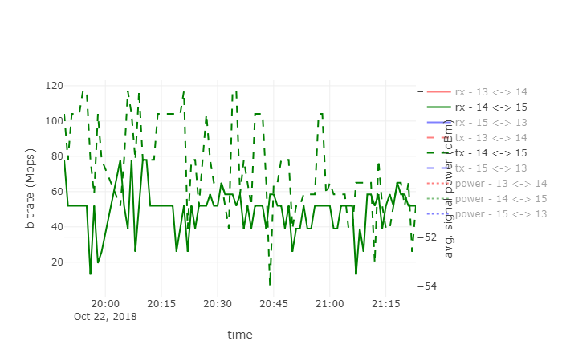
Fig. 9. Receive & transmit bitrate on backhaul link (14, 15)
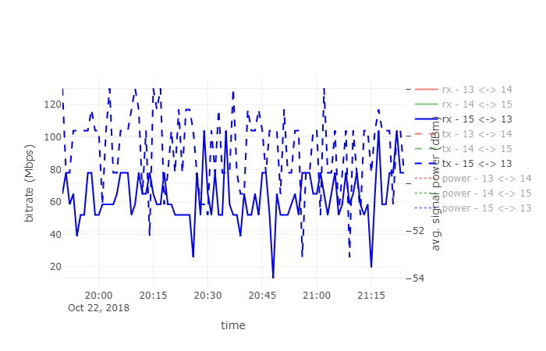
Fig. 10. Receive & transmit bitrate on backhaul link (15, 13)

Fig. 11 shows the packet failure rate on the NerveNet backhaul links (13, 14), (14, 15), and (15, 13). From the figure, we found two peaks at about 7.59 p.m. and 8.17 p.m., respectively. The packet failure rates at these peaks were 13.3% and 20%, respectively. Otherwise, packet failure rates remained quite low.
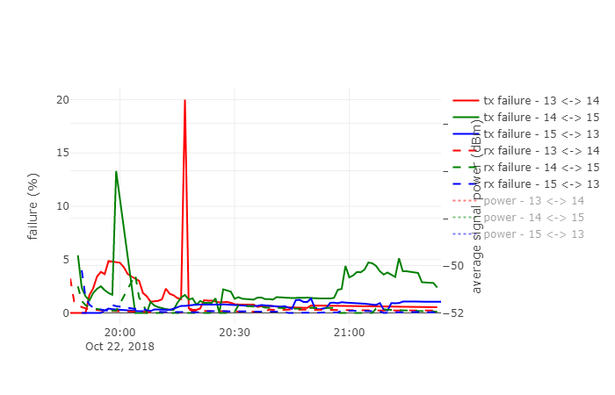
Fig. 11. Packet failure rate on backhaul links

Fig. 12 shows the average signal power of the NerveNet backhaul links. The time-average signal power is -47.5 dBm, -50 dBm, and -64 dBm, for links (15, 13), (13, 14), and (14, 15), respectively.

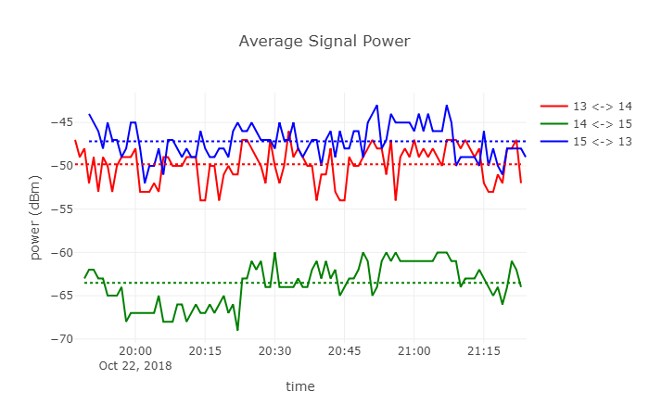
Fig. 12. Average signal power of backhaul links

Fig. 13 shows the connected times of the NerveNet backhaul links. From the figure, it can be observed that link (13, 14) was broken and auto-reconnected once. Meanwhile, links (14, 15) and (15, 13) were less stable as they disconnected and auto-reconnected four and three times, respectively. This is in agreement as the average signal power for the links as link (14, 15) has the lowest average signal power of all the links as shown in Fig. 12 and are thus the least stable of the three links.
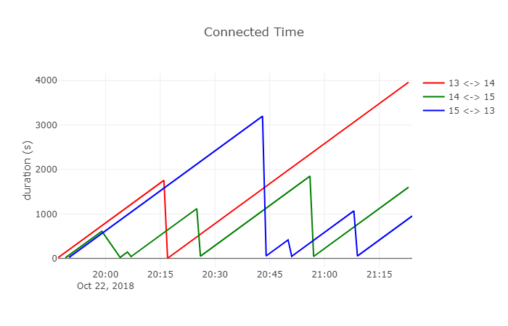
Fig. 13. Connected time of backhaul links

Fig. 14 shows the CPU utilization on the NerveNet nodes. The maximum CPU utilizations are 41.4%, 37.7%, and 40.4% on nodes 13, 14, and 15, respectively. However, the CPU utilization were quite low most of the time as can be seen from the figure.
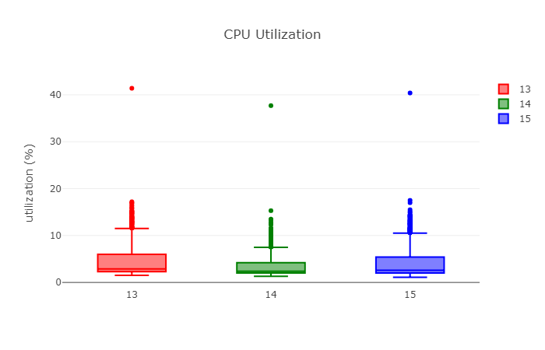
Fig. 14. CPU utilization on NerveNet nodes

Fig. 15 shows the memory usage on the NerveNet nodes. Memory usage maxed at 8.2% for both nodes 13 and 14, and 8.4% respectively. Both Fig. 14 and Fig. 15 show that the hardware used were more than sufficient for our application for a max crowd size of 79.
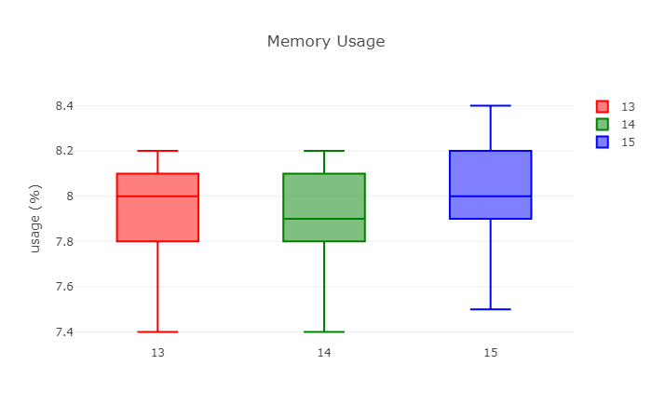
Fig. 15. CPU utilization on NerveNet nodes

Results show that the mean webview access time of the system is 4.5 second. This means it takes around 4.5 second in average for one user to obtain an updated screenshot right after the presenter has changed his/her presentation screen. One possible reason of this could be due to the network interface used on the access side of the NerveNet nodes. The Wi-Fi network interfaces used on this setup are consumer grade network interfaces on the IEEE 802.11n 150 Mbps standard. Further it operated in the 2.4 GHz frequency channel which is widely used, and therefore generally quite congested due to limited channel selection.

Conclusion
Besides the slow performance, another area of improvement would be on enabling automatic load balancing among Wi-Fi stations. In our test run, the load balancing function was performed manually by instructing participants to connect to different NerveNet APs based on their seating locations in the hall. This could deter less determined participants from using the system altogether. Therefore, more work is needed to ensure a better system deployment.
- Leveraged Resources and Participants
The collaboration of this project can be classified into two types including knowledge sharing and resources sharing.
Knowledge Sharing
We held 6 workshops/meetings in the project timeline. The schedule and the brief details of this knowledge sharing is shown in Table below.

Timing | Items | Venue | Remark
14/Apr/2017 | Project award | - | Project started from 1/June.
22/Jun/2017 | Kick off meeting | Chula in Bangkok | NICT,MIMOS,UTAR come to Bangkok  - To discuss the detail and the timeline of the project in this first official project meeting  - NICT lend 3 NerveNet devices to Chula and demo how to use NerveNet devices  Participants List:
  No. | Name | Organization
  1 | Dr. Hiroshi Emoto | NICT
  2 | Dr. Yasunori Owada | NICT
  3 | Dr. Masugi Inoue | NICT
  4 | Dr. Choong Khong Neng | MIMOS
  5 | Dr. Kok Gin Xian | MIMOS
  6 | Prof. Tham Mau Luen | UTAR
  7 | Prof. Kultida Rojviboonchai | Chula
  8 | Dr. Kulit Na Nakorn | Chula
  9 | Kiattikun Kawila | Chula
  10 | Teerapat Vongsuteera | Chula
  11 | Adsadawut Chanakitkarnchok | Chula
  12 | Nobuyuki Asai | NICT Asia
07/Nov/2017 | 2nd project meeting | WEB | In order to confirm the progress and the crucial topic is discussion on the outcome of this project.  Participants List:
  No. | Name | Organization
  1 | Dr. Yasunori Owada | NICT
  2 | Dr. Masugi Inoue | NICT
  3 | Dr. Choong Khong Neng | MIMOS
  4 | Prof. Tham Mau Luen | UTAR
  5 | Prof. Kultida Rojviboonchai | CU
  6 | Adsadawut Chanakitkarnchok | CU
  7 | Kiattikun Kawila | CU
  8 | Teerapat Vongsuteera | CU
  9 | Nobuyuki Asai | NICT Asia
10/Jan/2018 | 3rd project meeting | Chula in Bangkok  Suan-Ruam-Jai | NICT,MIMOS,UTAR come to Bangkok  In order to accelerate the progress and set the target milestone of this fiscal year, 3rd workshop will be held. And crucial topic is how is the way to develop the application program on NerveNet and explanation of more detail technical information such as about configuration file parameters.  Participants List:
  No. | Name | Organization
  1 | Dr. Hiroshi Emoto | NICT
  2 | Dr. Yasunori Owada | NICT
  3 | Dr. Masugi Inoue | NICT
  4 | Dr. Goshi Sato | NICT
  5 | Dr. Choong Khong Neng | MIMOS
  6 | Chrishanton Vethanayagam | MIMOS
  7 | Prof. Tham Mau Luen | UTAR
  8 | Prof. Kultida Rojviboonchai | CU
  9 | Adsadawut Chanakitkarnchok | CU
  10 | Kiattikun Kawila | CU
  11 | Teerapat Vongsuteera | CU
  12 | Nobuyuki Asai | NICT Asia
19/Jun/2018 | 4th project meeting | MIMOS in Malaysia  Tactic I, 2nd floor, Aloft KL | NICT,Chula visit Malaysia  In order to confirm the progress and set the next target milestone of this fiscal year, 4th workshop is required. And the crucial topic is discussion on the outcome of this project.  Participants List:
  No. | Name | Organization
  1 | Dr. Hiroshi Emoto | NICT
  2 | Dr. Yasunori Owada | NICT
  3 | Dr. Masugi Inoue | NICT
  4 | Dr. Goshi Sato | NICT
  5 | Dr. Choong Khong Neng | MIMOS
  6 | Dr. Kok Gin Xian | MIMOS
  7 | Chrishanton Vethanayagam | MIMOS
  8 | Prof. Tham Mau Luen | UTAR
  9 | Prof. Kultida Rojviboonchai | CU
  10 | Adsadawut Chanakitkarnchok | CU
  11 | Kiattikun Kawila | CU
  12 | Teerapat Vongsuteera | CU
  13 | Nobuyuki Asai | NICT Asia
14/Feb/2019 | 5th project meeting | WEB | In order to report the progress and discuss about the publication.  Participants List:
  No. | Name | Organization
  1 | Dr. Yasunori Owada | NICT
  2 | Dr. Masugi Inoue | NICT
  3 | Dr. Goshi Sato | NICT
  4 | Dr. Choong Khong Neng | MIMOS
  5 | Dr. Kok Gin Xian | MIMOS
  6 | Chrishanton Vethanayagam | MIMOS
  7 | Prof. Tham Mau Luen | UTAR
  8 | Prof. Kultida Rojviboonchai | CU
  9 | Adsadawut Chanakitkarnchok | CU
  10 | Kiattikun Kawila | CU
  11 | Teerapat Vongsuteera | CU
  12 | Nobuyuki Asai | NICT Asia
11/Oct/2019 | 6th closing meeting | Chula in Bangkok  Suan-Ruam-Jai | To conclude the project outcome and prepare a presentation for ASEAN IVO Forum 2019  Participants List:
  No. | Name | Organization
  1 | Dr. Yasunori Owada | NICT, Japan
  2 | Dr. Masugi Inoue | NICT, Japan
  3 | Dr. Goshi Sato | NICT, Japan
  4 | Adsadawut Chanakitkarnchok | CU, Thailand
  5 | Kiattikun Kawila | CU, Thailand
  6 | Teerapat Vongsuteera | CU, Thailand
  7 | Prof. Kultida Rojviboonchai | CU, Thailand
  8 | Dr. Choong Khong Neng | MIMOS, Malaysia
  9 | Chrishanton Vethanayagam | MIMOS, Malaysia
  10 | Prof. Tham Mau Luen | UTAR, Malaysia

(1) Topics on 3rd project meeting (10/January/2018)
I) Report about IVO forum 2017
CU side studied on NerveNet system and Mesh Network protocol. Since NerveNet hardware is heavy and inconvenient to carry on the outdoor testing, CU side decided to use the Raspberry Pi 3 installing software environment same as the environment on the NerveNet device. Subsequently, CU side deployed OLSR protocol for indoor testing.
MIMOS side identified the application use case of NerveNet, defined the testbed using NerveNet to serve the application requirements, and also determined the set of network performance metrics and tools for measurement.
Due to the financial process which is time consuming and complicated, both CU and MIMOS side cannot manage the budget as planned. Then, we proposed the solutions to extend the project from March 2019 to June 2019 and requested to transfer the remaining budget to the next fiscal year. Moreover, we do not have the full English version of NerveNet documents so we cannot utilize the NerveNet devices efficiently.

II) MIMOS/UTAR Activity Report
MIMOS side planned to use NerveNet for extending the Wi-Fi coverage in order to provide the better services to user. So that MIMOS side improved the Presentation Delivery Gateway System during the purchased and delivered period. This system which can instantly share content and materials over NerveNet system is now support mobile phone version and also Air-Play protocol.
Since UTAR side cannot install NerveNet system in Mini-PC, UTAR side purposed the network testing to provide insight on how to deploy NerveNet system into a Mini-PC. Wireshark was used as a preliminary study tool for evaluating the data rates and signal strength. The preliminary study result shows that the data rate and signal strength are lowered if each Access Network is too close to a specific group of audience.

III) CU Activity Report
CU side performed the outdoor experiment for testing the communication. The objective of this experiment is to measure the packet delivery ratio, end-to-end delay, and communication range of the system. CU side deployed three Raspberry Pi devices in which the NerveNet software was installed. One of the Raspberry Pi devices served as a gateway. One mobile client was represented as a bus for testing. The testing location was in the faculty of Engineering. Because we do not have knowhow to use the NerveNet routing protocol, CU side decided to use OLSR routing protocol instead for testing. We will use the NerveNet routing protocol once we know how to configure it. The result shows that the packet delivery ratio between client and gateway is about 80% with the communication range up to 50 metres and the delay is less than 56 milliseconds. The packet delivery ratio between client and server is about 90% with the communication range up to 50 metres and the delay is less than 345 milliseconds. Additionally, the packet delivery ratio between each NerveNet device is more than 90%.

IV) NerveNet Configuration Session
NICT team has already explained how to use NerveNet routing protocol and some NerveNet APIs. The NerveNet routing protocol is layer-2 routing configured using VLAN. The Network Manager calculates all possible spanning trees and assigns VLAN ID to each calculated spanning tree. Then, Network manager broadcasts all discovered spanning trees to every NerveNet devices. After that, each NerveNet device will choose the minimum spanning tree to communicate with each other. For NerveNet APIs, most of them are script-based and the API for querying data in the NerveNet database has not been finished yet.

V) Conclusion
According to this workshop meeting, both CU side and MIMOS/UTAR side have already known how to install NerveNet system into Raspberry Pi devices and how to use the functions of NerveNet system. Finally, both of us plan to study more detail about the structure of NerveNet system before integrating it with our system.
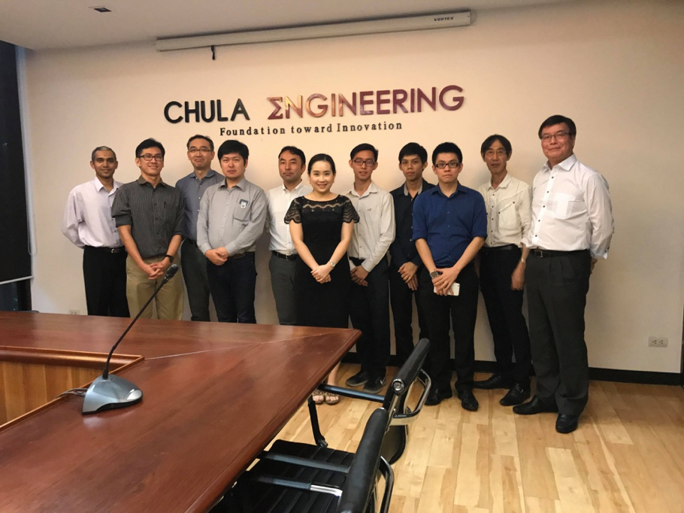
Team members (CU, MIMOS, UTAR, NICT)

(2) Topics on 4th project meeting (19/June/2018)
I) CU Activity Report
In the first fiscal year, CU side planned to study, deploy and test NerveNet system. Then, CU side integrates the NerveNet system with the heterogeneous network. The objective of this phase is to evaluate the network communication and heterogeneity of the network before fully integrating the whole system. The system consists of two networks which are LTE and NerveNet base station. The default connection is LTE because it is always on. However, if a client can detect any NerveNet base station, it will switch to connect to the NerveNet base station. At first, the NerveNet system was only temporarily deployed to ensure the stability. CU side also compared the NerveNet routing protocol with OLSR protocol, which is the well-known routing protocol, for the further improvement of NerveNet system. CU side evaluated the system in four metrics including packet delivery ratio, delay, throughput and load ratio. The results show that the packet delivery ratio is almost 1. The average delay of each NerveNet link and that of the path from each NerveNet node to the server is less than 6 milliseconds. The throughput of each NerveNet link is close to the maximum capacity of the wireless link. However, there are some unusual result in the path from each NerveNet node to the server. The throughput between the gateway node and the server is less than the throughput between other NerveNet nodes and the server even though every packet has to go through the gateway node. CU side will investigate this problem later. According to the load ratio result, NerveNet system can share traffic load up to 18 percent. Nevertheless, the result depends on the velocity of the client and the road traffic at that moment.

II) UTAR Activity Report
To study and analyze the performance of Recomedia connectivity over NerveNet system, UTAR side carried out successfully on two case studies in the first fiscal year. A typical classroom size with 70 audiences was used for first case study. It represented to a simple scenario. An access point was deployed to provide the connectivity between Recomedia so the audience devices can access a snapshot of presentation easily. The second case study was carried out on a large meeting room with 500 audiences. Three NerveNet nodes were used for providing the connectivity instead of the previous case. To increase the coverage range of Recomedia connectivity, three NerveNet nodes were located at the front, the rear-left, and the rear-right of the meeting room. During the briefing session on both scenarios, the audiences had to connect to the closest NerveNet node. The network traffic between all connected devices of audiences and Recomedia were sniffed by using a dedicated laptop with Kismet tool in Kali Linux and analyzed with Wireshark tool. Both case studies were analyzed in terms of number of connected clients, number of received presentation snapshots, management frames, control frames, and data frames. The results showed that the NerveNet system can serve a lot of connected devices during the briefing session although there was still freezing process issue of traffic sniffer inside the laptop in the second round of the experiment. For the improvement plan, two laptops equipped with Kismet tool in Kali Linux will be used simultaneously in order to yield a higher degree of confidence for the presented results.

III) MIMOS Activity Report
In this phase, MIMOS side completed the identified use case which is instant sharing of presentation content over NerveNet. The objective of the use case is to deliver presentation more effectively to a large number of audiences and to enrich with multimedia/interactive services. To evaluate the system, MIMOS side established a testbed with 3 NerveNet nodes which consists of a backhaul network using ethernet (tested in April 2018) and Wi-Fi connection (tested in June 2018). And, those NerveNet nodes create Wi-Fi hotspot for providing the connectivity to the end-user devices. MIMOS side modified wireless presentation system in 3 parts. First, the slide capture mechanism was modified to additionally trigger slide replication to each NerveNet node. Second, the replication scripts were created for transferring the slides to the folder path of NerveNet nodes and triggering the webserver in each NerverNet node to update the slide continuously. Third, the ‘rsync’ module and the registration of SSH keys in each NerveNet node were integrated. Additionally, each NerveNet node was modified in 3 parts. The first part is to integrate the relevant Sharing Server components from WPS into each NerverNet node. The second part is to modify ‘bind’ DNS resolver configuration to redirect the packet to NerverNet node. The final part is to modify the necessary link configurations for a backhaul network and hotspots.

IV) Conclusion
According to the meeting, CU side and MIMOS/UTAR sides have already worked as planned. CU side temporarily deployed and tested the integrated system by combining NerveNet system with the heterogeneous network. Moreover, CU side designed and implemented the public chat room application which can be used with the system. Next, CU side will deploy NerveNet system in the long-term and collect the data for analyzing the results before submitting to the international conference. MIMOS/UTAR sides also have already evaluated the network performance and modified the NerveNet system along with the Recomedia to increase the coverage and serve a large number of clients. MIMOS/UTAR sides got NerveNet configuration from NICT team. According to the previous testing problem, MIMOS/UTAR sides will repeat the experiment again.
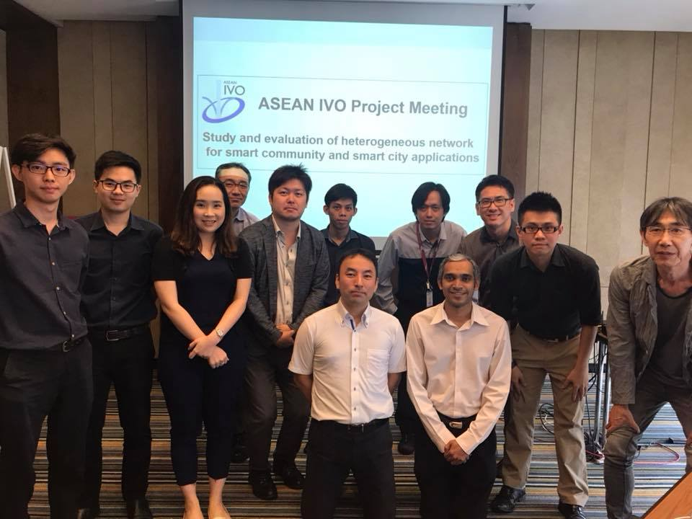
Team members (CU, MIMOS, UTAR, NICT)
Resources Sharing
We used NerveNet system which developed by NICT to show the use case scenarios and do a performance testing. Each institute has a responsibility to evaluate different scenarios based on supporting of NerveNet developer team from NICT. Moreover, Chulalongkorn University also cooperates with Electric Vehicle Thailand Co., Ltd. to install the equipment in the shuttle buses for evaluating the vehicular cloud system on wireless mesh network scenario.

(3) Topics on 6th closing meeting (11/October/2019)
I) CU Report
CU reported that the paper, titled “Disaster-Resilient Communication Framework for Heterogeneous Vehicular Networks” was presented on Sep 11, 2019 at IEEE International Symposium on Personal, Indoor and Mobile Radio Communications in Istanbul, Turkey. In this meeting, CU also summarized the outcomes of the overall project and reported the suggestion of NerveNet implementation in three different topics.

II) MIMOS/UTAR Report
MIMOS/UTAR reported a use case of serving large-scale distribution of presentation content, and concluded the design and implementation for integrating RecoMedia and NerveNet. MIMOS/UTAR published the paper, titled “An Analysis of a Large Scale Wireless Image Distribution System Development”, on Apr 28, 2019 at IEEE Symposium on Computer Applications & Industrial Electronics in Kota Kinabalu, Malaysia.

III) Conclusion
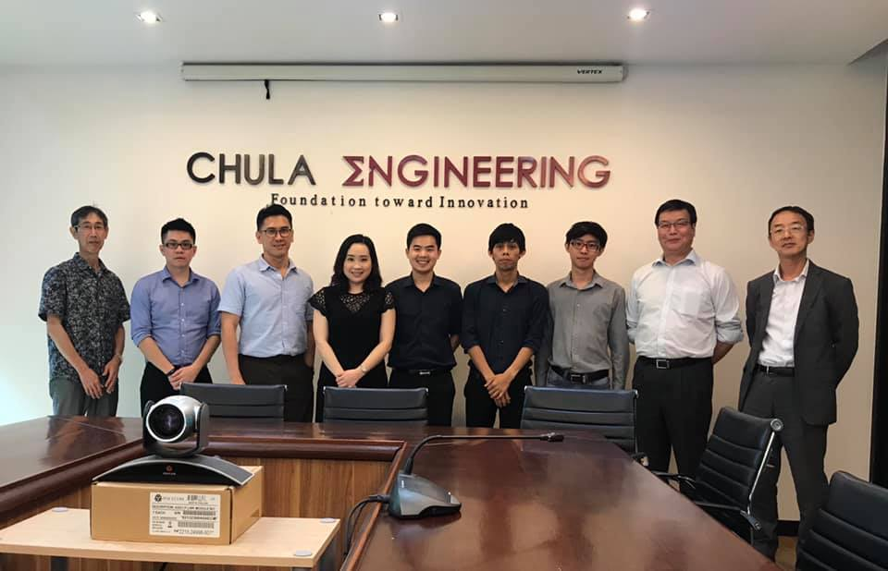
In this meeting, CU, MIMOS, UTAR, and NICT have already concluded all of the project outcomes. NICT also provided the template of the closing presentation at ASEAN IVO forum. This collaboration project will be finished by November 2019.
Team members (CU, MIMOS, UTAR, NICT)

- Findings and Outcomes
1) Vehicular Cloud System using wireless mesh network
In this scenario, we used NerveNet as one of alternative networks that can provides connectivity in its coverage area. NerveNet also cooperate with the traditional network for providing more bandwidth. Moreover, NerveNet which is a disaster-resilient mesh-topology network can be the main infrastructure while the main infrastructures are not available. The results of NerveNet performance in VANET are reported in Development and Implement section above.
2) Wireless presentation system
In this project, we have used NerveNet as the network infrastructure to extend the coverage of a wireless presentation system. NerveNet is chosen for its portability in setting up infrastructure and also for its ability to replicate content to sit closer to the users thereby reducing the unnecessary use of backhaul bandwidth. The setup and results of the NerveNet-enabled wireless presentation system are reported in the above section.

- Broader Impact
In the meantime, smart community and smart city applications will require network capacity much more than the current demand. The data distribution platform on wireless mesh network can overcome the limitation of traditional wireless communication and allow fast development of incoming IoT devices to be possible in both ASEAN and Japan. The proposed platform encourages various incoming applications such as environment sensing, traffic monitoring, content distributing, city management etc.
The wireless mesh network solution from this project will be an essential communication technology and it can support not only smart community and smart city applications in this project but also other kinds of further applications that rely on wireless communication. For example, in agricultural countries, sensors in a smart farm can be easily connected to their gateway using wireless mesh network to reduce the cost from base station deployment. For road applications, this network can be installed along the road to increase quality and efficiency of safety applications. Especially, developing countries can expand their communication in rural using wireless mesh network which is an affordable solution.
According to the above-mentioned reasons, the proposed data distribution platform using wireless mesh network will be an opportunity for communication technology that enable many edge technology devices to be connected to smart communities and smart cities. Therefore, the proposed platform will improve the daily life of people living in ASEAN, Japan and the rest of the world to be better than today.
The wireless mesh network can overcome the limitation of traditional wireless communication allow fast development of incoming IoT devices to be possible in both ASEAN and Japan.
Collaboration: The wireless mesh network can support any systems that need communication solution. The necessary content can be distributed to the desired vehicles or devices. For the vehicular cloud system, this type of communication can be the standard of vehicular communication among countries in ASEAN. It also can expand the range of communication in the rural area or the border of country. For the development plan of Presentation Delivery Gateway, it encourages collaboration from academia, research institutes and industries from different ASEAN countries, based on a common multimedia-based collaborative platform. New methods developed by academia and researchers can be made into product solutions by industries serving the market, enabling both a technology push and a market pull development.
Eco-Friendly Solution: Because the wireless mesh network can be installed in any small areas. It does not require the wire connection between nodes. Therefore, to increase the capacity of the network can be achieve simply and flexibly using wireless mesh network. For the vehicular cloud system, the wireless mesh network will reduce the number of base stations that need to build along the road. The network capacity also can be increase by just adding the number of nodes in wireless mesh. The fast process of communication deployment will make the intelligent transportation system to on the real world faster that will change our daily life on the road to be smarter, safer and greener. Moreover, when the wireless mesh network is applied on presentation system. It helps addressing the basic environmental challenge, i.e. to produce and use cables and papers in meeting room. With the Multimedia IoT Gateway, presenters no longer need a VGA cables or passing them around to other presenters in the meeting room. Sharing of screens takes place wirelessly, giving presenter complete mobility in the room. Presenter no longer need to distribute hands-out or CDs to audience because presentation contents can be easily accessed in digital forms wirelessly from the Presentation Delivery Gateway using WiFi from any smartphone and tablet devices.
Social Change through Interaction: The wireless mesh network will motivate the developer to introduce many applications to the social. The wireless communication has made it easier for people to develop any application based on IoT devices to work together to support a common cause, enhancing the potential for bringing about social change such as allowing vehicle to exchange the data for traffic management or allowing audience to communicate with each other without knowing each other.
Economy: While the traditional wireless communication technology requires complex installation, the wireless mesh network can be easily setup with low cost device and low-cost maintenance. The wireless mesh network will be the key for wireless communication to serve lots of application. For the vehicular cloud system, the system can reduce number of accidents, reduce the time for traveling and enable an efficient traffic management. For the presentation system, the completed system has various potential markets and applications, for managing presentation/meeting in enterprises, corporation, to event management in public seminar and teaching environment in the education sector.
As a result, the proposed data distribution platform using wireless mesh network using NerveNet will enable many edge technology devices in the smart cities that change the daily life of people living in ASEAN and Japan to be better.

- Future Developments
Outlook for the future of developed technology
The data distribution platform on wireless mesh network using NerveNet can be improved in term of integrated scenarios for smart community and smart city. The vehicular cloud system in mesh topology network can be adapted to use with public transport system. This can provide the NeverDie network to the smart city. Additionally, to integrate the wireless presentation system with the vehicular cloud system, thereby enabling everyone can access the knowledge from anywhere in anytime.
Plans/Ideas on how to spread them in country/region/world
To spread our developed system to the country, we have already presented our system in the National Science and Technology Fair (NSTF) which is Thailand’s largest science and technology annual festival in Year 2018 and 2019. For the region and also the world, the publication that we published in the IEEE international conference is an open-access which means that everyone can access our contribution with no cost.
Technology transfer
In this project, we provide the contact of project leader and project members for everyone who are interested in our project development.

- Social Contribution
In this project, each system design/implementation was published in the academic papers and presented at the IEEE international conferences. The vehicular cloud system on wireless mesh network was published in the 2019 Annual IEEE International Symposium on Personal, Indoor and Mobile Radio Communications (IEEE PIMRC 2019) with the title “Disaster-Resilient Communication Framework for Heterogeneous Vehicular Networks”. The wireless presentation system was published in the 9th IEEE Symposium on Computer Applications & Industrial Electronics (ISCAIE 2019) with the title “An Analysis of a Large Scale Wireless Image Distribution System Deployment”.
Additionally, we already presented our project in National Science and Technology Fair (NSTF) in Year 2018 and 2019. NSTF is Thailand’s the largest science and technology annual festival aiming to promote public understanding and awareness of science and technology to Thai young people.

