Appendix 2.2

Report of International Conference Presentation

Name:  (Presenter) | Tham Mau Luen
Affiliation: | Universiti Tunku Abdul Rahman (UTAR), Malaysia
Project Title: | Context-Aware Disaster Mitigation using Mobile Edge Computing and Wireless Mesh Network
Name of International Conference:  (Link to website) | 2023 the 6th International Conference on Big Data and Smart Computing (ICBDSC 2023)  http://www.icbdsc.org/
Title of Research Paper: | Artificial Intelligence of Things (AIoT) for Disaster Monitoring using Wireless Mesh Network
Name of all Co-authors (if any) | Yi Jie Wong, Ban-Hoe Kwan, Xin Hao Ng, Yasunori Owada
Comments or feedback received at the conference:
Comment: How do you integrate the wireless mesh network with artificial intelligence in actual prototype?
Answer: By using NICT NerveNet in docker mode.
Obtained certificate for best presentation
Contribution to the project:
To enable smart disaster monitoring applications, we first implement a lightweight multi-task model that performs joint disaster classification and victim detection. These AI outputs are then wirelessly synchronized via a mesh network solution called NerveNet. All the experiments are conducted in a real urban environment, including static and mobile nodes.
Photos
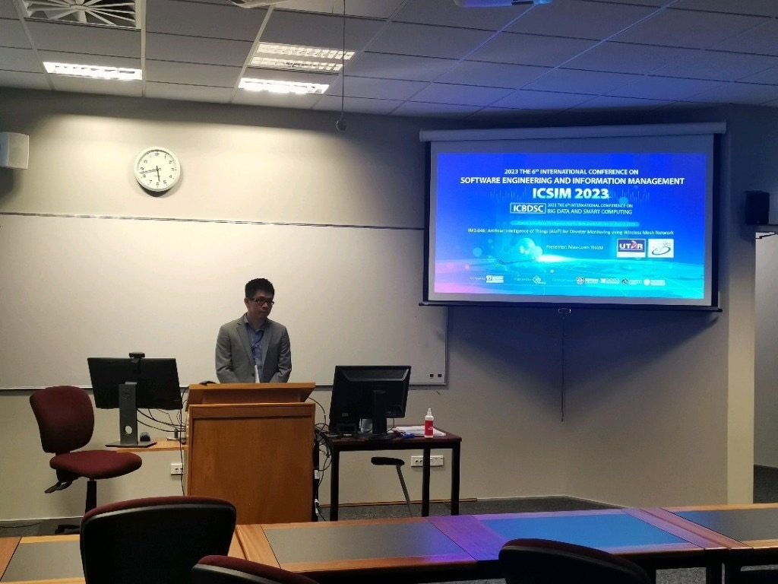
Presentation
[Required Documents]
- Presentation Materials (e.g. PPT slides)
- Final Program of the conference

Reporter: __Tham Mau Luen____________________________
Date: _______13 Feb 2023___________________________

