Appendix 2.2

Report of International Conference Presentation

Name:  (Presenter) | Tham Mau Luen
Affiliation: | Universiti Tunku Abdul Rahman (UTAR), Malaysia
Project Title: | Context-Aware Disaster Mitigation using Mobile Edge Computing and Wireless Mesh Network
Name of International Conference:  (Link to website) | 6th Conference on Cloud and Internet of Things  https://ciot.dnac.org/
Title of Research Paper: | Performance Study of Disaster-Resilient Mesh Networking using NerveNet Wi-Fi and LoRa
Name of all Co-authors (if any) | Chee Hong Lean, Wei-Sean Lim, Rong-Chuan Leong, Yasunori Owada, Myint Myint Sein
Comments or feedback received at the conference:
Comment: How did you ensure robust LoRa transmission for your deployment scenario?
Answer: By using NICT NerveNet LoRa mesh where the packets will be forwarded to neighboring nodes.

Contribution to the project:
Using NICT NerveNet technology as the communication platform, disaster nodes could be installed at disaster hotspots to send out disaster information or even provide lightweight Internet services. NerveNet can support data synchronization using Wi-Fi and LoRa. The former is used to provide wide bandwidth but low-range data transmission, whereas the latter enables narrow-bandwidth data transmission in coverage of kilometers, which is suitable for crucial or emergency disaster data updates.
Photos
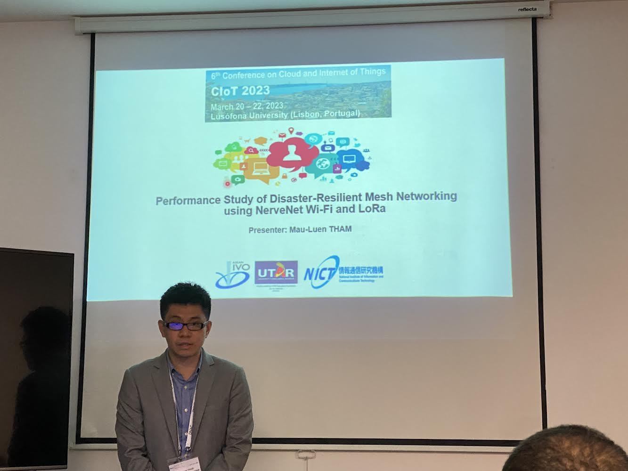
[Required Documents]
- Presentation Materials (e.g. PPT slides)
- Final Program of the conference

Reporter: __Tham Mau Luen____________________________
Date: _______28 March 2023___________________________

