Appendix 2.2

Report of International Conference Presentation

Name:  (Presenter) | Tham Mau Luen
Affiliation: | Universiti Tunku Abdul Rahman (UTAR), Malaysia
Project Title: | Context-Aware Disaster Mitigation using Mobile Edge Computing and Wireless Mesh Network
Name of International Conference:  (Link to website) | 12TH International Conference on Industrial Technology and Management (ICITM 2023)  http://www.icitm.org/  Finally published on:  6th International Conference on Signal Processing and Information Communications,ICSPIC 2023  https://link.springer.com/chapter/10.1007/978-3-031-43781-6_7  ＊Published:11 November 2023  ＊Publisher Name:Springer, Cham
Title of Research Paper: | Flood Forecasting using Edge AI and LoRa Mesh Network
Name of all Co-authors (if any) | Xin Hao Ng, Rong-Chuan Leong, Yasunori Owada
Comments or feedback received at the conference:
Comment: How much is the power consumption for the flood forecasting AI model?
Answer: The AI model consumes about 1.5 W.

Contribution to the project:
In this paper, the LoRa device is integrated with an edge AI model, which is based on long short-term memory (LSTM) neural network. OpenVINO is adopted to optimize the LSTM model, before executing the solution on a Raspberry Pi 4 in combination with Intel Movidius Neural Computing Stick 2 (NCS2). Experimental results demonstrate the feasibility of deployment of the customized model on low-cost and power-efficient embedded hardware.
Photos
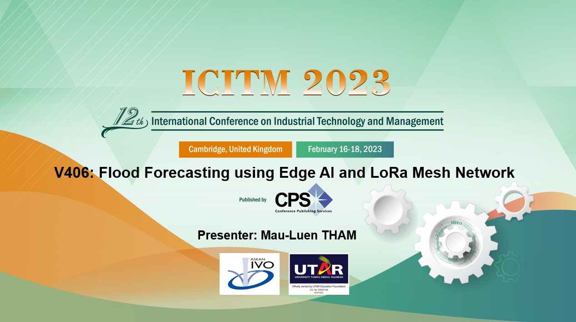
Presentation
[Required Documents]
- Presentation Materials (e.g. PPT slides)
- Final Program of the conference

Reporter: __Tham Mau Luen____________________________
Date: _______20 Feb 2023___________________________

