Appendix 5.2

“2.5D Technology-based Integrated Antenna Array mm-Wave System For Non-Invasive Food Safety Scanner (TIAS)”
[Traveling to Field Test Sites]
Report Form

I. Proposer:
Name: | Tran Thi My Hanh
Position: | Project member
Institution: | Nha Trang University

II. Objective:
- Perform together THz-based measurements with members from NICT, Waseda University (WU), The University of Tokyo (UTokyo).
- Prepare samples of chemical pellets at testing fields (UTokyo, NICT) for the target of making comparisons between Mm-Wave/THz-based measurements and chemical-based ones.
- Compare and analyze measurement results between Mm-Wave/THz methods and the one made by chemical methods which are performed by Nha Trang University (NTU), Vietnam.
TIAS project includes various research fields, from food safety, chemical analysis, chip design, antenna design, to the related IT ones. However, there are only two experts in the field of chemical analysis and food safety, which are from NTU, Vietnam as shown in Fig. 1. One member from UBD, Brunei is in biology field and does not have enough facilities for such chemical analysis required by TIAS. Therefore, the combination for such various research fields in this field test trip is nessesary.
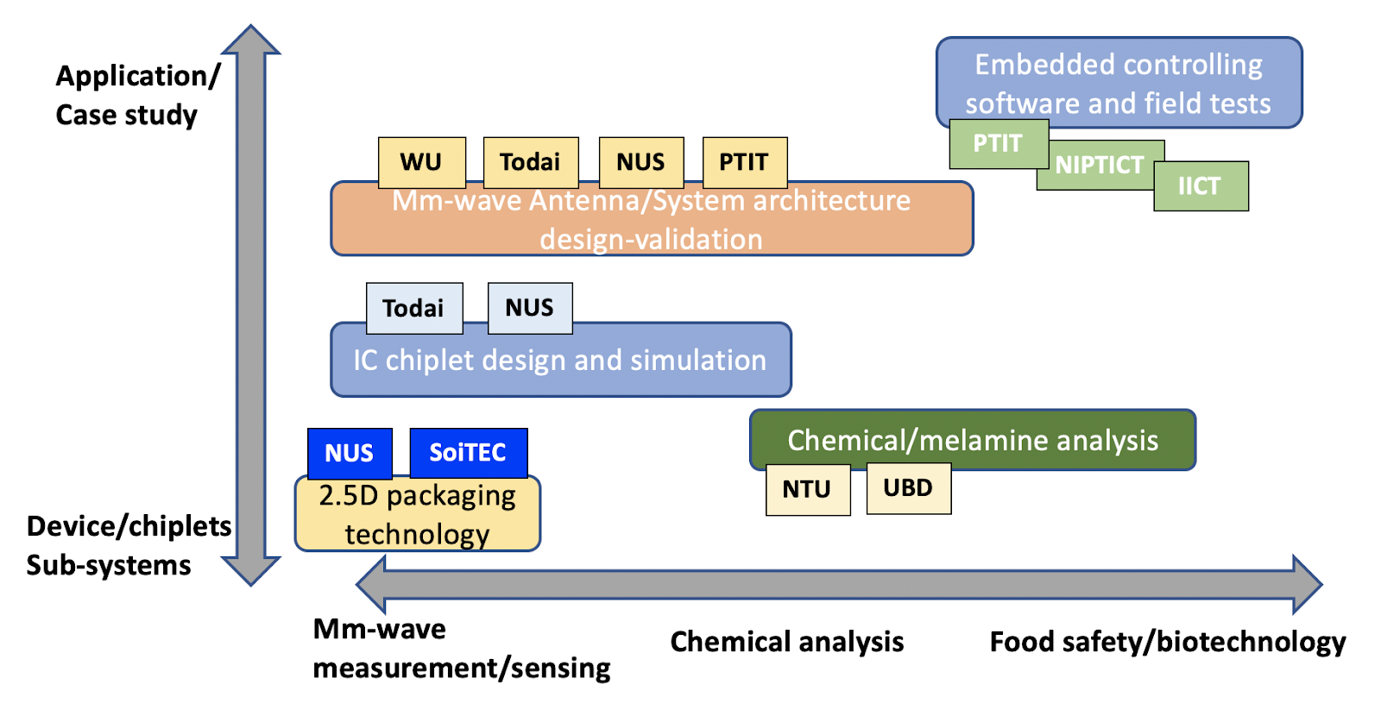
Fig. 1. Collaborative work map of the TIAS project
III. Schedule:
Date | Location | Work | Person in charge
Apr 10th, 12nd, 13 rd | University of Tokyo | - Meeting with members from UTokyo discuss on measurement results  - Progress of NTU and next plan  - Prepare measurement samples by making milk/rice powder pellets in the requirement for THz-based experiment.  - Journal preparation | Dr. Nguyen Ngoc Mai Khanh
Apr 11th & Apr 14th | NICT | - Visit NICT and discuss on measurement results  - Field test on chemical samples including milk/rice/melamine materials and their mixtures  - Progress of NTU and next plan  - Journal preparation | Dr. Keizo Inagaki
Apr 12nd | Waseda University | - Visit Waseda University and discuss on measurement results  - Progress of NTU and next plan  - Journal preparation | Prof. Tetsuya Kawanishi
(Note: describe the final schedule here)

IV. Participants:
No. | Name | Organization
1 | Tran Thi My Hanh | Nha Trang University
2 | Tran Ngoc Le | Nha Trang University
(Note: please add a participant list if there are a lot of people participating)

V. Summary of the activities corresponding to the objectives
(Note: Describe, in detail, the activities, e.g. how to install the equipment, maintain the equipment, train local researchers for data collection, etc.)
In this field test trip, we did these activities:
+ Perform together THz-based measurements with members from NICT, Waseda University (WU), The University of Tokyo (UTokyo);
+ Learn the method for preparing measurement samples by making milk and rice powder pellets in the requirement for THz-based experiment.
+ Prepare samples of chemical pellets at testing fields (UTokyo) for the target of making comparisons between Mm-Wave/THz-based measurements and chemical-based ones;
+ Compare and analyze measurement results between Mm-Wave/THz methods and the one made by chemical methods (HPLC method, FTIR method) which are performed by Nha Trang University (NTU), Vietnam;
+ Field test on chemical samples including milk/rice/melamine materials and their mixtures at NICT.
+ Discuss for next plan and a meeting face to face of members of TIAS project in August, plan for doing next experiment with chocolate and pet food (Target: exchange project’s information & share measurement results & future vision/knowledge for food safety, & out-door field trip).
+ And then together journal preparation: data analysis, writing and submission to IEICE Special Section (AIoT for Smart Farming) Issue for 2023 Oct and this manuscript is accepted now. (draft manuscript is in attachment).
VI. Others
Some of photos of field test trip
1. At University of Tokyo

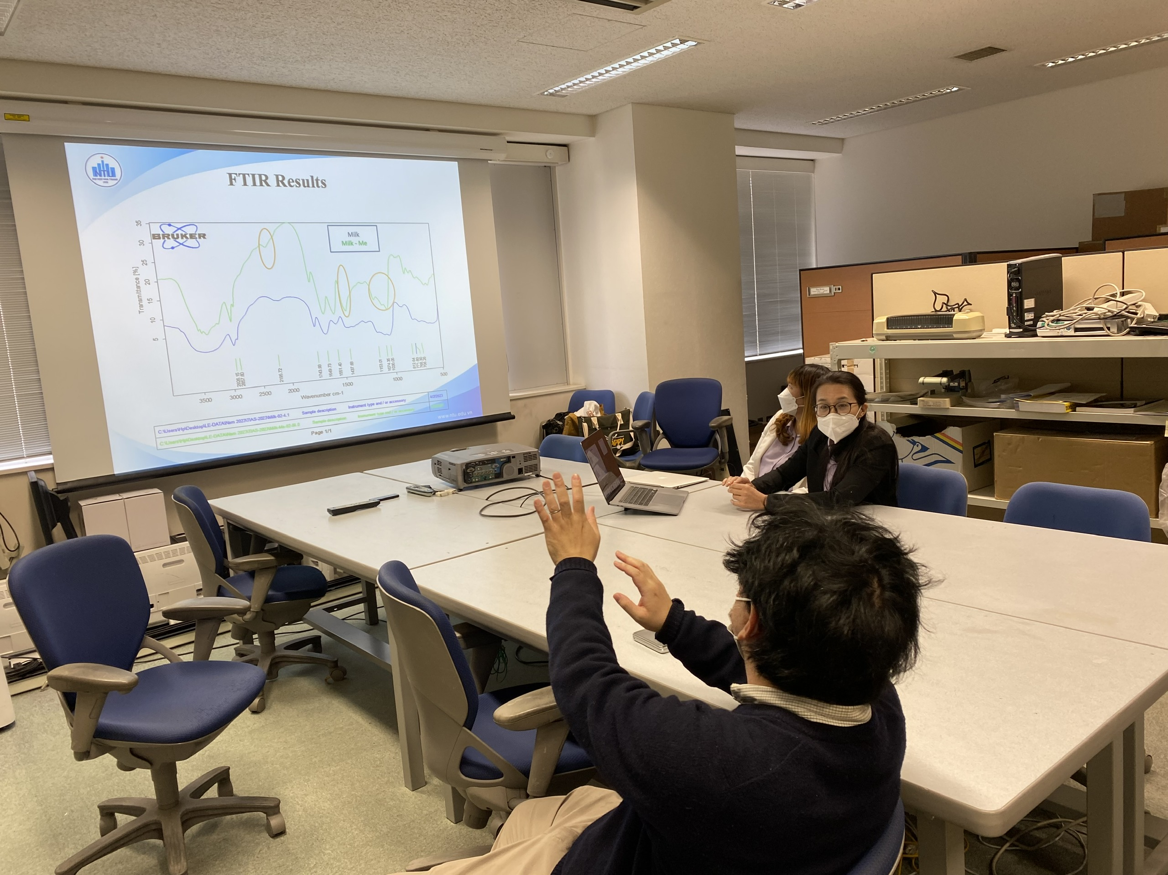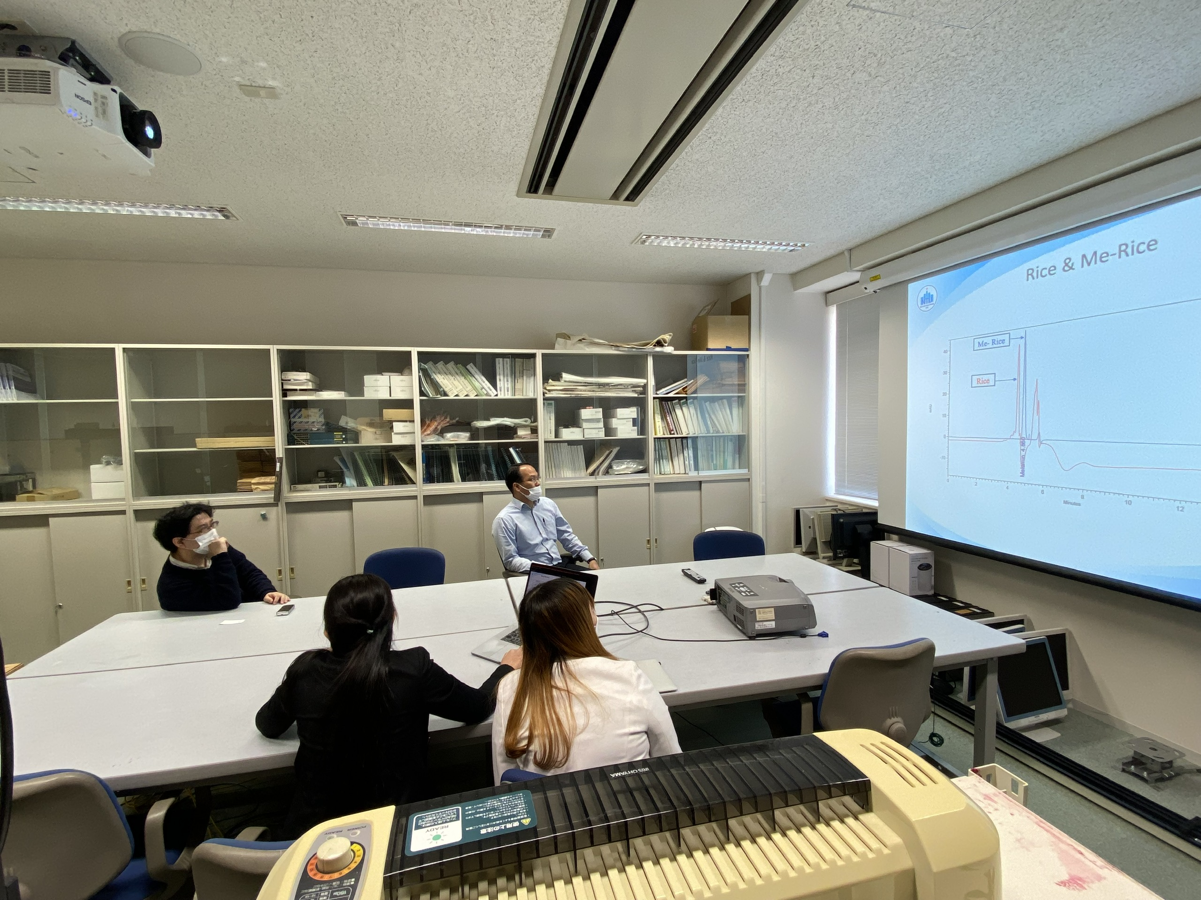
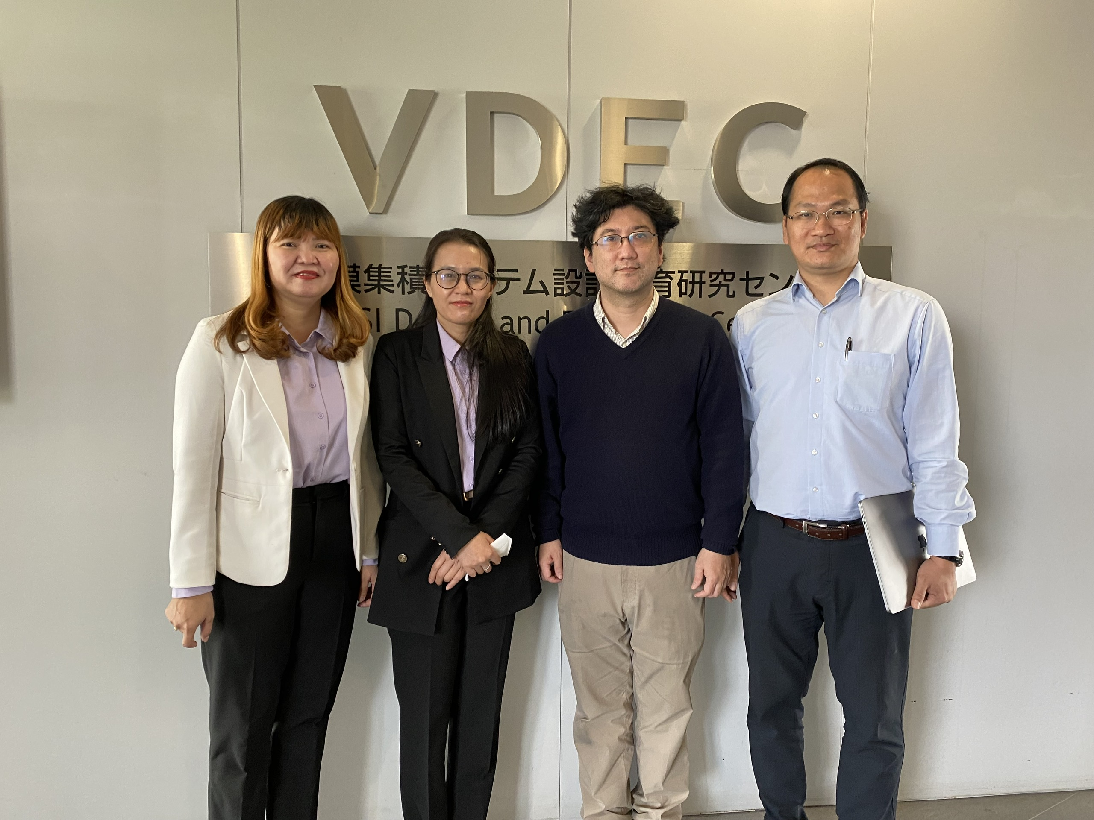

Dr. Tran Thi My Hanh (NTU); Dr. Tran Ngoc Le (NTU), Dr. Akio Higo (U-Tokyo), Dr. Nguyen Ngoc Mai-Khanh (U-Tokyo) at Systems Design Lab (d.lab), U-Tokyo.

2. At NICT

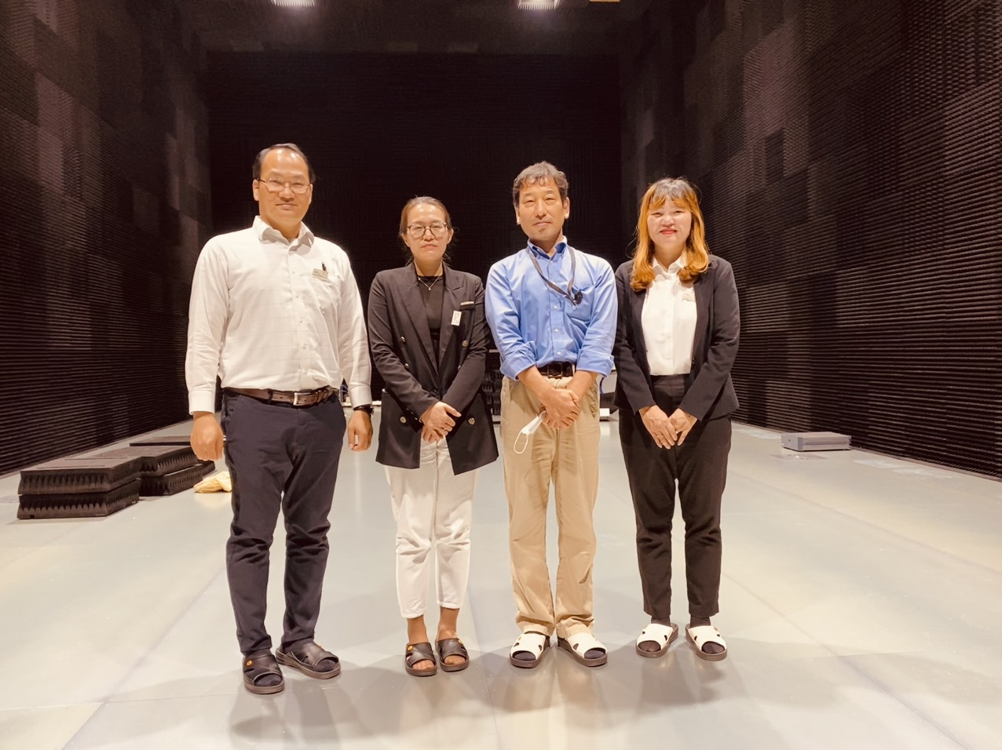

Dr. Nguyen Ngoc Mai-Khanh (U-Tokyo), Dr. Tran Ngoc Le (NTU), Dr. Keizo Inagaki (NICT); Dr. Tran Thi My Hanh (NTU) at NICT.

3. At Waseda University

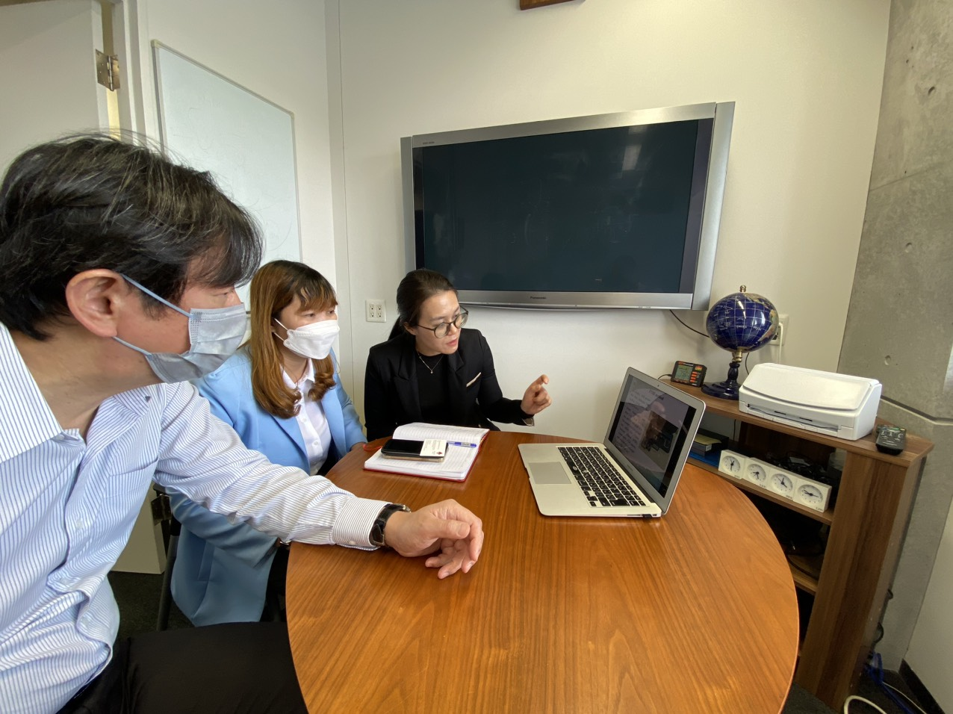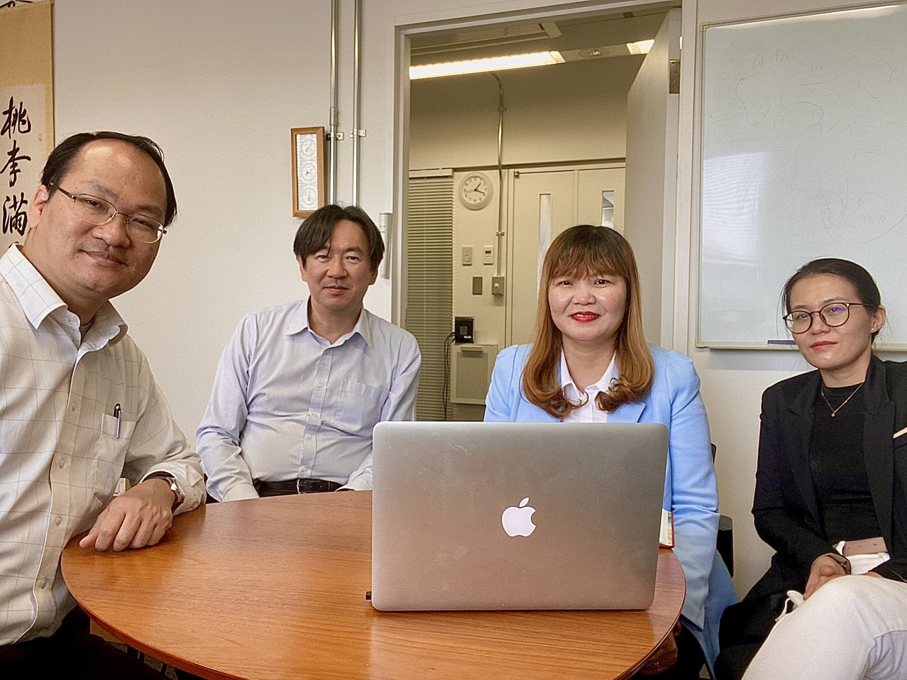

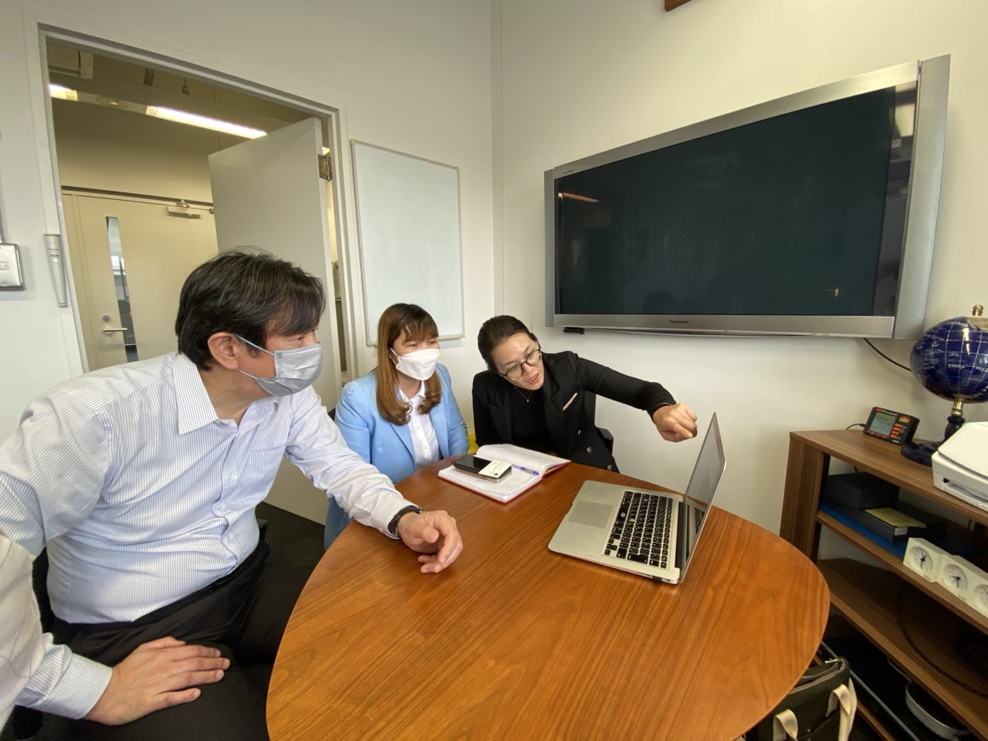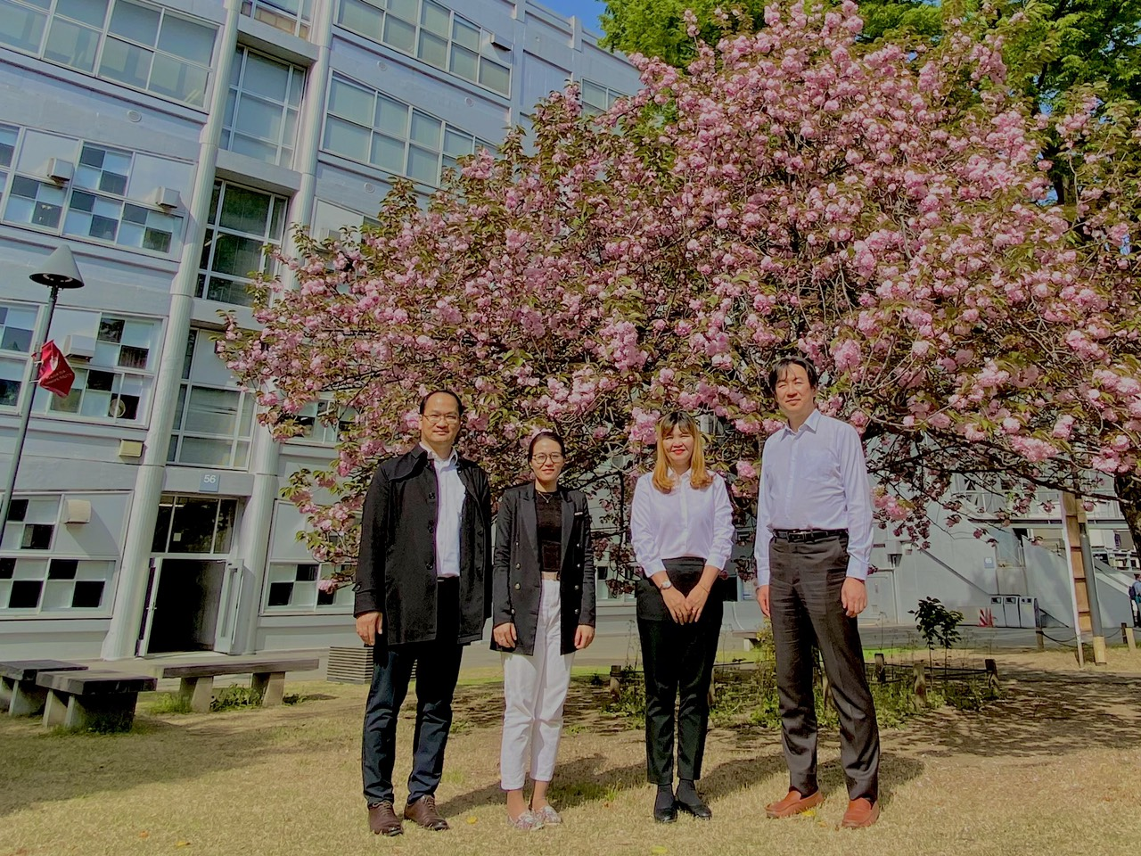

Dr. Nguyen Ngoc Mai-Khanh (U-Tokyo); Dr. Tran Ngoc Le (NTU); Dr. Tran Thi My Hanh (NTU) and Prof. Tetsuya Kawanishi at Waseda University

