Appendix 4.2

[IoT System for Water Reuse in Developing Cities]
[Knowledge transfer meeting and workshop I]
Report/Minutes Form

I. Organizer:
Name: | Assoc. Prof. Ir. Dr. Leo Choe Peng
Position: | Associate Professor
Institution: | Universiti Sains Malaysia

II. Program:

1. Closed project meeting
Date: 30/01/2024
Venue: Universiti Sains Malaysia

2. Open workshop
Date: 31/01/2024
Venue: The Institution of Engineers, Malaysia (Penang Branch) 1-04-02, E-Gate Lebuh Tunku Kudin 2 Gelugor, 11700 Pulau Pinang, Malaysia.

Program Agenda:
30/1/2024 (USM) | Activities | Participant
8.30-10.30am | Report and discussion on progress outcomes  Visit to REDAC and BIOECODS system | Huan-Bang Li  Matsumura Takeshi  Emoto Hiroshi  Leo Choe Peng  Yen Kim Sam  Yu Kok Hwa  Ho Ngo Anh Dao  Nguyễn Thành Quang  Chang Chun Kiat  Emoto Hiroshi  Tran Thi Phuong Quynh  Pham Thi Hong Nga
10.30-11.00am | Tea Break
11.00-1.00pm | Report and discussion on project outcomes  Visit to REDAC and BIOECODS system | Huan-Bang Li  Matsumura Takeshi  Emoto Hiroshi  Leo Choe Peng  Yen Kim Sam  Yu Kok Hwa  Ho Ngo Anh Dao  Nguyễn Thành Quang  Chang Chun Kiat  Emoto Hiroshi  Tran Thi Phuong Quynh  Pham Thi Hong Nga
1.00-2.00pm | Lunch
2.00 – 4.00pm | Proposal drafting | Huan-Bang Li  Matsumura Takeshi  Emoto Hiroshi  Leo Choe Peng  Yen Kim Sam  Yu Kok Hwa  Chang Chun Kiat  Ho Ngo Anh Dao  Nguyễn Thành Quang  Tran Thi Phuong Quynh  Pham Thi Hong Nga
4.00-4.30 pm | Tea Break
4.30 – 5.30pm | Proposal Drafting  Visit to School of Chemical Engineering and School of Mechanical Engineering | Huan-Bang Li  Matsumura Takeshi  Emoto Hiroshi  Leo Choe Peng  Yen Kim Sam  Yu Kok Hwa  Chang Chun Kiat  Ho Ngo Anh Dao  Nguyễn Thành Quang  Tran Thi Phuong Quynh  Pham Thi Hong Nga
31/01/2024 (IEM Penang E-gate Office) | Activities | Speaker
8.30-8.45 am | Welcome remarks | Project Leader  Assoc. Prof. Ir. Dr. Leo Choe Peng
8.45-9.00 am | Introduction to IEM | Ir. Ts. Dr. Chang Chun Kiat
9.00-9.30 am | Introduction to Wireless Networks Research Center, the National Institute of Information and Communications Technology (NICT) | Dr. Matsumura Takeshi
9.30-10.30 am | Device-to-device (D2D) communication and its applicatons | Prof. Huan-Bang Li (NICT)
10.30-11.00 am | Tea Break | Networking & exchange name cards
11.00-11.30 am | Introduction to Ton Duc Thang University | Dr. Ho Ngo Anh Dao
11.30-12.30 pm | IoT for environmental management in Vietnam, from policy to implementation | Dr. Tran Thi Phuong Quynh (TDTU)
12.30-1.00 pm | Introduction of NICT and ASEAN IVO | Dr. Emoto Hiroshi
1.00-2.00 pm | Lunch/ Prayer Time
2.00-3.00 pm | Sharing of IWK journey on Waste to Resource Towards a Resource Efficient & Circular Economy in Malaysia | Speaker: Ir. Khor Bee Chin
3.00-4.00 pm | Transition to green logistics in Malaysia | Mr. Gooi Liang Zheng
4.00-4.15 pm | Tea Break | Networking & exchange name cards
4.15-5.15 pm | Revolutionary milestone in water resources management: Application of SCADA and IoT in the context of Malaysia | Speaker: Ts. Tah Ai Sher
5.15-6.15 pm | Closing remarks | Project Leader  Assoc. Prof. Ir. Dr. Leo Choe Peng
01/02/2024 to 02/02/2024 (Cameron Highlands Field Trip) | Activities | Participants
9.00-12.00 pm | Check out  Check out and travel to Cameron Highlands (247 km)  Travel to Cameron Highlands (247 km) | Huan-Bang Li  Leo Choe Peng  Yen Kim Sam  Yu Kok Hwa  Chang Chun Kiat
1.00-5.30 pm | Farm Visits | Huan-Bang Li  Leo Choe Peng  Yen Kim Sam  Yu Kok Hwa  Chang Chun Kiat
7.00-11.00 am | Check out and travel to airport (251 km)  Check out and Farm Visits | Huan-Bang Li  Leo Choe Peng  Yen Kim Sam  Yu Kok Hwa  Chang Chun Kiat
2.00-7.00 pm | Travel to USM | Leo Choe Peng  Yen Kim Sam  Yu Kok Hwa  Chang Chun Kiat

III. Participants:

No. | Name | Organization | Itinerary
 | Leo Choe Peng | USM | 29.1.2024-2.2.2024
 | Yu Kok Hwa | USM | 29.1.2024-2.2.2024
 | Yen Kin Sam | USM | 29.1.2024-2.2.2024
 | Ho Ngo Anh Dao | TDTU | 29.1.2024-2.2.2024
 | Nguyễn Thành Quang | TDTU | 29.1.2024-2.2.2024
 | Tran Thi Phuong Quynh | TDTU (Speaker 2) | 29.1.2024-2.2.2024
 | Pham Thi Hong Nga, | TDTU (participant) | 29.1.2024-2.2.2024
 | Huan-Bang Li | NICT (Speaker 1) | 29.1.2024-2.2.2024
 | Matsumura Takeshi | NICT | 29.1.2024-2.2.2024
 | Emoto Hiroshi | NICT | 29.1.2024-31.1.2024
 | Chang Chun Kiat | IEM (Penang) Vice Chairman/ REDAC USM | 31.1.2024-2.2.2024
 | Ir. Khor Bee Chin (Speaker 3) | Indah Water Konsortium Sdn. Bhd | 30.1.2024-31.1.2024
 | Mr. Gooi Liang Zheng (Speaker 4) | Greenetrix Sdn. Bhd. | 31.1.2024
 | Ts. Tah Ai Sher (Speaker 5) | TCK e-solutions (M) Sdn. Bhd. | 30.1.2024-31.1.2024
 | IEM member | IEM | 31.1.2024
 | IEM member | IEM | 31.1.2024
 | IEM member | IEM | 31.1.2024
 | IEM member | IEM | 31.1.2024
 | IEM member | IEM | 31.1.2024
 | IEM member | IEM | 31.1.2024
 | IEM member | IEM | 31.1.2024
 | IEM member | IEM | 31.1.2024
 | IEM member | IEM | 31.1.2024
 | IEM member | IEM | 31.1.2024
 | IEM member | IEM | 31.1.2024
 | IEM member | IEM | 31.1.2024
 | IEM member | IEM | 31.1.2024
 | IEM member | IEM | 31.1.2024
 | IEM member | IEM | 31.1.2024
 | IEM member | IEM | 31.1.2024
 | IEM member | IEM | 31.1.2024
 | IEM member | IEM | 31.1.2024
 | IEM member | IEM | 31.1.2024
 | IEM member | IEM | 31.1.2024
 | IEM member | IEM | 31.1.2024
 | IEM member | IEM | 31.1.2024
 | IEM member | IEM | 31.1.2024
 | IEM member | IEM | 31.1.2024
 | IEM member | IEM | 31.1.2024
 | IEM member | IEM | 31.1.2024
 | IEM member | IEM | 31.1.2024
 | IEM member | IEM | 31.1.2024
 | IEM member | IEM | 31.1.2024
 | IEM member | IEM | 31.1.2024
 | IEM member | IEM | 31.1.2024
 | IEM member | IEM | 31.1.2024
 | IEM member | IEM | 31.1.2024
 | IEM member | IEM | 31.1.2024
 | IEM member | IEM | 31.1.2024
 | IEM member | IEM | 31.1.2024

IV. Summary of the activities corresponding to the objectives
Summary of Meeting
The main objective of this meeting and workshop is to transfer knowledge on water reuse and related IoT systems to the team members, at the same time providing a chance for the team members to understand the progress of each other. During the Closed project meeting on Jan 30, the team members presented their recent progress and they managed to brainstorm improvement in the project activities. Besides discussing the report and project outcome for the ASEAN IVO, the team members also spent their time on the proposal drafting. Moreover, the team members managed to visit REDAC and BIOECODS systems, the School of Chemical Engineering, and the School of Mechanical Engineering to see and understand their innovations for future collaboration. The water reuse system and D2D system in USM also have been discussed by the team members.

Summary of Workshop
During the workshop on Jan 31, more researchers related to water research were gathered to meet the team members and invited speakers. After the welcome remark from Assoc. Prof. Ir. Dr. Leo Choe Peng (Project Leader) and the IEM introduction from Ir. Ts. Dr. Chang Chun Kiat, Dr. Matsumura Takeshi was invited to introduce the Wireless Networks Research Center, NICT. Prof. Huan-Bang Li presented the D2D communication and its application before Dr. Ho Ngo Anh Dao introduced the Ton Duc Thang University (TDTU). Dr. Tran Thi Phuong Quynh from TDTU also shared her knowledge on the IoT for environment management in Vietnam, from the policy to implementation. Dr. Emoto Hiroshi also introduced the NICT and ASEAN IVO to the workshop participants. After lunch, 3 of our speakers from Malaysia, Ir. Khor Bee Chin, Mr. Gooi Liang Zheng, and Ts. Tah Ai Sher, shared their knowledge about water research, economy, logistics, management, and IoT in Malaysia. The participants took the opportunity to have QnA sessions with the speakers and build networks with each other. In general, the hotel and flight were covered for 2 speakers for this workshop (Ir. Khor Bee Chin and Ts. Tah Ai Sher) to travel between Kuala Lumpur and Pulau Pinang. Ts. Tah ai Sher and Ir. Khor Bee Chin did not request to travel by flight. Ts. Tah Ai Sher speaker stayed 1 night at the hotel.

Summary of Field Trip
The field trip was organised for 2 days 1 night (01/02/2024-02/02/2024) at Cameron Highlands. Prof Huan-Bang Li (NICT) and Assoc. Prof. Ir. Dr. Leo Choe Peng (USM), Dr. Yen Kim Sam (USM), Dr. Yu Kok Hwa (USM), and Ts. Ir. Dr. Chang Chun Kiat (USM) departed from the hotel and USM to Cameron Highlands. The team members planned to look for possible applications on a large scale. Thus, team members visited a few local farms where farms were developed with Agzui system IoT devices with automated farm and plantation irrigation. The weather-driven irrigation system was also a concern.

V. Others
Photos meeting at USM:

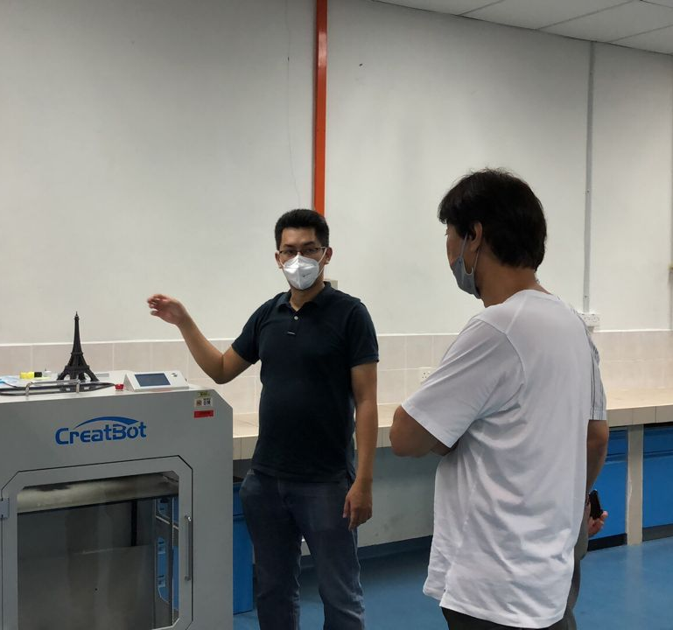
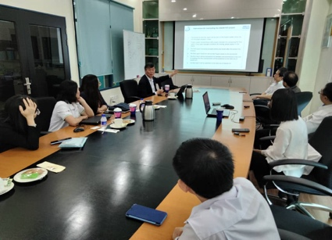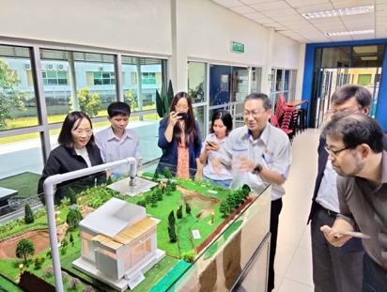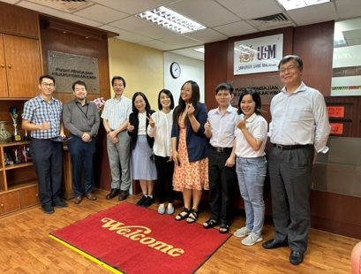
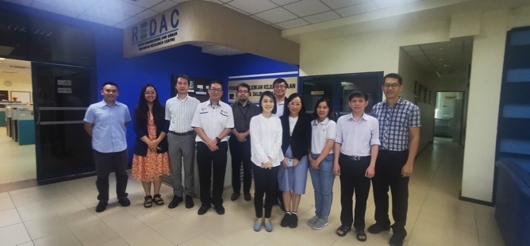
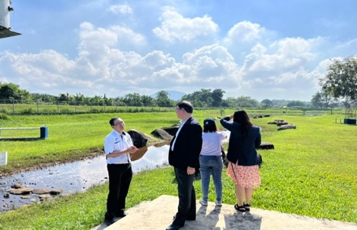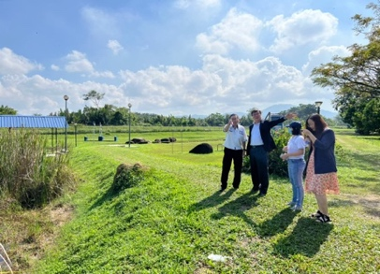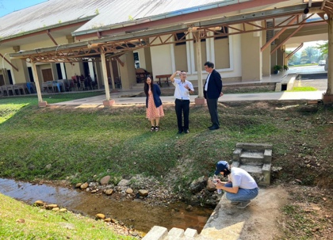
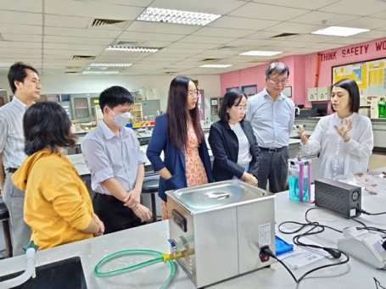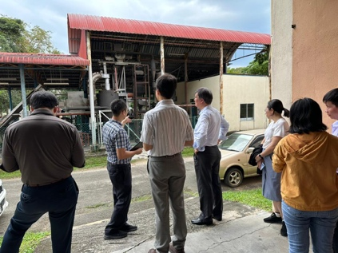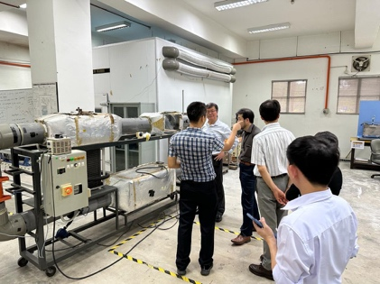
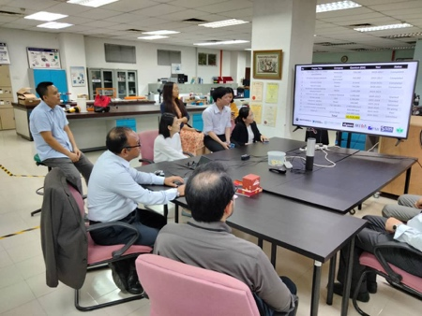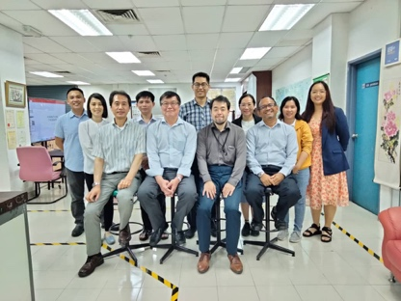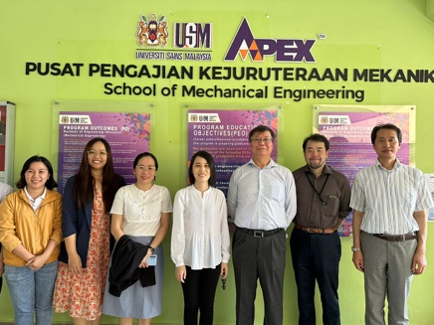

Photos of the workshop:
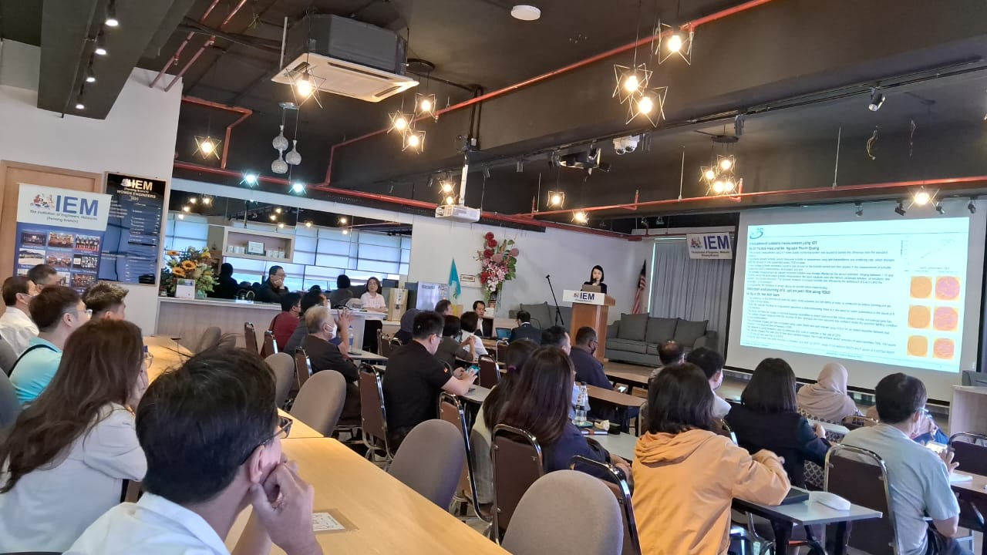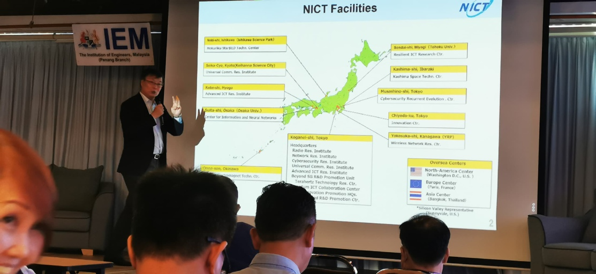
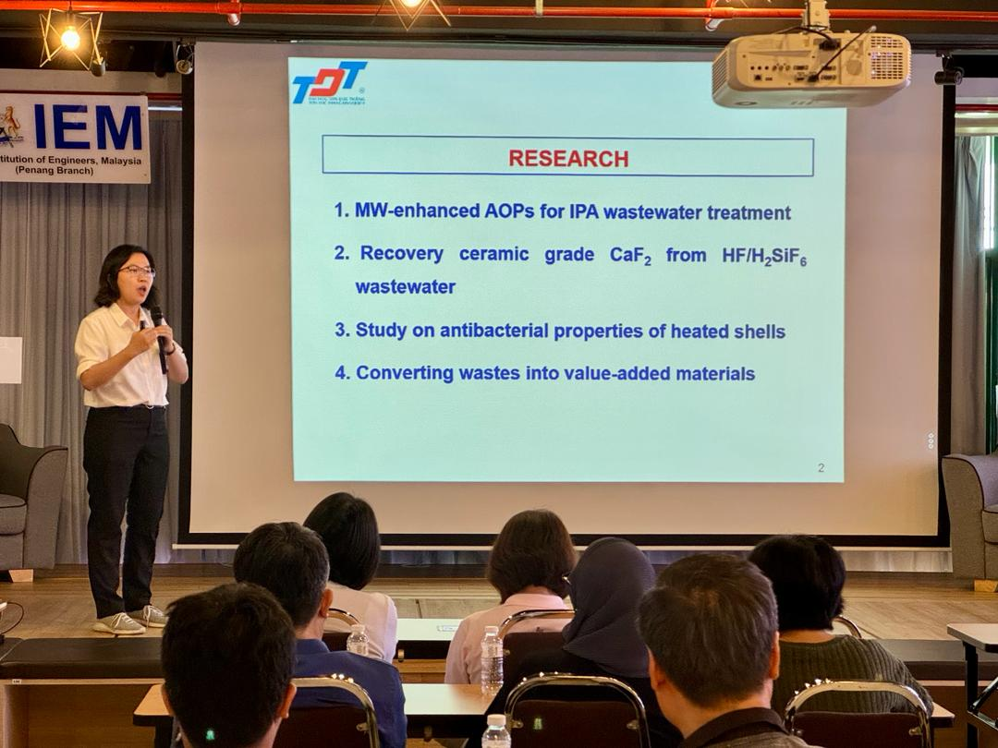

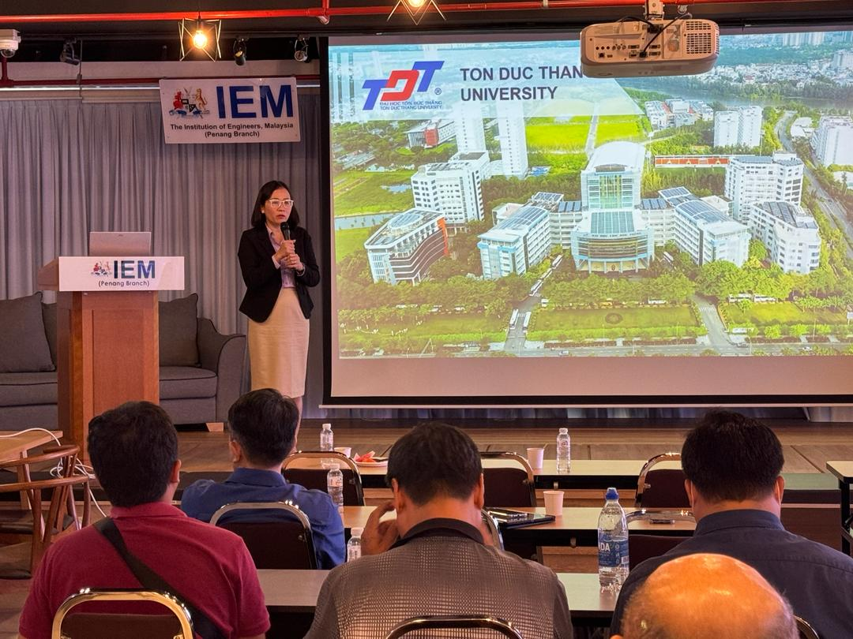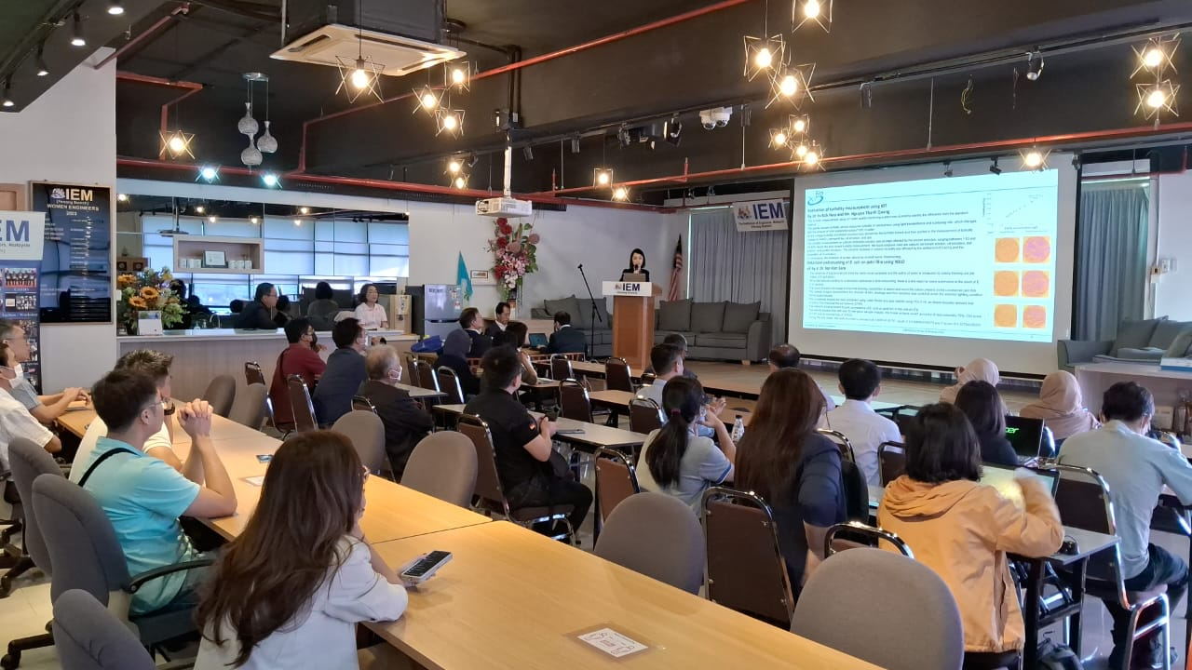

Photos of field trip at Cameron Highlands:

