Appendix 2.2

Report of International Conference Presentation

Name:  (Presenter) | Pornchai Supnithi
Affiliation: | School of Engineering,  King Mongkut’s Institute of Technology Ladkrabang,  Bangkok 10520, Thailand
Project Title: | GNSS and Ionospheric Data Products for Disaster Prevention and Aviation in Magnetic Low-Latitude Regions (Phase II)
Name of International Conference:  (Link to website) | The ION GNSS+ 2023, Denver, USA  https://www.ion.org/gnss/
Title of Research Paper: | Effects of Equatorial Plasma Bubbles over Real-Time Kinematic Positioning in Low-Latitude Region
Name of all Co-authors (if any) | Phyo C Thu, Pornchai Supnithi, Lin Min Min Myint, Jirapoom Budtho
Comments or feedback received at the conference:
Many participants were interested in the effects of equatorial plasma bubbles (EPB) on precise positioning. Some request that we work on EPB movement and prediction.
Contribution to the project:
In the conference, we presented some research works on the effects of equatorial plasma bubbles (EPB) to RTK positioning, which is an objective in the ASEAN IVO project, in the F5b – Atmospheric effects on GNSSS session. It results in a conference publication. In the session and the conference, we interacted with researchers who work with GNSS data in low-latitude region, so it is a productive experience. The comments and discussions on our research work related to RTKlib software setting (LAMDA ratio setting), data quality check will increase the quality of this research. As the ION GNSS+ conference is a premier conference in the area. Following the conference, we are finalizing the manuscript to be submitted to the prestigious Navigation journal.
Photos
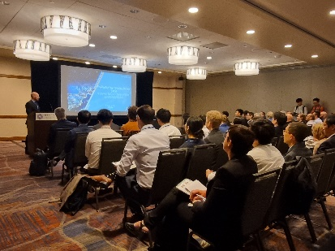
Figure 1: Atmosphere of a technical session

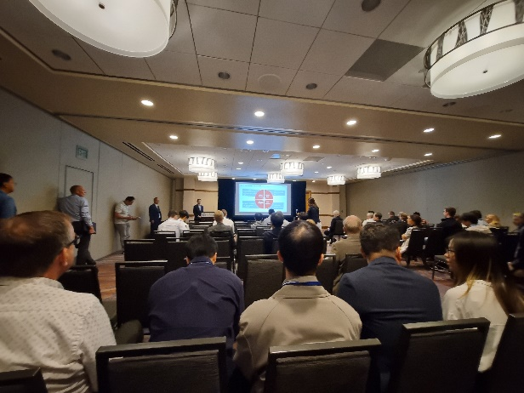Figure 2: Atmosphere of another active session | 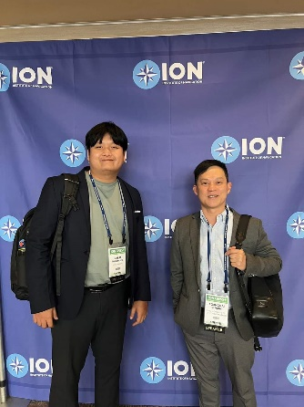  Figure 3: Photo op with a doctoral student of our lab | 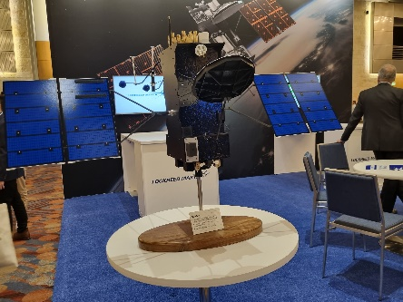  Figure 4: An exhibition in the ION GNSSS+ conference

[Required Documents]
- Presentation Materials (Slides)
- Final Program of the conference

Reporter: _____Pornchai Supnithi_________
Date: ________22/9/2023_________

