Appendix 2.2

Report of International Conference Presentation

Name:  (Presenter) | LIN MIN MIN MYINT
Affiliation: | School of Engineering,  King Mongkut’s Institute of Technology Ladkrabang,  Bangkok 10520, Thailand
Project Title: | GNSS and Ionospheric Data Products for Disaster Prevention and Aviation in Magnetic Low- Latitude Regions (Phase II)
Name of International Conference:  (Link to website) | The XXXVth URSI General Assembly and Scientific Symposium (URSI GASS 2023), SAPPORO, JAPAN  https://www.ursi-gass2023.jp/
Title of Research Paper: | Near Real-time Equatorial Plasma Bubble Monitoring System using GNSS at the Low Latitude Region in ASEAN
Name of all Co-authors (if any) | Napat Tongkasem (KMITL), Pornchai Supnithi (KMITL), Kornyanat Hozumi (NICT), Donekeo Lakanchan (NUOL), Thayheng Nhem (CADT)
Comments or feedback received at the conference:
Many participants were interested in our poster and ASEAN-IVO project. One important recommendation is to develop a real-time plasma bubble monitoring system using C programming language that is faster than MATLAB. Another recommendation is to use image processing techniques for real-time EPB detection.

Contribution to the project:
At this conference, I conducted a poster presentation in the G12 poster session, focused on Ionosphere monitoring and modeling review. Throughout the event, I actively participated in various oral and poster presentation sessions mostly related to the URSI’s Commission G which is related to Ionospheric Radio and Propagation. The sessions included G01: GNSS Radio Occultation and zenith data from Low Earth Orbit, G03: Ionospheric Space Weather and Impacts on Technological Systems, G04: International Reference Ionosphere: Improvement, Validation and Usage, G05: Advances in Irregularities and Scintillation Studies, G06: Advances in Machine Learning methods for ionospheric modelling, G10: International Beacon Satellite Studies, G12: Ionosphere monitoring & modeling review G15: Techniques, Methods and Issues for Real Time Ionospheric Modeling, C01: Low-Cost GNSS Receivers.
The conference provided me with valuable insights that I aim to apply to ongoing projects. Moreover, I have the privilege of meeting distinguished and experienced academics and researchers in space weather research. I plan to share my newfound knowledge with other project members in KMITL to enhance our collective projects. Therefore, this conference is very beneficial for me and the conference.

Photos
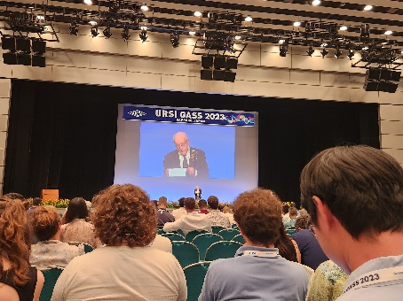
Figure 1: Attending Opening Ceremony on Monday, August 20, 2023
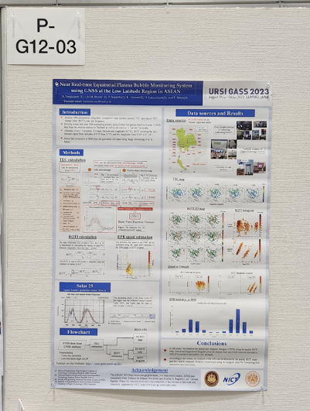  Figure 2: Poster presentation at G12 session | 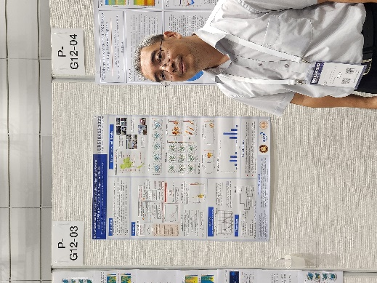  Figure 3: Poster presentation and presenter | 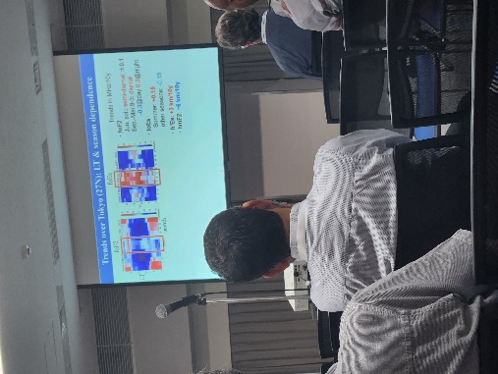  Figure 4: Attending other presentation sessions

[Required Documents]
- Presentation Materials (Poster)
- Final Program of the conference

Reporter: _____Lin Min Min Myint_________
Date: ________28/8/2023_________

