An IoT-based Public Transport Collection and Analytics Framework using Bluetooth Proximity Beacons (BLE)
Project Meeting and Knowledge Sharing in Malang Indonesia
Report/Minutes Form

I. Organizer:
Name: | Dr. Achmad Basuki (P2205R01)
Position: | Project Coordinator
Institution: | Universitas Brawijaya

II. Objective:

The Universitas Brawijaya team has deployed the Road-Side Unit (RSU) system at eight locations in Malang city, working with the local school bus operator on route A to provide estimated time of arrival for school bus. The project meeting and knowledge sharing aims to bring together all partners of An IoT-based Public Transport Data Collection and Analytics Framework using Bluetooth Proximity Beacons project to showcase the deployment sites in Malang and to share the technical know-how with the other team members, especially the team from Malaysia. The meeting will also enable partners to exchange ideas and discuss the challenges, solutions and approach for research and development collaboration.

III. Program:
In the beginning, the project meeting and knowledge sharing were planned for 14 – 15 December 2023. Unfortunately, the flight ticket rate was way too expensive, and the hotel was fully booked due to the festive season during that period. After discussing some other considerations with the project leader and all members, we finally decided to shift the planned schedule to 25-26 January 2024.

Date: 25 – 26 January 2024
Venue: The Shalimar Boutique Hotel (Malang, Indonesia)

08:15 – 08:30 | Registration – Housekeeping.
08:30 – 09:30 | Introductory Session  - Welcome and Opening by Achmad Basuki (10 mins)  - Introductory – Greeting by each member (15 mins)  - Overview of Deployment in Malang (35 mins)
09:30 – 10:00 | Morning Coffee Break
10:00 – 12:00 | IoT Deployment Discussion  - Knowledge sharing of the deployed system  - Discussion on the deployment from project members
12:00 – 13:00 | Lunch & Networking
13:00 – 15:00 | Site Visit – Knowledge sharing of field setup and issues:  - Tugu  - Ijen  - Jakarta  - Veteran
15:00 – 15:30 | Afternoon Coffee Break
15:30 – 17:00 | Wrap-up for Day 1

Day 2
08:45 – 09:00 | Registration
09:00 – 10:00 | Discussion & Showcase of Developed Mobile App  - Showcase of Mobile App
10:00 – 10:15 | Morning Coffee Break
10:15 – 11:15 | Discussion & Showcase of Developed Mobile App (Cont’d)  - Discussion on ETA algorithms
11:15 – 13:00 | Lunch and Networking
13:00 – 15:00 | Discussion on Data Analytics and Machine Learning  - Data collection and model training  - Journey duration prediction model
15:00 – 16:00 | Next Steps  - Year 2 Plan  - Project Management
16:00 | End of Meeting

IV. Participants:

No. | Name | Organization
1 | Dr. Achmad Basuki | UB
2 | Dr. Eko Setiawan | UB
3 | Dr. Agung Setia Budi | UB
4 | Prof. Ir. Dr. Sharul Kamal Abdul Rahim | UTM
5 | Mrs. Siti Fatimah bte Ausordin | UTM
6 | Dr. Noor Farizah Binti Ibrahim | USM
7 | Dr. Yung-Wey Chong | USM
8 | Dr. Sye Loong Keoh | UGS
9 | Dr Chee Kiat Seow | UGS
10 | Dr. Tham Mau Luen | UTAR
11 | Dr. Kok Chin Kor | UTAR

V. Summary of the activities corresponding to the objectives.

The objective of the meeting was to showcase the deployed system in Malang, Indonesia, in which the Universitas Brawijaya (Malang) team is working with the local agency and school bus operator on route ‘Pool A’. The project meeting aims to bring together all partners to showcase the deployment sites in Malang and to share the technical know-how with the other team members, especially the team from Malaysia. The meeting aims to also enable partners to exchange ideas and discuss the challenges, solutions and approach for research and development collaboration.

The organizer Prof Basuki first welcomed all the participants at The Shalimar Boutique Hotel and later provided an overview of the project deployment in Malang according to the current progress.
- 7 Road Side Units (RSU) using Raspberry Pi have been installed in Malang. They are installed on the CCTV poles managed by the government agency, so that there is continuous power supply for the RSU. A USB 4G modem is used to provide Internet connectivity to the RSU.
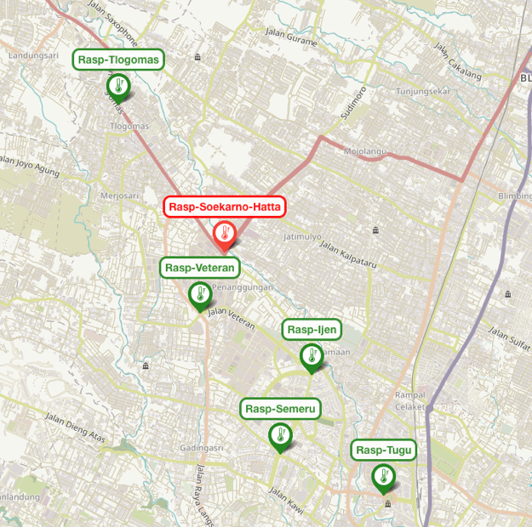

Fig 1: Location of the installed RSU in Malang
- The route ‘Pool A’ operates 2-3 trips per day, one in the morning the pick-up students and drop them off at their respective schools, while the return trip operates in the afternoon around 15:30pm. Occasionally, there will be a trip at noon.

There were discussions around the difficulty of getting a suitable 4G dongle / modem in Indonesia due to the regulation that all devices utilizing the SIM card need to register its IMEI with the authorities. Hence, the RSU (RPi) could be replaced using a mobile phone in the future for ease of deployment in Indonesia.

During the deployment in Malang, the team experienced an unstable Internet connectivity issue, likely due to the heat. A fan could be used to lower the temperature in the enclosure.

The Malang and UGS/Johor team discussed approaches to identify the direction of travel of the bus. Some of the RSU are placed on location where the bus would be detected multiple times throughout its journey and it is important to incorporate some intelligence or context on the RSU to send the correct information to the cloud server.

Recently, there is a change in the routing of the ‘Pool A’ bus as some of the roads have been changed to one-way traffic. Hence, the back-end server will need to adjust the bus routes accordingly. Due to the traffic change, one RSU can’t detect the bus in the evening trip. The estimation algorithm should be updated to handle this condition.

Dr Keoh also provided an update on the deployment in Johor, where the team has managed to engage a new bus operator, myBAS to work together on this project. Two bus service routes, T30 and T31 have been added to bus service routes for the Johor deployment. There are 6 buses for each route that are fitted with a BLE beacon. This will enable the team to collect more dataset for machine learning.

The team then proceeded to visit the sites with RSU installed. A bus was arranged to ferry the participants to all sites. We first visited the Tugu RSU, where the RSUi is installed, and the team members had the chance to see the infrastructure set-up deployed. A short test was carried out to measure the range of BLE detection at the roundabout where RSU is installed at the Tugu. Later on, the team proceeded to visit the other sites and ended the visit at Veteran near Universitas Brawijaya.

On Day 2, the team gathered in the morning to discuss Mobile App. Although a preliminary mobile app has been developed for Johor, the UI/UX needs to be improved. Both the UB and UTM/UGS team will get some students to develop a cross-platform mobile app. Prof Sharul suggests that the team take reference from the Moovit app.

For the data analytics and ETA algorithm, Dr Ibrahim presented their findings in that they have developed a LightGBM model that can predict the journey duration quite accurately from the test results. The finding will be presented at the International Conference on Artificial Intelligence in Information and Communication (ICAIIC) in Osaka, Japan in Feb 2024. The model was trained using the data collected from August – October 2023. Separately, another model trained on LSTM was also presented and for this model, weather information of Larkin is included as one of the features. The preliminary finding is promising. The next step is to deploy the model using Flask and integrate with the ETA algorithm to benchmark the performance. Additionally, the model can be tested and validated against the new dataset collected from November 2023 – January 2024.

Dr Khor also reported that Prof Somnuk will also make the dataset available as a class assignment for his students to develop models for the journey duration prediction. Dr Ibrahim said it is fine for the USM team to provide the clean data to UTB.

Dr Keoh also reported that the journey prediction model using ANN developed by his student has also been accepted for publication at ICAIIC in Osaka 2024.

Finally for Year 2 planning, the team will focus on the collection of quality data, possibility of installing more RSU / RPi in Johor and Malang. For Johor, as two new bus routes have been added, there is a need to install additional RPi to collect the bus fleet location data. While for Malang, it is important that we understand the operation schedule correctly so that the data collected are useful. The team will update the mobile application due to traffic change then demonstrate it to the Malang local agency so the team will have a good opportunity to apply RSU in another bus route. The team will also be working on the e-Ink display for deployment in Johor to show ETA to the public users (subject to approval). Workshops to engage the various stakeholders such as bus operators, government agencies in order to showcase our work will be organized in the second year. A project extension request has been submitted to NICT in December.

There is no change to the current project schedule or budget allocation.

VI. Others
Pictures
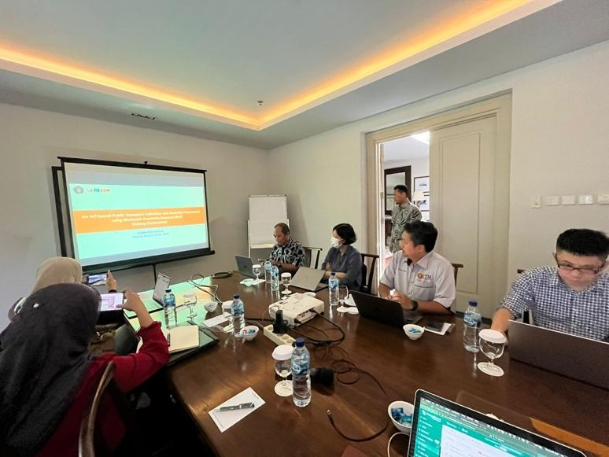
Figure 2: Prof Basuki kick-off the project meeting on Day 1

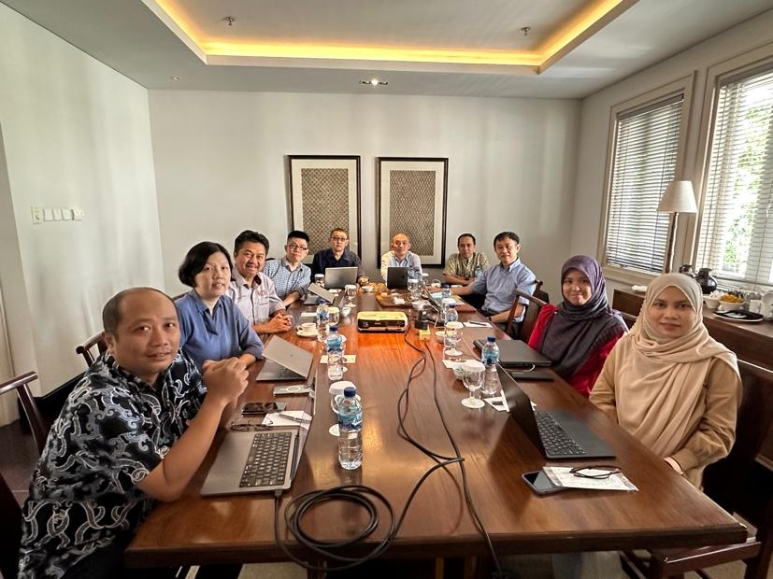
Figure 3: Group photo at the meeting venue

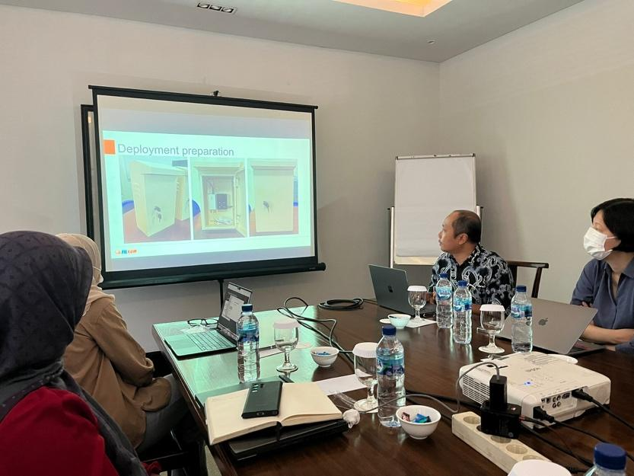
Figure 4: Discussion on Malang deployment
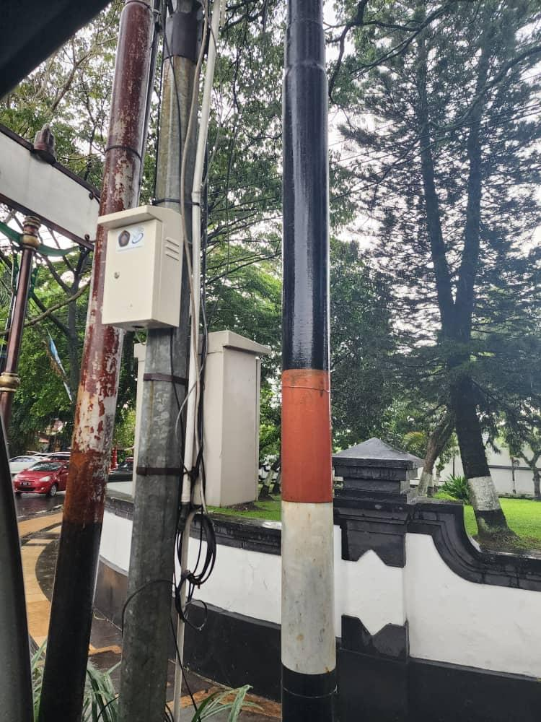
Figure 5: One of the RSUs installed in Malang

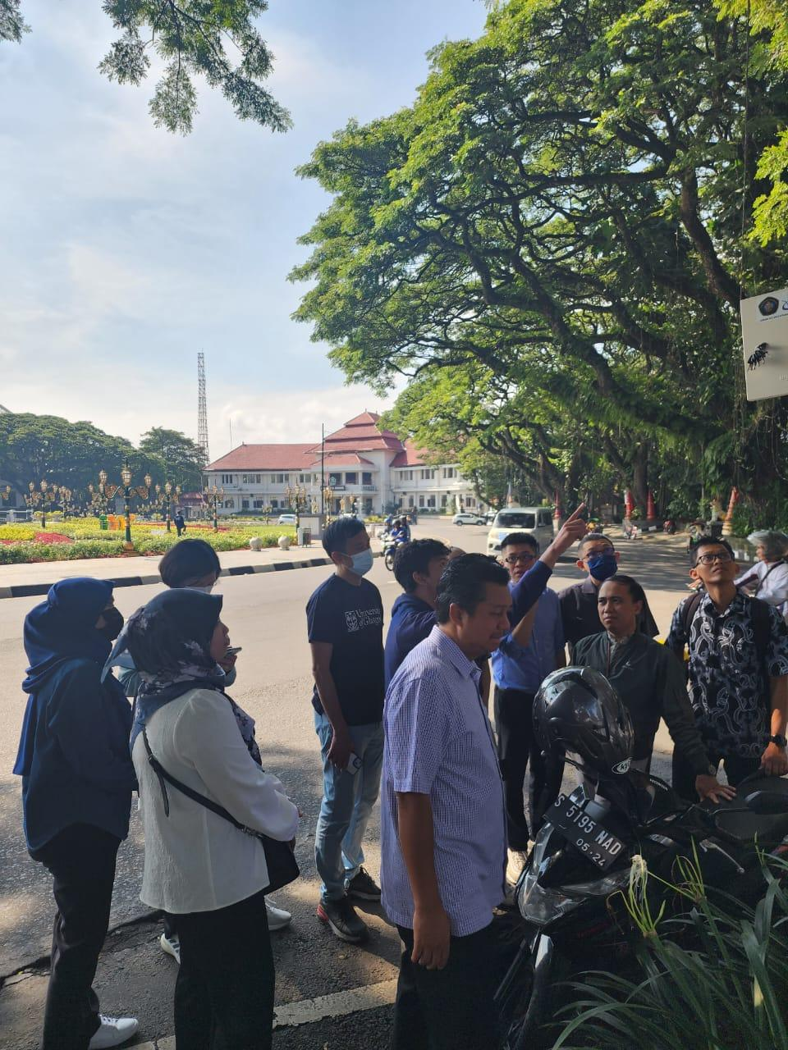
Figure 6: Visiting the Tugu Roundabout Site

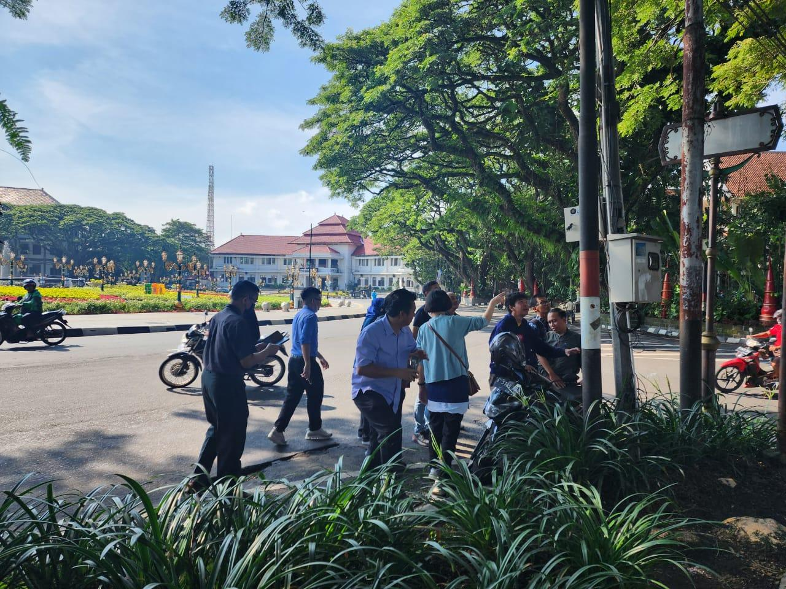
Figure 7: Visiting the Tugu Roundabout site

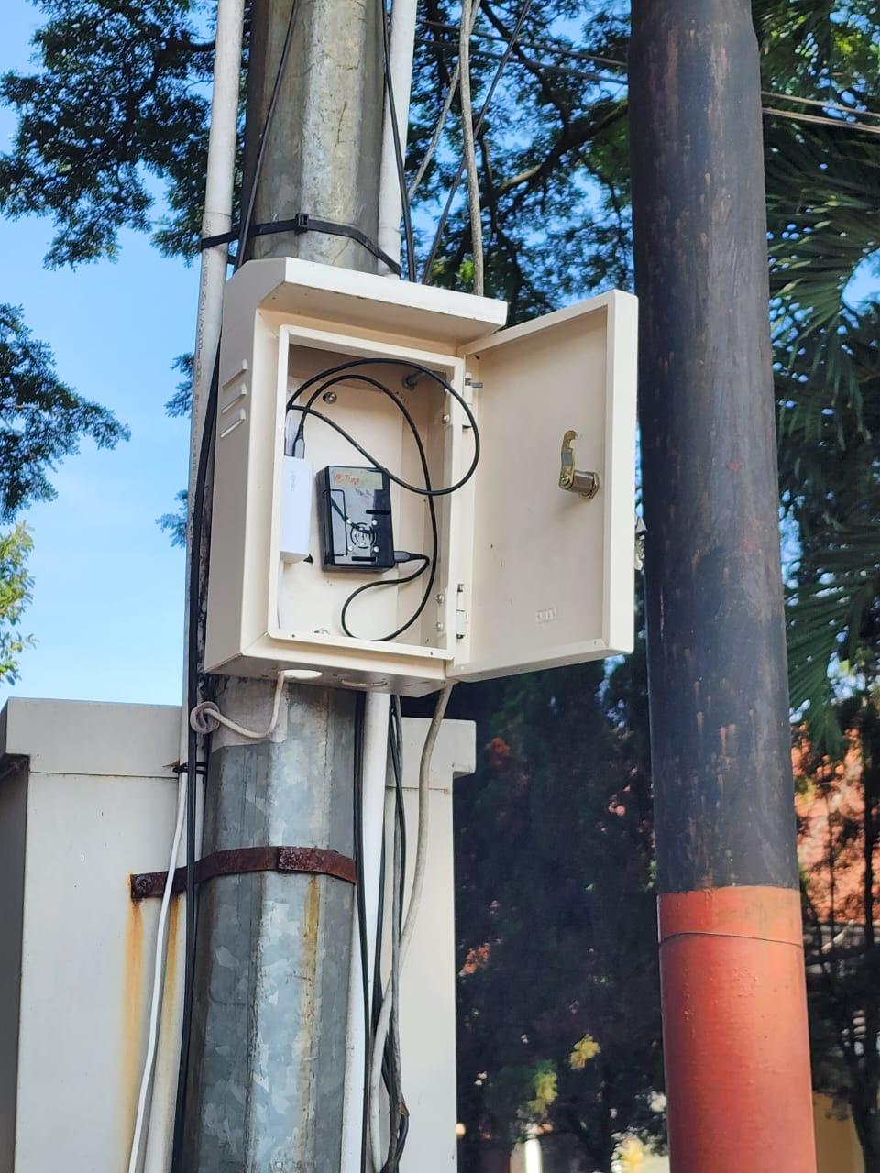
Figure 8: Inspecting the RSU installed

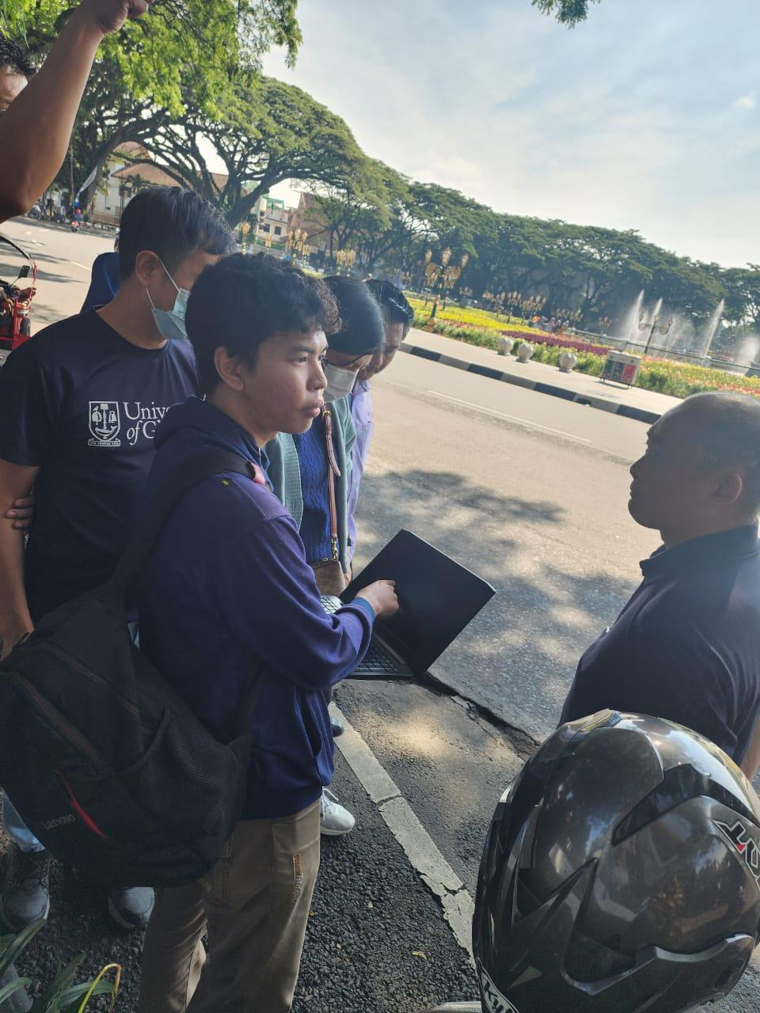
Figure 8: Testing the range of BLE detection

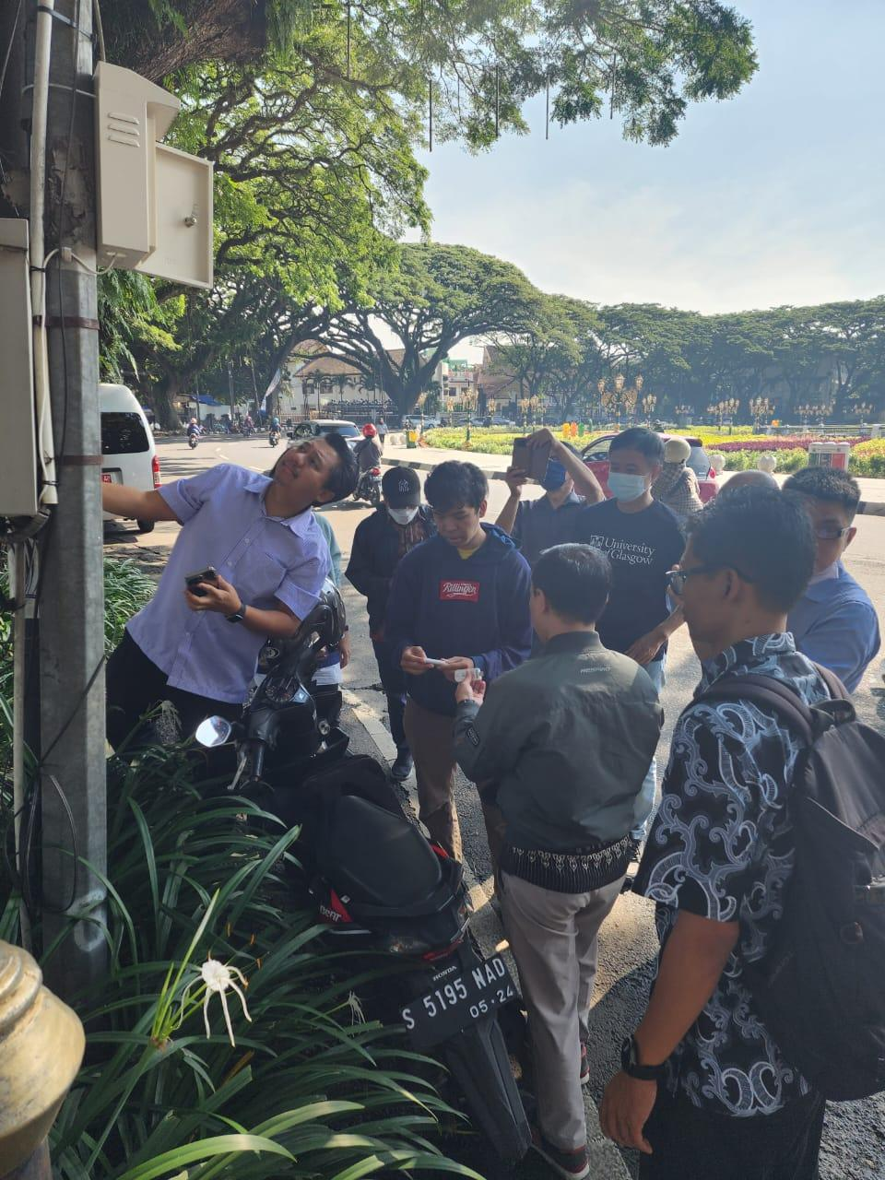
Figure 9: Inspecting the RSU installed

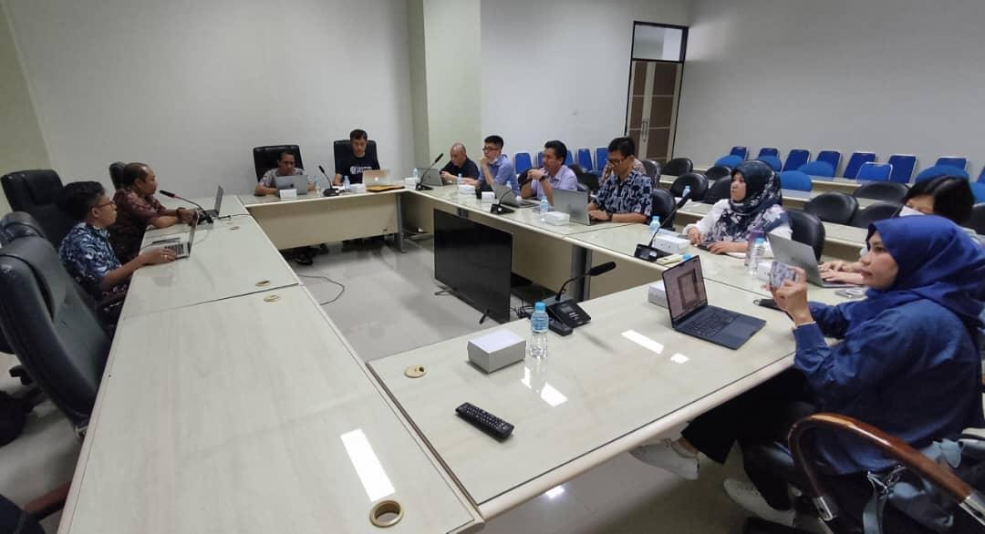
Figure 10: Discussion on future plan

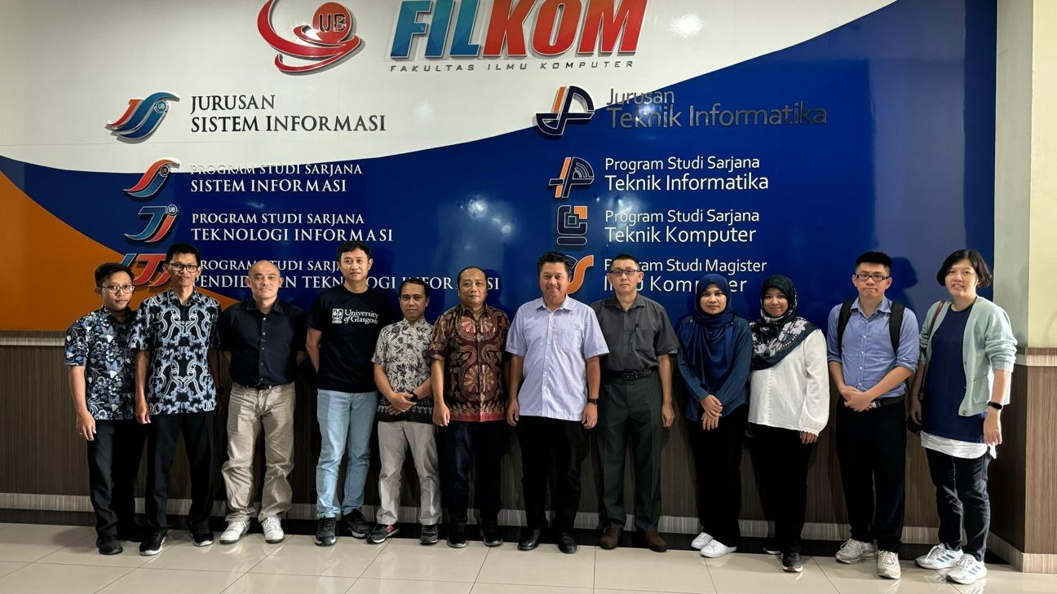
Figure 11: Group photo at the end of the meeting

