Appendix 2.2

Report of International Conference Presentation

Name:  (Presenter) | Chong Yung Wey
Affiliation: | Universiti Sains Malaysia
Project Title: | An IoT-based Public Transport Data Collection and Analytics Framework using Bluetooth Proximity Beacons
Name of International Conference:  (Link to website) | ICAIIC 2024 – The 6th International Conference on Artificial Intelligence in Information and Communication
Title of Research Paper: | Predicting Estimated Time of Arrival Using Boosting Models
Name of all Co-authors (if any) | Say-Hong Kam, Yung-Wey Chong, Noor Farizah Ibrahim, Sye-Loong Keoh, Somnuk Phon-Amnuaisuk, Sharul Kamal Abdul Rahim
Comments or feedback received at the conference:

One question: Are there any performance comparison with ANN?
Response: Comparison has been made with ANN but the performance is not as good as boosting models.

Contribution to the project:

- A data cleaning method to improve data quality by removing duplicate data from Bluetooth Low Energy (BLE) based system, breaking down bus routes into segments, and transforming data for training.
- Feature selection method to select the most relevant features using Boruta.
- Boosting models to minimize computational power while preserving accuracy.
Photos

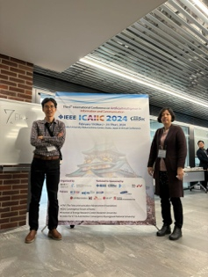

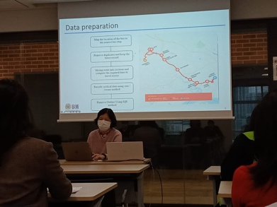

[Required Documents]
- Presentation Materials (e.g. PPT slides)
- Final Program of the conference

Reporter: __ CHONG YUNG WEY____________________________
Date: _____25 February 2024____________________________

Appendix 2.3

Expense Report of International Conference Presentation

Name (Presenter): | Chong Yung Wey
Affiliation: | Universiti Sains Malaysia
Project Title: | An IoT-based Public Transport Data Collection and Analytics Framework using Bluetooth Proximity Beacons
Name of International Conference:  (Link to Website) | ICAIIC 2024 – The 6th International Conference on Artificial Intelligence in Information and Communication
Date and Venue: | 19 February 2024 to 22 February 2024  Nakanoshima Centre Osaka University, Osaka, Japan

Note1: Use the "Remarks" column to provide further context or explanation for
each expense.
Note2: Acceptable proofs of payment are listed below the table for your
reference.
Note3: Add rows if necessary.

- Registration Fee
Payment Date | Category  (early bird/regular, etc.) | Amount | Currency | Remarks  (eg. paid by cash/  credit card, etc.)
25 January 2024 | Regular  (USD650) | 3,136.08 | MYR | Credit card
26 January 2024 | Bank charges for conference fees | 31.36 | MYR | Credit card
Necessary documents: receipt/proof of payment, etc.

- Transportation Fee (flight/train/bus/taxi/rental car, etc.)
Date of  Use | Means of  transportation  & Route | Amount | Currency | Remarks  (Reason of taxi use  required)
29 January 2024 | Flight (PEN-KIX-PEN) | 4,664.19 | MYR | Credit card
18 February 2024 | Train (Kansai Airport to Osaka Station) | 1,210 | JPY | Cash
19 February 2024 | Train (Osaka-Umeda to Fukushima station) | 160 | JPY | Cash
20 February 2024 | Train (Osaka-Umeda to Fukushima station) | 160 | JPY | Cash
20 February 2024 | Train (Fukushima to Osaka-Umeda station) | 160 | JPY | Cash
20 February 2024 | Train (Nishi-Umeda to Nanba Station) | 240 | JPY | Cash
20 February 2024 | Train (Nanba to Nishi-Umeda Station) | 240 | JPY | Cash
20 February 2024 | Train (Osaka-Umeda to Fukushima station) | 160 | JPY | Cash
21 February 2024 | Train (Osaka-Umeda to Fukushima station) | 160 | JPY | Cash
21 February 2024 | Train (Fukushima to Osaka-Umeda station) | 160 | JPY | Cash
22 February 2024 | Train (Higashi-Umeda to Tanimachiyonchome station) | 240 | JPY | Cash
22 February 2024 | Train (Tanimachiyonchome to Higashi-Umeda station) | 240 | JPY | Cash
22 February 2024 | Bus (Osaka station to Kansai airport) | 1,600 | JPY | Cash
Necessary documents: receipt/proof of payment, etc.
(E-ticket and boarding pass are required for flight use)

- Accommodation Fee
Date of  Use | Description  (hotel name, etc.) | Amount | Currency | Remarks  (eg. paid by cash/  credit card, etc.)
18-22 February 2024 | APA Hotel & Resort Osaka Umeda-eki Tower | 1,111.42 | MYR | Credit card
Necessary documents: receipt/proof of payment, etc.

- Others (Visa application/PCR test, etc.)
Date | Description  (for what) | Amount | Currency | Remarks  (eg. paid by cash/  credit card, etc.)
Necessary documents: receipt/proof of payment, etc.

TOTAL ALL ____MYR 9,093.05______________(currency)

*Proof of payment
cash → receipt
bank transfer → bank transfer information (with payer's name)
credit card → credit card statement (with payer' name)
others → relative evidence(mobile screenshot, etc.)

